Careless/Insufficient Effort Responding (C/IER) Detection
Pablo Rogers
2026-09-25
Abstract
This notebook presents a tutorial on the detection of careless or insufficient effort responding (C/IER) in self-report questionnaires. We use real database from WHOQOL-Bref scale as an example (n = 1,546), and we apply the ‘careless’ package and Laz.R (Biemann et al., 2025) to detect C/IER (post hoc indicators). We also discuss the importance of procedural C/IER detection in the quality control of data obtained through self-report questionnaires.

1 Contextualization
The detection of Careless or Insufficient Effort Responding (C/IER) is an essential step in the quality control of data obtained through self-report questionnaires. C/IER occurs when respondents complete the instrument without attention to the item content, compromising the validity of the psychometric and substantive inferences derived from the data (Curran, 2016; Huang et al., 2026).
The analytical flow of this document follows two sequential levels of detection:
- Questionnaire: procedural exclusions (a priori), including dropout, response time, and quality control items.
- WHOQOL Scale: diagnostic post-hoc indicators (Laz.R, Longstring, Mahalanobis Distance, and IRV) with cut-off points estimated via the Kneedle algorithm (Biemann et al., 2025).

2 Data reading and preparation
The data.csv file contains the raw survey responses (separator ;). In this step, dropout records are removed, variables for the analytical flow are selected, and the total response time (TIME) is derived.
Structure and variable dictionary of the prepared survey dataset (imported_data)
Group | Variables | Class / Type | Description
Identification | ID | Numeric (Double) | Unique respondent identifier
Timing | CREATED, MODIFIED, TIME | Date-time / Numeric (s) | Survey timestamps and total response duration in seconds
Attention Checks | CQ1, CQ2, CQ3 | Binary (0/1) | Quality control check items (1 = passed, 0 = failed)
WHOQOL-Bref Scale | Q1 to Q26 (26 items) | Ordinal (1 to 5) | Self-reported quality of life items
_{Source: Procedural exclusions}

3 Procedural exclusions
Level 1 applies three procedures prior to calculating post-hoc indicators: dropout removal, exclusion for response time below 208 seconds (104 items × 2 s/item) (Huang et al., 2026), and exclusion for two or more failures on quality control items (CQ1-CQ3) (Curran, 2016). Every exclusion is recorded in exclusion_log.csv with its reason and criterion.
Table 1: Procedural exclusions summary
Step | N
Raw data | 1546
Dropouts removed | 220
Excluded by time (< 208 s) | 0
Excluded by QC (≥ 2 fails) | 28
Excluded by missings (> 5 in Q1-Q26) | 3
Eligible for Level 2 | 1295
Remaining NAs in Q1-Q26 | 90

_{Source: Procedural exclusions}

4 Calculation of C/IER indicators
Each indicator captures distinct manifestations of C/IER; their concurrent presence offers stronger evidence than any single indicator alone (Curran, 2016; Hong et al., 2020; Huang et al., 2026).

4.1 Univariate visualization
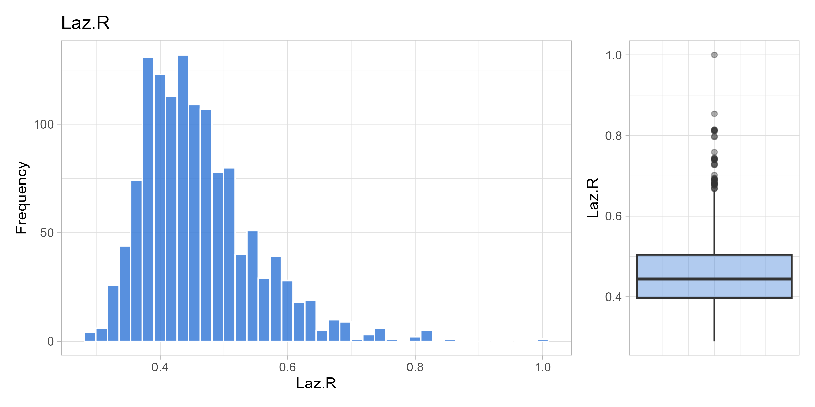
(a) Laz.R

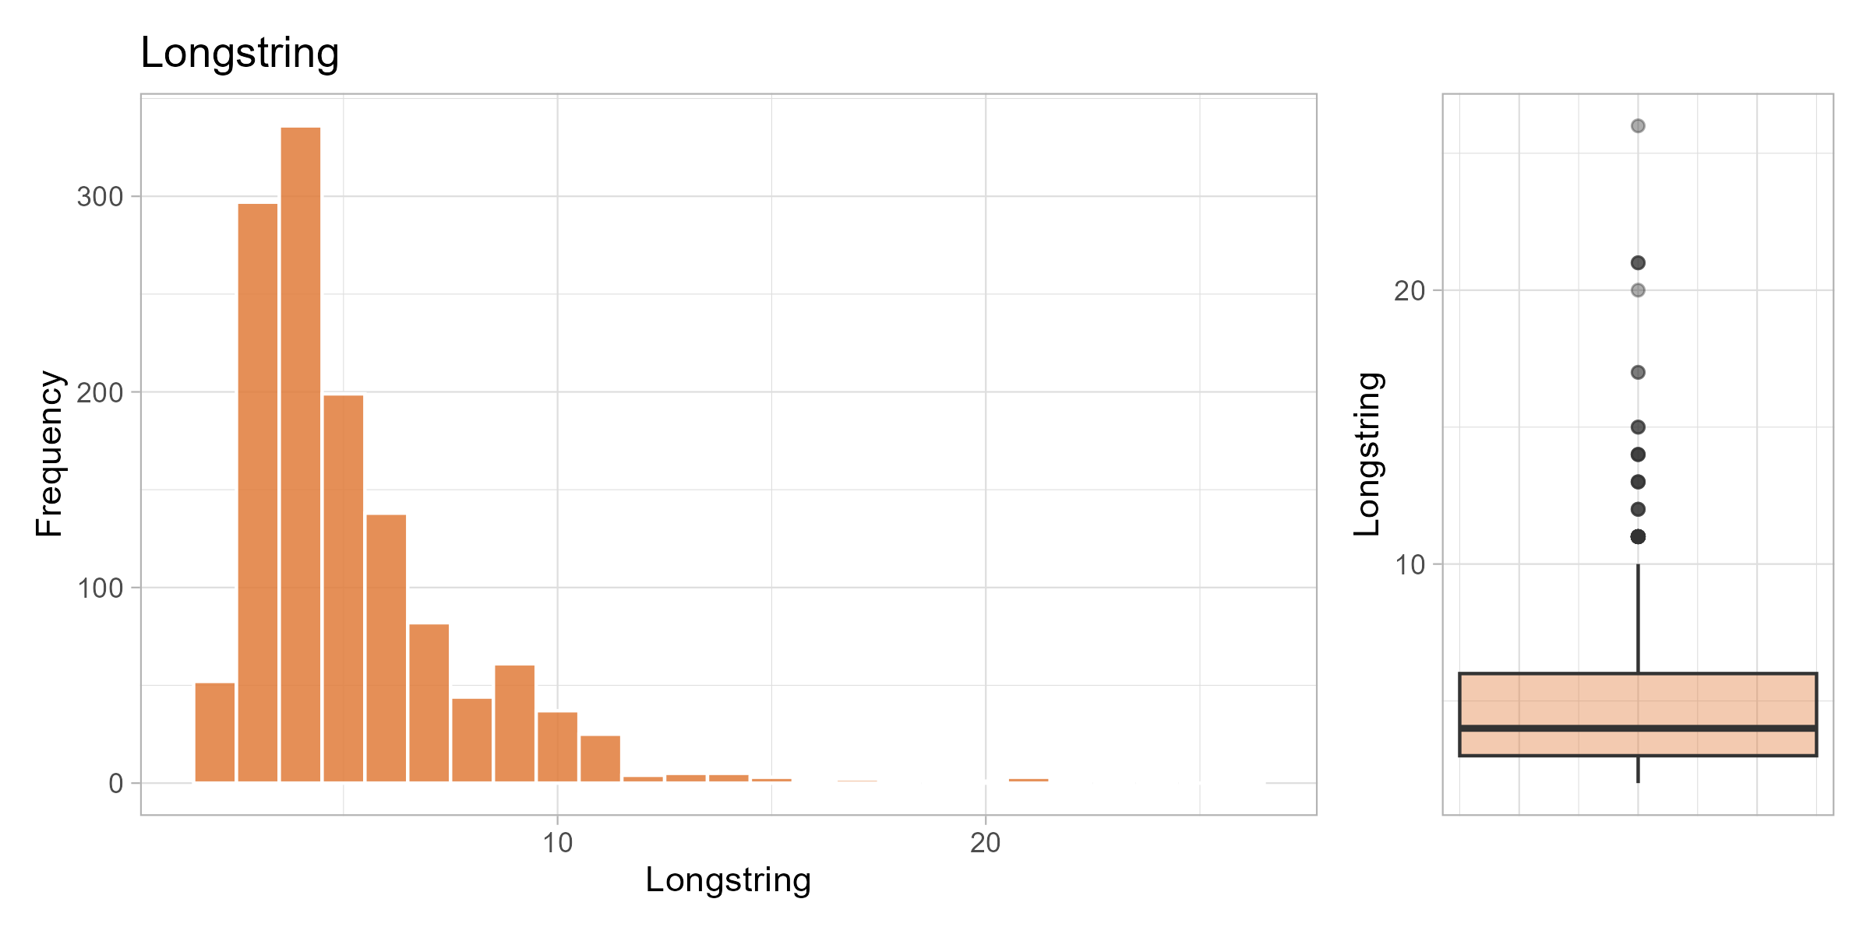
(b) Longstring

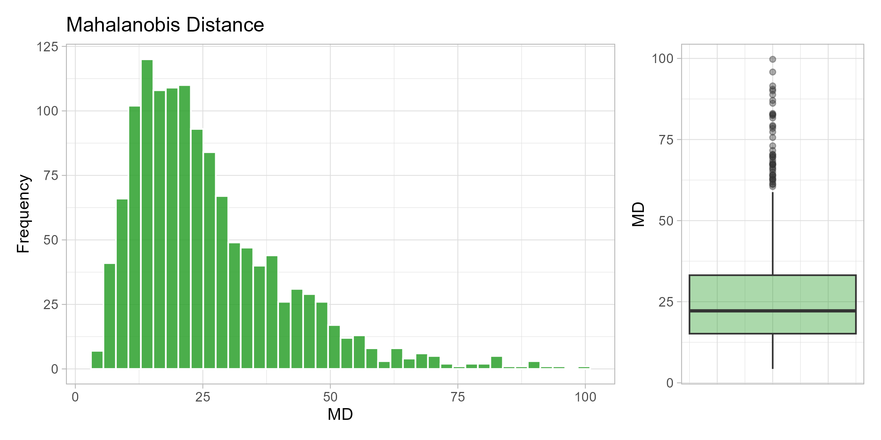
(c) Mahalanobis Distance

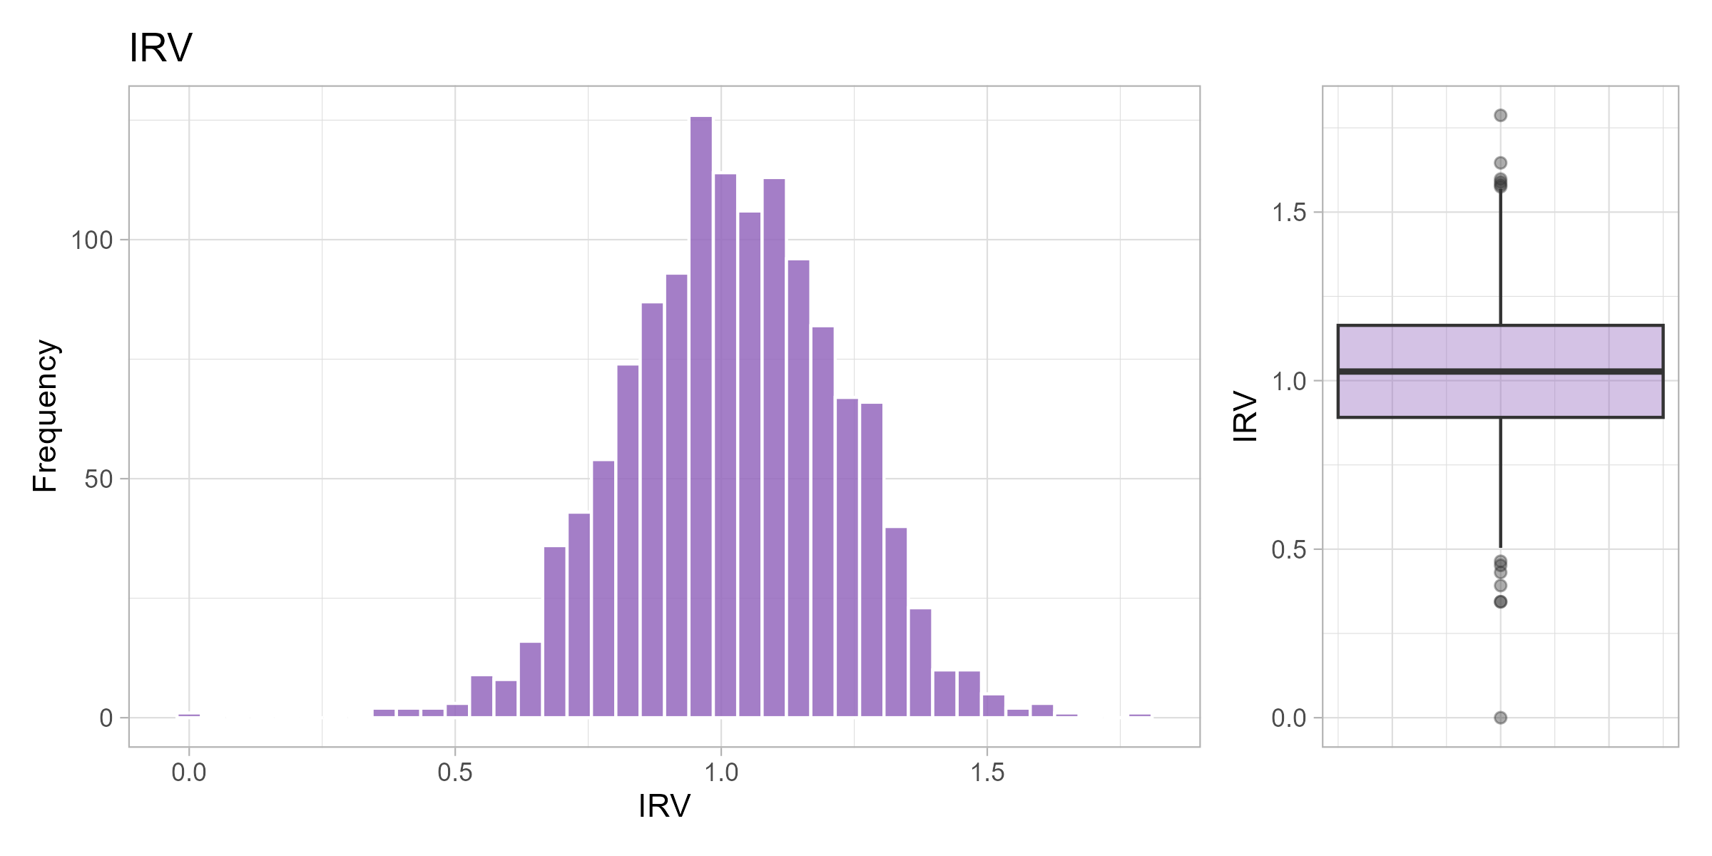
(d) IRV

Figure 1: Univariate distributions of C/IER indicators

4.2 Cut-off points via Kneedle algorithm
The Kneedle algorithm is applied to the sorted (descending) curve of each indicator. For Laz.R, Longstring, and MD, kneedle with sign = -1 identifies where extremely high values separate from the majority (right tail). For IRV, sign = -1 is used to detect excessively high IRV and sign = +1 for excessively low IRV, since both extremes can be considered suspicious.
Table 2: Cut-off points estimated with the Kneedle algorithm
Indicator | Critical value | % flagged
Laz.R | 0.60 | 6.8
Longstring | 7.00 | 14.8
MD | 40.12 | 15.4
IRV (high end) | 1.34 | 4.9
IRV (low end) | 0.69 | 3.8

Source: Post-hoc C/IER Indicators

4.3 Plots with cut-off points
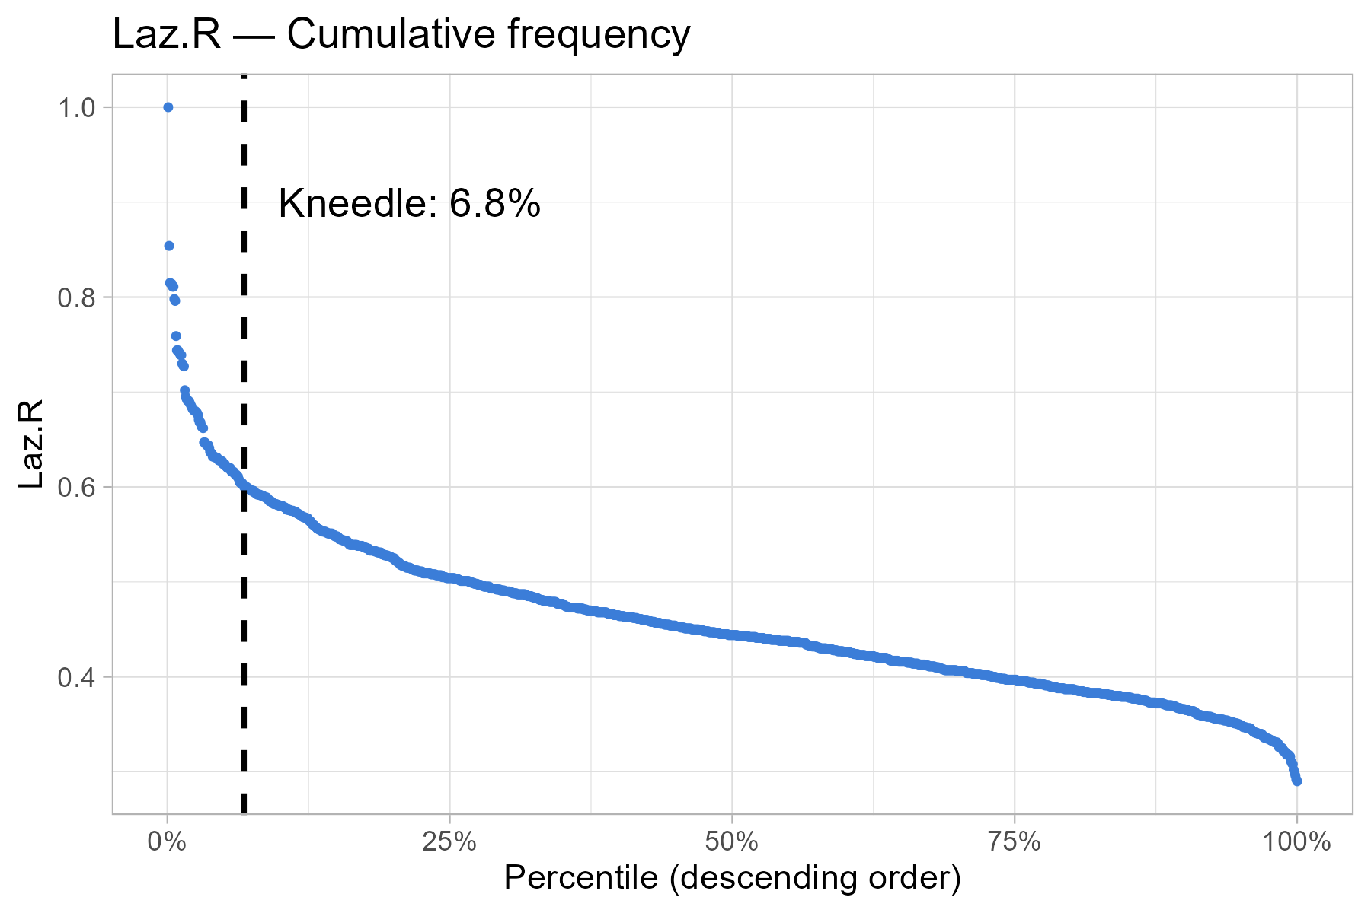
(a) Laz.R

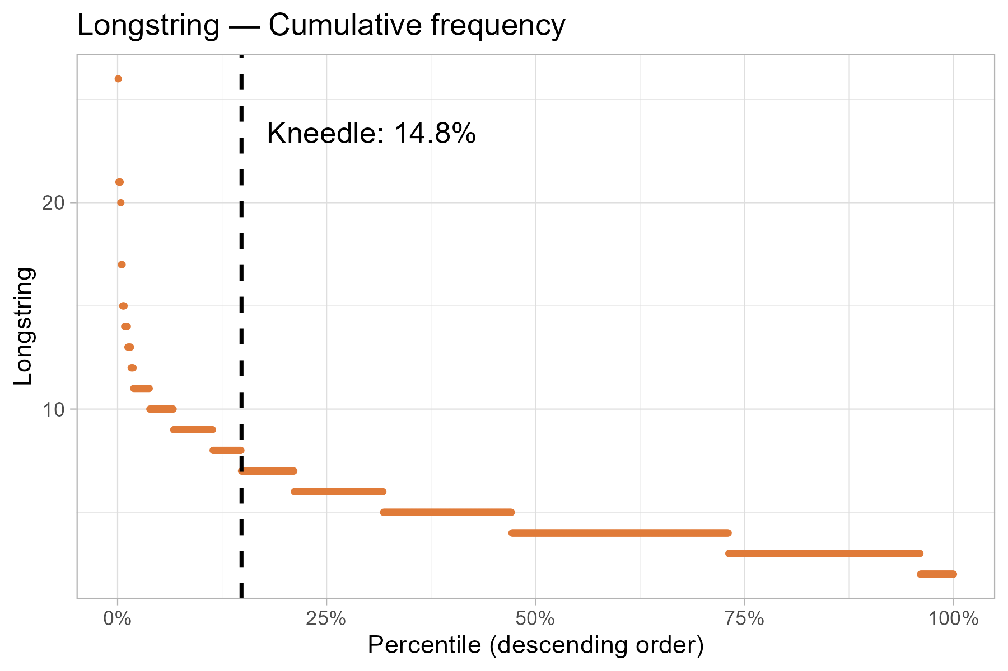
(b) Longstring

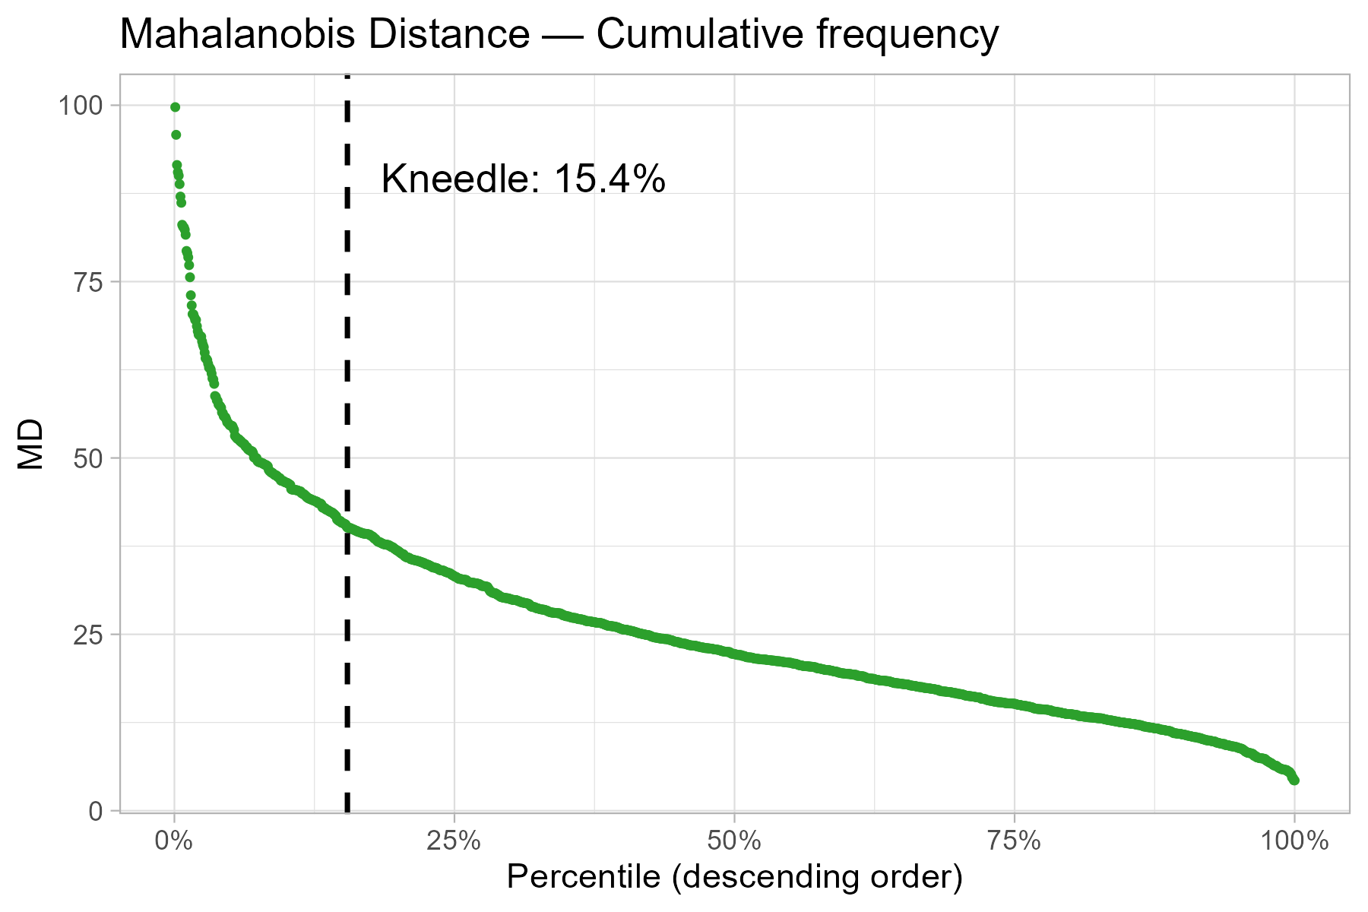
(c) Mahalanobis Distance

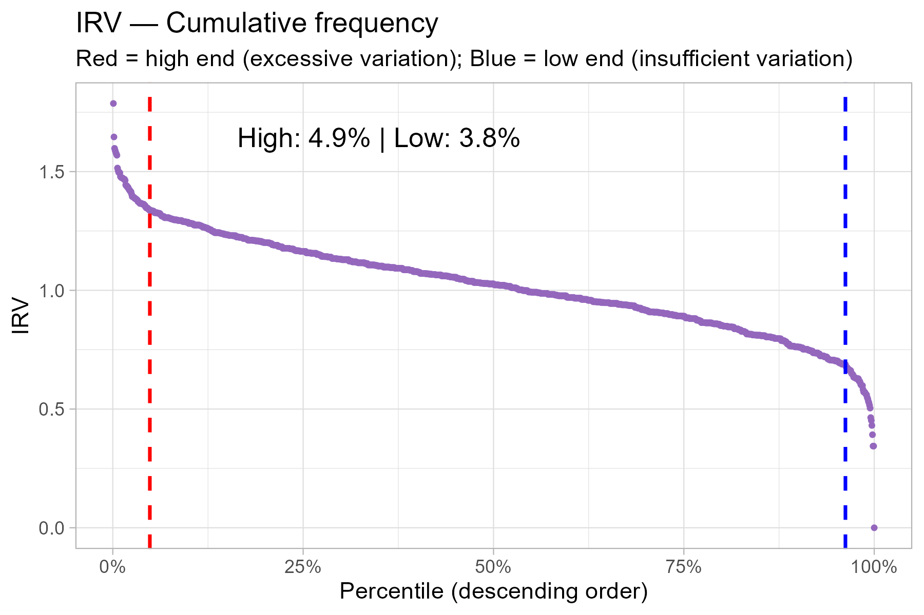
(d) IRV

Figure 2: Cumulative frequency curves with Kneedle cut-off points

4.4 C/IER Flags
For each indicator, a _FLAG variable is created (1 = flagged, 0 = not flagged) based on the Kneedle cut-off points.
Note: Post-hoc indicators are diagnostic, they do not trigger automatic exclusion in isolation. The final decision below requires corroboration from at least two of four selected indicators.
Table 3: Summary of respondents flagged by each C/IER indicator
Indicator | N flagged | % flagged
LazR_FLAG | 91 | 7.0
Longstr_FLAG | 191 | 14.7
MD_FLAG | 201 | 15.5
IRV_high_FLAG | 66 | 5.1
IRV_low_FLAG | 49 | 3.8

Source: Post-hoc C/IER Indicators

4.5 From diagnostic flags to final exclusions
The cut-offs above identify response patterns that warrant attention; they do not, by themselves, prove that a respondent answered carelessly. Detection methods are sensitive to different manifestations of C/IER and may also flag unusual but valid response profiles. Consequently, combining every available flag with an OR rule can increase sensitivity at the cost of specificity and sample size (Curran, 2016; Hong et al., 2020). Indiscriminate post-hoc removal may also distort statistical and psychometric estimates when valid atypical respondents are classified as inattentive (Wang et al., 2025).

4.5.1 Consequences of alternative decision rules
The scenarios below make the cost of each possible rule explicit. The first two use all five diagnostic flags. The next two remove Longstring from the decision set, while retaining it as a descriptive diagnostic. The final two show the Laz.R–MD screening alternative.
Table 4: Consequences of alternative post-hoc decision rules
Decision rule | Excluded | % excluded | Retained
Any of the five diagnostic flags | 436 | 33.7 | 859
At least two of the five diagnostic flags | 139 | 10.7 | 1156
Any of the four decision flags (excluding Longstring) | 344 | 26.6 | 951
At least two of the four decision flags (Plan A) | 62 | 4.8 | 1233
Laz.R or MD (case-review screening) | 290 | 22.4 | 1005
Laz.R and MD | 2 | 0.2 | 1293

Source: Post-hoc C/IER Indicators

An OR rule across all five flags would remove 436 respondents (33.7%), leaving 859 observations. Even after removing Longstring from the decision set, an OR rule would remove 344 respondents (26.6%). These reductions are difficult to defend when a single post-hoc indicator can produce false positives. In particular, Mahalanobis distance may overflag respondents when ordinal item responses depart from the multivariate-normal assumptions used in conventional outlier detection (Hong et al., 2020).

4.5.2 What the intersections show
Longstring and low IRV are invariability-oriented diagnostics, high IRV targets excessive variation, and MD targets multivariate atypicality. Laz.R detects predictable transitions, including straightlining, alternating, and diagonal patterns, but it is not a general detector of random responding. Laz.R should therefore be combined with complementary approaches, and its Kneedle cut-off should support scrutiny and possible exclusion rather than be treated as proof of carelessness (Biemann et al., 2025).
Table 5: Pairwise overlap among diagnostic C/IER flags
Indicator 1 | Indicator 2 | N intersection | % of indicator 1 | % of indicator 2
Laz.R | Longstring | 76 | 83.5 | 39.8
Laz.R | MD | 2 | 2.2 | 1.0
Laz.R | IRV high | 2 | 2.2 | 3.0
Laz.R | IRV low | 18 | 19.8 | 36.7
Longstring | MD | 8 | 4.2 | 4.0
Longstring | IRV high | 11 | 5.8 | 16.7
Longstring | IRV low | 26 | 13.6 | 53.1
MD | IRV high | 42 | 20.9 | 63.6
MD | IRV low | 0 | 0.0 | 0.0
IRV high | IRV low | 0 | 0.0 | 0.0

Source: Post-hoc C/IER Indicators

Of the 91 Laz.R flags, 76 (83.5%) are also Longstring flags. Counting both in the composite rule would allow one narrow manifestation - repetitive or highly predictable responding - to contribute two votes. Longstring remains useful for diagnosis and teaching, but its narrower scope and empirical redundancy with Laz.R justify excluding it from the final flag count. Conversely, 42 of the 66 IRV-high cases are also flagged by MD, providing convergent evidence for excessive variability or multivariate atypicality.
Table 6: Intersection of Laz.R and Mahalanobis distance flags
Classification | N | % of sample
Neither flag | 1005 | 77.6
MD only | 199 | 15.4
Laz.R only | 89 | 6.9
Both Laz.R and MD | 2 | 0.2

Source: Post-hoc C/IER Indicators

Only two respondents fail both Laz.R and MD, whereas 199 fail MD only and 89 fail Laz.R only. Requiring both would remove almost no cases, while using either would identify 290 cases (22.4%) for case-by-case review. This can be a useful screening pool, but it was not adopted as an automatic exclusion rule because the indicators are nearly disjoint in this sample and MD-only evidence is not sufficient to infer carelessness from ordinal responses (Hong et al., 2020; Ward & Meade, 2023).

4.5.3 Final rule: at least two of four decision flags
The final rule counts Laz.R, MD, IRV high, and IRV low and excludes a respondent only when at least two of these four flags are present. It requires corroboration, avoids deletion based on MD alone, and retains IRV as evidence for both insufficient and excessive within-person variability. This follows the recommendation to use multiple, context-appropriate indicators rather than rely blindly on one index (Curran, 2016; Ward & Meade, 2023).
Hong et al. (2020) best-subset simulations support selecting a smaller group of complementary indicators instead of a kitchen-sink combination, although their specific subset and cut-offs are design-dependent and should not be imported unchanged into the WHOQOL-Bref (Hong et al., 2020). Plan A is therefore a transparent teaching decision for this dataset, not a universal threshold.
Table 7: Evidence combinations among respondents excluded by Plan A
decision_evidence | Excluded | % of exclusions
MD + IRV high | 41 | 66.1
Laz.R + IRV low | 18 | 29.0
Laz.R + IRV high | 1 | 1.6
Laz.R + MD | 1 | 1.6
Laz.R + MD + IRV high | 1 | 1.6

Source: Post-hoc C/IER Indicators

Plan A removes 62 of the 1,295 eligible respondents (4.8%). The full audit log preserves each excluded ID, indicator value, flag, composite count, and evidence combination in posthoc-exclusion-log.csv.

4.5.4 Final analysis dataset
Table 8: Derivation of the final analysis sample
Stage | N
Eligible after procedural exclusions | 1295
Excluded by Plan A post-hoc rule | 62
Final analysis dataset | 1233

Source: Post-hoc C/IER Indicators

The final whoqol_analysis.csv contains 1,233 respondents, the ID column, and Q1-Q26. Items Q3, Q4, and Q26 are reverse-scored only after the C/IER indicators have been calculated on the response sequence as administered. For substantive analyses, the unfiltered 1,295-case dataset can be retained as a sensitivity condition. Large changes between filtered and unfiltered results should be reported rather than used to choose whichever cleaning rule produces the preferred result (Wang et al., 2025).

References
Biemann, T., Koch-Bayram, I. F., Meier-Barthold, M., & Aguinis, H. (2025). Using Markov Chains to Detect Careless Responding in Survey Research. Organizational Research Methods, 28(4), 543–568. https://doi.org/10.1177/10944281251334778
Curran, P. G. (2016). Methods for the detection of carelessly invalid responses in survey data. Journal of Experimental Social Psychology, 66, 4–19. https://doi.org/10.1016/j.jesp.2015.07.006
Hong, M., Steedle, J. T., & Cheng, Y. (2020). Methods of Detecting Insufficient Effort Responding: Comparisons and Practical Recommendations. Educ Psychol Meas, 80(2), 312–345. https://doi.org/10.1177/0013164419865316
Huang, J. L., Wang, Z., Huang, R., Wu, D., & Shi, H. (2026). Insufficient Effort Responding in Management Research: A Critical Review and Future Directions. 52(1). https://doi.org/10.1177/01492063251330268
Wang, M. D., Xiao, L., & Zang, X. (2025). When Cleaning Data Introduces Bias: A Critical Examination of Post-Hoc Methods in Detecting Insufficient Effort Responding. Journal of Official Statistics, 41(4). https://doi.org/10.1177/0282423X251337843
Ward, M. K., & Meade, A. W. (2023). Dealing with Careless Responding in Survey Data: Prevention, Identification, and Recommended Best Practices. Annu. Rev. Psychol., 74(Volume 74, 2023), 577–596. https://doi.org/10.1146/annurev-psych-040422-045007

