**Python test for data processing, plotting and video writing**

The attached csv file is a 5s data collection from sensors during a USFL game.

You need to parse this csv file to extract 2D locations of the ball and players on the field, aggregate by time interval of 50ms, then plot with matplotlib and generate a video. You can use either python script or jupyter notebook for this test.  
  
Here are the instructions for each step:

1 Parse the raw csv file

The raw file contains recorded data from two type of sensors – player sensors and ball sensors.

The header for ball data is:  
‘event_timestamp,event_structure_version,event_type<ball>,game_clock,play_clock,stop_flag,tag_serial_number,X,Y,Z,distance,Vx,Vy,V,Ax,Ay,A,direction’  
  
The header for player data is:

‘event_timestamp,event_structure_version,event_type<player>,game_clock,play_clock,stop_flag,tag_serial_number,player_id,X,Y,Z,distance,Vx,Vy,V,Ax,Ay,A,direction’  
  
You need to get the time information, tag_serial_number, and X/Y locations from each line.  
Raw timestamp is recorded as Unix timestamps in milliseconds.

Each sensor(tag) has a unique ‘tag_serial_number’.  
Note: the number of columns in ball/player records are different.

2 Aggregate to 50ms

To prepare this data for the next plotting step, aggregation is needed to obtain the mean value of locations during a fixed time interval.

For each unique sensor tag, please aggregate the value of X and Y locations by 50ms interval.  
Note: Sometime a sensor is not sending data during a 50ms interval, you can fill nan values for these missing values. You can use either left or right value of timestamps in the interval for the aggregation result, as long as the choice is consistent.

3 Plotting  
Now you have the X and Y locations for all players and balls on the field, for every 50ms.  
Please plot 2D images for each aggregated timestamp.

Here is a sample of the plotted result.   
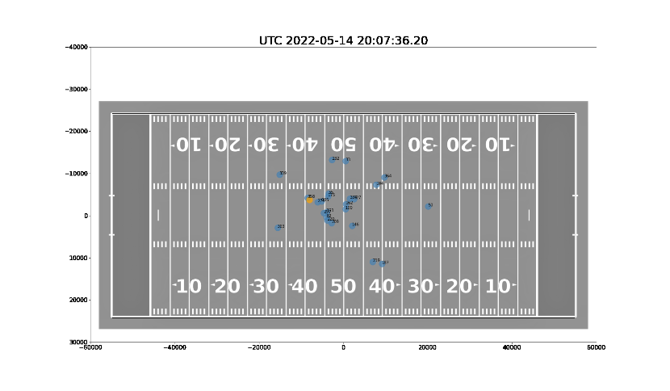  
You don’t need to plot your images with background image, it’s just for reference.  
  
As long as you plot the 2D points for players and balls correctly, the result will be accepted.  
The background image is attached. Plotting the background and the players’ IDs are **not** necessary.

Notes:  
The X location data refers to the axis along the short edge(vertical), while the Y location data is for the long edge(horizontal).  
The x limits for the field is (-24231.6, 24231.6) and y limits is (-54864.0,54864.0). Remove players and balls not on the field.

For each plotted image, please also add the time information. The raw timestamp needs to be converted to UTC datetime format.  
The plotted images will be used for next step, video generation. You can either save them on your hard drive or send to a video writer pipeline directly.

4 Video generation.  
Please resize the generated images to the height of 1080, while keeping the aspect ratio.

Then created a short video with the resized images

There should be around 100 images in total. You can choose any common video formats / encoders.

Note on result submission:

Please send your py script or ipynb notebook file, together with the generated video by email. Thank you!