Task1:

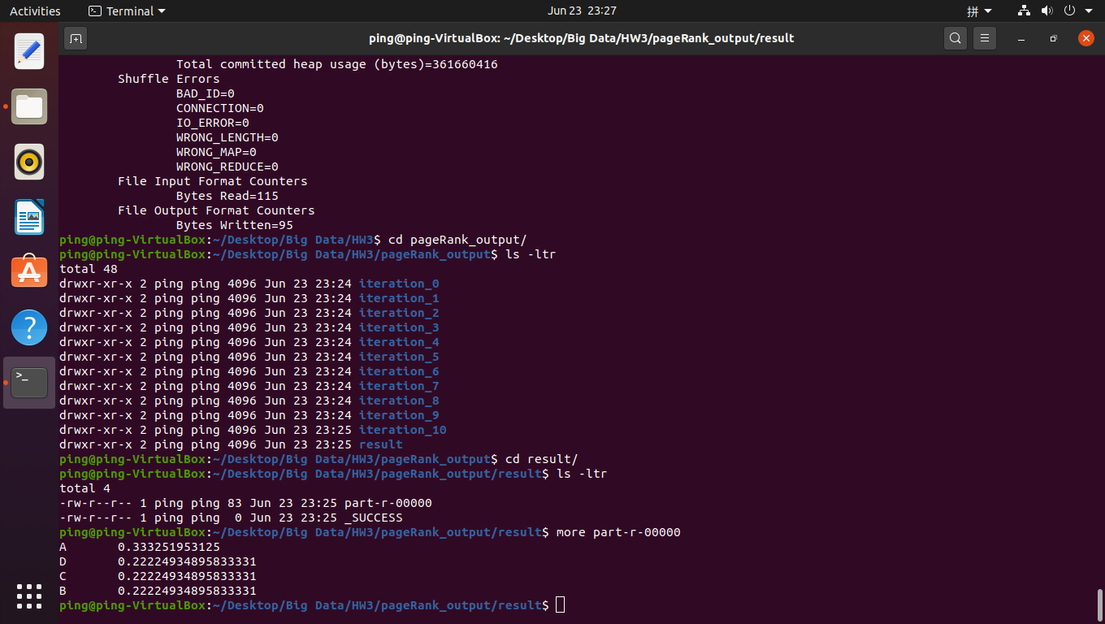

Code changes:

\*\*\*\*\*\*\*\*\*\*\*\*\*\*\*\*\*\*HadoopPageRank class\*\*\*\*\*\*\*\*\*\*\*\*\*\*\*\*\*\*\*\*\*\*\*\*\*\*\*\*\*\*\*\*\*

\*\*\*\*\*\*\*\*\*\*\*\*\*\*\*\*\*\*\*\*place holder part\*\*\*\*\*\*\*\*\*\*\*\*\*\*\*\*\*\*\*\*\*\*\*\*\*\*\*\*\*\*\*\*\*\*

resultJob.setMapperClass(HadoopPageRankResultMapper.class);

resultJob.setReducerClass(HadoopPageRankResultReducer.class);

resultJob.setOutputKeyClass(DoubleWritable.class);

resultJob.setOutputValueClass(Text.class);

resultJob.setInputFormatClass(TextInputFormat.class);

\*\*\*\*\*\*\*\*\*\*\*\*\*\*\*\*\*HadoopPageRankResultMapper class\*\*\*\*\*\*\*\*\*\*\*\*\*\*\*\*\*\*\*\*\*\*\*

import java.io.IOException;

import org.apache.hadoop.io.DoubleWritable;

import org.apache.hadoop.io.LongWritable;

import org.apache.hadoop.io.Text;

import org.apache.hadoop.mapreduce.Mapper;

import org.apache.hadoop.mapreduce.Mapper.Context;

public class HadoopPageRankResultMapper extends Mapper<LongWritable, Text, DoubleWritable, Text>{

public void map(LongWritable key, Text value, Context context)

throws IOException, InterruptedException {

if ( value == null || value.getLength() == 0 ) {

return;

}

int tabIdx1 = value.find("\t");

int tabIdx2 = value.find("\t", tabIdx1 + 1);

String link = Text.decode(value.getBytes(), 0, tabIdx1);

String pageRank = Text.decode(value.getBytes(), tabIdx1 + 1, tabIdx2 - (tabIdx1 + 1));

double PR = -1\*Double.parseDouble(pageRank.toString());

context.write(new DoubleWritable(PR), new Text(link));

}

}

\*\*\*\*\*\*\*\*\*\*\*\*\*\*\*\*HadoopPageRankResultReducer class\*\*\*\*\*\*\*\*\*\*\*\*\*\*\*\*\*\*\*\*

import java.io.IOException;

import org.apache.hadoop.io.DoubleWritable;

import org.apache.hadoop.io.Text;

import org.apache.hadoop.mapreduce.Reducer;

public class HadoopPageRankResultReducer extends Reducer<DoubleWritable, Text, Text, DoubleWritable> {

public void reduce(DoubleWritable key, Iterable<Text> values, Context context) throws IOException, InterruptedException {

double temp = 0.0;

temp = key.get() \* -1;

for (Text value : values) {

context.write(value, new DoubleWritable(temp));

}

}

}

Task2:

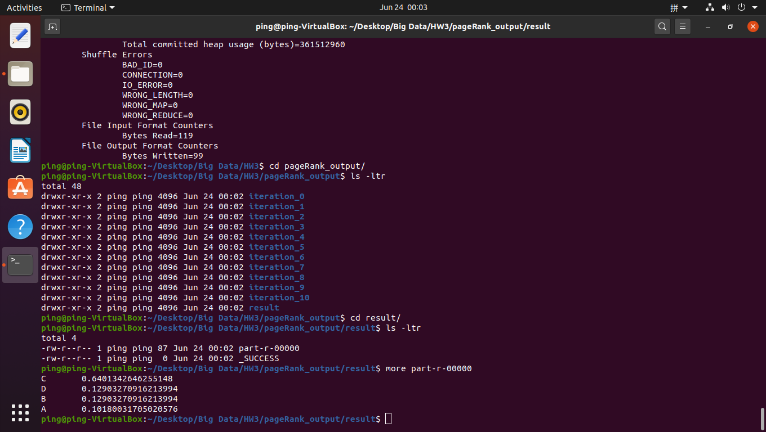

Code changes:

\*\*\*\*\*\*\*\*\*\*\*\*\*\*\*\*\*\*HadoopPageRankMainJobReducer class\*\*\*\*\*\*\*\*\*\*\*\*\*\*\*\*\*\*\*\*\*\*\*

// I changed the calculation function of receivedContribution

// with the updated flow model calculation

import java.io.IOException;

import org.apache.hadoop.io.Text;

import org.apache.hadoop.mapreduce.Reducer;

public class HadoopPageRankMainJobReducer extends Reducer<Text, Text, Text, Text> {

@Override

public void reduce(Text key, Iterable<Text> values, Context context)

throws IOException, InterruptedException {

if ( values == null ) {

return;

}

String links = "";

double receivedContribution = 0.0;

for (Text value : values) {

String content = value.toString();

if (content.startsWith("|")) {

links += content.substring("|".length());

} else {

receivedContribution += Double.parseDouble(content);

}

}

//the Google solution for spider traps:

receivedContribution = 0.80\*receivedContribution+0.20\*0.25;//here is the change

double newPageRank = receivedContribution;

context.write(key, new Text(newPageRank + "\t" + links));

}

}

Task3:

3 After iteration 4, b = 1/2