the class/function where you have made your change: (in the iteration part)

pageRank = contribs.reduceByKey(**new** RankAdjust()).mapValues(sum -> (1-***beta***)/numOfPages.value() + sum * ***beta***);

start Spark master node：

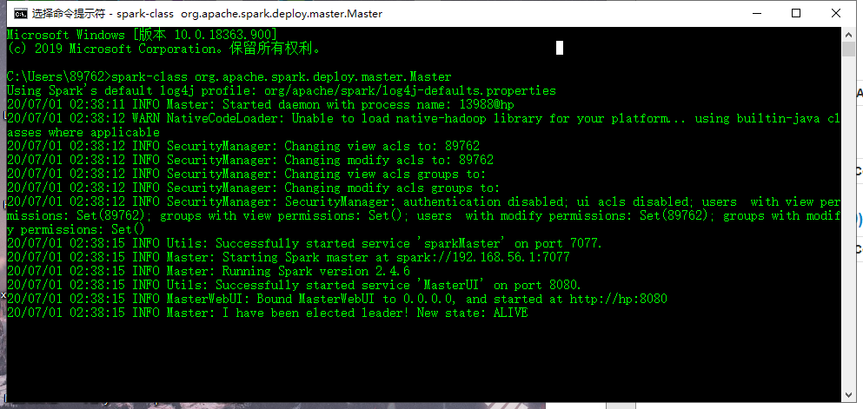

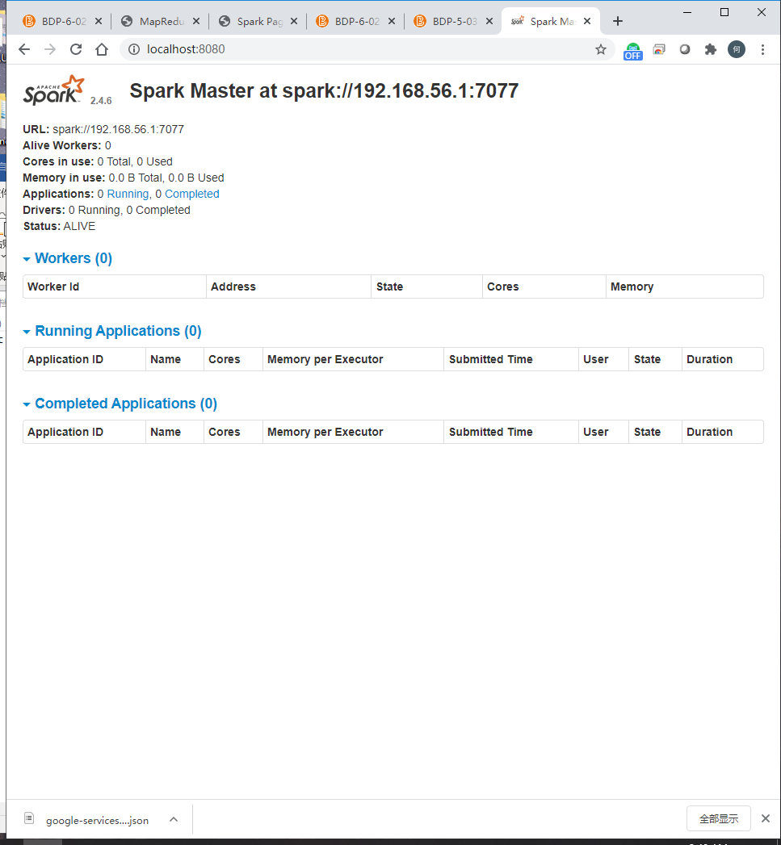

start a worker node：

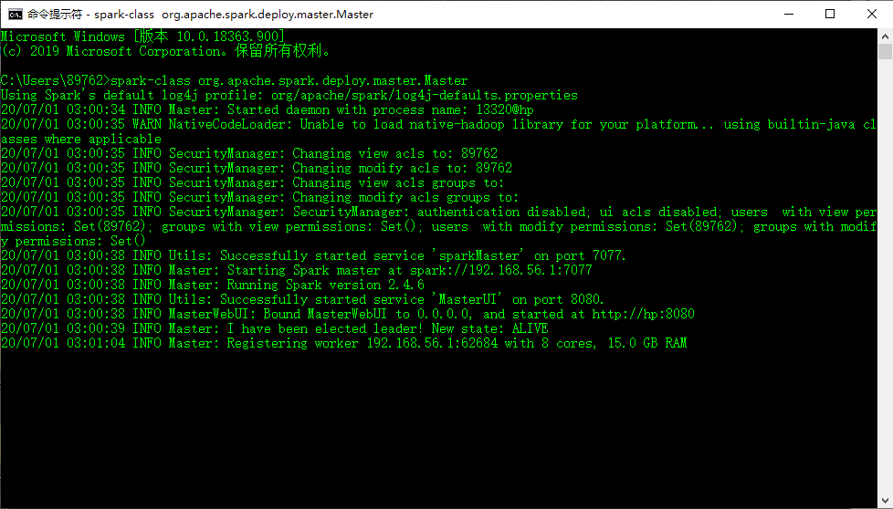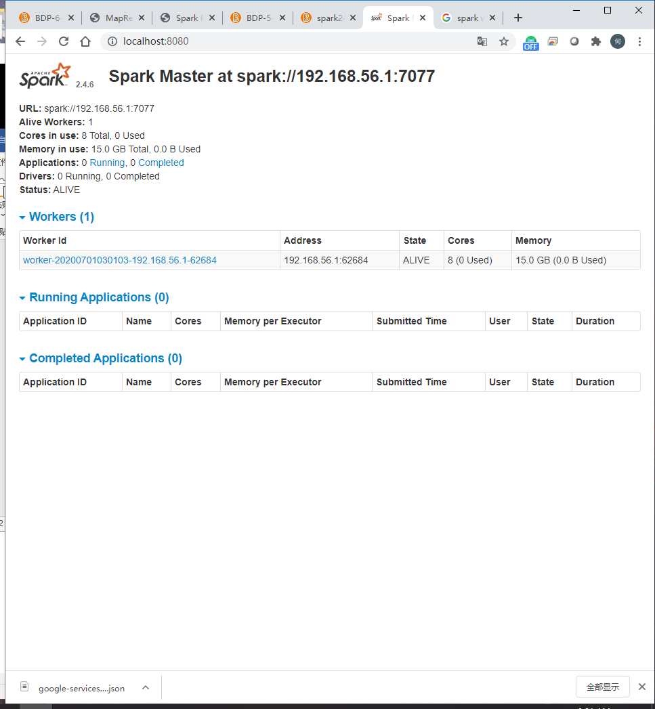

submit the job, and the result of running the job:

