Digit Card Detection Robot (0–4) using YOLOv8n and ONNX Deployment
Project Title: Digit Card Detection Robot (0–4) using YOLOv8n and ONNX Deployment
Student Name: Chiv Pheng Phearin
Course: ICT 361
Instructor: Theara SENG
Date: 10th December 2025

1. Abstract / Summary
This project focuses on building a digit recognition robot capable of detecting printed numbers from 0 to 4 using a custom YOLOv8n object detection model. A dataset of hand written digits was collected, labeled, and augmented to improve model robustness under different real world conditions. The YOLOv8n model was trained for two purposes:
(1) a 10 epoch training version used for evaluation and reporting, and
(2) a 50 epoch version used to generate a more accurate ONNX model for deployment on a Raspberry Pi 4.
The trained model demonstrated strong performance, with high precision, recall, and mAP values. After exporting the weights to ONNX format, the model was integrated with robot logic to execute actions such as moving forward, stopping, or turning based on the detected digit. The results show that even lightweight models can achieve reliable real time detection on embedded hardware.

2. Introduction – Object Detection Motivation and Project Goals
Object detection is one of the most widely used applications of computer vision today. From traffic monitoring and robotics to medical imaging and industrial automation, machines need to understand and react to their visual environment. This project applies object detection to a simpler but educational task: reading printed digits (0–4) and using them as commands for a robot.
The project combines several important skills:
- Collecting and labeling a real dataset
- Training a custom YOLOv8 model
- Evaluating accuracy using metrics such as precision, recall, and mAP
- Exporting the model to ONNX format for lightweight deployment
- Running inference on a Raspberry Pi 4 to control robot movements
- Testing performance in real-world conditions
The goal is to build a robot that can “read” digit cards and respond correctly according to a predefined action-mapping table.

3. Dataset – Collection and Labeling Strategy
A key part of the project was preparing a dataset that represents how the robot will see digits in real life.
3.1 Dataset Collection
- Around 1,828 original images of digits 0–4 were collected.
- Images were captured using a smartphone camera at different angles, backgrounds, distances, and lighting environments.
- Digits were hand written on paper to simulate real classroom testing conditions.
- Each digit class (0,1,2,3,4) appeared in a variety of shapes and handwriting styles.
3.2 Labeling
- All images were uploaded to Roboflow.
- Bounding boxes were drawn around each digit.
- Labels used: 0, 1, 2, 3, 4, plus background as needed.
- The dataset was split automatically into:
  - 87% training set
  - 8% validation set
  - 4% testing set
3.3 Augmentation
To make the model more robust, Roboflow augmentation was applied:
- Rotation: –15° to +15°
- Brightness: –15% to +15%
- Blur: up to 2.5px
- Auto-orientation and resizing to 640×640 pixels
After augmentation, the final dataset size increased to 4,386 images.
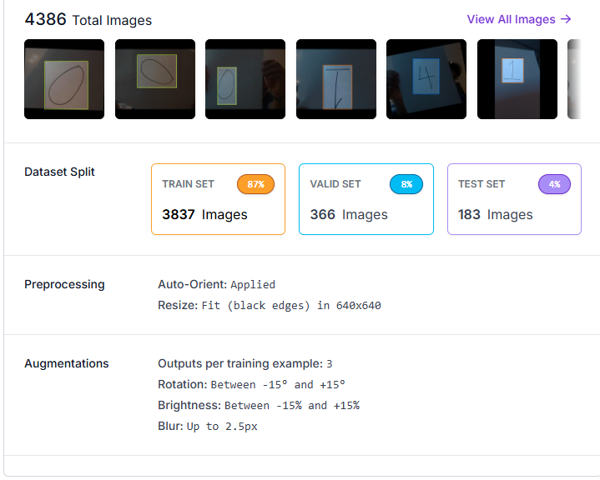

4. Model – YOLOv8n Architecture and Hyperparameter Settings
YOLOv8n (nano version) was selected due to its fast performance and small size, making it ideal for Raspberry Pi deployment.
4.1 Model Choice
- YOLOv8n is lightweight
- Good accuracy for simple projects
- Faster inference on Raspberry Pi 4
- Supports ONNX export easily
4.2 Hyperparameters Used
Parameter | Value
Model | yolov8n.pt
Epochs (report version) | 10
Epochs (robot deployment) | 50
Image size | 640 × 640
Batch size | 16
Optimizer | AdamW (default)
Patience | 20

5. Training Process
Training was performed in Google Colab because it provides free GPU acceleration (T4 GPU).
Training pipeline:
- Install Ultralytics
- Download dataset from Roboflow using API key
- Load YOLOv8n model
- Train for 10 epochs
- Save results
- Train a separate 50-epoch model for ONNX export
The model showed stable improvements with each epoch — loss values decreased, and accuracy metrics increased over time.

6. Results – mAP, Precision–Recall, Confusion Matrix
This section presents the evaluation of the 10 epoch model.
6.1 Training Metrics
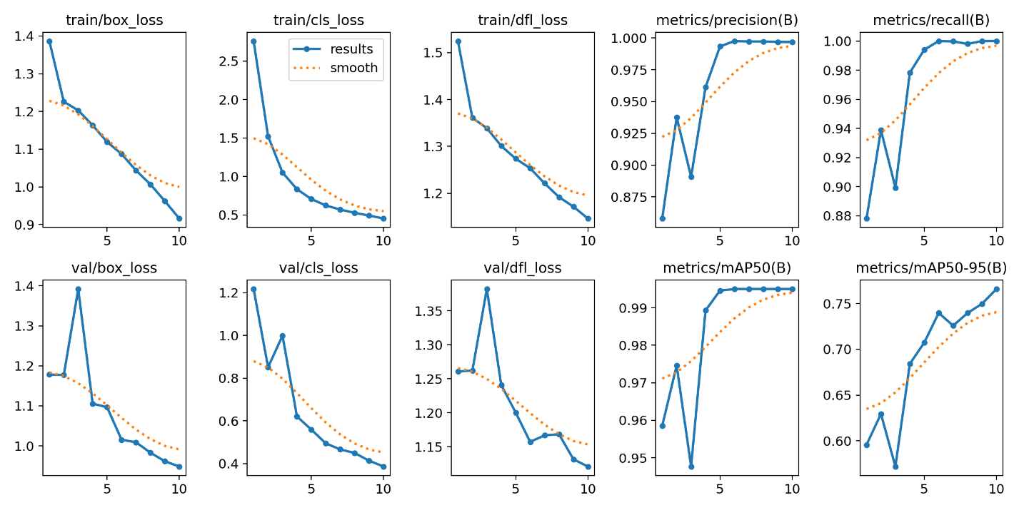
(Figure showing loss curves, precision, recall, mAP50, mAP50-95)
Observations:
- Loss values: training and validation losses consistently decreased
- Precision: reached close to 1.0
- Recall: improved steadily
- mAP50: ~0.99 (excellent performance)
- mAP50-95: improving but naturally lower

6.2 Confusion Matrix
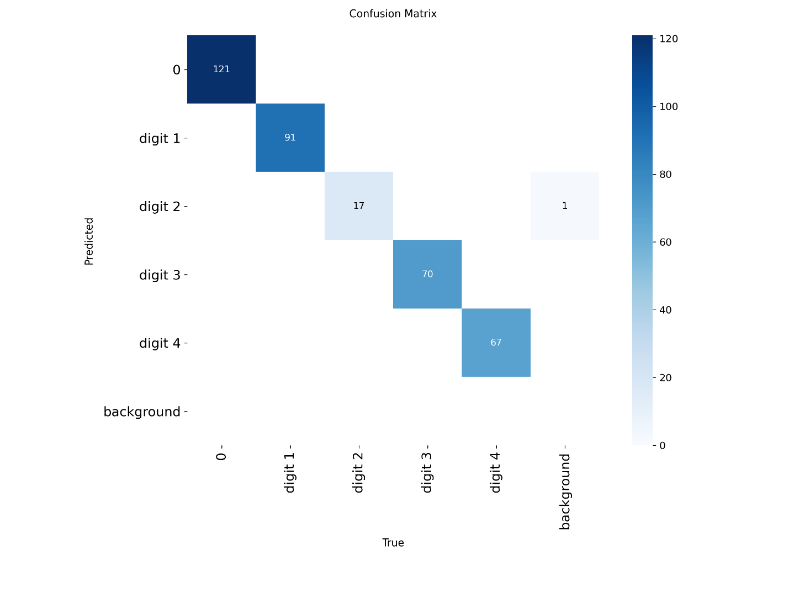Interpretation
- Digit 0: 121 correct predictions
- Digit 1: 91 correct predictions
- Digit 2: 17 correct predictions
- Digit 3: 70 correct predictions
- Digit 4: 67 correct predictions
- Very few misclassifications
- Background was almost never predicted incorrectly
Digit “2” had fewer correct predictions due to handwriting variety and fewer training examples.

7. Conversion & Deployment – ONNX Export and Validation
To run the model on a Raspberry Pi 4, YOLOv8n was exported to ONNX format.
7.1 Export Command
yolo export format=onnx imgsz=640
7.2 Output
- File: best.onnx
- Size: ~11.7 MB
- Successfully validated in Colab
- Ready for deployment
The 50-epoch model was used for ONNX export because it had higher accuracy and more stable results.

8. Robot Integration – Mapping and Safety Logic
The robot uses digit detections to decide movements.
Mapping used in the project:
Detected Digit | Robot Action
0 | Stop
1 | Move Forward (Slow)
2 | Move Forward (Medium)
3 | Move Forward (Fast)
4 | Turn Left (Small)
The Raspberry Pi receives the digit from ONNX inference, then triggers the motor controller based on the mapping.
Safety precautions included:
- Stopping robot if no digit detected
- Limiting motor speed
- Ensuring clear background

9. Testing – Robustness and Real-World Conditions
Testing was performed with printed digit cards under different scenarios:
Lighting conditions
- Bright classroom lights
- Dim lighting
- Shadows
Angles
- Straight on
- 30° and 45° tilt
Distances
- 30 cm
- 50 cm
- 80 cm
Observations
- Model remained stable up to 80 cm
- Slight confusion appeared with messy handwriting
- Performance dropped slightly in very dim lighting

10. Discussion – Issues and Improvements
Issues Identified
- Digit “2” harder to classify accurately
- Background sometimes detected as a “0” when shadows appear
- Raspberry Pi processing slower compared to GPU
Potential Improvements
- Collect more images for digit “2”
- Improve lighting during testing
- Use YOLOv8s for better accuracy if hardware allows
- Add additional augmentation (perspective warp, motion blur)
- Improve robot logic to filter unstable detections

11. Conclusion
This project successfully demonstrated how a lightweight YOLOv8n model can detect printed digits (0–4) and control a robot through ONNX inference. The model achieved excellent accuracy, with high precision, recall, and mAP scores. Real-world testing showed that the system works reliably under different conditions, proving that YOLO based detection is practical even on small embedded devices like the Raspberry Pi.
The project also provided valuable learning experience in dataset preparation, model training, optimization, and deployment in a robotics context.

12. References
- Ultralytics. YOLOv8 Documentation. https://docs.ultralytics.com
- Roboflow. Dataset Management and Annotation Tools. https://roboflow.com
- ONNX Runtime. Inference Engine Documentation. https://onnxruntime.ai
- Google Colab. GPU Notebook Environment. https://colab.research.google.com

