Adkins, Christopher B.

Blankenship, Sean A.

Blevins, Odin M.

Colfer, Pheba J.

4/24/2022  EKU CSC 340

**Calendar Software System**

Design Specification Report

Table of Contents

Table of Figures 3

I. Introduction 4

A. Problem Statement 4

B. Proposal 4

II. System Description 4

III. System Requirements 4

A. Functional Requirements 4

B. Non-functional Requirements 10

IV. Use Case Diagram 11

V. Class Diagram 12

VI. Sequence Diagrams 13

A. Log In 13

B. Log Out 14

C. Display Monthly Event List 15

D. Create Event 16

E. View Event 17

F. Delete Event 18

G. Edit Event 19

H. Manage Coordinated Event 20

VII. State Diagram 21

VIII. Activity Diagrams 22

A. Log In 22

B. Log Out 23

C. Display Monthly Event List 24

D. Create Event 25

E. View Event 26

F. Delete Event 27

G. Edit Event 28

H. Manage Coordinated Event 29

IX. Database Design 30

A. ER Diagram 30

B. Table Schema 31

X. Conclusion 31

XI. Data Dictionary 32

# Table of Figures

Figure 1 Calendar Use Case Diagram 11

Figure 2 Calendar Class Diagram 12

Figure 3 Log In Sequence Diagram 13

Figure 4 Log Out Sequence Diagram 14

Figure 5 Display Monthly Event List Sequence Diagram 15

Figure 6 Create Event Sequence Diagram 16

Figure 7 View Event Sequence Diagram 17

Figure 8 Delete Event Sequence Diagram 18

Figure 9 Edit Event Sequence Diagram 19

Figure 10 Manage Coordinated Event Sequence Diagram 20

Figure 11 Calendar State Diagram 21

Figure 12 Log In Activity Diagram 22

Figure 13 Log Out Activity Diagram 23

Figure 14 Display Monthly Event List Activity Diagram 24

Figure 15 Create Event Activity Diagram 25

Figure 16 View Event Activity Diagram 26

Figure 17 Delete Event Activity Diagram 27

Figure 18 Edit Event Activity Diagram 28

Figure 19 Manage Coordinated Event Activity Diagram 29

Figure 20 Calendar ER Diagram 30

Figure 21 Calendar Table Schema 31

# Introduction

## Problem Statement

The customer currently has no system for coordinating events between employees. They are seeking out help to create a calendar software system for them.

## Proposal

We propose a calendar system that allows users to create events in their personal calendars and allows managers to view an outline of the times that other users are available. These features will simplify meeting scheduling for managers, allow event creation by all users, and allow all users to manage their schedules through an online calendar.

# System Description

This personal use calendar system shall provide a variety of services to the user such as adding, editing, viewing, and removing events from the calendar. It also allows the user to view a monthly-based list of events. Another core feature is the system’s ability to allow the manager to coordinate meetings with employees by accessing their available times. The system shall be able to check for time conflicts between events and all of the calendar events should only be able to be changed and deleted by the one who created them.

# System Requirements

## Functional Requirements

1. The system shall allow a user to log into the calendar.
   1. The system shall display a login screen for the user to input their username and password.

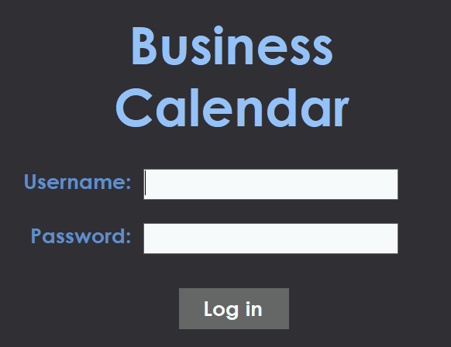

* 1. The system shall validate the user’s login credentials.
     1. If the credentials are validated with an existing account, the system shall go to step 1.3.
     2. If the credentials are not validated, the system shall display an error and return to the previous screen in step 1.1.

* 1. The system shall log the employee in and display their personal calendar.

1. The system shall allow an employee to log out of the calendar.
   1. The employee shall select the logout button from the month menu.

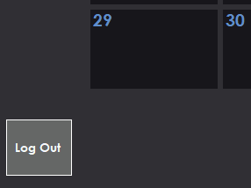

* 1. The system shall prompt the user asking them if they are sure they wish to log out.

* + 1. If yes, Then the system shall log the employee out and return to the login screen from step 1.1.
    2. If no, then the prompt will disappear, and the user will not be logged out.

1. The system shall allow an employee to view a monthly-based event list.
   1. Upon logging in, the system shall display the monthly calendar for the specific month, along with buttons to view future or past months.

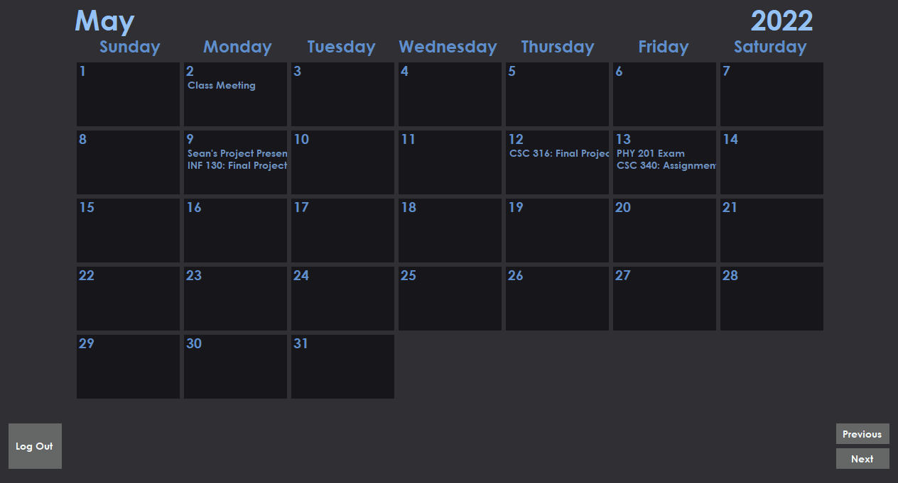

* + 1. If the “Next” button is selected, the next month will be shown.



* + 1. If the “Previous” button is selected, the previous month will be shown.



1. The system shall allow an employee to add an event to the calendar.
   1. The employee shall select the day that they wish to add an event to.
   2. The system shall display a popup for adding events with the date automatically inserted.

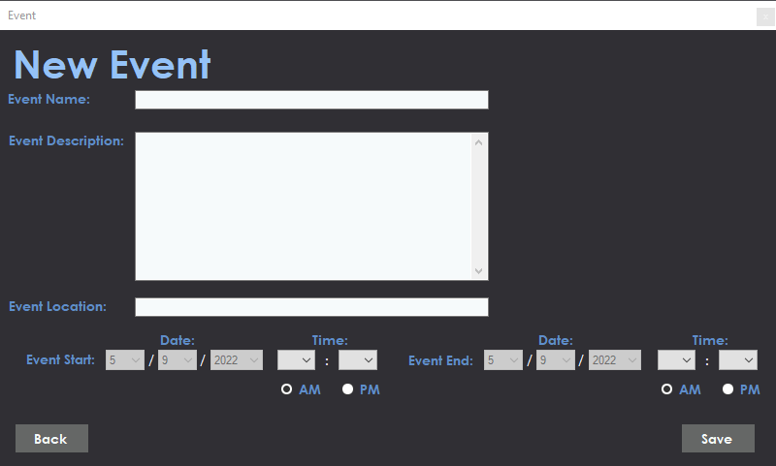

* 1. The employee shall input the title of the event they wish to add.
  2. The employee shall input the time that this event will occur or simply select the “all-day” checkbox for events that last all day.
  3. The employee can choose to add an event location.
  4. The employee can choose to add an event description.

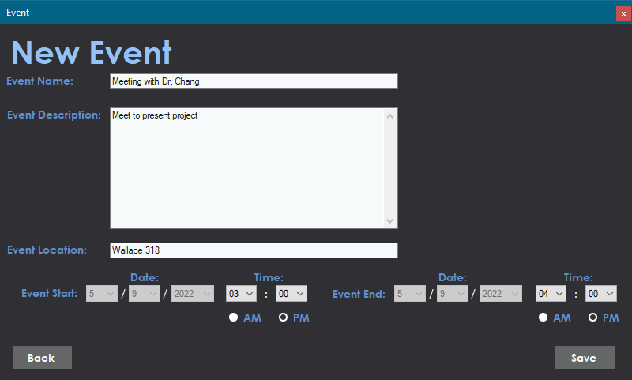

* 1. The employee shall select the save event button.
     1. If the event conflicts with other calendar events, the system shall display a warning with a cancel and proceed button.

* + - 1. If the employee selects cancel, the system shall delete the event that the employee just attempted to create and proceed to the next step.
      2. If the employee selects proceed, the event will be created and displayed normally, and the system shall proceed to the next step.
  1. The system shall remove the popup and add the event to the calendar

1. The system shall allow an employee to view an event on the calendar.
   1. The employee shall select the day that displays an event on it from the month menu.
   2. The system shall prompt the employee to select a specific event from that day.
   3. The system shall show the employee details of that event.



* 1. Once satisfied, the employee shall select the return button.
  2. The system shall return to the month menu.

1. The system shall allow an employee to delete an event from the calendar.
   1. While selecting an event, The employee shall select the “Delete Event” button on the event menu.

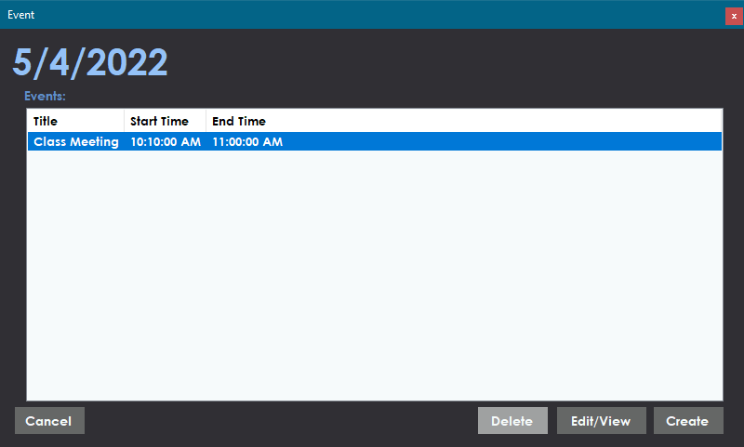

* 1. The system will then display a warning informing the employee they are deleting an event

* + 1. If the employee selects yes, the system shall delete the event that the employee just attempted to create and proceed to the next step and the system shall return to the month menu.
    2. If the employee selects no, the event will not be deleted and the system shall return to the event menu.

1. The system shall allow an employee to edit an event on the calendar.
   1. While viewing an event, The employee shall select the “Edit Event” button on the view event menu.



* 1. The system shall provide the employee with a screen that allows them to select the event name, time, location, and description.

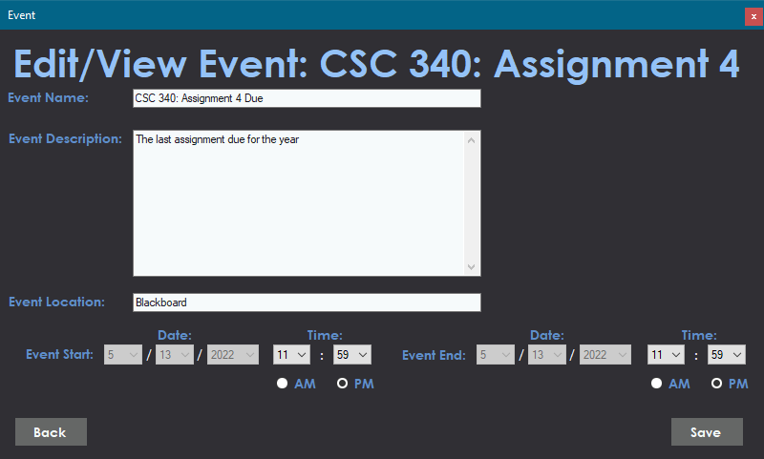

* + 1. If the employee selects the event name, they can input a new name for the event.
    2. If the employee selects the event time, they can alter the beginning and end times of the event.
    3. If the employee selects the event location, they can alter the location the event will take place or add a new one if one is not already present.
    4. If the employee selects the event description, they can alter the details of the current event.
  1. Once the employee has made all the changes they like, they shall select the save changes button.
  2. The system shall return to the month menu and apply the changes.

1. The system shall allow a manager to coordinate a meeting with their teammates.
   1. The manager shall select the day that they wish to add an event to.
   2. The system shall display a popup for adding events with the date automatically inserted.
   3. The manager shall input the title of the event they wish to add.
   4. The manager can choose to add an event location.
   5. The manager can choose to add an event description.
   6. The manager shall select the “coordinate event with team” button.



* 1. The system shall look through all employees’ calendars for available times and display these times to the manager.

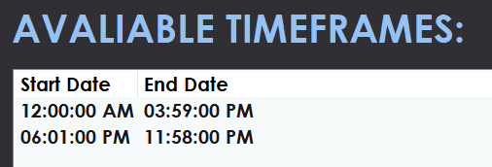

* 1. The manager shall choose one of the available times.
  2. The manager shall select the save event button.
     1. If the event conflicts with one of the manager’s own events, the system shall display a warning with a cancel and proceed button.

* + - 1. If the manager selects cancel, the system shall delete the event that the manager just attempted to create and proceed to the next step.
      2. If the manager selects proceed, the event will be created and displayed normally, and the system shall proceed to the next step.
  1. The system shall remove the popup and add the event to all the participating employees’ calendars.

## Non-functional Requirements

1. Include conflict check for two events
2. Calendar events can only be changed or deleted by the employee who created it
3. Only the manager can view the available times of other employees

# Use Case Diagram



Figure Calendar Use Case Diagram

Figure 1 provides an explanation of who can use what features of the calendar software system.

Users can log into the machine but do not have access to any other features.

Once a user logs in they become either an employee or manager based on if their login credentials delegate them as an employee or manager.

Employees gain access to almost every other feature offered by the system. These features include creating calendar events, deleting calendar events, viewing calendar events, viewing the monthly display of events, and logging out of the system.

Managers get access to all these same features however they can also manage coordinated events.

# Class Diagram



Figure Calendar Class Diagram

Figure 2 shows the entire process of the calendar software system. The single user logs into the system and becomes either an employee or manager. These two use the system to manage events for the calendar.

# Sequence Diagrams

## Log In



Figure Log In Sequence Diagram

Figure 3 provides an explanation of the simple process of logging in.

First the user inserts their username and password, which is validated by the system. Then the system checks to see if the users credentials match that of a manager. If they are, a manager class is created, if they aren’t (like in this case) an employee class is created.

## Log Out



Figure Log Out Sequence Diagram

Figure 4 provides an explanation of the simplest process of the system, logging out.

All the employee needs to do is select the log out button, which will be accompanied by a popup ensuring the employee wishes to do so (both contained in logOut()), once finished the system will log out the user and take them back to the main menu.

## Display Monthly Event List



Figure Display Monthly Event List Sequence Diagram

Figure 5 shows the process of displaying the monthly event list to the employee.

Upon logging in, the employee will be shown all the events for the current month, and if they change the day, they can be shown the events for a different month.

## Create Event



Figure Create Event Sequence Diagram

Figure 6 shows the process of creating an event

The employee will request the creation of an event through the employee class, who will in turn request the event details from the employee. Once provided, a new event is created and is added to the calendar’s event list, which is promptly displayed back to the user.

## View Event



Figure View Event Sequence Diagram

Figure 7 shows the process of viewing an event.

When the employee selects a specific date, the events for that day will be shown, and once the employee selects a specific event from that date, the calendar will display to them the event from the event list.

## Delete Event



Figure Delete Event Sequence Diagram

Figure 8 shows the process of deleting an event.

When the employee selects a specific event from that date, the calendar will display to them the event from the event list, the employee can then request for the deletion of said event. The list will be updated and the event will be removed.

## Edit Event



Figure Edit Event Sequence Diagram

Figure 9 shows the process of editing an event.

When the employee selects a specific event from that date, the calendar will display to them the event from the event list, the employee can then request for the editing of said event. The event will request details back from the user, who will provide the details. The event will be updated to reflect the changes and will in turn update the calendar’s event list.

## Manage Coordinated Event



Figure Manage Coordinated Event Sequence Diagram

Figure 10 shows the process of managing a group event.

The process of managing coordinated events is largely the same as the process of managing regular events. The main difference is that only the manager has access to the group event features.

# State Diagram



Figure Calendar State Diagram

Figure 11 shows the entire process of the calendar software system. The user can become an employee or manager based on their login credentials. The employee and manager can create events that interact with the calendar. The events can be edited and deleted as well.

# Activity Diagrams

## Log In



Figure Log In Activity Diagram

Figure 12 provides an explanation of the simple process of logging in.

First the user inserts their username and password, which is validated by the system. Then the system checks to see if the users credentials match that of a manager. If they are, a manager class is created, if they aren’t (like in this case) an employee class is created.

## Log Out



Figure Log Out Activity Diagram

Figure 13 provides an explanation of the simplest process of the system, logging out.

All the employee needs to do is select the log out button, which will be accompanied by a popup ensuring the employee wishes to do so (both contained in logOut()), once finished the system will log out the user and take them back to the main menu.

## Display Monthly Event List



Figure Display Monthly Event List Activity Diagram

Figure 14 shows the process of displaying the monthly event list to the employee.

Upon logging in, the employee will be shown all the events for the current month, and if they change the day, they can be shown the events for a different month.

## Create Event



Figure Create Event Activity Diagram

Figure 15 shows the process of creating an event

The employee will request the creation of an event through the employee class, who will in turn request the event details from the employee. Once provided, a new event is created and is added to the calendar’s event list, which is promptly displayed back to the user.

## View Event



Figure View Event Activity Diagram

Figure 16 shows the process of viewing an event.

When the employee selects a specific date, the events for that day will be shown, and once the employee selects a specific event from that date, the calendar will display to them the event from the event list.

## Delete Event



Figure Delete Event Activity Diagram

Figure 17 shows the process of deleting an event.

When the employee selects a specific event from that date, the calendar will display to them the event from the event list, the employee can then request for the deletion of said event. The list will be updated and the event will be removed.

## Edit Event



Figure Edit Event Activity Diagram

Figure 18 shows the process of editing an event.

When the employee selects a specific event from that date, the calendar will display to them the event from the event list, the employee can then request for the editing of said event. The event will request details back from the user, who will provide the details. The event will be updated to reflect the changes and will in turn update the calendar’s event list.

## Manage Coordinated Event



Figure Manage Coordinated Event Activity Diagram

Figure 19 shows the process of managing a group event.

The process of managing coordinated events is largely the same as the process of managing regular events. The main difference is that only the manager has access to the group event features.

# Database Design

## ER Diagram

Figure Calendar ER Diagram

Figure 20 shows all of the interactions between the Calendar Software System. The user can become an employee or manager based on their login credentials. The manager is a special form of employee. The employee and manager can alter events that are displayed on the calendar.

## Table Schema



Figure Calendar Table Schema

Figure 21 is relatively the same as figure 20. However, more emphasis is placed onto how these would work in a table format.

# Conclusion

The proposed calendar software system will provide its userbase with a quick, efficient, and easy-to-understand user interface that will provide not only the employees with a convenient experience but will also provide the company with an efficient event coordinator that will increase workplace productivity and lead to effective communication.

# Data Dictionary

Activity Diagram - An activity diagram is a graphical representation of the exact steps used in the process of what they represent for the Calendar system.

Actors - Actors, seen in the diagrams, are the individuals or objects that take part in the Calendar software system process.

Class Diagram - An ER diagram is a graphical representation that shows the general relationships between classes in the system with an emphasis on their variables and functions within the program.

Employee - Once a user logs in, they are officially an employee in the system.

ER Diagram - An ER diagram is a graphical representation that shows the relationship between classes in the system with an emphasis on how they would work in a database.

Sequence Diagram - A Sequence diagram is a graphical representation that shows the functions that will be used to perform a certain process in the calendar system.

State Diagram - A State diagram is a graphical representation that shows the general process of the entire system.

Table Schema - A table schema is a graphical representation that shows the relationship between classes in the system with an emphasis on how they work together as tables within a database.

Use Case Diagram - A use case diagram is a graphical representation used to illustrate the functions that the calendar system can perform, and who/what can perform them.

User - A user is any individual who interacts with the system, but has not logged in.