Interpreting the Biscuit Run
Traffic Impact Report
John Pfaltz

The "Traffic Impact Analysis Report" by Ramey Kemp &Associates for the Biscuit Run Development is a complex document looking primarily at the effect that rezoning the Biscuit Run property for higher density development might have on 32 selected intersections in both the county and the city. This was what was requested of them. Unfortunately, it is a rather indigestible document because of the necessary level of detail.

We find that it is easier to understand if we step back and try to see the larger picture of overall traffic on affected roads, and then look at the individual intersections within this context. "Traffic" is usually described in terms of "vehicles per day" (vpd) as used in this report, or "Average Daily Traffic" (ADT) as used in VDOT analyses. They are the same, and "vehicles per day" is probably the more descriptive, although we will use ADT in this analysis to conform to VDOT usage.

First, the study (p. 33) assumes 4,100 new dwelling units comprised of 930 residential, 1,700 apartment and 1,470 town home/condo units (which is only 80% of the commonly reported, e.g. Daily Progress, 5,000 units). Based on this, they expect to generate 33,576 more vehicle trips per week day. Of these, they assume that 3,204 of those trips will be within the development itself and only 30,372 will be "primary" trips (leaving the development). That is, there will be 7.40 primary trips per residential unit per day. At a MPO Technical Meeting, VDOT explained that they normally assume 10 primary trips per dwelling per day, but that internal traffic (e.g. an urban development where many might walk or bicycle to work or shops) this could be as low as 6 primary trips per day. The study estimate is near the low end of the accepted VDOT range. It seems optimistic, but we will accept it.

The report has collected current ADT, the calculated expected ADT in 2021 due to normal background growth, and expected ADT in 2021 assuming background growth and the Biscuit Run developmental seven different sites (Six sites are enumerated on p. 8, but the data is presented for a seventh site on 5th Street Extended south of I-64. Also on page 8, they say data was collected at the I-64 off ramps at 5th Street, but it is presented in the body of the report as the I-64 off ramps at Route 20. We assume that the data refers to the off ramps at Route 20.) This data is somewhat separated in the report. The current existing counts are in Figures 3.A-D (p. 9-12). (Note, these figures are labeled “Existing Peak Hour (2006) Traffic Conditions", but in addition to peak hour intersection counts, they contain vehicle per day (vpd) counts in rectangular boxes.) Figures 4.A-C (p. 19-22) display the projected (2021) counts due just to background growth, and Figures 6.A-D (p. 40-43) display projected 2021 traffic counts due to both the expected background growth and to the Biscuit Run development.

To bring these counts together, we have created Table A below. Simple subtraction yields the differential effect of background growth and the Biscuit Run development. These are tabulated in columns 4, 6 and 7. In column we have also presented VDOT's estimated ADT for 2005 where available. (These VDOT estimates are less reliable than actual counts.) The correspondence is evident, except for Rt. 53 and 5th Street where VDOT seriously underestimated the housing boom in Fluvanna County and south along Old Lynchburg Road. Since Mill Creek and nearby development are nearly built out, almost all background growth will enter the area from Fluvanna, Buckingham, and southern Albemarle counties along Routes 53 (TJ Pkwy), 20 (Scottsville Rd.) and 631 (Old Lynchburg Road). From the 4th column of Table A we have an increase of 3,313 + 3,136 + 746 = 7,195 more vehicles per day due to background growth. Using the VDOT formula of 6 to 10 trips per residence unit, this corresponds to between 1,199 to 719 new homes in the area south and east of the study area. It seems reasonable.

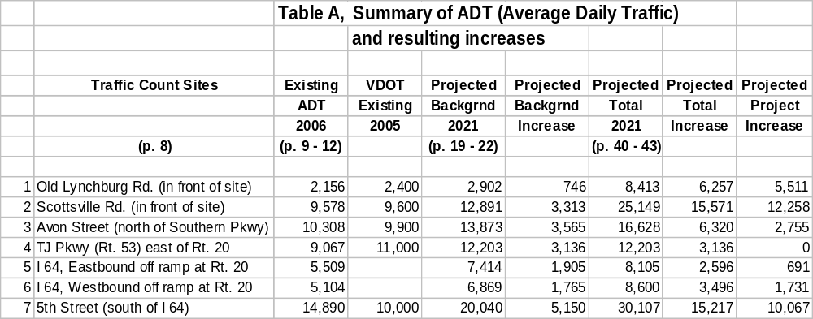

Total projected ADT (column 5) is important; but because our concern is with the rezoning of Biscuit Run for high density development, from now on we will concentrate solely on column 7 (the projected increase that would result from this development).

Further, our primary interest is in the number of vehicles that will travel north and transit the city. Of the projected 30,372 primary (external) trips, almost all will head north towards the city where virtually all area employment and shopping is. Relatively few will turn south to Esmont, Keene, or Scottsville. (Comment, not all vehicles heading towards Charlottesville will actually enter the city. Some will turn off onto I-64.) Our goal now it to project the number of vehicles using the four roads that enter the city: that is, Monticello Ave. (Rt. 20), Avon Street (Rt. 742), 5th Street Extended (Rt 631), and Old Lynchburg Road (Rt. 780). The report presents ADT for only Avon Street and 5th Street, but we can determine the other two as well.

The 30,372 vehicles must exit/enter the development on either the east (Rt. 20) or the west (Rt. 631). Since the study expects 12,258 vehicles to use the east (Rt. 20) interchange and turn north, an expected 18,114 will use one of the two Rt 631 interchanges to the west. Note: 18,114 is somewhat too high since some vehicles will travel to the south. But there is little employment or shopping in Esmont, Keene or Scottsville, so this quantity will be small---much smaller than the 3,204 internal trips assumed by the report. Nevertheless, to be optimistic we will assume that there will be only 17,000 more vehicles per day on Rt. 631 to the north of the development.

Avon Street splits off of Route 20, just north of the eastern ADT site in the report. The projected ADT increase on Avon St. is 2,755 vehicles per day, so an increase of 9,503 vpd is expected on Rt. 20 south of I-64.

To the west, the report projects an additional 10,067 vehicles per day south of I-64, so at least 6,930 more vehicles will traverse Old Lynchburg Road in the city just as a result of developing Biscuit Run. Column 1 of Table B summarizes the projected traffic increases that can be clearly inferred from the figures given in the report. The values in Column 2 we must derive. They are less reliable and may be in error.

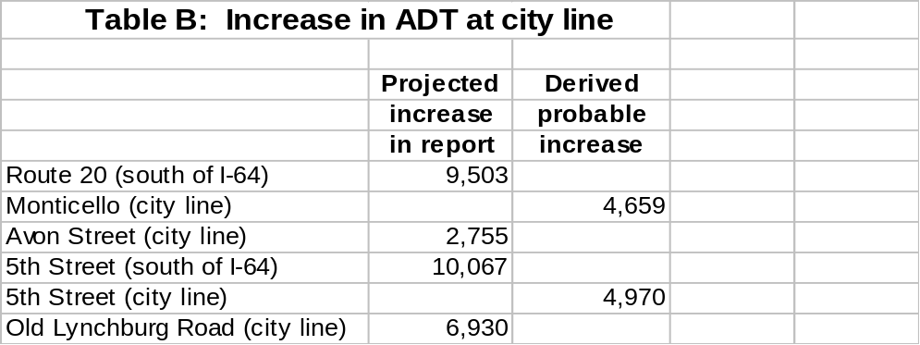

Using the projected figures presented in the report and summarized in Table A, we see that the consultants expect 2,422 additional vehicles to exit I-64 (both off ramps) at Route 20 because of the Biscuit Run development. The figure of 9,503 in column 1 of Table B represents the total increase in vehicles per day --- in both directions. Vehicles using the off ramps are presumably going to Biscuit Run, so we have (9503/2) - 2,422 = 2,329 additional vehicles coming to Biscuit Run through the city, or 4,659 additional ADT on Monticello Ave. because of Biscuit Run.

Some of the projected 10,067 vehicles added to Rt. 631 (5th Street) south of I-64 because of traffic from/to Biscuit Run will turn off on (or enter from) I-64. We examine intersections 1 and 2 in Figure 6-A (p.40). These represent turning movements in the peak AM/PM hours. We will calculate the percentage turning onto I-64 (i.e. using I-64 rather than using 5th Street in the city) and assume this percentage is representative of traffic throughout the day. At intersection 1 (west bound on and off ramps), 33.9% use I-64, and 66.1% continue straight on 5th Street. At intersection 2 (east bound on and off ramps), 25.3% use I-64. So we calculate that (.747 * .661)*10,067 = 4,970 vehicles continue 5th Street as indicated in column 2 of Table B.

With these overall roadway flows in mind, we can now examine the behavior at individual intersections. Three key intersections for northbound commuter traffic at the morning peak hour are those of 5th Street Extended with I-64, and then at 5th Street and Harris Road. The traffic entering any intersection from a specific direction can be derived by summing the numbers of left turning, straight through, and right turning traffic. In the following example we were interested to see if there was any significant change in the percentage of traffic turning off 5th Street Extended to use I-64 during the morning rush hour commute. As shown in the following table the percentages were reasonably constant. But, another curious phenomenon became evident. There can be a considerable difference between the calculated number of vehicles leaving an intersection (that is, the number entering minus those turning left or right, i.e. those continuing straight ahead plus those entering from the left and/or right) and those that arrive at the next intersection. For example, using Figure 3-A, we calculate that (590 + 243) = 833 vehicles enter intersection #2 from the south. While 243 vehicles turn east onto I-64, 349 vehicles entered from the west on I-64, so 939 vehicles traveled north across the I-64 bridge to intersection #1. But, intersection #1 shows 991 vehicles entering from the south. Where did these extra 52 vehicles come from? Is this an artifact of the counting process. Probably it is, since physical counts are always susceptible to small errors, especially when conducted over several days.
This kind of difference is more striking when we look at the combined 2021 projections for intersections #1 and #21. Here (1229 + 647) = 1876 vehicles enter intersection #1 where 647 exit westbound and 505 enter from the east on I-64, so 1,734 vehicles continue north towards the city line. But only 1,521 arrive at intersection #21 with Harris Road. What has happened to 213 vehicles? Since this is a simulation package, we would expect consistency.

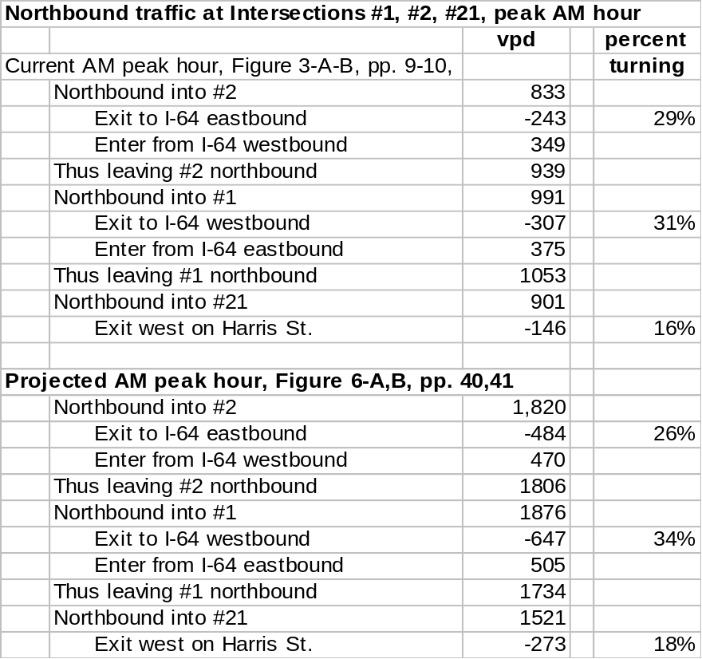.
Using the same summing technique, we calculate the total current traffic south of intersection #2. Northbound in the morning we have 833 vehicles as shown above, and southbound there are (354 + 221) = 575. In the evening rush hour, there are (447 + 204 + 2) = 651 northbound and (596 + 219) = 815 vehicles southbound. Thus, these two rush hour periods account for (833 + 575 + 653 + 815) = 2,876 (or 19.4%) of the 14,890 vehicles that were actually counted. This agrees with the traditionally accepted figure of 1/5 of all traffic occurring in the two peak rush hours. Similar calculations for the combined 2021 peak rush hours (Figure 6-A, p. 40) yield similar results, namely 2,974 (AM) + 3,036 (PM) = 6,010 / 30,107 = 19.9%. Can you visualize 3,036 vehicles using this stretch of 5th Street Extended during the evening rush hour? That is 50.6 vehicles per minute or roughly one vehicle per second.

We now turn to intersection #16 where Old Lynchburg Road intersects Mountainwood south of the city line. Projected combined rush hour traffic in 2021 (Figure 6-A, p.40) is 590 (AM) + 1,061 (PM) = 1,653 vehicles in these rush hour periods. This is 205 of 8,265 vehicles per day, which is somewhat lower than my minimum value of (6,930 + 2,600) = 9,530 vpd obtained by just adding the Biscuit Run component to VDOT’s 2005 AADT estimate of 2,600. (It ignores background growth.) There is an inconsistency here, and I suspect RK&A’s figure, since they expect only 593 vehicles to use this segment in the morning, but 1,061 vehicles in the evening. This is suspicious.

