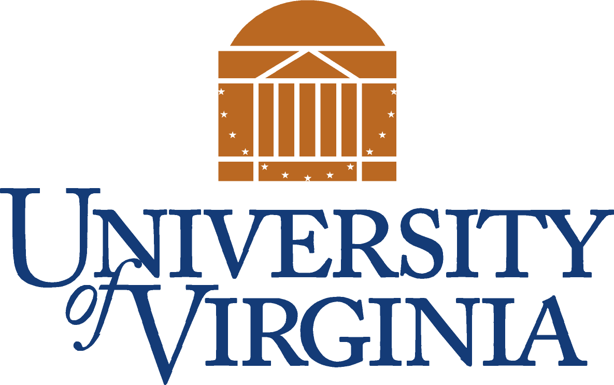
Community Relations Office
“Linking the University to the Community”

Neighborhoods Advisory Group Meeting
Wednesday, April 12, 2006
Noon
Arena Trailer Conference Room

Agenda

Welcome/Announcements
Jim Fitzgerald/Ida Lee Wootten
U.Va. Community Relations

Reports

Update on John Paul Jones Arena
Dick Laurance
Arena Project Director

Events at John Paul Jones Arena
Larry Wilson
General Manager

Grounds Maintenance at U.Va.
Rich Hopkins
Landscape Division Superintendent

Major Project Updates
David Neuman
Architect for the University

