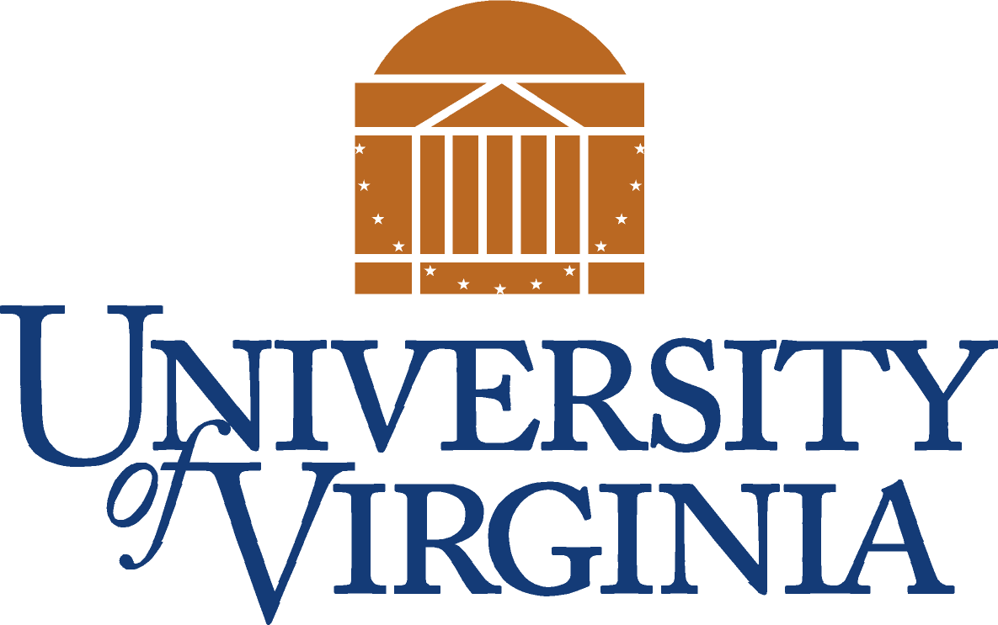
Community Relations Office
“Linking the University to the Community”

Upcoming Neighborhood Meetings With U.Va. Reps

Venable Neighborhood Community Meeting
Wednesday, Feb. 8, 2006
7 p.m.
Gordon Avenue Library
Lower Level Conference Room
"Update on the John Paul Jones Arena"
Dick Laurance, Arena Project Director
"Update on the Arts Precinct/Plans for Arts Grounds Parking Garage"
David Neuman, Architect for the University
~~~~
Jefferson Park Avenue Neighborhood Association Meeting
Thursday, Feb. 16, 2006
7 p.m.
Room 1006, McLeod Hall
202 15th Street, SW
Free parking available in the McLeod Hall Garage
"Update on the South Lawn Project"
David Neuman, Architect for the University
~~~~
10th and Page Neighborhood Meeting
Tuesday, June 27, 2006
6 p.m.
Region 10, 800 Preston Avenue
"Update on the Medical Center Expansion"
David Neuman, Architect for the University

