# Taken from here

[Create a 6dof IMU with a gyro and accelerometer for (Arduino) multicopters. (brokking.net)](http://www.brokking.net/imu.html)

Great explanation here

<https://lastminuteengineers.com/mpu6050-accel-gyro-arduino-tutorial/>

# Axis Explained

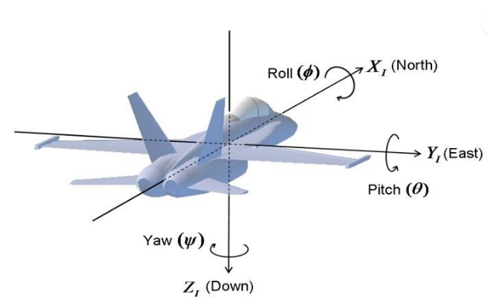

Acc in Z:

1. From flat:
   1. Steady state, 1 m/s2
   2. Rotate CCW + m/s2
   3. Rotate CW – m/s2
   4. Raise up + m/s2
   5. Drop – m/s2
2. Tilt in X
   1. Any direction, 0 m/s2 at 90Degrees
   2. Goes to -1 m/s2 when inverted
3. Tilt in Y
   1. Any direction, 0 m/s2 at 90Degrees
   2. Goes to -1 m/s2 when inverted

Acc in X:

1. From flat, Steady state, 0 m/s2
2. Tilt in X
   1. Arrow down, at 90d -0.98 m/s2
   2. Arrow up, at 90d +0.98 m/s2
   3. Back to 0 when inverted
3. Tilt in Y, no response
4. Move horiz in x (follow arrow), + m/s2

# Basics

Gyroscope sensitivity

Angular velocity LSB/(degree/second) Note, 16bit

+/- 250 d/s 131

+/- 500 d/s 65.5

+/- 1000 d/s 32.8

+/- 2000 d/s 16.4

## Example to get degrees from degrees/second

So if Zaxis constantly rotating for +/-500 d/s, at 6d/s we get 393

Then angleDegreesPerSecond = rawGyro/65.5

Take this 393 and multiply by 60

393x60 = 23580

So 23580/65.5 = 360 ie in 1 minute the gyro will rotate 360d (6d/second)

If we sample this at say 250Hz (0.25ms), and add to previous value we can end up with degrees/angle

250Hz = 0.25ms

By ZaxisRaw / 250 / 65.5

= ZaxisRaw * 0.0000611

So

Angle_pitch += rawGyroX * 0.0000611;

Angle_roll += rawGyroY * 0.0000611;

Problem with the above

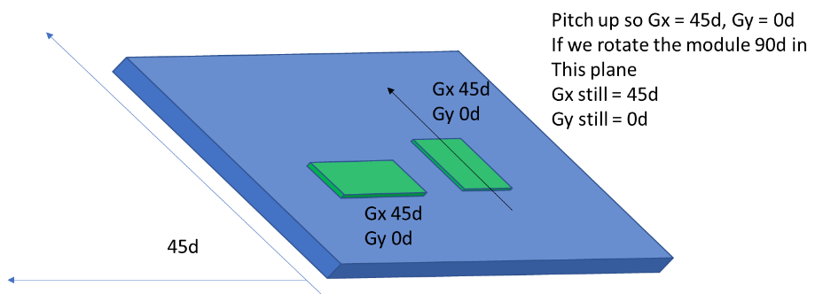

To fix this we can combine both axis:

Gy -= Gx * sin(RawGyroZ * 0.0000166 * (3.142 / 180) > need to convert to radians

Gx += Gy * sin(RawGyroZ * 0.0000166 * (3.142 / 180)

## Compensating for drift