Roles

Hackers
- Tech
  - Specialized in exploiting systems
    - Has improved hacking skills
- Thug
  - Specialized in aggressive encounters and exploring
    - Has basic weapons
- Engineer
  - Specialized in tools for creating new exploits
    - Has different electronics that can be placed
IT staff
- Tech
  - Specialized in preventing attacks
    - Has improved anti hack skills
- Guard
  - Specialized in aggressive encounters and exploring
    - Has basic weapons
- Pentester
  - Specialized in finding exploits
    - Has the ability to find exploits before they are exploited

Map Examples
-------------------------------------------------------------IT BASE---------------------------------------------------------------
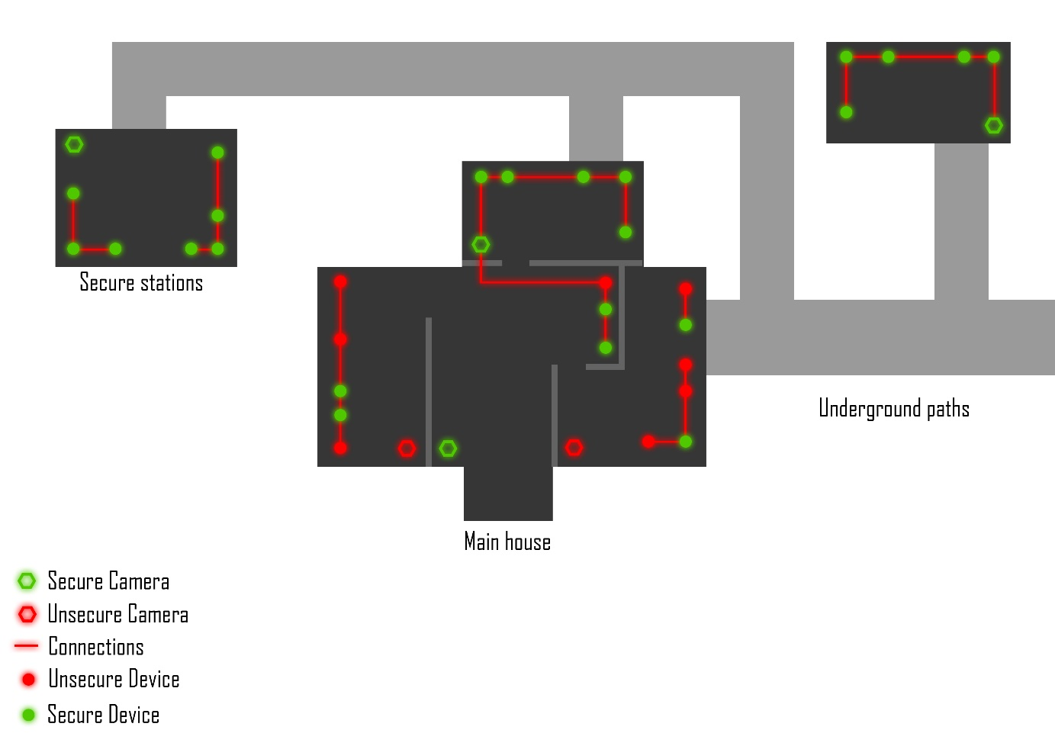 ------------------------------------------------------------FULL MAP-------------------------------------------------------------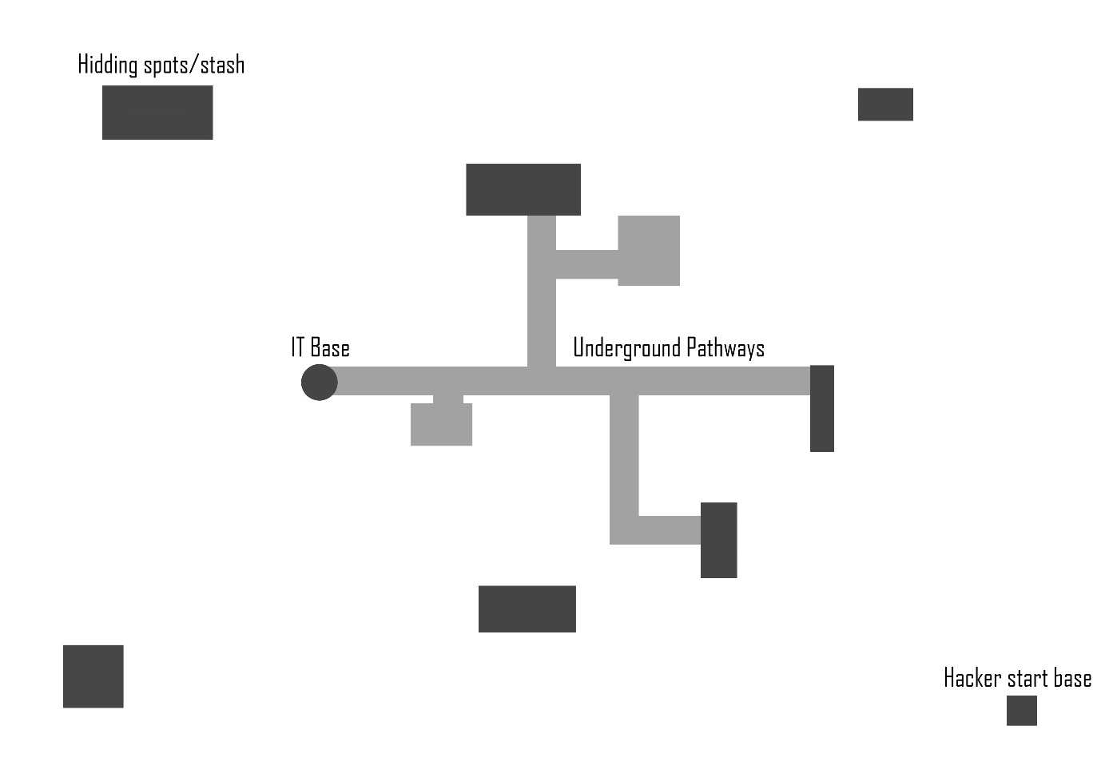

Gameplay

Hackers
Hack valuable resources in the IT base.
All roles can hack, but tech have increased hacking skills.
Thug have improved combat skills, such as improved stamina, basic weapons and taser to knock out enemies.
Engineers can use different electronics to exploit secure devices or explore hidden areas with wireless camera devices.

IT
Defend valuable resources in the IT base.
All roles can defend from hacks, but tech have increased mechanics to prevent attacks.
Guards have improved combat skills, such as improved stamina, basic weapons and taser to knock out enemies.
Pentesters are able to test systems and find exploits before they are exploited.

Honey pots
Both teams can create honey pots. These works as decoys.
Hackers can create fake threats that looks like real hacks to misleads IT of where attacks are coming from.
IT can setup unsecure devices that are worthless to hack to delay hackers.
IT can setup traps that will alert them of things like the position of the hacker that hacked the device. Guards can then try to find their location and therefore hackers have to find new locations to hide in.
Both teams can create executable programs on some devices that could be useful in different scenarios.
Hacks
Hackers can scan different networks on the map, they can with this technique find valuable, unsecure and potentially interesting devices.
Hackers can keep crawling through a network of connected devices when they’ve exploited a device, they can with this technique open new unsecure devices, this also means that IT can shutdown paths to specific networks completely if they manage to secure all devices on the network. Hackers are however still able to exploit these devices through engineering tools or invading, this is riskier for hackers though since they have to get close to the IT base to use these features.
IT have cameras in their IT base that can be unsecure and therefore hacked. This means that hackers can find valuable position information of IT staff but also shutdown cameras to cut off important information for IT.
Devices may have interesting programs that could help both teams get important information. These features may be dangerous to execute though since someone on either team may have tampered or created the program.

