1501 Quantitative Lab Troubleshooting

* **Quitting the Kernel:** If Mathematica is non-responsive or if you would like to clear all stored variables and definitions, you may quit the kernel. This action quits the current evaluation session and requires all input to be executed again, just as you would if you opened a new notebook. As a shortcut, you may execute the command *Quit* in any input cell to quit the current kernel.

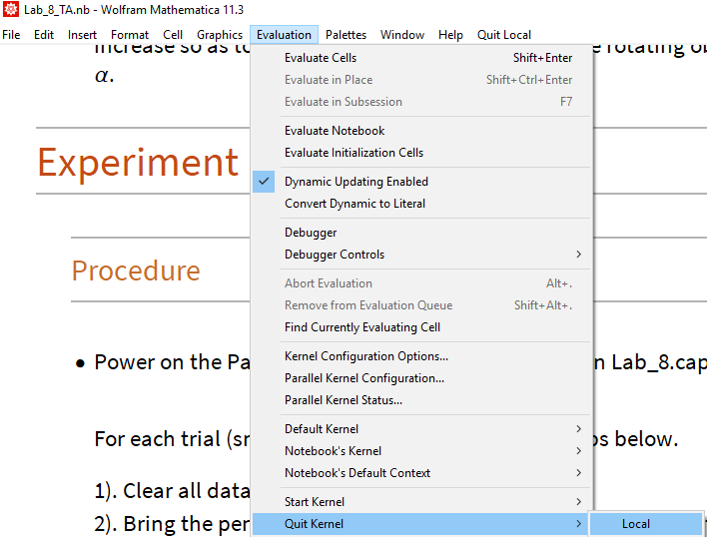

* **Dynamic Updating**: In order for Manipulate to function correctly, the Mathematica notebook must be set to allow “Dynamic Updating”.

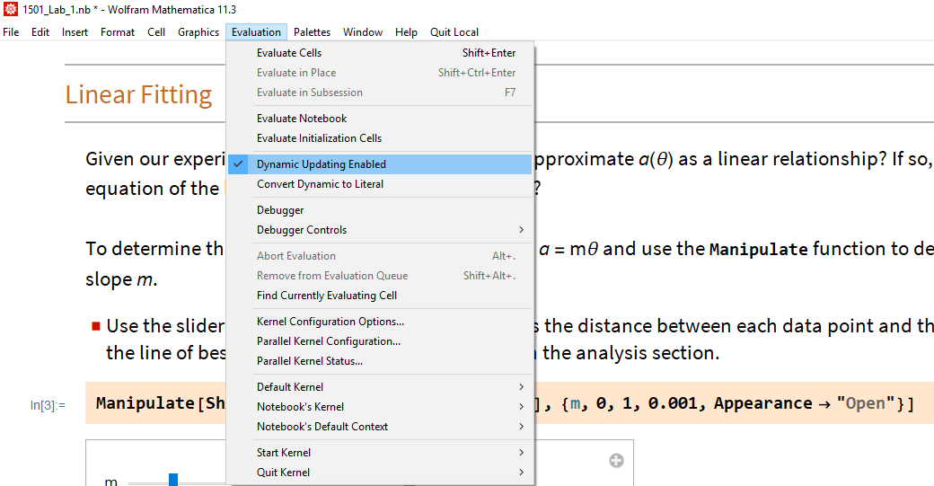

Notebooks are set to update dynamically as default, but if you see a gray box output when evaluating a manipulate function, such as the image below, try enabling dynamic updating.

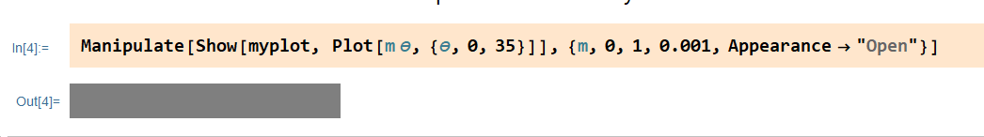

* **Cell > Editable**: Cells that students are not expected to edit are by default set to non-editable. There may be circumstances that make sense for a TA to edit the underlying code.

Select cell *> Cell > Cell Properties > Editable*

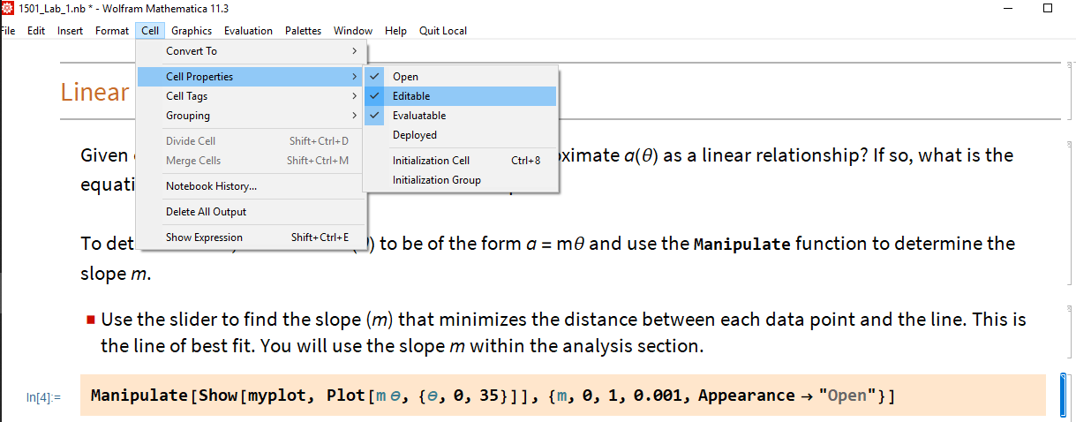

Keep in mind that you may always copy the contents of a cell into a new cell, and evaluate the new cell, without having to adjust any editable settings. (To access advanced cell properties, select the cell and use “Ctrl” + “Shift” + “O”. Under Cell Options > General Properties we can find more advanced cell settings such as deletable and copyable).

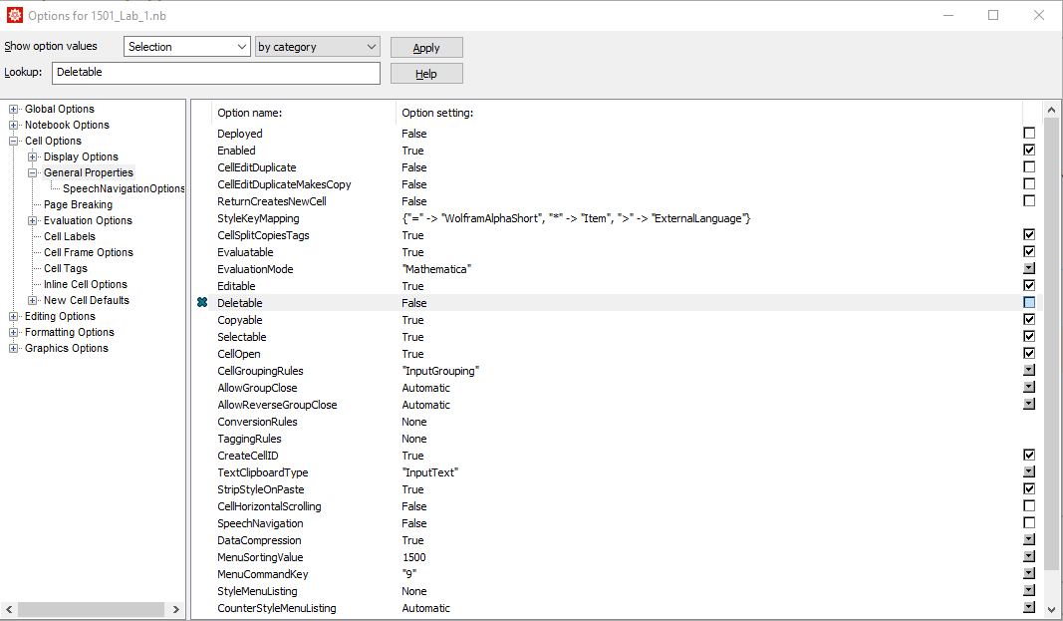

* **Smart Cart Bluetooth**: If a PASCO Smart Cart is not pairing appropriately, try the following

1. Turn the Smart Cart off. Restart Capstone.
2. Restart computer.