Ryan Louvien (Rva123)
Phelps Williams (pww36)
12-Feb-2008
CS569 Assignment 1 Written Part
1. Warm Up:
The projection of w onto the function o + td equals the following:
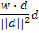
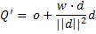
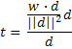
2. Tangent space:
i)
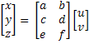
With two known points and texture coordinates, relative to P₀ it is possible to solve matrix M. Where M is composed of the Tangent (T) and Binormal(B) vectors.
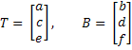

Relative to P₀ we can write equations relating the relative positions of P₁ and P₂ to the relative positions of texture coordinates uv₁ and uv₂.
We now have a linear function which maps uv texture coordinates to points on the triangle relative to position P₀.

ii) With the work from part i, we can now solve for equations of T and B, the Tangent and Binormal vectors respectively.
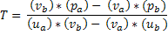
Or expanded as:
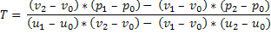
Similarly B in expanded form:
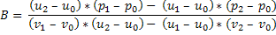
Because T, B and the Normal vector N should be a coordinate system base, we can calculate N by the cross product of T and B:
Using Gram-Schmidt Orthogonalization it is possible to ensure these vectors are orthogonal.
References:
http://jerome.jouvie.free.fr/OpenGl/Lessons/Lesson8.php
http://www.blacksmith-studios.dk/projects/downloads/tangent_matrix_derivation.php

