PHENIX Muon Spectrometer Analysis Software

Introduction

- Architecture
- Source Tree Organization
- Build Instructions
- Documentation Generation

Core Infrastructure

- Containers
- Object Association
- Persistence Model

Muon Identifier Software

- Overview
- Interface Objects
- Analysis Modules
- Simulation & Evaluation
- Plane Efficiency Calculation

Muon Tracker Software

- Overview
- Interface Objects
- Low Level Modules
- Pattern Recognition Modules
- Momentum & Vertex Reconstruction
- Simulation & Evaluation

Event Loop Super-Modules

- Overview
- Unpackers
- Analysis
- Evaluation
- Ntuple Generation

Introduction

Architecture

The first stage in the re-engineering of the analysis software for the PHENIX muon spectrometer was the enumeration of a set of Interface Objects (IO) representing the output of a particular stage of the analysis. These objects represent boundaries between well -defined tasks in the analysis chain, for example the TMutHit interface object represents calibrated and un-calibrated charge data for active cathode strips in the MUTR. The motivation for defining such a set of objects a-priori was to impose a level of modularity in the analysis software. Well-defined analysis tasks conform to well defined input and output interfaces. By design interface objects are ROOT streamable and can therefore be made persistent via the PHENIX standard PHOOL interface to ROOT object persistence technology.
A fair amount of design effort was put into the management of collections of interface objects. The resulting Interface Object Containers (IOC) provide safe and efficient access to subsets of IOs associated with a particular detector subsection. IOCs model the ordered associative container concept from the C++ standard library. The containers for particular IOs are a thin class around the core IOC implementation in PHMap. The thin wrapper provides the mapping from detector subsets (represented by a tuple of finite interval integers) to keys and thus determines how objects are ordered in the container. In addition the wrapper provides a set of overloaded get methods for accessing ordered subsets that correspond to detector subsets. Access to ordered ranges is managed by Bounded Iterators. Bounded iterators have range of validity and provide methods for traversing this range.
Since all of the IOs in the new muon framework have a unique key it was relatively straightforward to implement object associations based on maintaining parallel lists of keys. The relational database approach was dictated by the requirement that object associations survive the persistence cycle. The key matching required to actually provide access to associated objects is hidden by an Associated Object Iterator interface that has semantics that are identical to the iterator interface for direct containers access.
Analysis Modules execute core analysis task. Communication between analysis modules is strictly through the aforementioned set of interface objects. Each is analysis modules has a Analysis Module Interface (AMI) specification that indicates which interface objects the analysis module interacts with and whether the module modifies a particular interface object. The AMI for each analysis module is published in the online documentation.
The final layer in the architecture is provided by the Subsysreco interface that is part of the fun4all framework developed by Chris Pinkenburg. Groups of analysis modules chained together to accomplish a particular analysis task are encapsulated in Subsysreco modules (also called “super-modules”). In addition to providing encapsulation for collections of analysis modules there are dedicated supermodules for ntuple generation, trigger filtering etc.

Source Tree Organization

The “muon new framework” consists of three distinct cvs packages enumerated below:

offline/packages/mutoo MUTR analysis code
offline/packages/muioo MUID analysis code
offline/packages/mutoo_subsysreco MUID & MUTR analysis super modules

The source code in the latter two packages is in flat directories (i.e. no sub-directories) whereas in mutoo the build-able source code is organized in the directory structure enumerated below.

mutoo/interface Interface object and containers
mutoo/classes Core infrastructure and utility classes
mutoo/modules Analysis modules
mutoo/display Event display classes

Build instructions

All of the above packages are build-able via the standard PHENIX build procedure.

cvs co –d muioo offline/packages/muioo
mkdir muioo_b
cd muioo_b
../muioo/autogen.sh –-prefix=[your install area]
make
make install
The fact that mutoo has subdirectories is handled by the automake files and is transparent to the user. The easiest way to build mutoo, muioo & mutoo_subsysreco packages is to checkout mutoo first and use the setup_dirs.prl script to checkout & autogen the other relevant packages. Using the script has the added advantage of ensuring you and fellow script using developers have identical & correct build setups thus making library snafus less common. Upon executing the mutoo/setup_dirs.prl script one will have the following directory setup.

mutoo mutoo source
muioo muioo source
mutoo_subsysreco mutoo_subsysreco source
mutoo_b mutoo build area
muioo_b muioo build area
mutoo_subsysreco_b mutoo_subsysreco build area
preco_s preco source
preco_b preco build area
mutoo_i common install area
For historical reasons (MutooReco.C & MuiooReco.C) the two main run 3 analysis supermodules are part of the preco packages hence this packages is also part of the standard suite of packages. Note: Until the above super-modules are removed from the preco package it is necessary to build preco whenever module parameter tables (inlined) are modified.

Automatic Documentation Generation

Both mutoo and muioo analysis packages use the freeware documentation Doxygen. Doxygen generates html format hyperlinked documentation from the source tree and a configuration file. Doxygen works by scanning source files and parsing in-code documentation that is marked using Doxgyen specified tags. The default behavior for mutoo & muioo is for Doxygen to generate documentation only for the public or interface segments classes. Private or protected methods are documented internally using standard C++ comments and are not part of the public interface or documentation.
Detailed user documentation for Doxygen are available on the web at www.doxygen.org. Basic tags for the documentation of public methods are

//! [comments] - brief description
/*! [comments] */ - full description

The token “[comments]” should be replaced by the actual description. The two configuration files for mutoo and muioo are listed below. Typing “doxygen Doxyfile_mutoo” runs the documentation generation.

mutoo/docs/Doxyfile_mutoo
muioo/docs/Doxyfile_muioo

Core Infrastructure

Interface Objects

Interface objects serve a dual role in as much as they are used to communicate data between various stages of the analysis in addition being the format for persistent storage of analysis primitives in the DSTs (data summary tapes). Analysis modules are analogous to factories that interact and modify collections of interface objects. The complete set of interface objects used in by the mutoo and muioo packages is published in the online documentation. The basic requirements on interface objects are that they be ROOT streamable and that they have separate interface (abstract base class) and implementation classes. The latter requirement is a tacit acknowledgement that interfaces tend to evolve with time. The use of state-less interface classes in manipulating interface objects enables user code to accommodate input from persistent objects with different implementations.

Implementing Scheme Change:

A scheme change is non-trivial change in the data member set of an interface object. Interface objects separate interface from implementation by the use off an abstract base class (no data members and only virtual functions). The use of an abstract interface and a hidden implementation class with a version tag in the class name admits the possibility that one can change the data member set of an implementation class and still read back older versions of the interface object from the DSTs. The steps necessary to implement a scheme change are enumerated below.

- Modify the abstract base class. That is, add or remove the appropriate get/set functions to accommodate the change in data member set. Remember all member functions should be public and virtual.

- Write a new versioned class that implements the interface defined by the base class (use standard issue public inheritance to pick up the interface class) A common error at this stage is to mis-type the signature you are trying to implement. Polymorphism relies on an exact match between method signatures in the virtual base class and the implementation class. The signature includes argument types and const level. The implementation class must be constructable from a pointer or reference to the abstract base. See any of the classes in mutoo/interface for an example of how to implement these constructors.

Modify the interface object container (e.g. TMutHitMap.h) to use the new version of the implementation class. This is done once in the header when you modify the template parameter passed to the PHMap. The PHMap class defines a name value_imp_type that is used in the insert_new method in the map implementation. The only place the actual implementation type is used is instantiating a new object all other manipulations are done via the base class.

Containers

The PHMap signature shown below indicates some of the key features of the core container used to implement all the muioo/mutoo IOCs. Specifically the seperation between interface and implementation in each of the interface objects is accommodated by passing Value and ValueImp as template parameters. The only place it is necessary to manipulate the implementation type is in implementing the insert_new method of the associated IOC. Memory management of interface objects is handled by heap allocating new instances of interface objects and reference counting the pointers used to hold and manipulate the object. This is actually implemented using the shared_ptr template from the BOOST library. All IOCs use the standard SL trick of embedding typedefs to insulate the user from the use of explicit template parameters. Specifically the value_type of IOCs is always a boost::shared_ptr to the interface object. It follows that the pointer typdef is a pointer to a shared pointer. Also of note is the fact that all containers define const and non-const pointer and reference types. These definitions are used in the provided const and non-const iterator interfaces.
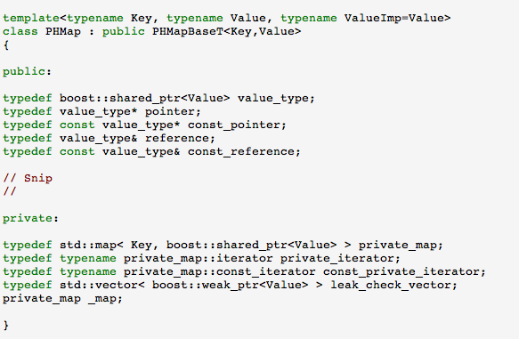

Bounded Iterators

The iterators provided for standard library containers are ignorant of their domain of validity. As is shown in the example below a std::map iterator is initialized by querying the continer. It us up to the user to check the below iterator agains my_map.end() before attempting to use said iterator.

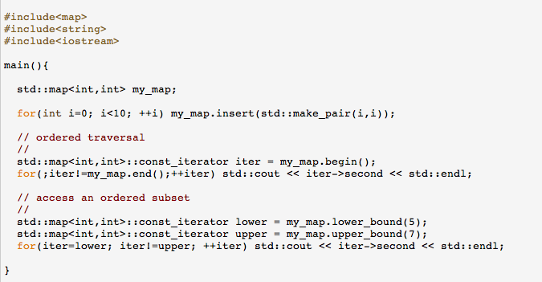

The iterator interface to IOCs borrows and idea from ROOT in that it uses bounded iterators. Bounded iterators are objects that are cognizant of their domain of validity. Upon initialization a bounded iterator points to the beginning of the valid range. Methods to advance the iterator to the end of its valid range are provided as part of the iterator interface. Specifically IOC iterators provide a current and next method that return a pointer to the current value_type. In addition the next method advanceds the iterator. If the iterator is outside of its valid range both methods return a null pointer. This design allows for the syntactically concise and safe traversal of an iterators valid range shown in the example below.

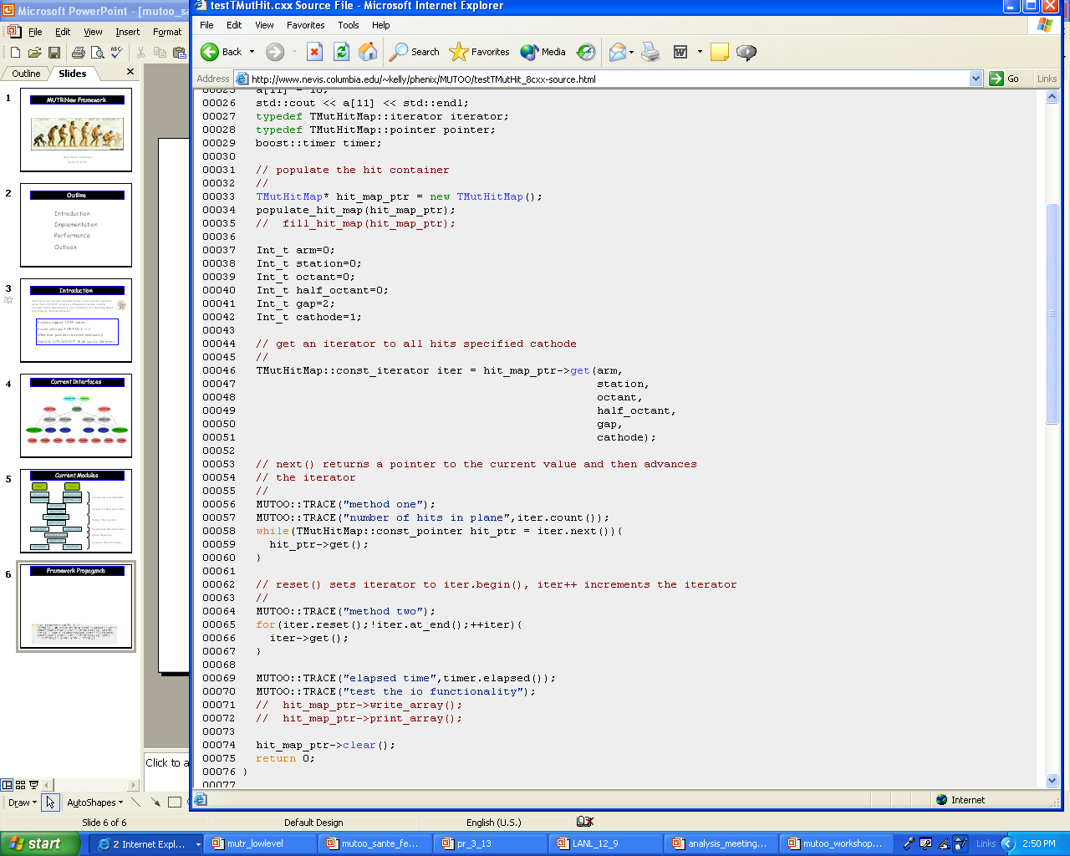

The IOC iterators are implemented in the classes PHMapIterator and PHConstMapIterator.

Object Association

The problem of associating objects, e.g. clusters with hits is typically solved using a relational database approach. That is objects are keyed and associations are made by storing lists of keys. This idea depicted in the below diagram.

Hit IOC Container
key hit
= 123
cluster
hit key list = 123,124
hit
key = 124
hit
key = 125
Cluster IOC

Container

Much of the inconvenience associated with maintaining and accessing key lists is amortized by the use of key iterators. The block of code below demonstrates the use of key iterators and the template function get_associated. If there are no associated objects of the requested type the get_associated call returns an iterator with an empty range

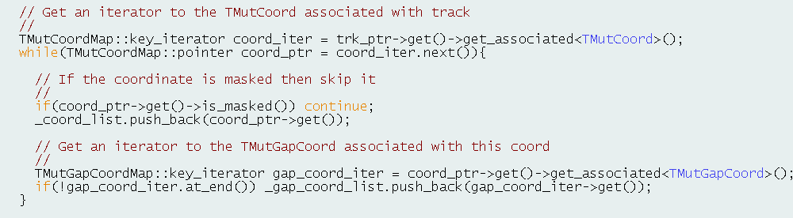

Associations are established using the statically scoped function PHKey::associate as is shown in the example below.

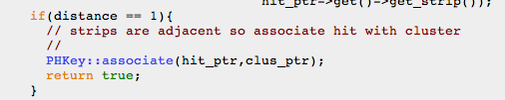

PHKey also provides statically scoped associate_unique and disassociate member functions. All object associations are reflexive i.e. bi-directional.

Object Association Details

In order to provide automatic key lookup all the IOCs must themselves be keyed and look locating a container by key must be implemented in a globally available way. This is accomplished by keying IOCs with a globally unique identifier and implementing a statically class to manage IOCs. The manager class is called PHMapManager. When IOCs are instantiated they are automatically assigned an globally unique identifier and they register themselves with PHMapManager. Since IOCs are of different types (instances of template classes with different template parameters correspond to different types) PHMapManager employs a std::map from key to boost::any. The any construct from BOOST provides a typesafe way to implement non-homogeneous containers.
Efficiency considerations in the implementation of object associations motivated the development of a pointer based caching scheme. The master list is only used for key lookup when reading back objects from the DST for the first time otherwise the pointer cache is used. Populating the cache from the master key list is lazy evaluated upon first request for associations of a particular type. The caching scheme also makes use of boost::any as is indicated in the paraphrased interface below.

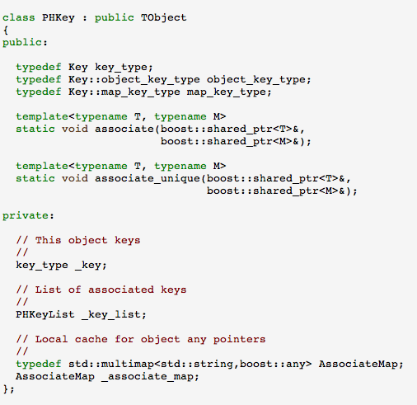

Muon Identifier Software

Muon Identifier Software

Overview

Interface Objects

Analysis Modules

Simulation & Evaluation

The application of finite efficiency effects in the MUID is managed by the class TMuiHVMask. Upon initialization class opens and reads an tube efficiency file with white space delimited format “arm plane orientation twopack efficiency”, all tokens are unsigned integers except the last which is a float. TMuiHVMask is a static class, ie manifest the singleton pattern. The configuration of TMuiHVMask is handled via static methods. The code fragment below demonstrates how to enable and initialize the class.

TMuiHVMask::set_disabled(false);
TMuiHVMask::set_filename_north("north.txt");
TMuiHVMask::set_filename_south("south.txt");

Initialization occurs upon first use and the class has a dictionary and is therefore available at the macro level.

Plane Efficiency Calibration

The plane efficiency calibration has been implemented in the super-module MuidEffic.cxx. The macro implementation was ported and runs in the fun4all framework. There are two steering macros GenMuidEffic.C and ReflexiveMuidEffic.C, that are under cvs control in mutoo/macros. The former reformats the text file generated by the analysis to be in the form used by the masking software, the latter runs the reflexive test used to check the analysis. In addition there is perl script that applies the overlap correction in mutoo/tools called MuidEfficOverlapCorrect.prl. Although the analysis code has been ported to the super-module the actual files were generated by JN using the now ported macro implementation. There is a little work to be done to handle the run/event averaging in code in MuidEffic.

Muon Tracker Software

Overview

The ultimate goal of the MUTR analysis software is the characterization of charged tracks in the muon spectrometer via their momentum at their primary vertex. Signals from the MUID detector can either be used to seed the reconstruction in the MUTR or can be associated after the fact. Muon candidates consist of the combination of a MUTR track and a MUID road. The Muon Tracker Analysis software modules can be grouped into four general categories: low level modules for generating coordinates from raw detector signals, pattern recognition or the association of coordinates with track candidates, momentum and vertex reconstruction, and simulation and evaluation modules.

Interface Objects

The set of interface objects used by muon tracker analysis modules is enumerated below with a brief description of the purpose. Complete documentation is available in the web docs.

Analysis Interface Objects

- TMutHit calibrated & uncalibrated cathode hit information
- TMutClus contiguous groups of active cathodes
- TMutCoord directed line segments representing a fit to cathode clusters
- TMutGapCoord spacepoint formed from two TMutCoord w/common gap
- TMutStub linear tracklet made from hits in single station
- TMutTrk muon track track
- TMutVtx di-muon object

Monte-Carlo Interface Objects

- TMCPrimary parent monte-carlo particle
- TMutMCTrk monte-carlo track object
- TMutMCHit monte-carlo hit object
- TMutEval evaluation object

Low Level Modules

Analysis Modules: mMutUnpack, mMutCalibrate, mMutFindClus,
mMutFitClus, mMutFindGapCoord

Pattern Recognition

Analysis Modules: mMutFindTrack, mMutBPFit, mMutStubFit,
mMutRejectTrack

Classes: TMutStubFinder

The analysis module in which the bulk of the pattern recognition software is implemented is mMutFindTrack. This module calls various other modules, the precise set of which is determined by the choice of run-time parameters. The execution path described below assumes the runtime parameter set associated with high multiplicity Au+Au running.

Step 1: Seed Tracks from MUID

Description: Reconstructed roads in the MUID are used to define windows in station three of the MUTR. Stubs that fall within these windows are used to define track seeds. A stub is a track segment in a given station and is represented by the interface object TMutStub. The stubs are identified by the stub finder algorithm, which is encapsulated in a class TMutStubFinder. The stub finder algorithm maintains an internal representation of stub objects in a std::list. The internal list is read and TMutStub interface objects are instantiated upon completion of the algorithms execution.
The code is designed such that there is a maximum of one track associated with each found station three stub. The possibility that multiple MUID roads are within the proximity window is handled by allowing track seeds to associate multiple MUID roads. Disambiguating which MUID road is the correct one is deferred until a later stage in the analysis when the full information from the reconstruction track can be brought to bear.

Method: mMutFindTrack::start_tracks_muid

Pseudo-code:
Find all station 3 stubs
Loop over station 3 stubs
Loop over MUID roads
If passes proximity cut
If first

Create TMutStub, TMutTrk & associate TMuiRoadO
Else
Associated TMutTrk and TMuiRoadO
Endif
Endif
End Loop MUID roads
End Loop station 3 stubs

Step 2: Fit Stubs

Method: mMutStubFit::event

Description: Upon completion of the first step of the pattern recognition track candidates consist of a TMutTrk that associates as single station three TMutStub and one or more TMuiRoadO. The stub finder algorithm executes a simple linear fit to gap coordinates if the number of accumulated coordinates in the stub finder is sufficient to constrain the fit. The module mMutStubFit executes the full fit to projections using a linear track model and GSL based minimization and includes proper error propagation and coordinate weighting. Since upstream windows are defined by the partially formed track it is necessary execute the full stub fit in between step one and step three of the pattern recognition.

Note: The fit algorithm in TMutStubFinder could be modified to include the sophistications used in the full stub fit. This would have positive performance benefits as the GSL non-linear minimization machinery has been shown to be quite slow

Step 3: Find and Associate Stubs in Station Two

Description: Track candidates are used to define search windows in station two of the MUTR. The stub finder algorithm is run in windowed mode for each track candidate.
The structure of the code is such that the list of stubs produced contains no duplicates and each stub in the master list passes a set of minimal quality cuts. Subsequently the code loops over the list of found stubs and attempts to associate each stub with a track candidate. Instances in which two or more stub can associate with a given track candidate are handled by cloning the track and creating a unique TMutTrk, TMutStub association for each stub track match.

Method: mMutFindTrack::find_in_station()

Pseudo-code:
Loop over track candidates
Find stubs in search window defined by track
Loop over stub list
If first stub in station
Associate TMutStub & TMutTrk
Else
Clone Track and associate TMutStub
Endif
End Loop over stub list
End Loop over track candidates

Step 5: Fit Stubs and Execute 2 Station Bend Plane Fit

Method: mMutStubFit::event, mMutBPFit::event

The module mMutBPFit executes a two or three station bend plane depending on the number of stubs associated with the track. The bend plane fit uses a parametric track model with one or two effective bend planes to constrain the track parameters. The momentum resolution one can achieve with this method is of order 10-20% and the execution time is very fast relative to the full track fit executed by the kalman filter module mMutKalFit.
The bend plane fit parameters are used to construct upstream windows in station one.

Step 6: Find and Associate Stubs in Station 3

Description: Same as step 3 but the windows are defined using 2 station bend plane fit.

Ancillary Documentation:

The stub finding algorithm used in various places throughout the pattern recognition is encapsulated in the class TMutStubFinder.

Pseudo-code:
Build a local list of TMutCoord that intersect prescribed theta, phi window
Loop over local coordinate list
Attempt to append TMutCoord to existing stubs
If not appended start new stub
End loop over coordinates

Although the pseudo code for the above algorithm looks very simple the implementation requires about 800 loc. The implementation includes adaptive logic for deciding if a coordinate can be appended to a stub, the ability to bifurcate an existing stub should multiple coordinates in the same plane pass the association criteria, the ability to sort and remove duplicate stubs and stubs with coordinate sets that are subsets of other stubs. In addition the stub finder can operate in a mode in which it runs the algorithm twice. The second pass operates upon a reverse sorted list of coordinates. The combination is less sensitive to mis-associations in the first few hits where the association criteria are relatively loose.

The stub finder algorithm contains static data-members for controlling how strict the association criteria are. The two key cut parameters are set via the methods TMutStubFinder::set_w_prox_cut and TMutStubFinder::set_dca_cut.

Momentum & Vertex Reconstruction

Analysis Modules: mMutKalFit, mMutL2FastVtx

Simulation & Evaluation

Analysis Modules: mMutSlowsim mMutResponse, mMutEmbed, mMutEval

Event-Loop Super-Modules

The term “super-module” refers to classes that satisfy the Subsysreco interface from the fun4all framework. The Subsysreco interface defines the software quanta manipulated by the fun4all event loop. In the new muon framework super-modules fall into three basic categories; unpackers, analysis, evaluation/ntuple generation. In addition there are specialized super modules for event selection and event display etc. The flow diagram for the basic cataegories of super-modules is shown below.

PISAEvent
DST
PRDF
MC DST
MuonUnpackPisa
MuonUnpackPRDF
MuonUnpackDST
MuonUnpackSim
MuiooReco
MuonDev
MuonEval
MuonAnaTuples
MC DST

The use of “super-module” unpackers insulates the core analysis routines in MuiooReco and MuonDev from the specifics of the input data format. The blue arrows in the above flow chart indicate the path taken when running on real data the red the path taken when running on simulated data. The MuonUnpackSim super module reads from two DST format data streams, one containing signal and the other background. The signal file contains new framework monte-carlo objects (TMCPrimary, TMutMCTrk, TMutMCHit, TMuiMCHit). The background can contain either monte-carlo hits or the TMutHit and TMuiHit objects from real data. More information on running the simulation and evaluation event loop can be found in the Fun4Sim tutorial. In addition to populating the hit maps needed for the core analysis super-modules the unpackers also deal with the database initialization.

