<http://www.gmayor.com/replace_using_wildcards.htm>

Test finding strings:

**Sat, set, sit, sot, soot, asoot, seat, Zzt, T&t**

? and *

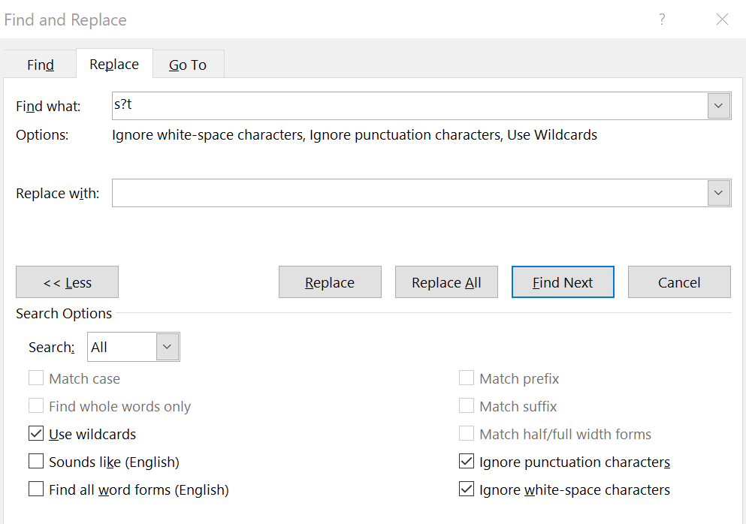

Note:

* Wildcard searches are case sensitive.
  + The above command in “Find what” box only find set, sit, sot

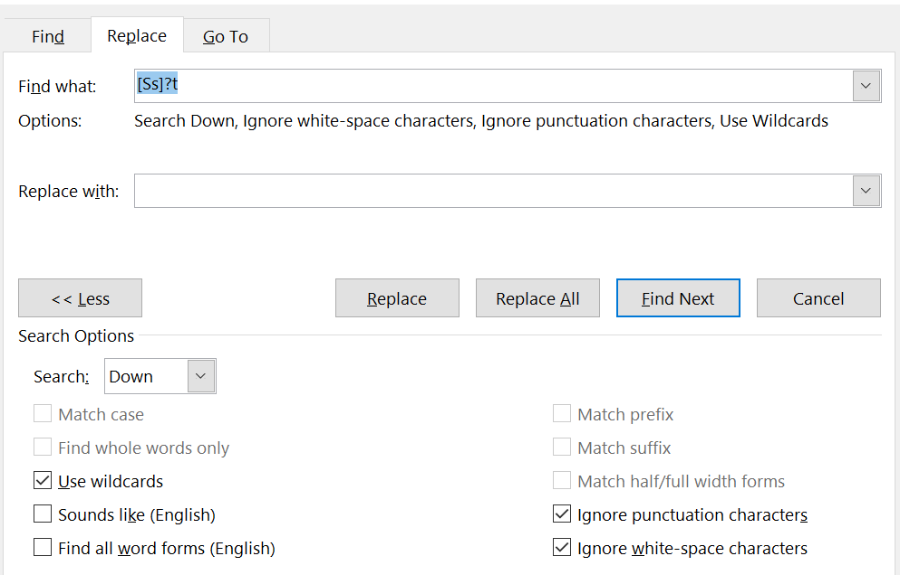

Note:

* []: Square brackets are always use in pairs and are used to identify specific characters or range of characters
  + **[abc]** will find any of the letters **abc**
  + **[F]** will find upper case '**F**';
  + **[0-9]** will find any single number;
  + **[13579]** will find any odd numbers;
  + **[0-9A-Za-z]** will find any numbers or letters.

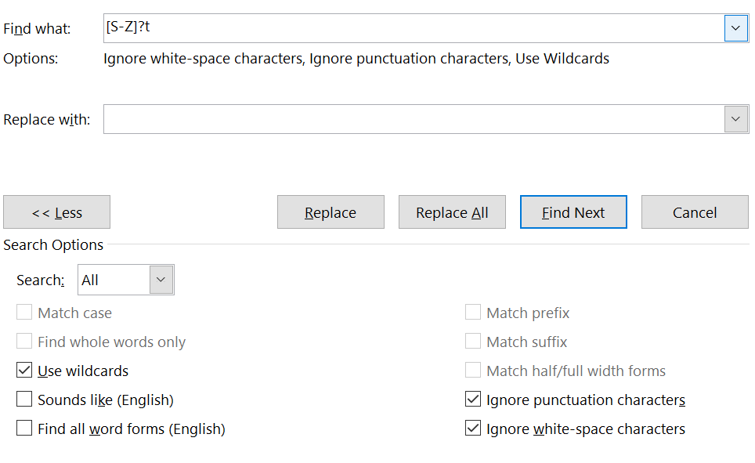

Note:

* **[A-Z]** will find any upper case letter;

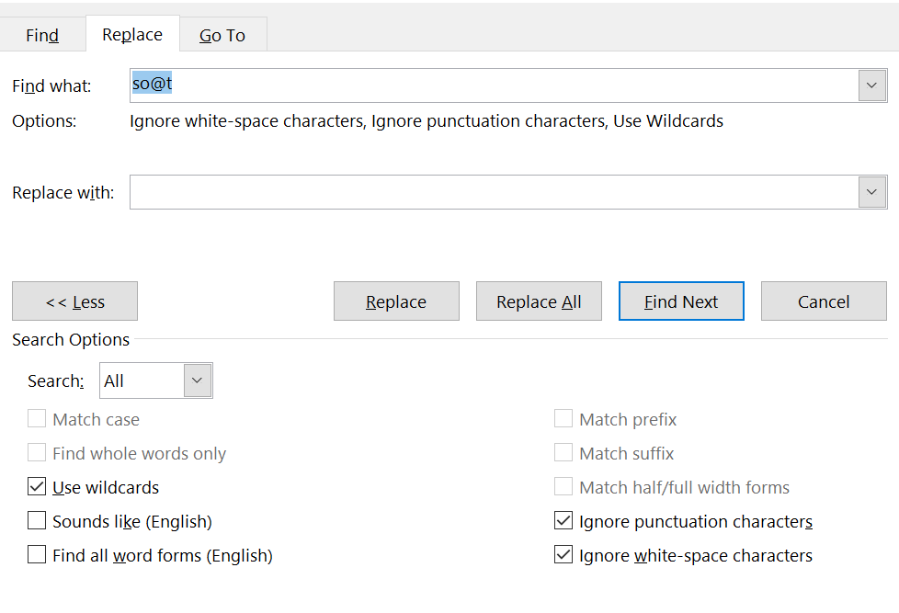

Note：

* **@** is used to find re-occurrences of the previous character (if any). e.g. **lo@t** will find **lot** or **loot**, **ful@** will find **ful** or **full** etc.
* **The above command will find sot, soot, asoot**

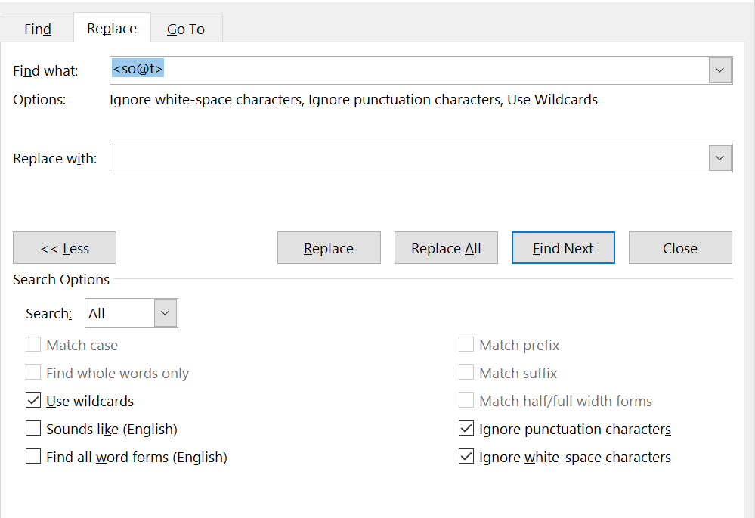

Note:

* **The above command will find sot, soot**

()

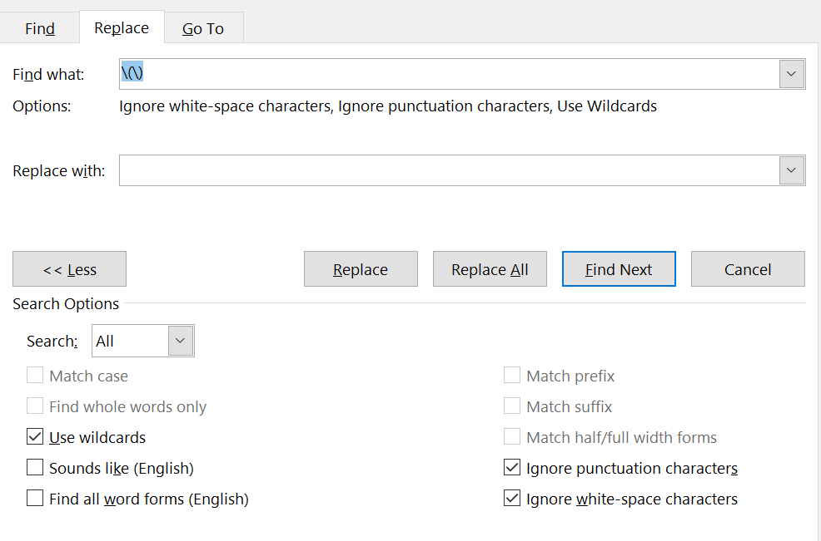

Note：

* The search result is ()
* If you wish to search for a character that has a special meaning in wildcard searches - the obvious example being '**?**'. then you can do so by putting a backslash in front of it: **[\?]** will find the question mark character '**?**'  
    
  If you wish to find the backslash itself then you need to precede that with a backslash **[\\]**.  
    
  The following is a list of the characters that have a special meaning in wildcard searches **( [ ] { } < > ( ) - @ ? ! * \ )**

(hello)

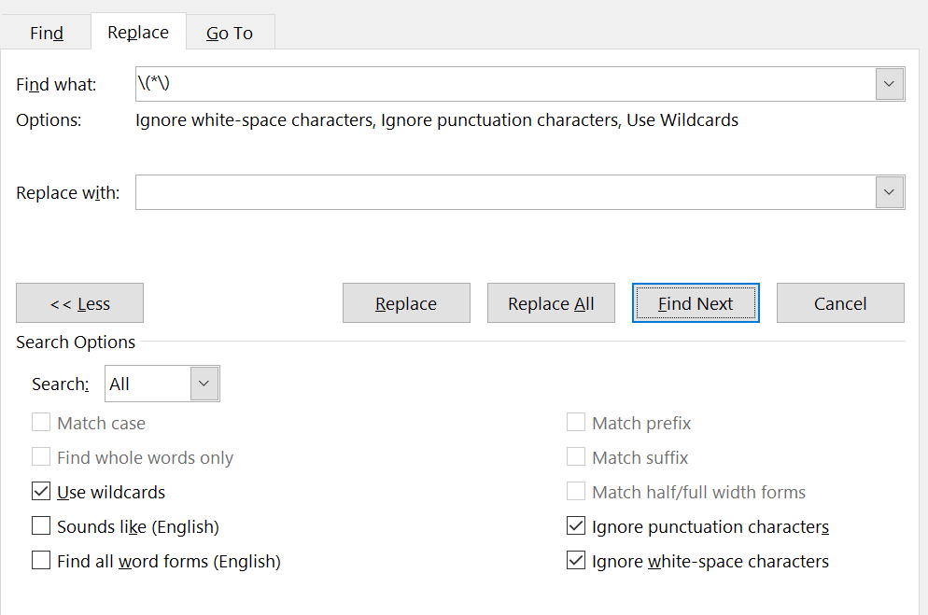

John Smith

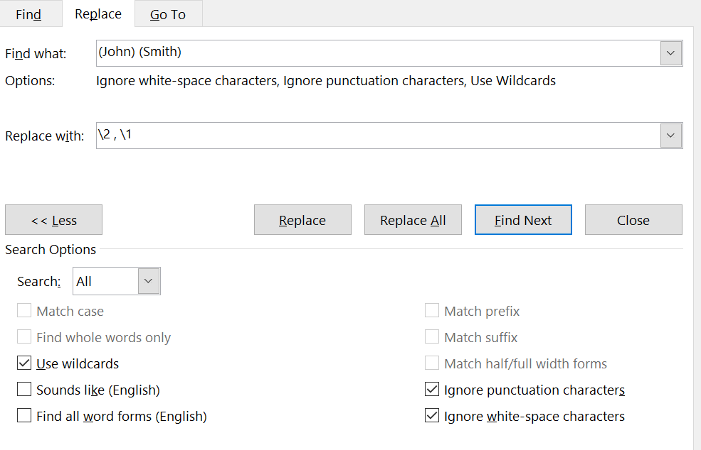

Note:

* The result is that John Smith is replaced by Smith, John
* Round brackets have no effect on the search pattern, but are used to divide the pattern into logical sequences, where you wish to re-assemble those sequences in a different order during the replace - or to replace only part of that sequence. They must be used in pairs.  
    
  The partnering backslash character is used as a replacement string in conjunction with a number to indicate which pair of brackets ***numbered from the left*** is required e.g.  
    
  **(John) (Smith)** replaced by **\2 \1** - ***note the spaces in the search and replace strings*** -  will produce **Smith John**or replaced by **\2** alone will give **Smith**.