Requirements

- Functional Requirements

FR1. The system shall allow a new individual customer to register by capturing first name, surname, address, ID number phone number, email, and a username and password.
FR2. The system shall let customers log in with a username and password and show only that customer’s own data.

FR3. The system shall let a customer open one Savings, one Investment, and one Cheque account. Each account gets a unique, system-generated number, and an account can only be closed when its balance is zero.

FR4. The system shall support deposits, withdrawals (Investment and Cheque only, not Savings), and transfers between the customer’s own accounts. Amounts must be greater than zero, and any withdrawal or transfer exceeding the available balance shall be rejected with a clear message.

FR5. The system shall record every transaction (date and time, type, amount, balance after, account) and display it to the customer. Interest shall be calculated automatically each month on the closing balance.

- Non Functional Requirements

NFR1. The system shall store customer passwords and data in a database.

NFR2. Personal information (ID number, address, contact details) and financial data shall be accessible only to the authorised customer.

NFR3. Balances must always be accurate and never go negative. Every transaction shall be recorded in the history, and a failed or rejected transaction shall leave balances unchanged.

NFR4.The system shall be usable by a customer with no training. It shall provide simple menus, clear and friendly messages and a confirmation prompt before important actions such as transfers or closing an account.

Behavioral Modeling

Structural Modeling

Use Case

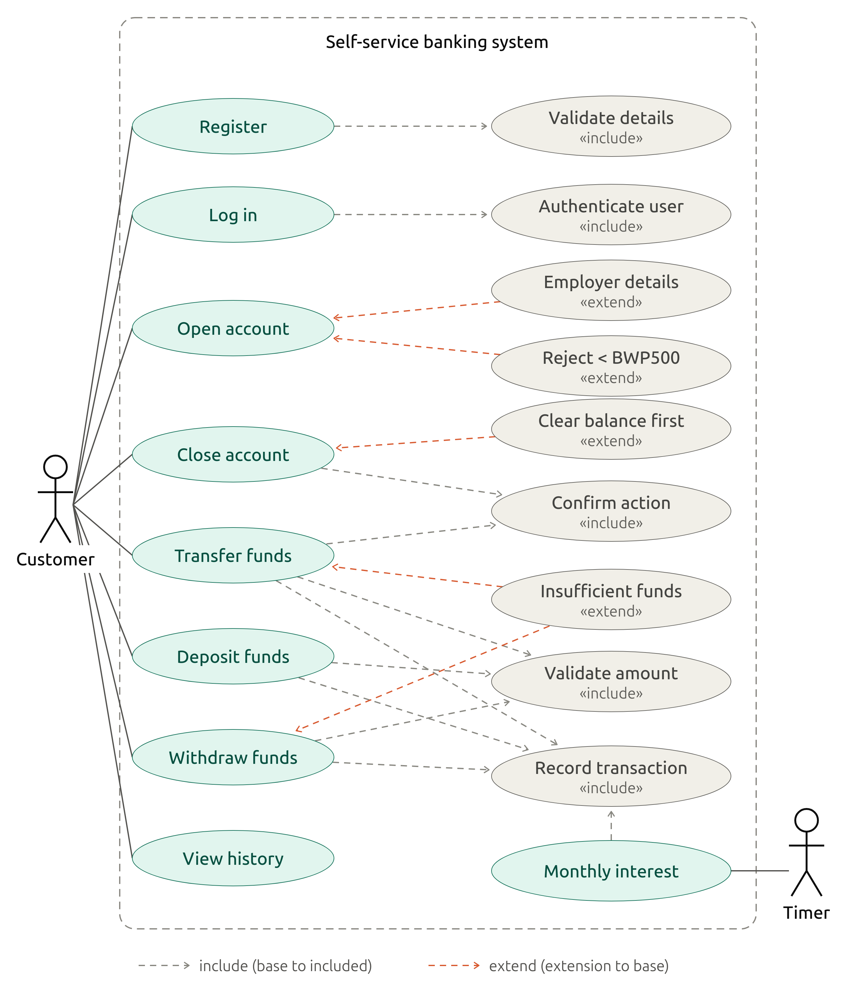

Class Diagram

Appendix
Interview
Users
- Q:Who will use the system?
A: Mainly customers. It’s a self-service banking app so they use it themselves.
- Q: Do customers log in themselves?
A: Yes. The customer logs in and does everything on their own.
- Q: Authentication?
A: Username and password is fine.
Customers
- Q: What are their registration details?
A: First name, surname, address, ID number (Omang or passport), phone number, email, username and password.
- Q: Individual or company?
A:Individuals only for now.
Accounts
- Q: Several accounts of the same type?
A: A customer can have one of each type: one Savings, one Investment, one Cheque. One of each is enough for me.
- Q: Account number generation?
A: Automatic and unique, generated by the system, such as (e.g. SAV-0001, INV-0001, CHQ-0001). Prefix for each type plus number. The customer shouldn’t choose it.
- Q: Cheque account employer details?
A: Employer name, employer address, and employer contact number are mandatory.
- Q: Investment account with less than BWP500?
A: Reject it with a clear message saying the minimum opening deposit is BWP500. Account must not be created.

- Q: Can accounts be closed?
A: Yes, but balance must be zero. If there’s money in it, the system asks them to withdraw or transfer it to another of their accounts before closing.

Transactions
- Q: Withdrawals and transfers?
A: Yes to all. Deposits, withdrawals and transfers between a customer’s own accounts. Savings shouldn’t allow withdrawals.
- Q: Minimum or maximum amounts?
A: Amounts must be greater than zero.
- Q: Overdraft on Cheque?
A: No overdraft. Withdrawal that exceed the balance should be refused with a message.
- Q: Transaction history?
A: Yes: date and time, transaction type (deposit, withdrawal, transfer, interest), amount, and balance after the transaction.
Interest
- Q: Automatic or triggered by a teller?
A: Automatic, once a month.
- Q: Closing or average balance?
A: Closing balance at month-end. It’s simpler to implement and easy to explain to customers.

Quality attributes
- Q: Security and privacy?
A: Of paramount importance, since it’s a bank. Passwords, personal details and balances should be stored in a database and should only be visible to the logged-in customer. Customers must never see anyone else’s data.
- Q: Usability?
A: It must be intuitive and very easy to use with no training, since it’s self-service. Simple menus, clear messages and error text (e.g. “Insufficient funds”), and confirmation before important actions like transfers or closing an account.

