Documentation

Website Specification

Website Objective
I have been tasked by a newly founded streaming company, Visor Inc., with creating this project. The primary objective of this project is to make a specialized digital video-on-demand platform, that allows users to watch Japanese animation online.
This project serves as an opportunity to demonstrate my skills, and if I perform well, I may be put as project leader to fully implementing this in real life. That would grant me access to their official API and full video content, rather than relying on YouTube trailers like on this project.
The goals are as follows;

Technical Knowledge: Demonstrate the ability to integrate real-time metadata (Jikan API) and high-performance video playback (HLS/HTML5) using Youtube embedded trailers.
Visual Branding: Establish a Premium-First identity that Provide a high quality user experience comparable to platforms like Crunchyroll and Apple TV.
Performance: Test the responsiveness of the interface on locally to ensure a zero lag experience for end-users.

Target Audience
The Primary target audience are Anime viewers and streaming platform users.
Demographics:
- Age: 13 to 35
- Gender: All

Technical Aptitude:
- Beginner to Intermediate users
  - Familiar with websites like YouTube and Netflix.
  - No tolerance for slow loading times.
  - Comfortable with:
    - Searching content
    - Navigating menus
    - Playing videos

Type of Website
This is a media streaming and content discovery website.
Content Type:
- Anime titles
- Video content (trailers)
- Real-Time Metadata: Weekly airing schedules, global community ratings and trending status fetched from APIs.

Key Features:
- Search functionality
- Individual anime detail pages
- Embedded video player (trailers or streaming)
- Responsive design for mobile, tablet, and desktop

Information Design and Taxonomy
Content is categorized into high-level sections such as Browse, Series, Films, Contact Us and User Account. The homepage and browse pages utilize carousels to group anime by themes such as trending, genres, and Must-See Hits. This improves usability by allowing users to quickly scan and explore content. A dynamic filtering system(xyz.html?123=...), is also used, allowing content to be displayed based on selected categories, without making many many html files.
Navigation is designed to minimize user effort, with key pages accessible via a persistent navigation bar and supporting links(contact us, login and create account) in the footer.

1. Site Map
Below is the overall structure of the website:

Home
├── Browse
│ ├── Series (series.html)
│ ├── Films (films.html)
│ ├── Genres Overview (browse.html)
│ └── Genre Results (browse.html?genre=...)
├── Anime Detail Page (anime.html?id=...)
├── Player Page (watch.html?id=...)
├── Search Results (search.html?q=...)
├── Profile / Account
│ ├── Login (login.html)
│ └── Create Account (accountCreate.html)
└── Contact Us (contact.html)

2. Site Map

1. Browsing via Genres
Home → Browse → Genres → Browse Page (Genres Overview) → Select “See More” on a Genre → Browse Page (Filtered by Genre) → Anime Detail Page → Watch Page

2. Browsing Series
Home → Browse → Series → Series Page → Select Anime → Anime Detail Page → Watch Page

3. Browsing Films
Home → Browse → Films → Films Page → Select Film → Anime Detail Page → Watch Page

4. Using Search
Home → Search Icon → Search Results Page → Select Anime → Anime Detail Page → Watch Page

5. Login
Home → Profile Icon → Login → Login Page

6. Creating an Account
Home → Profile Icon → Create Account → Create Account Page

7. Contact Page Access
Home → Footer → Contact Us → Contact Page

3. Storyboard Flowchart
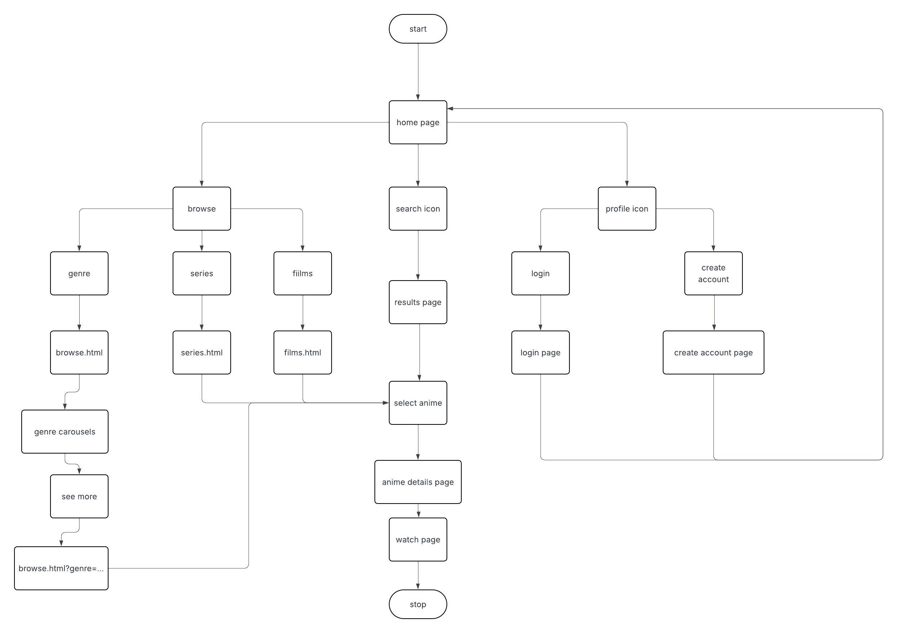

Technical Brief

Core Technologies

Frontend Technologies
- HTML5
Used to structure the content and layout of the website.
- CSS3
Used for styling, layout design, and responsiveness (including Flexbox and Grid).
- JavaScript (ES6+)
Used to implement interactivity, dynamic content rendering, and API communication. (JavaScript frameworks e.g, React, may be used if need be.)
- BootStrap 5.3
- Used for rapid, responsive prototyping.

Video Streaming Technology
- hls.js
Used to enable playback of HLS streams in web browsers that do not natively support it.

API Technology
- Jikan API or AniList API
Used to fetch real-time anime data such as:
  - Trending titles
  - Ratings
  - Descriptions
  - Seasonal releases

Development Tools

Code Editor
- Visual Studio Code
Used for writing and managing code, with extensions for web development.

Version Control
- Git
Used to track changes and manage project versions.
- Build Tool: Vite 7
- Bundles CSS and JS instantly, ensuring the site feel fast.

Design & Graphics Tools

- UI/UX Design: Figma
- Used to design layouts, wireframes, and user interface components.
- Typography: Inter Variable Font
- Used to achieve a clean, modern, and professional appearance similar to Apple-style interfaces.
- Icons
- Open-source icon libraries, i.e, Lucide Icons and Heroicons.
- Free image sources for posters, placeholders and episode stills.

