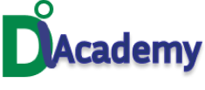

Hello,

Trust you are doing well.

I am so excited to be sending this message to you.

You are wondering why, Well the reason is not far-fetched.

The October Cohort for Full Stack development Virtual Training is here.   
I know you, and you are sure that D I Academy is there to guide you through this training to teach you the basics.

D I Academy is the perfect guiding angel for your career in full-stack development.

Your instructor is efficient, Knowledgeable, and ready to welcome you to this class.

You would not want to go through this coding class alone.

It is time you joined others in making the best decision in Tech.

Please do not miss this opportunity!

Come and learn HTML, CSS, JavaScript, React, PHP, Word Press, SQL, Database, Python, Java, and Project Management techniques for Web development.

Join our October Cohort for your perfect guidance in Full-stack development.

Looking forward to hearing from you soon

Regards,

Ifeoluwa