**Ti-6Al-4V** **Material and its Applications**

The project focuses on the tensile testing of the titanium alloy Ti-6Al-4V, known for its remarkable properties and widespread use across industries. The titaniumTi-6Al-4V alloy is composed of titanium (Ti), aluminium (Al), and vanadium (V).

TiAl6Ti-6Al-4V with composition of Titanium 88.75% Aluminium 6.75%, vanadium 4.50% is known as workhorse titanium alloy because of its wide applications in aerospace industries, chemical processing plants and medical devices [8]. It possesses excellent combination of mechanical properties, specific strength, and corrosion resistance. Ti-6Al-4V is commercially used in gas turbine engine up to the test temperature of 350 ºC. Industrial applications usually limit Ti-6Al-4V use to 400 °C [9]. It is a two-phase alloy consisting of primary α with HCP crystal structure and metastable β with BCC structure. Titanium undergoes allotropic phase transformation from α (HCP) to β (BCC) at 882 ºC [10]. The structural titanium alloys are classified mainly into three categories: α, β, and α + β alloys. The α alloys of titanium categorized as commercially pure titanium, is relatively low in strength but offers a good combination of corrosion resistance, weldability, and creep resistance [11]. The β alloys are responsive to forging and offer excellent fracture toughness. The dual phase (α + β) alloys offer a combination of excellent ductility and strength with proper heat treatment to make them stronger than α phase and β phase alloys [12]. It is well known that mechanical behaviour of the alloy Ti-6Al-4V is highly dependent on test temperature [13,14].

This composition gives it a unique blend of characteristics, including high strength, low density, and excellent corrosion resistance. These properties make Ti-6Al-4V a preferred material for various critical applications. which give it a unique combination of high strength, low density, and excellent corrosion resistance. Ti-6Al-4V alloy is commonly used in aerospace components, such as aircraft frames and engine parts, as well as in medical implants and automotive components. Its high strength-to-weight ratio makes it ideal for applications where strength and lightness are essential. Additionally, Ti-6Al-4V alloy offers excellent biocompatibility, making it suitable for medical implants. Overall, the titanium alloy Ti-6Al-4V is a versatile material with a wide range of applications, thanks to its exceptional properties and performance.

**Motivation**

The motivation for choosing the titanium alloy Ti-6Al-4V for this project stems from its exceptional properties and wide range of applications. Ti-6Al-4V is known for its high strength, low density, and excellent corrosion resistance, making it a versatile material suitable for various industries. Its high strength-to-weight ratio is particularly advantageous for applications where weight reduction is critical, such as in aerospace components. The primary justifications for using titanium in the aerospace industry are Weight savings (primarily as a steel replacement), Space limitation (replace A1 alloys), Operating temperature (A1, Ni, steel alloys replacement) [8]. Additionally, Ti-6Al-4V's biocompatibility makes it suitable for medical implants, further expanding its application potential. This material is ideal for many high-performance engineering applications, for example in aerospace, motor racing and biomedical implants [8]. In aerospace engineering, Ti-6Al-4V components are traditionally manufactured through intense milling of bulk parts, the hot forming of sheets and assembly welding [15].

The benefits of Ti-6Al-4V extend to its ease of fabrication, which allows for complex shapes and structures to be easily manufactured. Its resistance to high temperatures also makes it ideal for applications in extreme environments. Furthermore, Ti-6Al-4V exhibits good fatigue resistance, enhancing its durability and longevity in use.

The diversity of Ti-6Al-4V's applications is evident in its use in aerospace, medical, automotive, and marine industries. In aerospace, Ti-6Al-4V is used for aircraft components, engine parts, and landing gear. In the medical field, it is used for implants such as hip joints, bone plates, and dental implants. In the automotive industry, Ti-6Al-4V is used for high-performance components. Additionally, Ti-6Al-4V is used in marine applications for its corrosion resistance in saltwater environments.

Overall, the unique combination of properties offered by Ti-6Al-4V makes it an attractive choice for this project, as studying its mechanical behaviour can provide valuable insights for its practical use in different fields, showcasing its versatility and wide-ranging applications.

**Objective**

1. **Specimen Preparation:**
   * Acquired Ti-6Al-4V alloy material for the project.
   * Prepared soft model in SolidWorks for specimen design.
   * Fabricated two specimens as per ASTM standards using Wire EDM machine:
     1. First specimen prepared at normal temperature.
     2. Second specimen subjected to heat treatment at 750 degrees Celsius for 3 hours and cooled at room temperature for 18 hours after heat treatment.
2. **To Conduct Experiment to Get Ductile Properties:**
   * Conduct a comprehensive tensile test on the Ti-6Al-4V alloy to explore its mechanical behaviour under various loading conditions.
   * Utilize Ansys as a simulation tool to analyse and visualize the response of Ti-6Al-4V to tensile forces.
3. **To Evaluate Tensile Curve Using FEM:**
   * Employ Ansys for virtual simulation and analysis of the tensile behaviour of Ti-6Al-4V, providing insights into the alloy's response to different loading conditions.
   * Validate the simulation results against the experimental data to enhance the credibility of the study.

**Summary**

In summary, the titanium alloy Ti-6Al-4V (Ti-6Al-4V) is a versatile material with exceptional mechanical properties, making it highly valuable in engineering applications. Its high strength-to-weight ratio, combined with good ductility and corrosion resistance, makes it suitable for aerospace, automotive, and biomedical applications. Tensile testing and computational simulations have provided valuable insights into Ti-6Al-4V's behaviour under different conditions, enhancing our understanding of its mechanical characteristics. Comparisons with other materials, such as the magnesium alloy AZ31B, highlight Ti-6Al-4V's unique advantages. In biomedical applications, Ti-6Al-4V's biocompatibility and mechanical properties make it a compelling choice for implants and medical devices. Overall, Ti-6Al-4V's versatility and exceptional properties position it as a key material in advancing engineering innovations.

**Procedure**

**Introduction**

We have chosen the titanium alloy Ti-6Al-4V for this project due to its favourable mechanical properties, including high strength-to-weight ratio and excellent corrosion resistance. The alloy was ordered in sheet form from a reliable distributor, ensuring quality and consistency for the experiments.

The specific dimensions of the sheets, 500 by 400 centimetre with a thickness of 2.5 millimetres, were selected to meet the project's requirements. This alloy is widely used in aerospace, medical, and marine applications, making it a suitable choice for the project's investigation into tensile strength under varying conditions.

**Specimen Preparation:**

Upon receiving the titanium alloy Ti-6Al-4V material, we precisely created a digital model of the specimen dimensions using SolidWorks software. This step was crucial for ensuring the specimens would meet the required specifications. Subsequently, the SolidWorks model was converted into a code compatible with the wire EDM (Electrical Discharge Machining) machine. This code guided the wire EDM machine in cutting the titanium alloy material into the desired dumbbell shape, a process that spanned several days due to the hard and complex nature of the cuts and the high precision required.

After the cutting process was completed, we proceeded to drill holes on both sides of the dumbbell-shaped specimens. These holes were strategically placed for the purpose of mounting the specimens securely on the Universal Testing Machine (UTM) during the tensile testing phase. This meticulous approach to specimen preparation was essential to ensure the specimens were accurately shaped and properly configured for the successive mechanical testing, which is critical for our project's objectives.

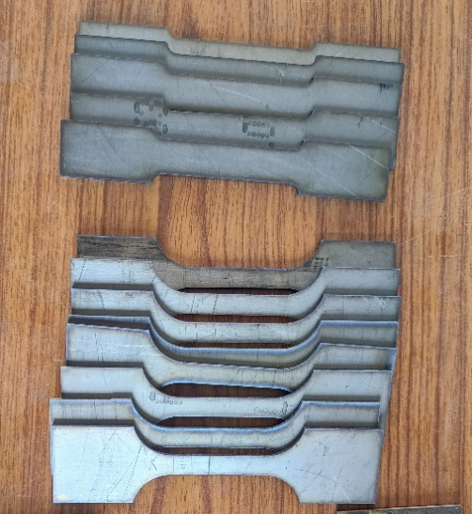**Fig. 3.1 Specimen**

**EDM (Electrical Discharge Machining) Process:**Wire EDM is a precise machining method used to shape hard materials like titanium alloys. EDM is mostly used for metal components especially electrically conductive metals or heat-treated metals like high carbon steels, Inconel, Titanium alloys [17-19]. In this process, a thin, electrically conductive wire is guided through the material, creating a controlled electrical discharge or spark that erodes the material. The workpiece is mounted on a platform, and the wire is threaded through it, following a programmed path to cut the desired shape. As the electrical discharges occur, they melt tiny portions of the material, which are then flushed away by a dielectric fluid. This process allows for the creation of intricate shapes with very tight tolerances. Wire EDM is especially useful for materials that are difficult to machine using conventional methods, ensuring high precision and minimal stress on the material.

**Fig. 3.2 Wire EDM Fig. 3.3 Sample Cutting**

**Drilling Process:**

Drilling machines are tools used to create holes in materials like metal, wood, and plastic. They use a rotating drill bit to remove material and come in types like portable drills, bench drills, radial drills, and magnetic drills. Features include speed control, depth stop, table adjustment, and variable chuck sizes. Drilling machines are essential in manufacturing, construction, and woodworking for their precision and efficiency in hole-making.

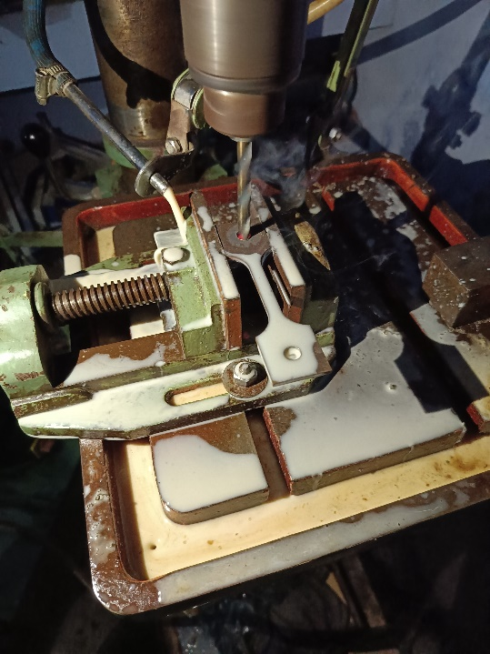 **Fig. 3.4 Drilling Machine Fig. 3.5 Drilling Process**

**3.2.3 Heat Treatment**

To investigate the tensile behaviour of Ti-6Al-4V alloy specimens, a series of heat treatments were conducted. This process aimed to reduce internal stresses within the material, thereby enhancing its tensile strength and ductility. [20]

Subsequently, the specimens were subjected to further heat treatment at 750°C for 4 hours as shown in Fig. After this treatment, the specimens were allowed to cool for 18 hours. However, during the cooling process, a slight deformation was observed in the specimens.

These heat treatments and observations are crucial for understanding the material's behaviour under different conditions and can provide valuable insights into its mechanical properties and potential applications.

**Fig. 3.6 Heating Furnace**

**Specimen**-**1 at Room Temperature** For the project, specimens of the titanium alloy Ti-6Al-4V was received in form of sheet with thickness of 2.5 mm which was cut in accordance with ASTM E8 standards. Utilizing Wire EDM technology, the specimens were cut to precise dimensions with a gauge length of 50 mm, a grip length of 35 mm, and a width of grip of 20 mm, featuring a curvature radius of 3.75 mm, width of 12.50 mm and a thickness of 2.5 mm. The cutting process was executed under specific parameters, including a voltage of 75 volts and a current of 2 amperes, ensuring optimal performance and accuracy. Additionally, the machine's cutting speed was maintained at 200 Hz, with the entire cutting operation completed within a duration of 45 minutes. The feed rate of the machine was 2.38 mm/minute.

**Fig. 3.7 Specimen-1**

**Fig. 3.8 Dimension Specimen-1**

**Specimen**-**2 at Elevated Temperature**

For the second specimen, we followed similar procedures to the first, adhering to ASTM E8 standards for preparing Ti-6Al-4V (Ti-6Al-4V) alloy samples. The specimen dimensions were 57 mm gauge length, 50 mm grip length, 50 mm width of grip, with an 18.75 mm curve radius, 12.50 mm width, and 2.5 mm thickness. Using Wire EDM at 80 volts and 2 amperes, with a cutting speed of 200 Hz, the specimen was cut in 50 minutes. The feed rate of the machine was 5.795 mm/minute. Subsequently, the specimen underwent heat treatment in a furnace at 450 degrees Celsius for 3 hours, followed by cooling for 12 hours. The heat treatment caused slight deformation in the metal.

**Fig. 3.9 Specimen-2**

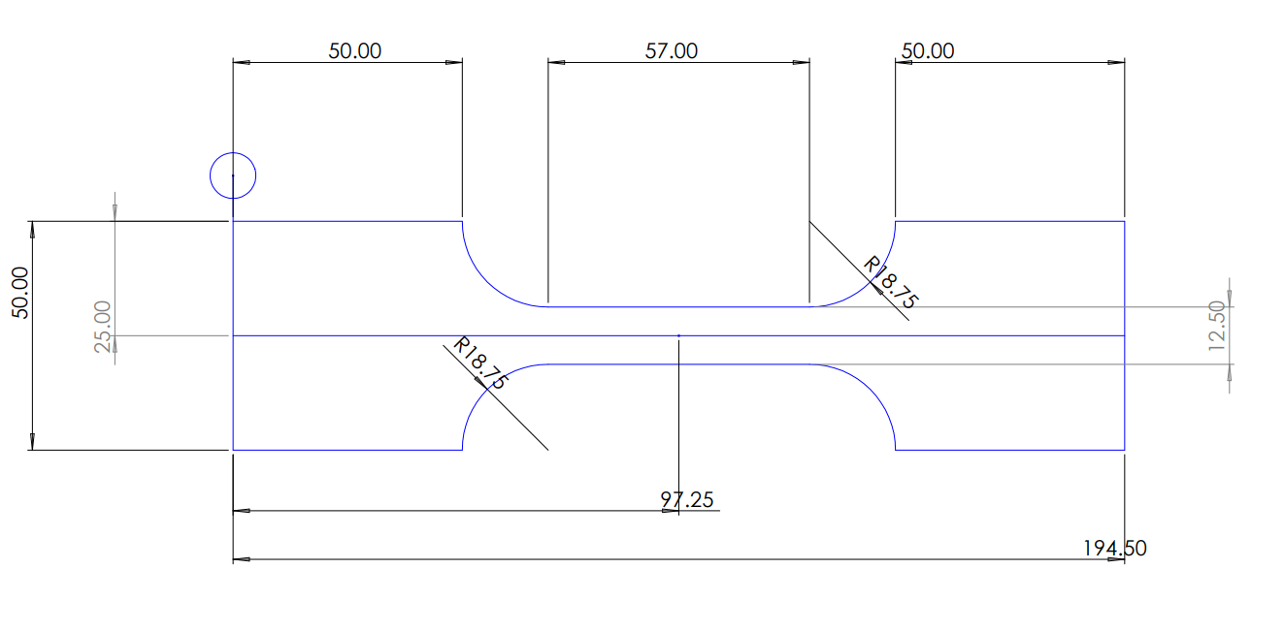

**Fig. 3.10 Dimension Specimen-2**

**Specimen Dissemination for Testing**

After completing the specimen preparation process, including cutting the Ti-6Al-4V alloy sheet into the dumbbell shape using wire EDM and drilling holes for mounting on the Universal Testing Machine (UTM), the samples were collected and prepared for testing. The specimens were carefully packaged and sent via courier to a reputable institution specializing in materials testing, specifically for tensile testing. This step ensured that the samples would undergo rigorous examination under controlled conditions to determine their tensile strength and other mechanical properties. The testing institution would provide accurate and reliable data, crucial for evaluating the quality and performance of the Ti-6Al-4V alloy specimens.

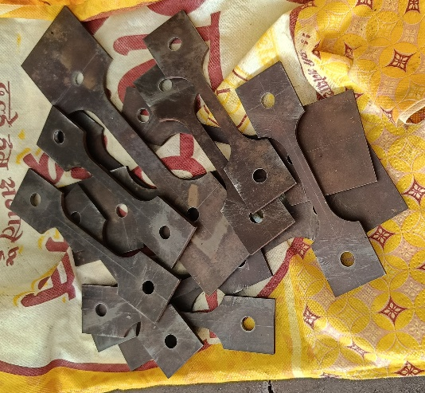

**Fig. 3.11 Specimen Prepared Fig.3.12 Specimen After Drilling**

**Chapter 4: Result and Discussion**

**4.1 Unforeseen Challenges and Experimentation Hurdles**

Following unforeseen machine failures at the testing institution, our focus shifted to mathematical modelling of the Ti-6Al-4V alloy using ANSYS software. This approach allowed us to simulate the effects of different types of forces on the material, providing valuable insights into the resulting strain and stress distributions. This modelling exercise not only compensates for the testing setbacks but also offers a comprehensive understanding of the material's behaviour under varying loading conditions, aiding in future design and analysis undertakings.

**4.2 Specimen Dimension and CAD Modelling**

After the original specimen failed, we created a new design in the shape of a dumbbell to replace it. This new design was then converted into a digital model using a software called ANSYS, which helps simulate how materials behave under different conditions.

In ANSYS, we specified that the material of the dumbbell is titanium alloy Ti-6Al-4V, which is a common material used in engineering. We also inputted the dimensions of the dumbbell, with a standard size of 2.5mm, to accurately represent its physical properties in the simulation.

This meticulous process ensures that our digital model closely resembles the real-world dumbbell, allowing us to conduct detailed analysis and simulations. By accurately defining the material properties and dimensions, we can obtain reliable results that help us understand how the titanium alloy behaves in different situations.

**Fig. 4.1 CAD Model**

**4.3 Static Structure Analysis**

In a static structural analysis, we apply loads, such as forces to a structure and then calculate how the structure deforms or how much stress it experiences. This information is crucial for engineers to ensure that a structure is safe and can withstand the forces it will encounter in its intended use.

In our project, we used static structural analysis in ANSYS to simulate a tensile test on a specimen. By applying this analysis, we were able to predict how the specimen would behave under tension and understand its mechanical properties without performing a physical test. This helped us save time and resources while still obtaining valuable insights into the material's behaviour.

**4.3.1 Meshing**

In the simulation, we divided the specimen into small elements, each about 2.5 mm in size, using ANSYS software. This process helps the computer understand the shape of the specimen. We chose 2.5 mm because it's a good balance between accuracy and speed. If the elements are too small, it takes a long time for the computer to calculate. If they're too big, the results might not be accurate. We also used special techniques to make sure the elements fit the shape of the specimen well, especially in areas where there's a lot of stress or bending. This helps us get reliable results about how the material behaves when it's stretched.

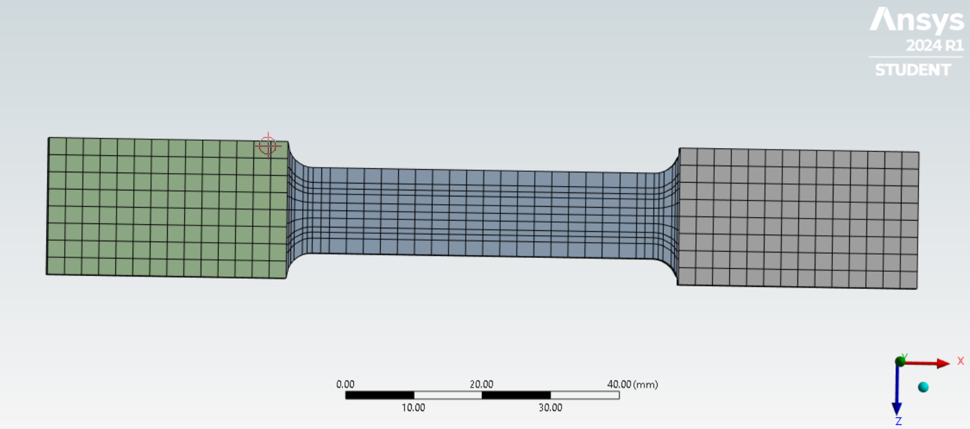

**Fig. 4.2 Meshing**

**Boundary Condition**

In the tensile test simulation, a displacement boundary condition was applied to the specimen in ANSYS. This means that one end of the specimen was fixed, or held in place, while the other end was pulled by a specified amount. This boundary condition reflects the real-world scenario of a tensile testing machine pulling on the specimen. By applying this displacement, we can simulate the stretching of the material and analyse how it deforms and behaves under tension.

The displacement value applied to the free end of the specimen was based on a specific strain rate of 0.1 mm/sec which determines how fast the specimen is stretched. This allows us to control the rate at which the material deforms, which is important for understanding its mechanical properties.

Additionally, the displacement boundary condition ensures that the material responds realistically to the applied load, providing insights into its stress-strain behaviour and ultimately its tensile strength and other mechanical properties. This boundary condition, along with the meshing and material properties, forms a key part of the simulation setup for accurately modelling the tensile test.

**Fig. 4.3 Boundary Condition**

**Analysis**

In the static structural analysis for our project, we used a tabulated form to input 144 values of displacement. This approach allowed us to simulate the deformation of the specimen over time and obtain a detailed stress and strain curve.

The process involved setting up the analysis in ANSYS, defining the material properties of the specimen, applying the displacement boundary condition at one end, and fixing the other end to simulate the tensile test setup. We then ran the analysis, which calculated the deformation of the specimen at each of the 144 displacement values.

By analysing the results, we were able to observe how the specimen deformed under increasing load, leading to the creation of a stress-strain curve. This curve is crucial for understanding the material's behaviour under tension and is used to determine its mechanical properties, such as tensile strength, modulus of elasticity, and yield strength.

Additionally, we can use the data to validate our mathematical models and simulations, ensuring that they accurately represent the real-world behaviour of the material. This approach provides valuable insights for design optimization and material selection in engineering applications.

**Fig. 4.4 Static Structure Analysis**

**Evaluation**

We also calculated equivalent von Mises stress and strain. This is a way to measure how much stress a material can handle before it starts to deform permanently. It helps us understand how strong the material is under different conditions.

After calculating this, we plotted the results on a graph using a chart tool. This graph helps us visualize how the material behaves under stress. This information is important for engineers to design structures or machines that can withstand the forces they'll encounter in real-world use.

Static structural analysis is a type of engineering analysis that deals with the behaviour of structures under static loading conditions. In simpler terms, it helps us understand how a structure, such as a beam or a mechanical part, responds to forces acting on it when it's not moving or changing its speed.

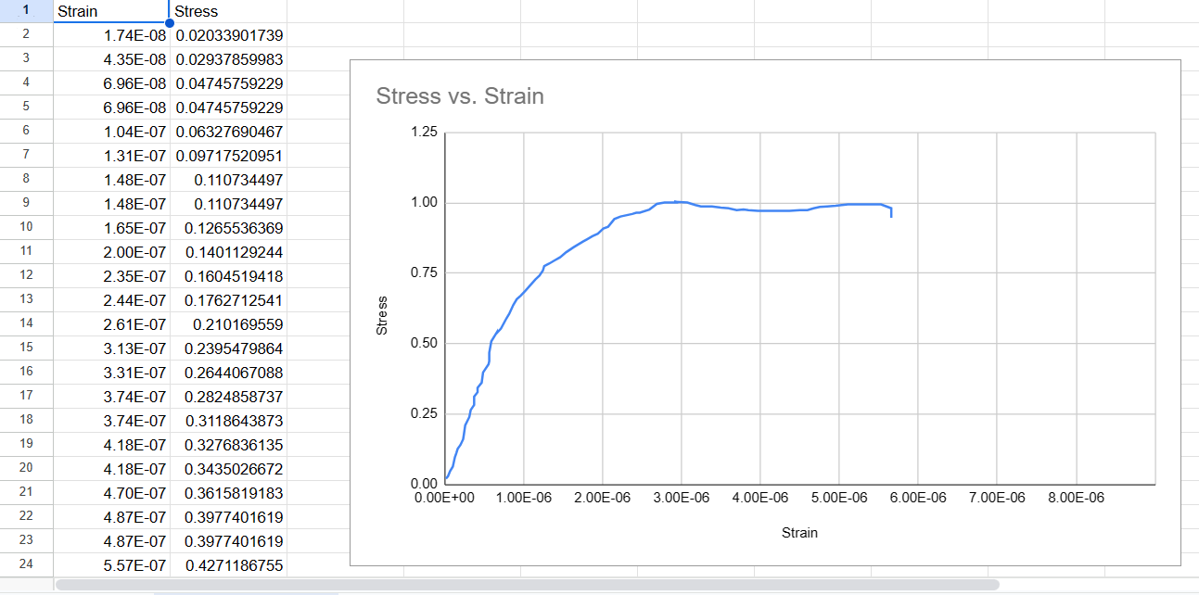

**Fig. 4.5 Stress Vs. Strain**