When modelling the database an important decision was made regarding the existence of the Character and Genre relations. Because the books will be divided into more Categories (and subcategories) we decided that this would replace the Genre table.

The categories and subcategories used are the ones from Amazon.uk – Book Store, therefore if a book has Science Fiction Genre, in our database will belong to Science Fiction Category.

Figure 1: Amazon's Book Store parent categories and example of subcategories (for young adult).

Still regarding the Categories, the relationship between the Category and Subcategories is a recursive one. In this way we created the hierarchy, category-subcategory, where each record is related to another record in the same table, Category 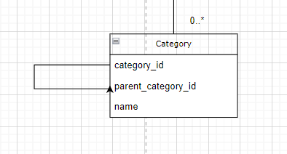

Figure 2: Recursive relationship in Category table.

Another modelling choice was made when creating the relationships between Book and Author. Because between these two relations there is a Many-To-Many relationship. Therefore, a junction table, BookAuthor, was created. This third table plays a role in the normalization of the database, improves the data integrity, and simplifies the logic required to retrieve many-to-many relationships.

Figure 3: Book - Author Many-to-Many Relationship