# Introduction

Bladder cancer is recognized as one of the most prevalent malignancies worldwide, with approximately 20% of those diagnosed ultimately succumbing to the disease (**Warrick, Joshua I., et al. 2024**).

Bladder cancer exhibits the highest incidence in Europe, followed by the United States and Egypt **(Babjuk, Marko, et al. 2022).**

Bladder cancer is 3 to 4 times more common in men than women. It's incidence increase in the sixth decade of life **(Aveta, Achille, et al. 2022).**

It is the 2nd common site of cancer in men as it represent 12.7% **(Ibrahim, Nurul Khalida, et al. 2022).**

Transitional cell carcinoma (TCC) is the most common type of bladder tumor, presenting as a superficial disease at the time of initial diagnosis in approximately 75% of cases **(Gravas, Stavros, et al. 2023).**

Transurethral resection of bladder tumor(s) (TURBT), is considered the treatment of choice **(Mohanty, Sambit K., et al. 2023).**

Despite achieving visually complete resection, bladder cancer is associated with a high recurrence rate, potentially due to tumor cell implantation following transurethral resection of bladder tumor (TURBT) or the presence of residual microscopic disease. **(Zhang, Yongzhen, et al., 2018).**

The high rates of recurrence and stage progression present a significant clinical challenge. Intravesical instillation of chemotherapeutic or immunotherapeutic agents following transurethral resection of bladder tumor (TURBT) plays a crucial role in reducing the risk of recurrence and disease progression. Immunotherapeutic agents, such as Bacillus Calmette-Guérin (BCG), may enhance the body's immune response, exerting a direct effect on tumor cells **(Bazargan, Sarah, et al. 2023).**

Local side effects are observed in approximately 90% of patients receiving Bacillus Calmette-Guérin (BCG) therapy. More serious systemic complications may occur, including hemodynamic instability, persistent high-grade fever, allergic reactions such as arthralgia and rash, or involvement of solid organs (e.g., epididymitis, liver, lung, kidney, osteomyelitis, and prostate). These complications can necessitate discontinuation of treatment and, in some cases, have resulted in fatal outcomes **(Babjuk, Marko, et al. 2022).**

Despite the significant morbidity associated with BCG therapy, an improvement in overall survival has not been demonstrated, with only approximately two-thirds of patients showing a response to the treatment **(Claps, Francesco, et al. 2023).**

Research has thus focused on developing new drugs or novel drug combinations for intravesical instillation. Gemcitabine (GEM) has demonstrated efficacy with minimal bladder irritation and is generally characterized by rapidly self-resolving side effects **(Tomko, Andrea M. et al. 2022).**

Gemcitabine is an active systemic chemotherapeutic agent in the management of advanced bladder cancer and it has also been evaluated in the management of superficial disease **(Bazargan, Sarah, et al. 2023).**

Gemcitabine has a molecular weight of 299 Da, which is lower than that of most commonly used intravesical chemotherapeutic agents. This molecular size facilitates its penetration into the bladder mucosa, enhancing its therapeutic efficacy, while remaining sufficiently large to prevent significant systemic absorption. Additionally, its favorable pharmacokinetic profile makes gemcitabine an optimal candidate for regional therapy **(Li, Changjiu, et al. 2024).**

Intravesical gemcitabine is a promising drug that may be an option in treating patients with non muscle invasive bladder cancer **(Chen, Wujun, et al. 2022).**

Comparative trials of intravesical gemcitabine and Bacillus Calmette-Guérin (BCG) have yielded comparable outcomes regarding recurrence rates and disease progression, with the gemcitabine group experiencing fewer side effects **(Bazargan, Sarah, et al. 2023).**

# Aim of The Work

The aim of this work is to evaluate the efficacy and

safety of Gemcetabine as a local intravesical adjuvant

treatment of non muscle invasive TCC in reducing the risk

of recurrence and progression after TURBT in comparison

to BCG.

# Chapter (1) Non Muscle Invasive Bladder Cancer

**Introduction and incidence**

Bladder tumor is the 9th most commonly diagnosed tumor in the world and the 2nd most common malignancy of the urogenital tract **(Chen, Ji-Qing, et al. 2022).** It's causing more than 130,000 deaths annually **(ŞEN, Selda, et al. 2021).**

Bladder cancer is more prevalent in developed countries and demonstrates a pronounced gender disparity, with an incidence ratio of approximately 4:1 favoring males over females **(Ferlay, Jacques, et al. 2020).**

The incidence and prevalence of bladder tumors increase in the sixth decade of life, reaching a peak in the seventh and eighth decades, which predominantly characterizes the disease as one affecting the elderly **(Aveta, Achille, et al. 2022).**

The highest incidence of bladder cancer has been observed in Europe, the United States, and Egypt, whereas the lowest incidence rates are reported in Sub-Saharan Africa, Asia, and South America **(Babjuk, Marko, et al. 2022).**

About 75% of bladder tumors are non-muscle invasive at initial diagnosis **(Tran, Linda, et al. 2021).** Sixty percent of these patients experience recurrence and ten percent experience progression in 5 years **(Ferro, Matteo, et al. 2022).**

**Risk Factors of Bladder Cancer**

* **Smoking :**

Cigarette smoking is the most significant risk factor for bladder cancer, although its association is not as strong as that observed with respiratory tract cancers. Tobacco smoke is estimated to be responsible for approximately 50% of bladder cancer cases, contributing substantially to the disease burden. Carcinogenic urinary compounds derived from cigarette smoking include aromatic amines, inorganic substances such as arsenic, polyaromatic hydrocarbons, and aldehydes. Moreover, electronic cigarette use may not be risk-free, as the complex composition of e-cigarette liquids can contain or generate, through vaporization, known bladder carcinogens, including aromatic amines, aldehydes, and polyaromatic hydrocarbons **(Jubber, Ibrahim, et al. 2023).**

* **Occupation :**

Occupational exposure is recognized as the second most significant risk factor for bladder cancer, with estimates suggesting that such exposures may account for up to 20% of all cases. Agents such as naphthylamine, 4-aminobiphenyl (ABP), and benzidine—primarily encountered among workers in the textile dye and rubber tyre industries—have been associated with bladder cancer. Due to stringent regulations, these chemicals are now banned from the workplace and contribute minimally to the current incidence of bladder cancer in Western countries. Nonetheless, several other potential carcinogens persist, such as orthotoluidine, which is currently used in the manufacture of dyes, rubber chemicals, pharmaceuticals, and pesticides. Recent studies have further revealed that cumulative occupational exposure to aromatic acids is linked to an elevated risk of bladder cancer **(Zhao, Xiaohu, et al. 2022).**

* **Bacterial Infections :**

Several investigators have proposed that chronic bacterial infections may contribute to the development of bladder cancer. Clinically, conditions such as prolonged catheter use, urolithiasis, and persistent infections have been associated with bladder carcinoma, although the precise mechanisms underlying neoplastic transformation remain poorly understood. It is hypothesized that factors such as immunological dysregulation, chronic chemical and mechanical irritation, and the production of carcinogens like nitrosamines may play a role in this process. Notably, chronic urinary tract infections have been linked to bladder cancer, with individuals exhibiting a relative risk of 1.4 to 1.6 for developing the disease following any history of such infections **(Huan, Jianya, et al. 2022).**

* **Radiation and Chemotherapy :**

Second malignant neoplasms represent late complications following exposure to genotoxic therapies, including radiotherapy and certain chemotherapeutic agents. Notably, the development of urothelial cancer after radiation exposure is not age-dependent, typically emerging after a latency period of 15 to 30 years. Furthermore, the increased risk of urothelial cancer in patients with prostate or cervical cancer treated with radiation therapy further substantiates the carcinogenic potential of radiation in the bladder **(Goswami, Ritabrita, et al. 2024).**

Chemotherapy exerts its cytotoxic effects on malignant cells by inducing significant DNA and cellular damage; however, it may also adversely affect rapidly dividing normal epithelia, such as those found in the bladder. Notably, cyclophosphamide is the only chemotherapeutic agent that has been conclusively linked to the development of bladder cancer **(Zuo, Mingshun, et al. 2023).**

* **Genetic Factor :**

Genetic predisposition influences the incidence of bladder cancer by modulating an individual's susceptibility to other risk factors. Exposure to arsenic in drinking water has been shown to elevate the risk of bladder cancer, while the chlorination process, which increases trihalomethane levels in water, may also contribute to carcinogenic risk **(Babjuk, Marko, et al. 2022).**

A link between dietary habits and BC risk has been suggested **(Jubber, Ibrahim, et al. 2023).** While family history seems to have little impact **(Adrien, Oriane, et al. 2023).**

**Staging and Classification Systems**

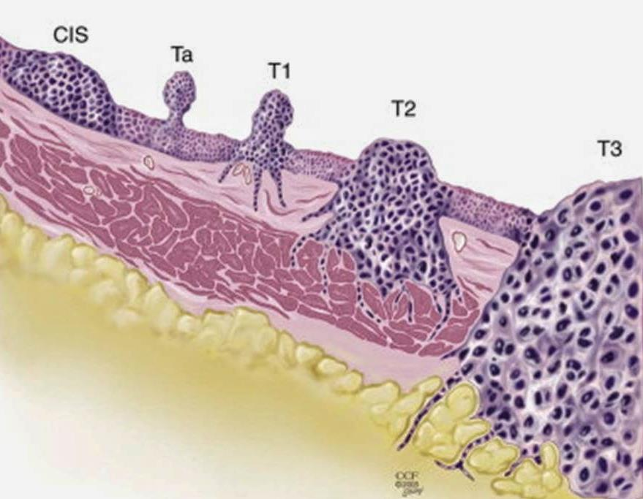

**Figure (1):** Histopathological classification of bladder cancer

***(Babjuk et al., 2021).***

**Table (1):** 2017 TNM classification of urinary bladder

cancer ***(Babjuk et al., 2021)***

|  |  |
| --- | --- |
| **T: Primary tumor** | |
| **Tx** | Primary tumor cannot be assessed |
| **T0** | No evidence of primary tumor |
| **Ta** | Noninvasive papillary carcinoma |
| **Tis** | Carcinoma in situ: "flat tumor" |
| **T1** | Tumor invades subepithelial connective tissue |
| **T2** | Tumor invades muscle |
| **T2a** | Tumor invades superficial muscle (inner half) |
| **T2b** | Tumor invades deep muscle (outer half) |
| **T3** | Tumor invades perivesical tissue |
| **T3a** | Microscopic invasion |
| **T3b** | Macroscopic invasion (extravesical mass) |
| **T4** | Tumor invades any of the following: prostate stroma, seminal vesicles, uterus, vagina, pelvic wall, abdominal wall |
| **T4a** | Tumor invades prostate stroma, seminal vesicles, uterus or vagina |
| **T4b** | Tumor invades pelvic wall or abdominal wall |
| **N: Regional lymph nodes** | |
| **N** | Regional lymph nodes cannot be assessed |
| **N0** | No regional lymph node metastasis |
| **N1** | Metastasis in a single lymph node in the true pelvis (hypogastric, obturator, external iliac, or presacral) |
| **N2** | Metastasis in multiple regional lymph nodes in the true pelvis (hypogastric, obturator, external iliac, or presacral |
| **N3** | Metastasis in common iliac lymph node(s) |
| **M: Distant metastasis** | |
| **M0** | No distant metastasis |
| **M1a** | nonregional lymph nodes |
| **M1b** | Other distant metastases |

Papillary tumors confined to the mucosa and invading the lamina propria are classified as stage Ta and T1, respectively (fig.1), according to the TNM classification system **(Brierley et al., 2017).**

Flat, high- grade tumors confined to the mucosa are classified as CIS (carcinoma in situ) (Tis) (fig. 2). All of these tumors are grouped under the heading of NMIBC (non-muscle invasive bladder cancer).

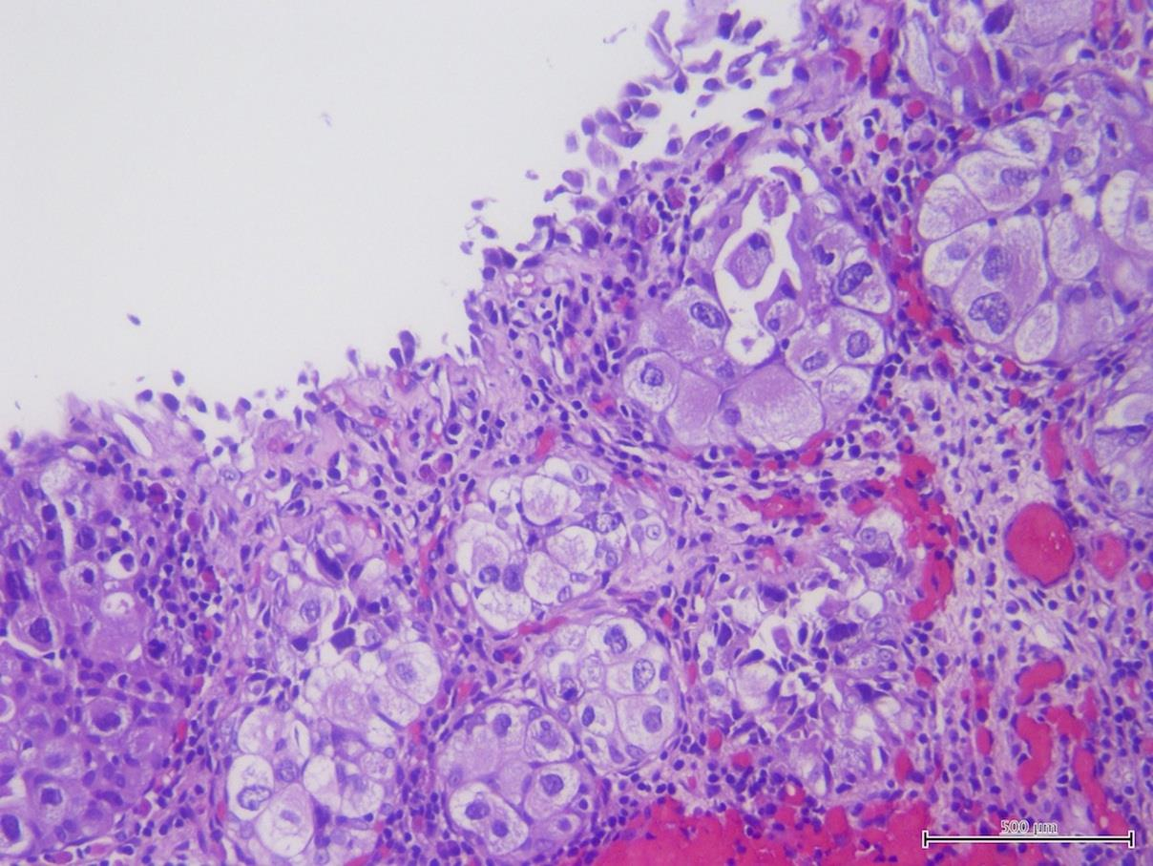

**Figure (2):** Carcinoma in situ ***(Magers et al., 2019).***

**CIS and its classification :**

CIS is a flat, high-grade, noninvasive urothelial carcinoma. It can be missed or misinterpreted as an inflammatory lesion during cystoscopy if not biopsied. CIS is often multifocal and can occur in the bladder, as well as the upper urinary tract (UUT), prostatic ducts, and prostatic urethra **(Babjuk et al., 2021).**

**CIS can be classified as follows :**

* ▪ Primary: isolated CIS with no previous or concurrent

papillary tumors and no previous CIS.

* ▪ Secondary: CIS detected during follow-up of patients

with a previous tumor that was not CIS.

* ▪ Concurrent: CIS in the presence of any other urothelial

tumor in the bladder.

**Histological grading of non–muscle-invasive bladder urothelial carcinomas**

WHO and the International Society of Urological Pathology (ISUP) in 2016 updated a histological classification of urothelial carcinomas that provides a different patient stratification between individual categories compared to the older 1973 WHO classification **(Moch et al., 2016)** (Tables 2 and 3). In 2016, an update of the 2004 WHO grading classification without major changes **(Moch et al., 2016).**

**Table (2):** WHO grading in 1973 and in 2004/2016 ***(Moch et al., 2016).***

|  |
| --- |
| **1973 WHO grading** |
| Grade 1: well differentiated  Grade 2: moderately differentiated  Grade 3: poorly differentiated |
| **2004/2016 WHO grading system (papillary lesions)** |
| Papillary urothelial neoplasm of low malignant potential (PUNLMP)  Low-grade (LG) papillary urothelial carcinoma  High-grade (HG) papillary urothelial carcinoma |

**Table (3):** WHO 2004 histological classification for flat lesions ***(Babjuk et al., 2020).***

|  |
| --- |
| **Non-malignant lesions** |
| * Urothelial proliferation of uncertain malignant potential (flat   lesion without atypia or papillary aspects   * Reactive atypia (flat lesion with atypia) * Atypia of unknown significance * Urothelial dysplasia |
| **Malignant lesion** |
| * Urothelial CIS is always high grade |

**Diagnosis of Cancer Bladder**

* ***Signs and Symptoms***

1. Gross painless hematuria is the most common finding in NMIBC. Visible hematuria was found to be associated with higher-stage disease compared to nonvisible (microscopic) hematuria **(Ramirez et al., 2016)**. CIS might be suspected in patients with lower urinary tract symptoms, especially irritative voiding.
2. Voiding symptoms although most people with bladder cancer do not have symptoms, some have voiding symptoms, such frequency or urgency during the day or night and/or urge-incontence **(Rais-Bahrami and Pietryga, 2016).**

* ***Imaging***

**Ultrasonography (U/S)** facilitates the characterization of renal masses, detection of hydronephrosis, and visualization of intraluminal bladder masses. While U/S can differentiate between fluid-filled cysts and solid tumors (Fig 3), it cannot ascertain the malignancy of a tumor **(Messina, Emanuele, et al. 2023).** Moreover, U/S is unable to exclude all potential causes of hematuria, does not reliably rule out the presence of upper tract urothelial carcinoma (UTUC), and therefore cannot substitute for CT urography.

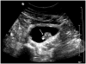

**Figure (3):** Urinary bladder mass in U/S ***(Salmanoglu et al., 2018).***

**Computed tomography** (CT) (of the abdomen and pelvis) urography is used to detect papillary tumors in the urinary tract as mass lesion enhanced with cotrast, as showen in (fig. 4) and/or hydronephrosis. The CT scan can show the extent of a cancer, and determine if the cancer has

spread outside the bladder **(Trinh et al., 2018).** The incidence of simultaneous upper tract urothelial carcinoma (UTUC) is low (1.8%), but increases to 7.5% for tumors located in the trigone **(Lee & Chang, 2018).**

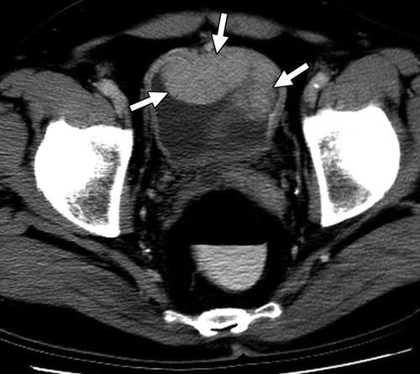

**Figure (4):** CT scan shows tumor as intraluminal enhancing mass

(arrows) ***(Vikram et al., 2009)***

**Magnetic resonance imaging (MRI)** of the kidney, ureters, and bladder (fig.5) may provide additional information in staging bladder cancer and can be used in people with allergies to contrast dye **(Rais-Bahrami and Pietryga 2016).**

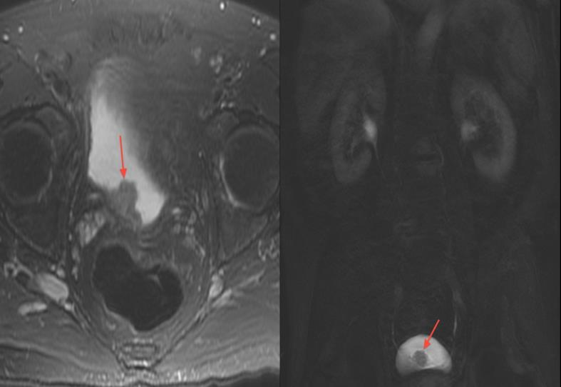

**Figure (5):** Bladder mass in MRI ***(Verma et al., 2012)***

* ***Urine Cytology***

Examination of voided urine or bladder-washing specimens for exfoliated cancer cells has high sensitivity in high-grade tumors (84%), but low sensitivity in low grade tumors (16%). The sensitivity for CIS detection is 28-100% **(Liem et al., 2018).**

Cytological interpretation is user-dependent. Evaluation can be hampered by low cellular yield, urinary tract infections, stones, or intravesical instillations; however, in- experienced hands the specificity exceeds 90% **(Goutas et al., 2021).**

* ***Urinary Molecular Marker Tests***

Numerous urinary tests have been developed as NMP22, Lewis X, FISH, CYFRA 21.1. None of these markers can replace cystoscopy in routine practice, but the knowledge of positive test results can improve the quality of follow-up cystoscopy **(Hu, Xinzi, et al., 2022).**

* ***Endoscopic Evaluation***

**White light cystoscopy (WLC)**

WLC is an endoscopic technique to visualize the urethra, bladder, and ureteric orifices. It is the gold standard for the examination and diagnosis of cancer of the lower urinary tract, using either flexible or rigid cystoscopy **(Babjuk et al., 2017).**

WLC has a sensitivity of 85–90% for detecting papillary tumors and lower sensitivity (up to 67%) to detect CIS **(Daneshmand et al., 2018).**

* *Advantages of semi-rigid WLC:-*

WLC has the advantage of being widely available and has lower cost than all the newer endoscopic techniques.

* *Disadvantages of semi-rigid WLC:-*

WLC has lower sensitivity to detect flat and CIS lesions, has limited ability to differentiate benign from malignant lesions, and is operator dependent **(Tschirdewahn et al., 2020).**

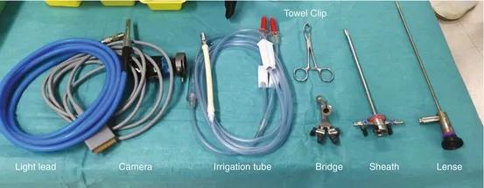

**Figure (6):** Instruments of semi-rigid cystoscopy ***(Ku, 2019).***

**Flexible Cystoscopy**

Flexible cystoscopy is often performed for initial diagnosis and surveillance.

* *Disadvantages of Flexible Cystoscopy:-*

It can miss up to 10% of papillary tumors when compared to rigid cystoscopy **(Daneshmand et al., 2018).** The diagnostic yield of endoscopic removal of the tumor using flexible cystoscopy is limited, which can potentially compromise grading and staging of the tumor **(Bourlotos, Georgia, et al., 2024).**

* *Advantages of Flexible Cystoscopy:-*

While flexible cystoscopy is more comfortable and convenient for the patient, and has higher cost than semirigid cystoscopy.

Flexible cystoscopy thus can be used in the primary evaluation or surveillance of BC patients, and (Transurethral resection of bladder tumor) (TURBT) can be then conducted using rigid cystoscopy when needed **(Tschirdewahn et al., 2020).**

**Fluorescent Cystoscopy (FC)**

FC, also known (photodynamic diagnosis) PDD, is a modification of WLC where an intravesical agent is instilled, and blue light (375-440 nm) is used for visualization. The instilled agents are photoactive porphyrin analogs, such as a 5-aminolevulinic acid (5-ALA) and hexaminolevulinate, which are taken up by epithelial cells and used in the formation of intermediate photoactive porphyrins. Intermediate porphyrins accumulate preferentially in neoplastic cells because of the accelerated enzymatic activity, and after excitation with blue light will return to lower energy levels and fluoresce. Tumor tissues will thus appear as well demarcated bright red lesions against a dark blue background (Fig. 7) **(Soubra & Risk, 2015).**

PDD was found to have higher sensitivity 92% than WLC 71%, but lower specificity 57% vs. 72% **(Ascione, Claudia Maria, et al.2023).**PDD has a higher sensitivity for CIS 92.4% compared to WLC 60.5% **(Lai, Lillian Y., et al. 2022)** and 10% more T1 20lesions detected by PDD compared to WLC. No difference was detected for MIBC **(Veeratterapillay, Rajan, et al. 2021).**

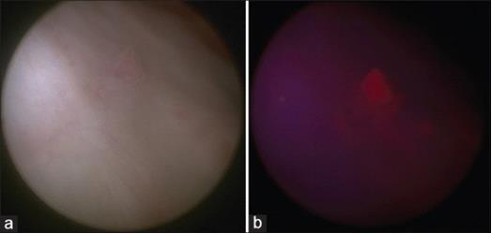

**Figure (7):** (a) White light cystoscopic image of a small bladder tumor. (b)Blue light cystoscopic image of the same small bladder tumor **(Soubra & Risk, 2015).**

**Narrow Band Imaging (Figure 8)**

NBI is another modification to conventional WLC, where discrete blue (415 nm) and green (540 nm) light bands are used instead of the entire visible light spectrum **(Lee et al., 2021).**

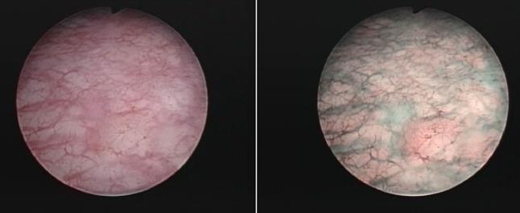

**Figure (8):** Carcinoma in situ lesion missed during standard cystoscopy and only visible in narrow-band imaging **(Geavlete et al., 2012).**

**Confocal Laser Endomicroscopy (CLE) (Figure 9)**

Confocal laser endomicroscopy (CLE) employs optical biopsy and high-resolution in vivo subsurface imaging to visualize tissue microarchitecture and cellular features. It utilizes a 488 nm laser as the light source and employs fluorescein as an exogenous contrast agent, which may be administered either intravenously or intravesically **(Shkolyar et al., 2019).**

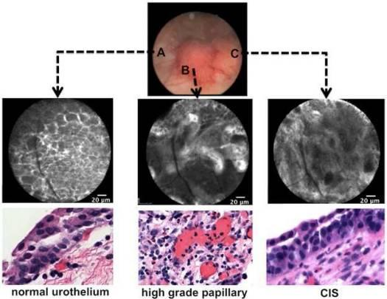

**Figure (9):** Intraoperative image guidance of a tumor seen under white light with corresponding confocal imaging and histology. A) Normal urothelium. B) High-grade, papillary tumor. C) CIS **(Chen and Liao, 2014)**

**Optical Coherence Tomography (OCT) (Figure 10)**

Optical coherence tomography (OCT) serves as an optical analogue to ultrasound, facilitating cross-sectional tissue imaging. Unlike ultrasound, which employs sound waves, OCT utilizes infrared light and achieves a resolution that is approximately ten times higher **(Xiong et al., 2019).**

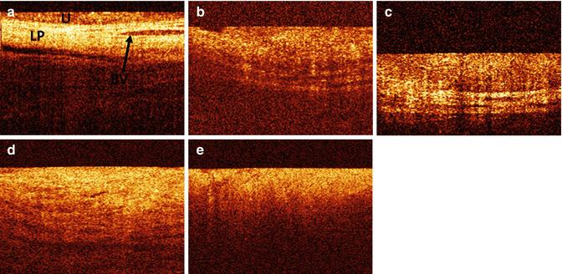

**Figure (10):** OCT bladder pathology. (a) Normal bladder lining (b) Carcinoma in situ (CIS), (c) Ta carcinoma of the bladder (d) T1 carcinoma of the bladder. (e) T2 carcinoma of the bladder **(Bus et al., 2014).**

* ***Management of Non-muscle Invasive Bladder Cancer***

*Counselling on smoking cessation:-*

Smoking increases the risk of tumor recurrence and progression **(Zheng, Rui, et al. 2023).** Although the impact of smoking cessation on bladder cancer treatment outcomes remains contentious, patients should be counseled to quit smoking due to the well-established health risks associated with tobacco use **(Ma, Wenchao, et al. 2021).**

1. **Transurethral resection of Ta/T1 bladder tumors:**

The goal of TURBT in Ta/T1 BC is to make the correct diagnosis and completely remove all visible lesions.

TURBT should be performed systematically in individual steps **(Suarez‐Ibarrola et al., 2019).** A complete resection of the urinary bladder tumors, is essential to achieve good prognosis **(Teoh et al., 2020).**

**Bladder biopsies**

CIS can present as a velvet-like, reddish area that is indistinguishable from inflammation, or it may not be visible at all. For this reason, biopsies from :

1. Suspicious urothelium should be taken.
2. For patients with positive urine cytology.

1. With a history of HG (G3) NMIBC.
2. Tumors with a non-papillary appearance, mapping biopsies from normal-looking mucosa are recommended **(Babjuk et al., 2021).**

**Prostatic Urethral biopsies**

Involvement of the prostatic urethra and ducts in men with NMIBC has been reported **(Gravas, Stavros, et al. 2023).** The risk of prostatic urethra or duct involvement is higher if the:-

1. Tumor is located at the trigone or bladder neck.
2. Presence of bladder CIS, and in cases with
3. Multiple tumors.

On the basis of this observation, a biopsy from the prostatic urethra is necessary in some patients **(Brant et al., 2019).**

1. **Adjuvant Treatment**

Although TURBT by itself can eradicate a Ta/T1 tumor completely, these tumors commonly recur and can progress to MIBC. It is therefore necessary to consider adjuvant therapy for these patients **(Babjuk et al., 2019).**

* ***Immediate Intravesical Chemotherapy***

A single, immediate, postoperative intravesical instillation of chemotherapy.

It has been shown that immediate single instillation (SI) acts by destroying circulating/floating tumor cells after TURBT, as well as via an ablative effect on residual tumor cells at the resection site and on small overlooked tumors **(Girouard et al., 2020).**

Four large meta-analyses have consistently shown that after TURBT, SI significantly reduces the recurrence rate compared to TURBT alone. In a systematic review and meta-analysis, SI reduced the 5-yr recurrence rate by 14% **(Powles, Thomas, et al. 2022).**

SIs with mitomycin C (MMC), epirubicin, or pirarubicin have all shown a beneficial effect **(Powles, Thomas, et al. 2022).** SI with emcitabine was superior to a placebo control (saline) with remarkably low toxicity rates. The efficacy of continuous saline irrigation in the prevention of early recurrences has also been suggested. Prevention of tumor cell implantation should be initiated within the first few hours after TURBT **(Roos et al., 2019).**

* ***Additional Adjuvant Intravesical Immunotherapy and/or Chemotherapy Instillations***

The need for further adjuvant intravesical therapy depends on prognosis. For patients with low-risk tumors, It reduces the risk of recurrence and is considered to be the standard and complete treatment **(Powles, Thomas, et al. 2022).**

For other patients, however, SIs remains an incomplete treatment because of the considerable likelihood of recurrence and/or progression. Treatment recommendations in Ta, T1 tumors and carcinoma in situ according to risk stratification as in table (4) **(Babjuk et al., 2019).**

**Table (4):** Treatment recommendations in Ta, T1 tumors and carcinoma in situ according to risk stratification **(Babjuk et al., 2019)**

|  |  |  |
| --- | --- | --- |
| Risk category | Definition | Treatment recommendation |
| Low-risk tumors | Primary, solitary, TaG1 (PUNLMP, LG), < 3 cm, no CIS. | One immediate instillation of intravesical chemotherapy after TURBT |
| Intermediate-risk tumors | All tumors not defined in the two adjacent categories (between the category of low and high risk) | In patients with previous low recurrence rate (less than or equal to one recurrence per year) and expected EORTC recurrence score <5. one immediate instillation of intravesical chemotherapy after TURBT. In all patients either one-year full-dose BCG treatment (induction plus 3weekly instillations at 3, 6 and 12 months), or instillations of chemotherapy (the optimal schedule is not known) for a maximum of one year. |
| High-risk tumors | Any of the following: T1 tumors; G3 tumor; CIS; Multiple, recurrent and large (>3 cm) TaG1G2 tumors (all features must be present). | Intravesical full-dose BCG instillations for one to three years or radical cystectomy (in highest-risk tumors - see below) |
| Subgroup of highest-risk tumors | |
| T1G3 associated with concurrent bladder CIS, multiple and/or large T1G3/ and/or recurrent T1G3, T1G3 with CIS in the prostatic urethra,some forms of variant histology of urothelial carcinoma, LVI. | Radical cystectomy should be considered. In those who refuse or are unfit for RC intravesical full-dose BCG instillations for one to three years |

**Intravesical BCG immunotherapy (discussed in next chapter)**

**Intravesical chemotherapeutic agents**

***Types of chemotherapeutic agents used intravesically***

Many chemotherapeutic agents are used for induction and maintenance intravesical therapy.

1. **Thiotepa** is a nonspecific alkylating agent and was the first drug approved by the US Food and Drug Administration (FDA) at 1959 as intravesical therapy for NMIBC. Thiotepa is absorbed through the bladder mucosa and causes myelosuppression.

Its side effect are dose dependent. In a meta-analysis, patients who received thiotepa had a lower risk of bladder cancer recurrence than those who received only TURBT, but the difference was not significant, and the risks of progression and mortality also showed no differences **(Propper, David J., 2022).**

1. **MMC** is another alkylating agent but is rarely absorbed by the bladder mucosa and thus shows a lower risk of systemic side effects than thiotepa. MMC is the most widely used intravesical chemotherapeutic agent. MMC instillation has been reported to decrease the risk of recurrence in comparison with TURBT alone.

Both single instillation and maintenance therapy are effective. The effect on bladder cancer progression is significant **(Propper, David J., 2022).**

1. **Doxorubicin** is an anthracycline drug, with a high molecular weight. It is also rarely absorbed by the bladder mucosa; thus systemic side effects are not common. Intravesical instillation of doxorubicin has been shown to reduce the risk of recurrence but does not significantly reduce the risks of progression and mortality **(Ku ,2019).**
2. **Epirubicin** is another type of anthracycline drug; it is more effective and has fewer side effects than doxorubicin. Patients receiving epirubicin in addition to TURBT reportedly have a reduced risk of recurrence in comparison with TURBT alone **(Propper, David J., 2022).**
3. **Gemcitabine** is a nucleoside analog. Current evidence suggests that a single dose of gemcitabine is not as effective as multiple doses. The recurrence and progression rates have been reported to be lower with gemcitabine than with MMC **(Bazargan, Sarah, et al. 2023).**

* **Prognosis**

The cancer-specific survival in high-grade NMIBC is approximately 70-85% at 10 years. Low-grade Ta lesions demonstrates a progression rate of approximately 6%, whereas high-grade T1 lesions have an increased chance of progression of approximately 17% **(Flores Monar, Gabriela Vanessa, et al. 2023).**

**Table (5):** Probability of disease progression at 1, 5, and 10 yr for the new European Association of Urology non muscle-invasive bladder cancer risk groups **(Sylvester et al., 2021)**

|  |  |  |  |
| --- | --- | --- | --- |
| **New risk**  **groups** | **Probability of progression.%**  **(95% confidence interval)** | | |
| **1 yr** | **5 yr** | **10 yr** |
| **With WHO 2004/2016** | | | |
| Low | 006 (001-043) | 0.93 (049-1.7) | 3.7 (23-5.9) |
| Intermediate | 10 (0.50-2.0) | 4.9 (3.4-7.0) | 8.5 (5.6-13) |
| High | 3.5 (2.4-5.2) | 9.6 (7.4-12) | 14 (11-18) |
| Very high | 16 (10-26) | 40 (29-54) | 53 (36-73) |
| **With WHO 1973** | | | |
| Low | 0.12 (0.02-0.82) | 0.57 (0.21-1.5) | 3.0 (1.5-6.3) |
| Intermediate | 0.65 (0.36-1.2) | 3.6 (2.7-4.9) | 7.4 (5.5-10) |
| High | 3.8 (2.6-5.7) | 11 (8.1-14) | 14 (10-19) |
| Very high | 20 (12-32) | 44 (30-61) | 59 (39-79) |

**Table (6 a, b and c):** Probability of disease recurrence and progression at 1, 5 year, according to EORTC 2006 **(Sylvester et al., 2006)**

**Table (6 . a)**:

|  |  |  |
| --- | --- | --- |
| **Factor** | **Recurrence** | **Progression** |
| **Number of tumor** | | |
| Single | 0 | 0 |
| 2-7 | 3 | 3 |
| =8 | 6 | 3 |
| **Tumor diameter** | | |
| <3cm | 0 | 0 |
| 23 | 3 | 3 |
| **Prior recurrence rate** | | |
| Primary | 0 | 0 |
| < recurrence/year | 2 | 2 |
| > recurrence/year | 4 | 2 |
| **Category** | | |
| Ta | 0 | 0 |
| Tl | 1 | 4 |
| **Concurrent CIS**  No  0  0  Yse  1  6  Grade  G1  0  0  G2  1  0  G3  2  5  Total score  0-17  0-23 | | |
| No | 0 | 0 |
| Yes | 1 | 6 |
| Grade |  |  |
| G1 | 0 | 0 |
| G2 | 1 | 0 |
| G3 | 2 | 5 |
| Total Score | 0-17 | 0-23 |

|  |  |  |  |  |
| --- | --- | --- | --- | --- |
| Recurrence  score | **Probability of**  **recurrence at 1 year** | | **Probability of**  **recurrence at 5 years** | |
| % | **(95% CI)** | % | **(95% CI)** |
| 0 | 15 | (10-19) | 31 | (24-37) |
| 1-4 | 24 | (21-26) | 46 | (42-49) |
| 5-9 | 38 | (35-41) | 62 | (58-65) |
| 10-17 | 61 | (55-67) | 78 | (73-84) |

**Table (6 . b)**:

**Table (6 . c)**:

|  |  |  |  |  |
| --- | --- | --- | --- | --- |
| Progression  score | **Probability of**  **Progression at 1 year** | | **Probability of**  **Progression at 5 years** | |
| % | **(95% CI)** | % | **(95% CI)** |
| 0 | 0.2 | (0-0.7) | 0.8 | (0-1.7) |
| 2-6 | 1 | (0.4-1.6) | 6 | (5-8) |
| 7-13 | 5 | (4-7) | 17 | (14-20) |
| 14-23 | 17 | (10-24) | 45 | (35-55) |