**Electronics Students and Staff Association**

**Session: 2019-20**

**Activity Report**

**1.Title:** Guest lecture on AI Applications

**Date:** 11 July 2019

**Time:** 11 am to 12 pm

**Venue:** C2 class room

**Total Students:** 59 students

**Resource Person:** Mr. Sanjay Mishra, Tech Mahindra, USA

**Activity Outcome :** After Completion of this activity students will be able to learn about various AI Applications.

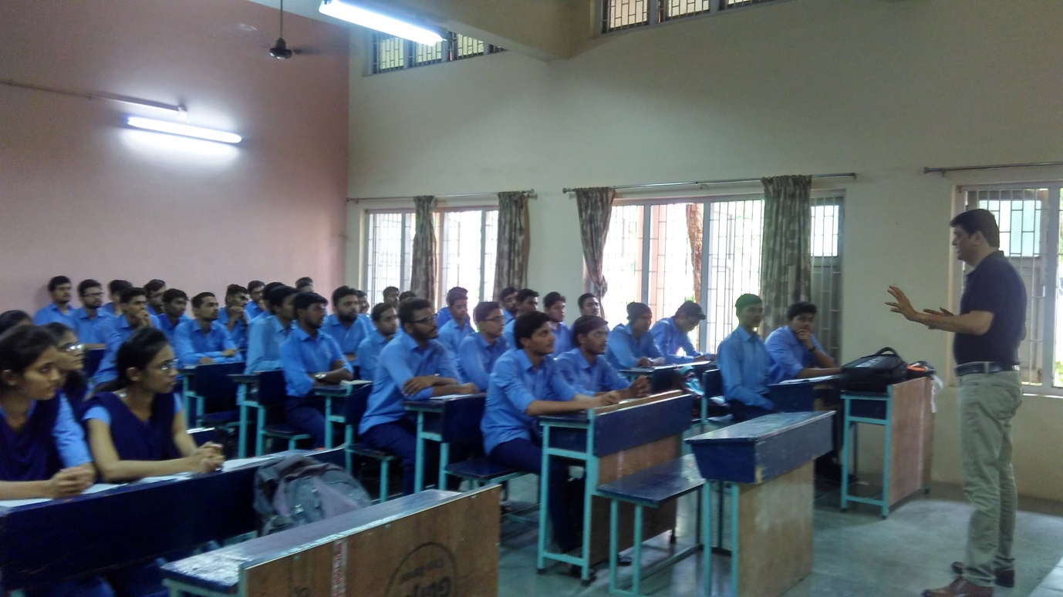

**2.Title:** Electro – Ethix workshop

**Date:** 4 and 5 October 2019

**Time:** 11 am to 5 pm

**Venue:** Old Auditorium

**Total Students:** 69

**Resource Person:** Ritanshu Khatke, Sherya Pole, Rushikesh Balapure, Mohit Vyas

**Activity Outcome :** After Completion of this activity students will be able to simulate small projects.

3. **Title:** Roboignitors

**Date:** 25 and 26 January 2019

**Time:** 2 pm Onwards

**Venue:** EXTC Department

**Total Students:** 67 students

**Resource Person:** ESSA chair

**Activity Outcome :** After Completion of this activity students will be able to design small robotics circuits.

