**Electronics Students and Staff Association**

**Session: 2021-22**

**Activity Report**

**1.Title:** Webinar on placement awareness

**Date:** 2 October 2021

**Time:** 1 pm to 3 pm

**Venue:** Online Platform : MS Teams

**Total Students:** 120 students

**Resource Person:** Mr.Mohit Vyas, Mr. Shreyas Pole, Mr. Manish Tinkhede and Ms. Harshada Babar

**Activity Outcome :** After Completion of this activity students will be able to learn resume writing and differentiate between types of interview process



**2.Title:** Orientation Program For First Year

**Date:** 30 December 2021

**Time:** 11 am to 5 pm

**Venue:** EXTC Seminar HAll

**Total Students:** 95 students

**Resource Person:** Prof. D. L. Bhombe, Prof. A. N. Dolas, Prof. K. T. Kahar, Prof. V. K. Bhangadiya and Dr. P. R. wankhede

**Activity Outcome :** After Completion of this activity students will be able to differentiate between various applications of Electronics.

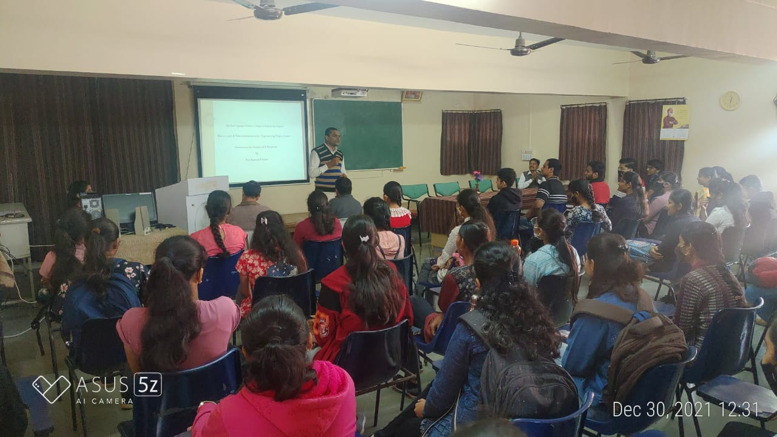

**3.Title:** Webinar on Job Avenues in Electronics and Telecommunication Engineering

**Date:** 8 January 2022

**Time:** 9.30 am to 11.30 am

**Venue:** EXTC Seminar HAll

**Total Students:** 95 students

**Resource Person:** Pramod Chopade, General Manager and Regional Lead- South, Reliance Jio, Mumbai

**Activity Outcome :** After Completion of this activity students will be able to learn about job opportunities in Electronics sector and required Skill set.

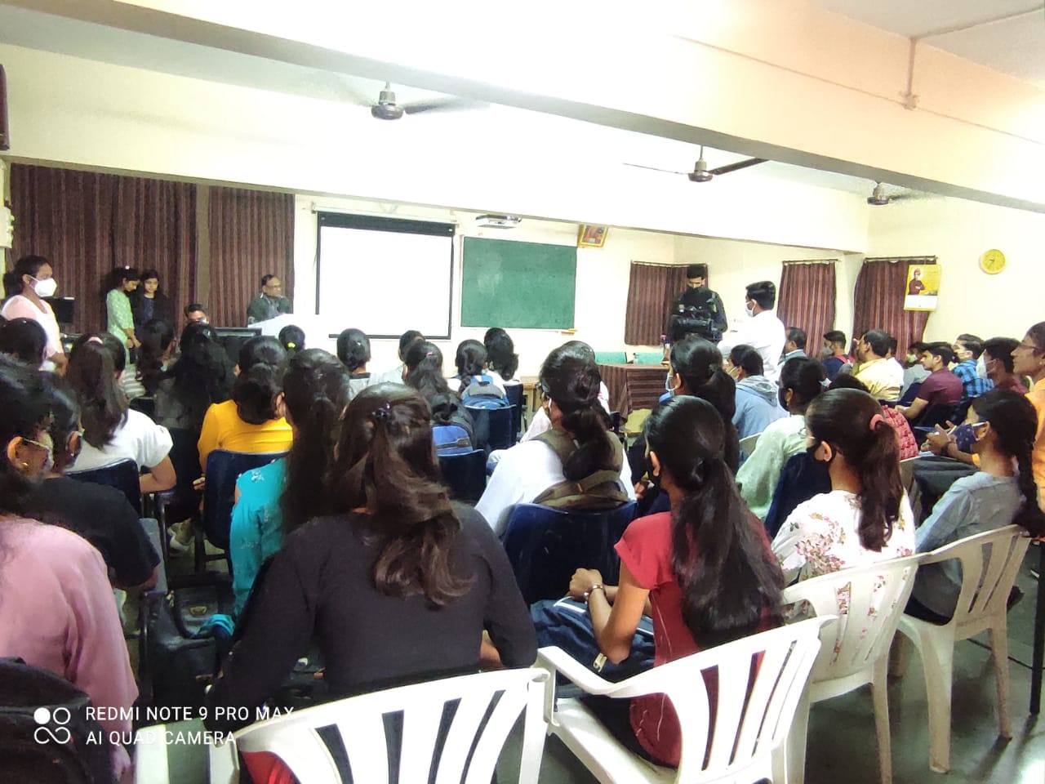

**4.Title:** Workshop on Chasing Calsi

**Date:** 9 January 2022

**Time:** 11 am to 5 pm

**Venue:** Old Auditorium

**Total Students:** 180

**Resource Person:** Dr. Pravin Wankhede

**Activity Outcome :** After Completion of this activity students will be able to use calculator effectively.

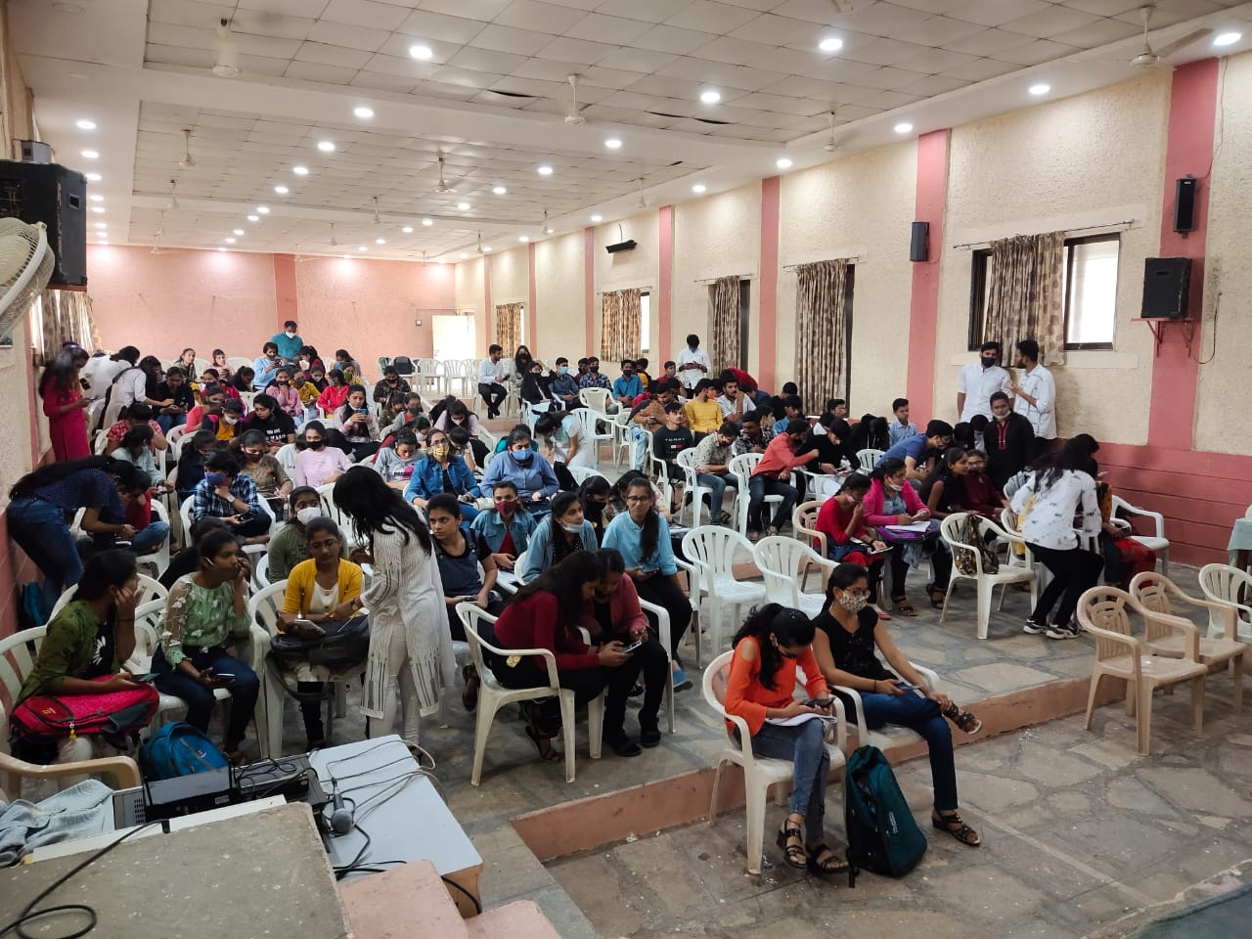

5. **Title:** “Electro-Metro” - Skill development Workshop on Basic Electronics and Mini project

**Date:** 11/03/2022 to 13/03/2022

**Time:** 11 am to 6 pm (Day 1), 10 am to 5 pm (Day 2 and Day 3)

**Venue:** EXTC Department

**Total Students:** 44 groups (167 students)

**Resource Person:** Mrs. K. S. Vyas, Mr. Sanjay Satal, Mr. Saleem Ahmed, Mr. Bhushan Hazare

**Activity Outcome :** After Completion of this activity students will be able to design and develop small project.

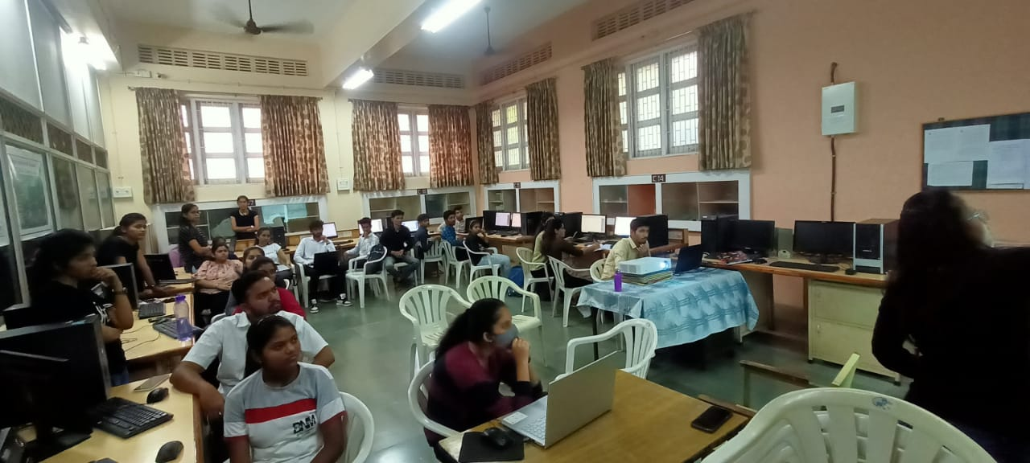

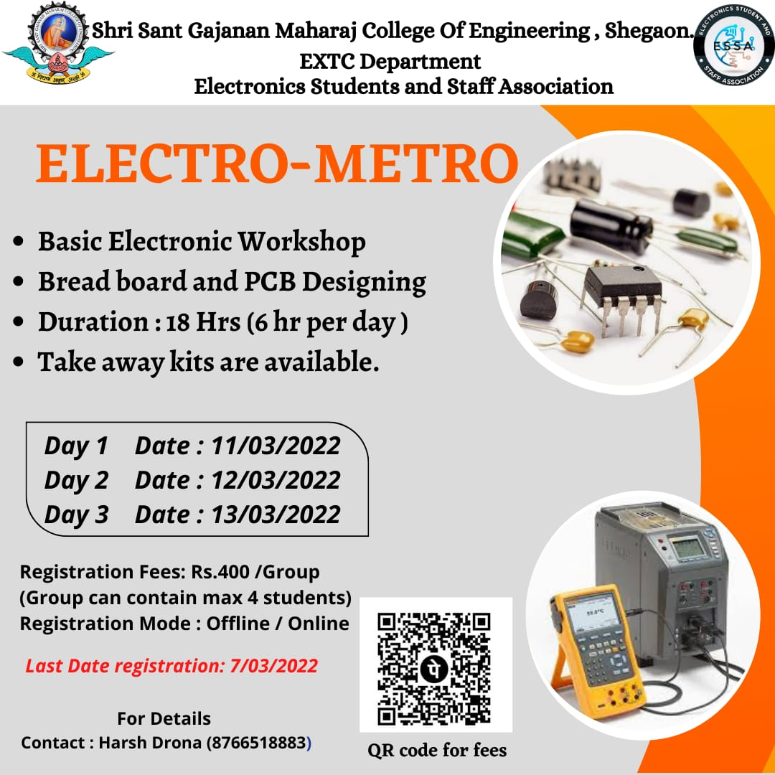

**6.Title:** Event “Troll by Tronics”

**Date:** 25-26 March 2022

**Time:** 11 am to 5 pm

**Venue:** C2 Class room, EXTC Department

**Total Students:** 19 Teams/Individual

**Conducting Committee :** ESSA

**Activity Outcome :** After Completion of this activity students will be motivated to participate in events and competitions

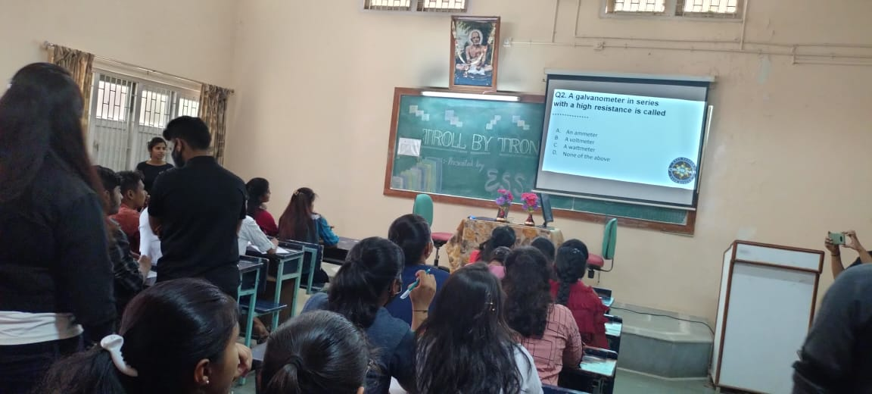

7. **Title:** Workshop on Multisim and PCB design

**Date:** 25-26 March 2022

**Time:** 4.30 pm to 6.30 pm (Day 1) and 2 pm to 4 pm (Day 2)

**Venue:** DSP Lab, EXTC Department

**Total Students:** 24 Students

**Resource Person:** Lokesh Hiwarkar, Shwetatai Bhagat, Bhushan Hazare

**Activity Outcome :** After Completion of this activity students will be able to simulate small projects.

