**Department of Electronics and Telecommunication Engineering**

**Electronics Students and Staff Association**

**Report**

Date: 16 May 2023

**Event 1:**

“Workshop on Secret of Canva”

Date: 10th December 2023

Attendees: 32

Venue: DSP Lab EXTC department

Event Description: Mr Prathmesh Gattani and Miss Mrunal Patil explained about various aspects of Canva. The points covered were ,”What is canva”, “what are the inclusive features for editing”, “how to edit photos”, “how to add background text and music”, “how to add make business card, invitation card, posters ” etc. The workshop was very successful and excellent feedback was received by Team ESSA.

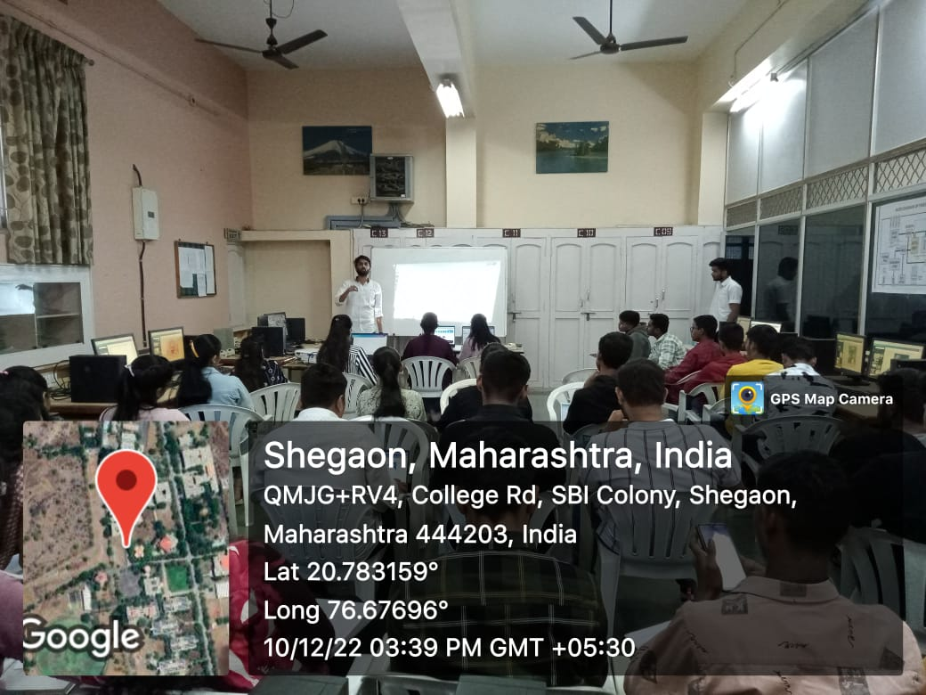

**Event 2:**

Workshop on : “Hello to Embedded System”

Date: 7th and 8th April 2023

Attendees: 42

Venue: DSP Lab EXTC department

Event Description: Miss Smruti Gangane introduced the basics of embedded systems. Mr Prathmesh Gattani took the hands on session on keil and proteus software. Mini project were also made by the attendees at the end of workshop. The workshop was very interactive and informative.

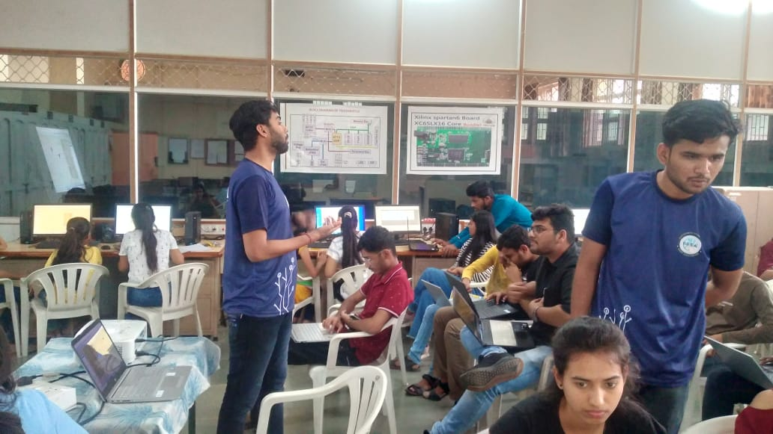

**Event 3:**

“Battle of Electronics”

Date: 7th and 8th April 2023

Attendees: 44

Venue: C2 Classroom, EXTC department

Event Description: The event consisted of three rounds: buzzer round, word wipe and circuit construction. In buzzer round students participated in groups of two and the task was to guess the correct names of images shown. In word wipe the teams had to correct the spellings of jumbled word shown. In round three, teams had to design and run the circuits from the electronic components given.

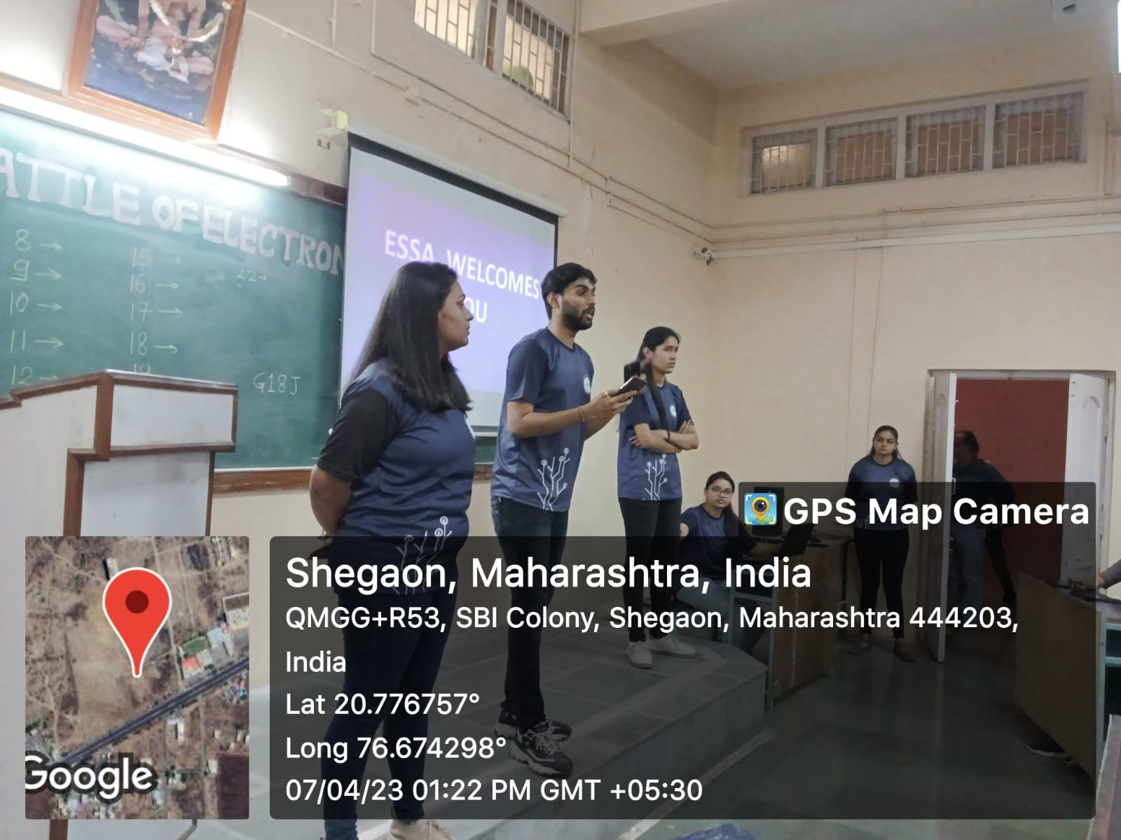

**Proud Moment:**

Team ESSA was awarded as the best Performer in Pursuit 2023.

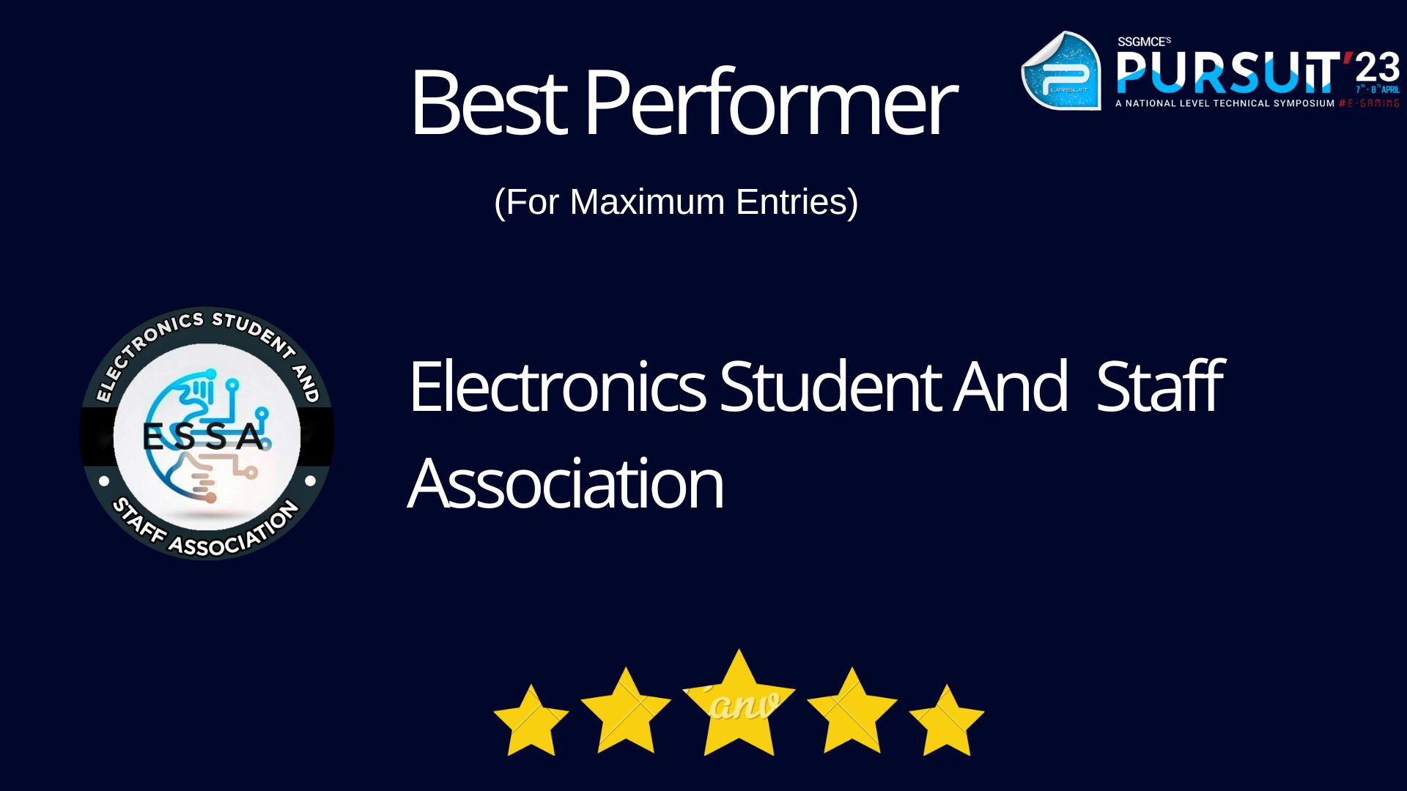

Mrs K. S. Vyas Dr. M. N. Tibdewal

Faculty Advisor, ESSA HOD, EXTC