**Electronics Students and Staff Association**

**Session: 2023-24**

**Activity Report**

**1.Title: Secret of Canva**

**Date:** Sunday 8th October, 2023

**Time:** 9am to 12pm

**Venue:** DSP Lab

**Total Students:** 28 Students

**Resource Person:** Prasad Deshmukh, Niharika Dagaonkar, Shreya Dharmale

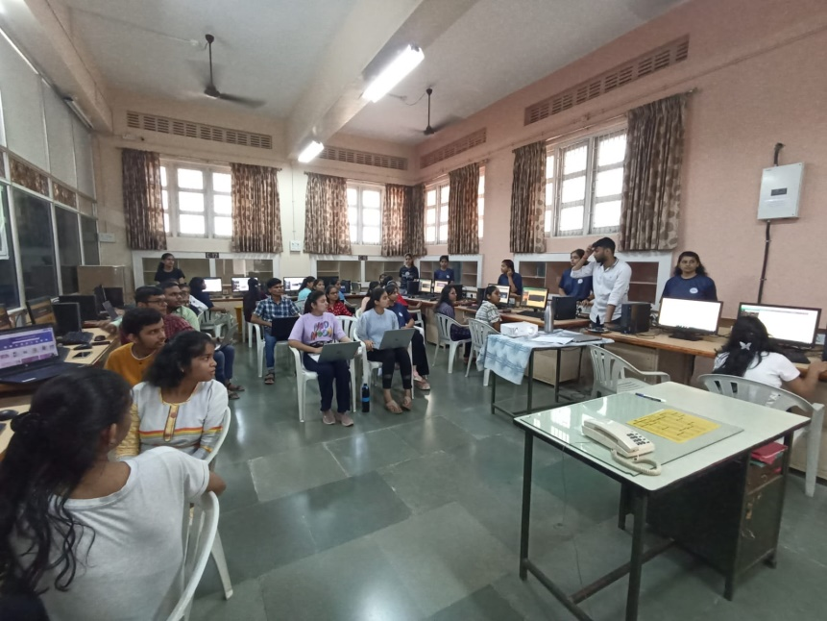

**2.Title: Arduino Mastery**

**Date:** 13th & 14th March,2024

**Time:** 4pm to 8pm

**Venue:** Old Auditorium

**Total Students:** 95 Students

**Resource Person:** Prof. Mangesh Bharati and Team

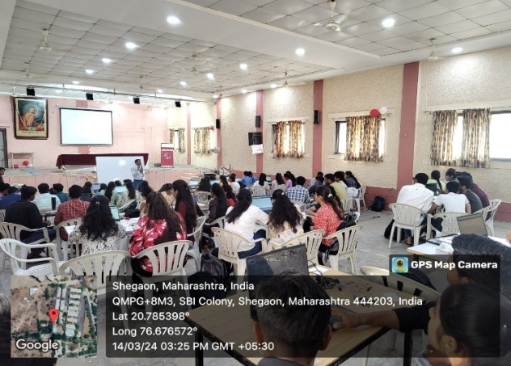

**3.Title: Electrofiesta**

**Date:** 15th & 16th March, 2024

**Time:** 4pm to 6pm,1pm to 3pm.

**Venue:** EXTC Department, Class C2.

**Total Students:** 20 Students

**Resource Person:** Mansi Agrawal, Prasad Deshmukh , Niharika Dagaonkar.

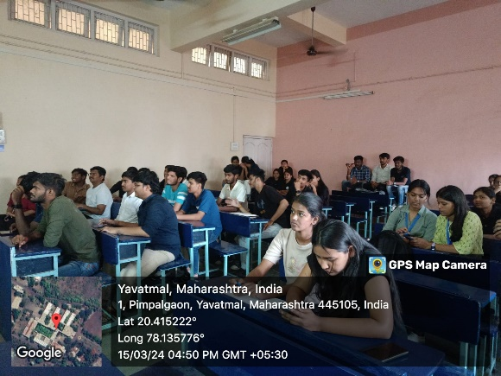

**4.Title: First Year Orientation**

**Date:** 25 August 2023

**Time:** 11 am to 5 pm

**Venue:** EXTC Seminar Hall

**Total Students:** 80 Students

**Resource Person:** Dr. M. N. Tibdewal, Mrs. K. S. Vyas, Mr. S. P. Badar, Mr. S. G. Nemane

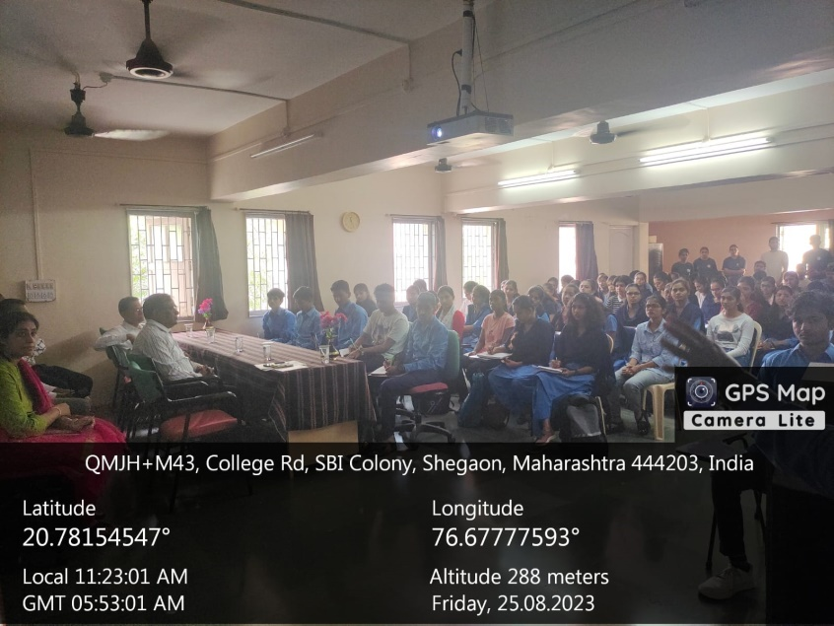

5. **Title: Aerobics Training**

**Date:** 23 January 2024

**Time:** 4-8 pm

**Venue:** Chinchili

**Total Students:** 54 Students

**Resource Person:** Bhumika Deshmukh

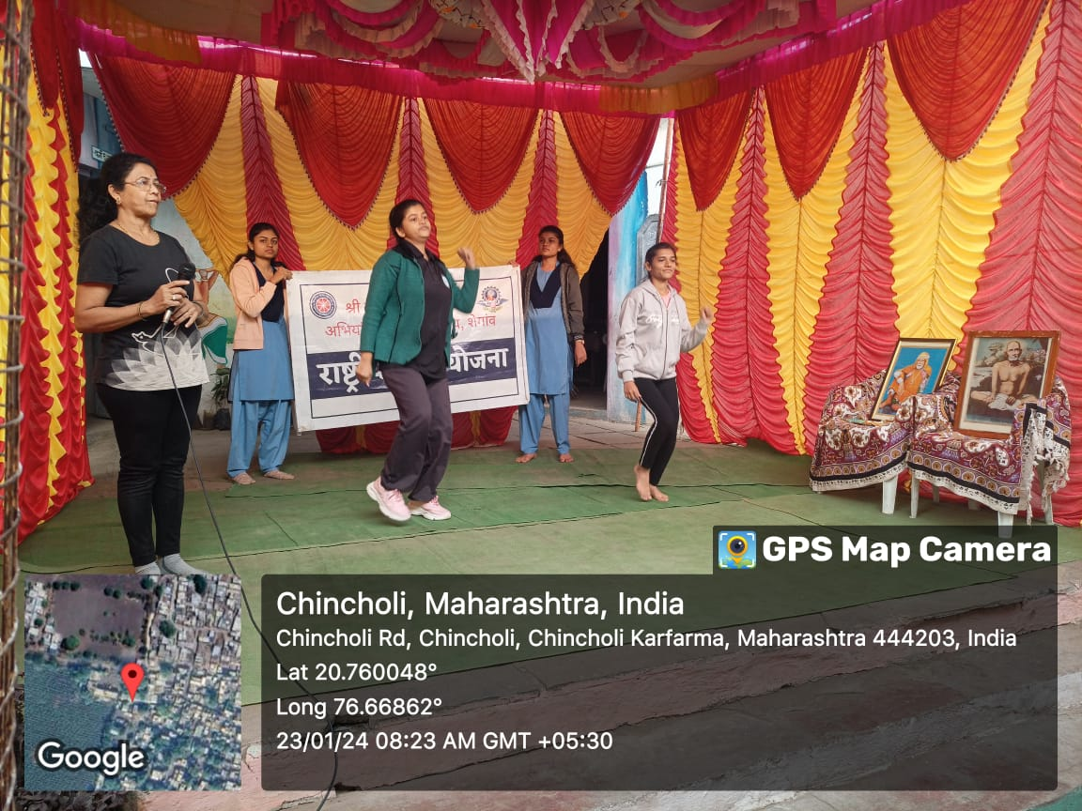

**Proud Moment:**

Team ESSA was awarded as the …………………….. in Pursuit 2024.