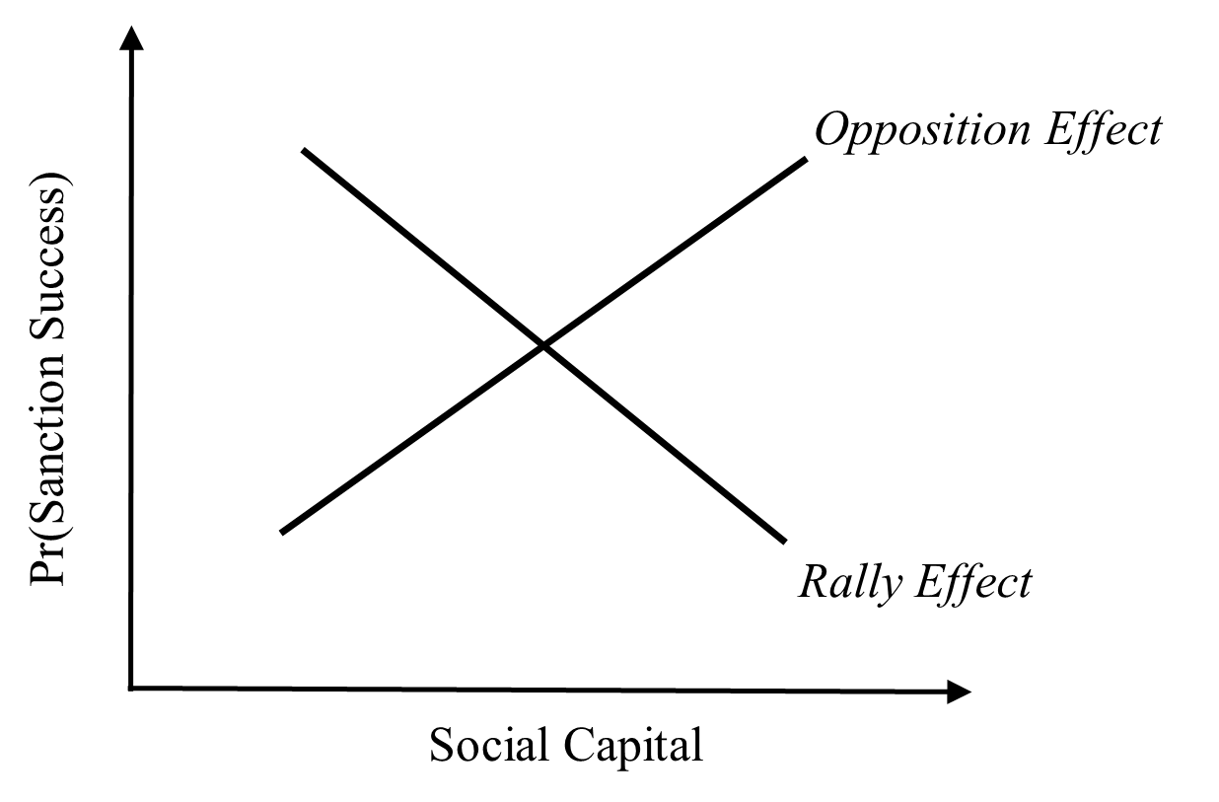

**Figure 1.** Offsetting effects of social capital on the likelihood sanctions are successful.

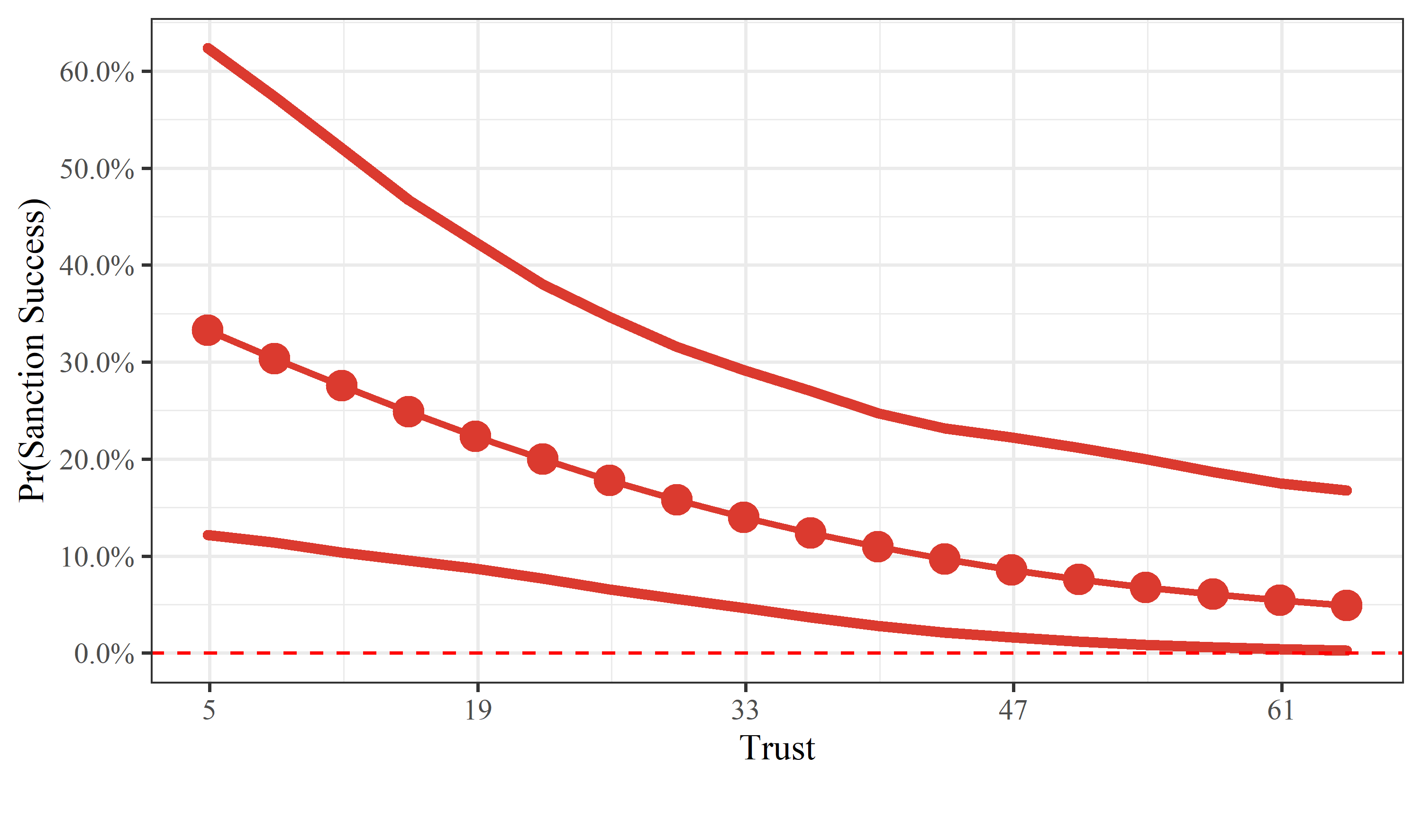

**Figure 2**. Predicted probability of successful sanctions as a function of *Trust*.

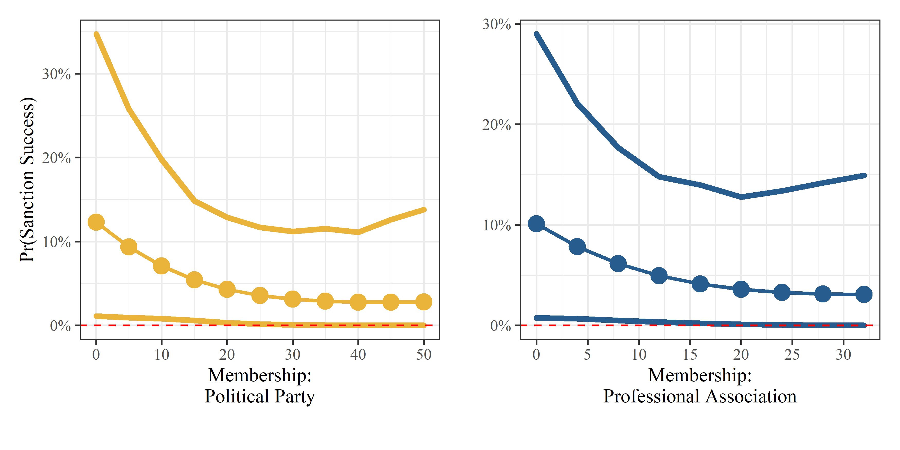

**Figure 3**. Predicted probability of successful sanctions as a function of *Membership: Political party and Professional association.*

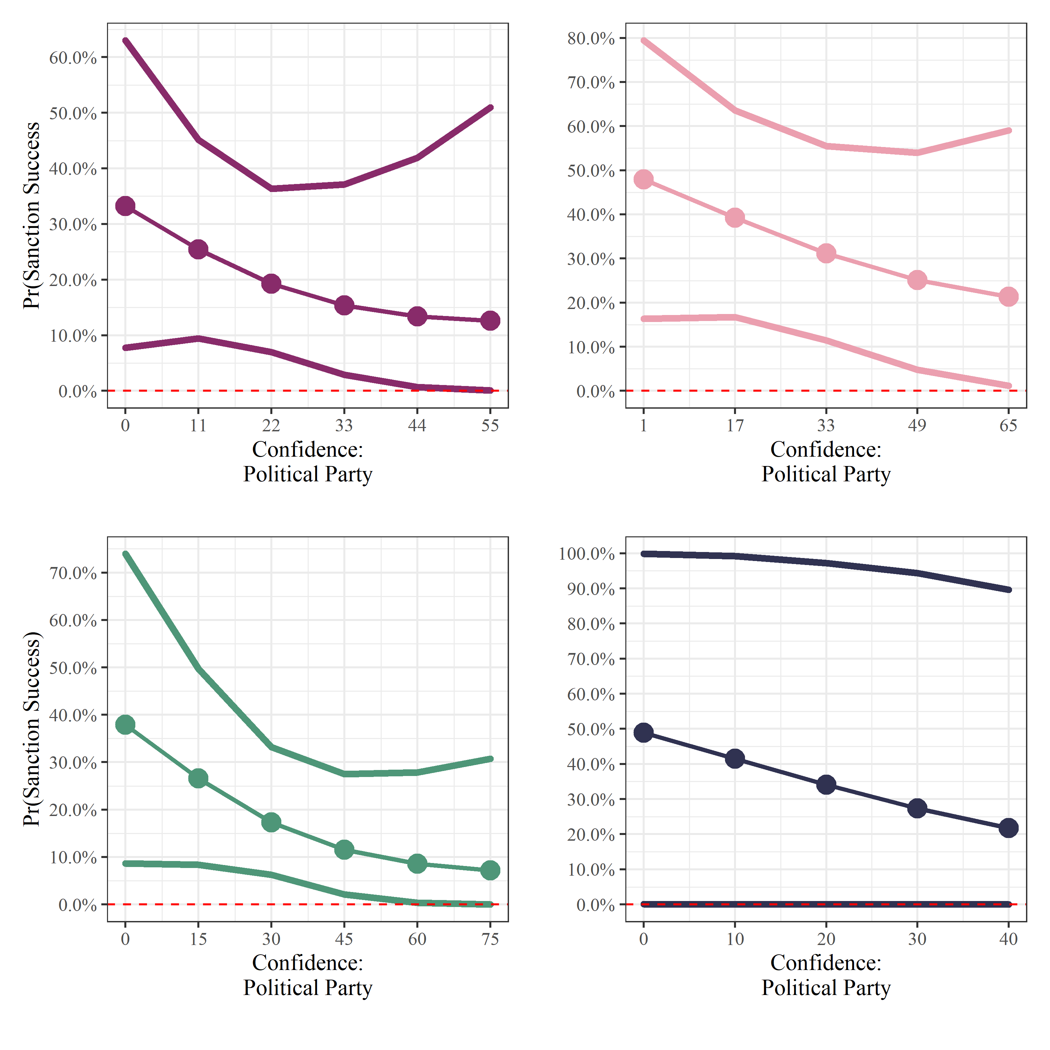

**Figure 4.** Predicted probability of successful sanctions as a function of confidence: *Professional party, government, parliaments,* and *courts.*