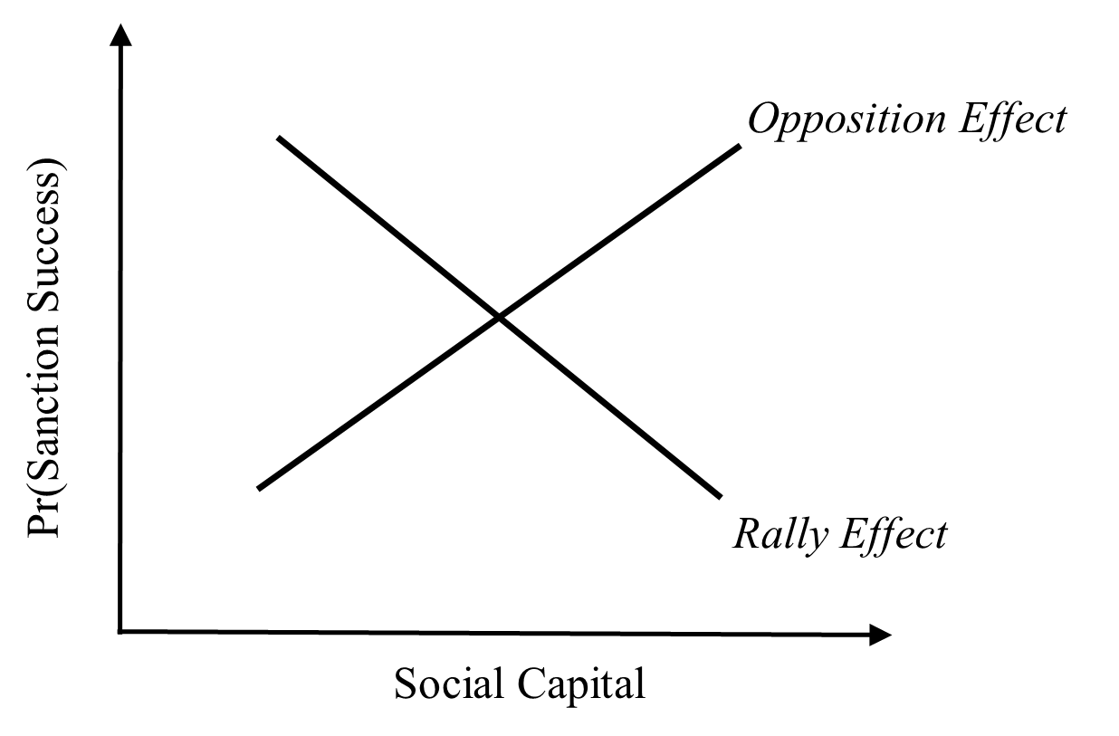

**Figure 1.** Offsetting effects of social capital on the likelihood sanctions are successful.

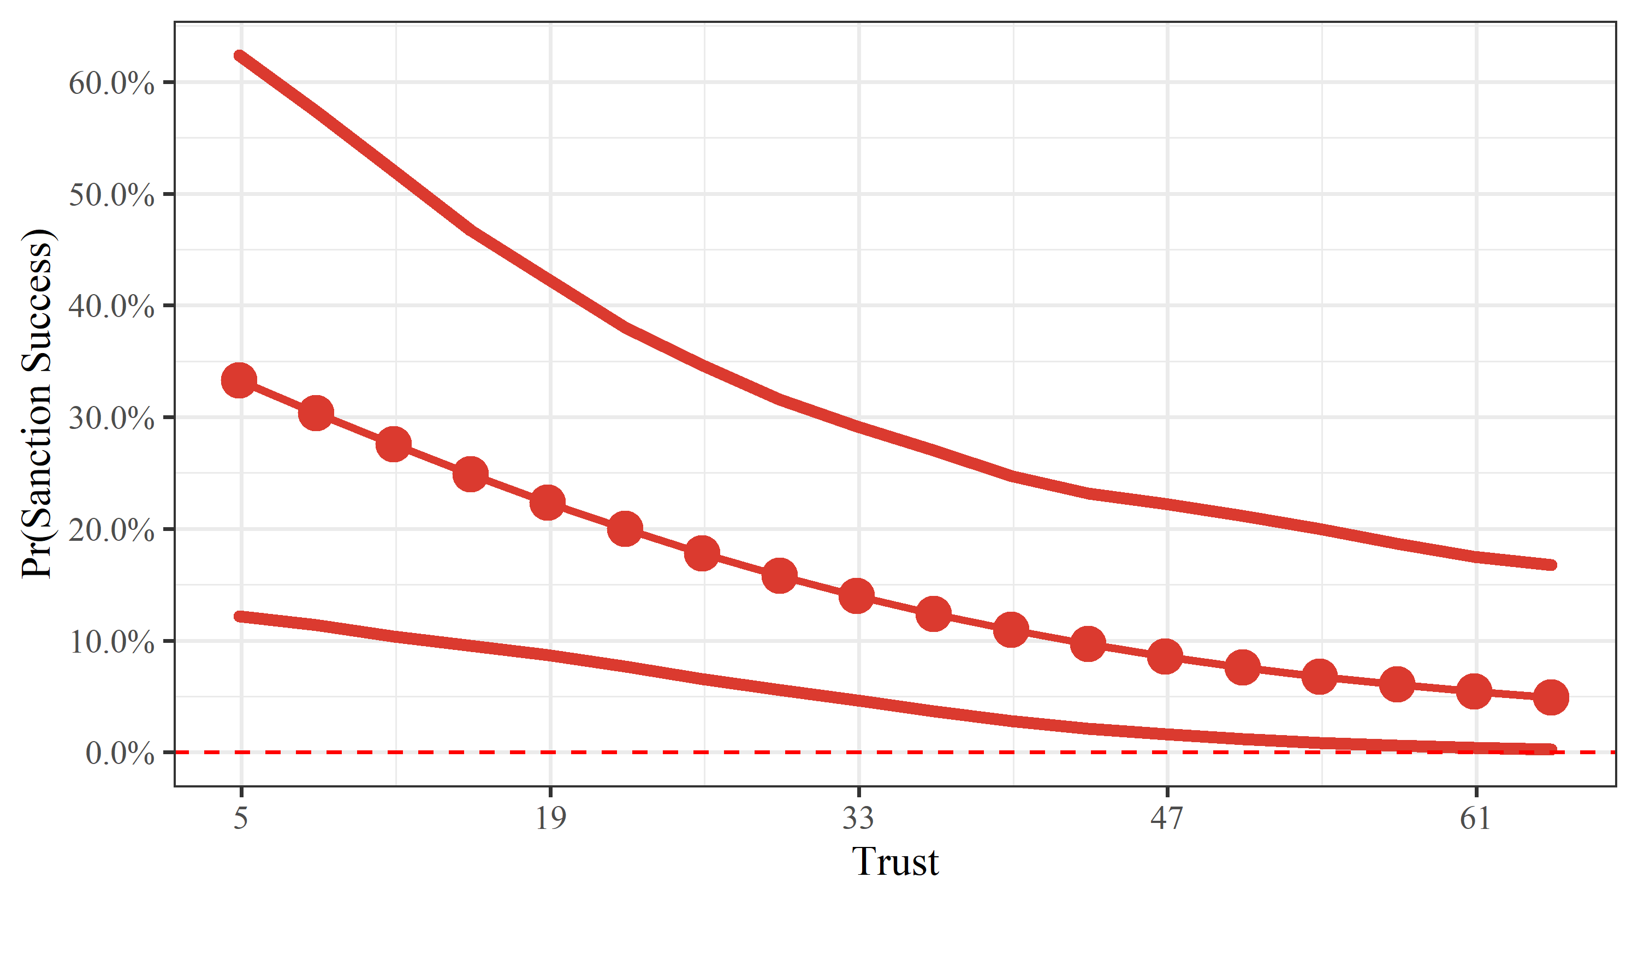

**Figure 2**. Predicted probability of successful sanctions as a function of *Trust*.

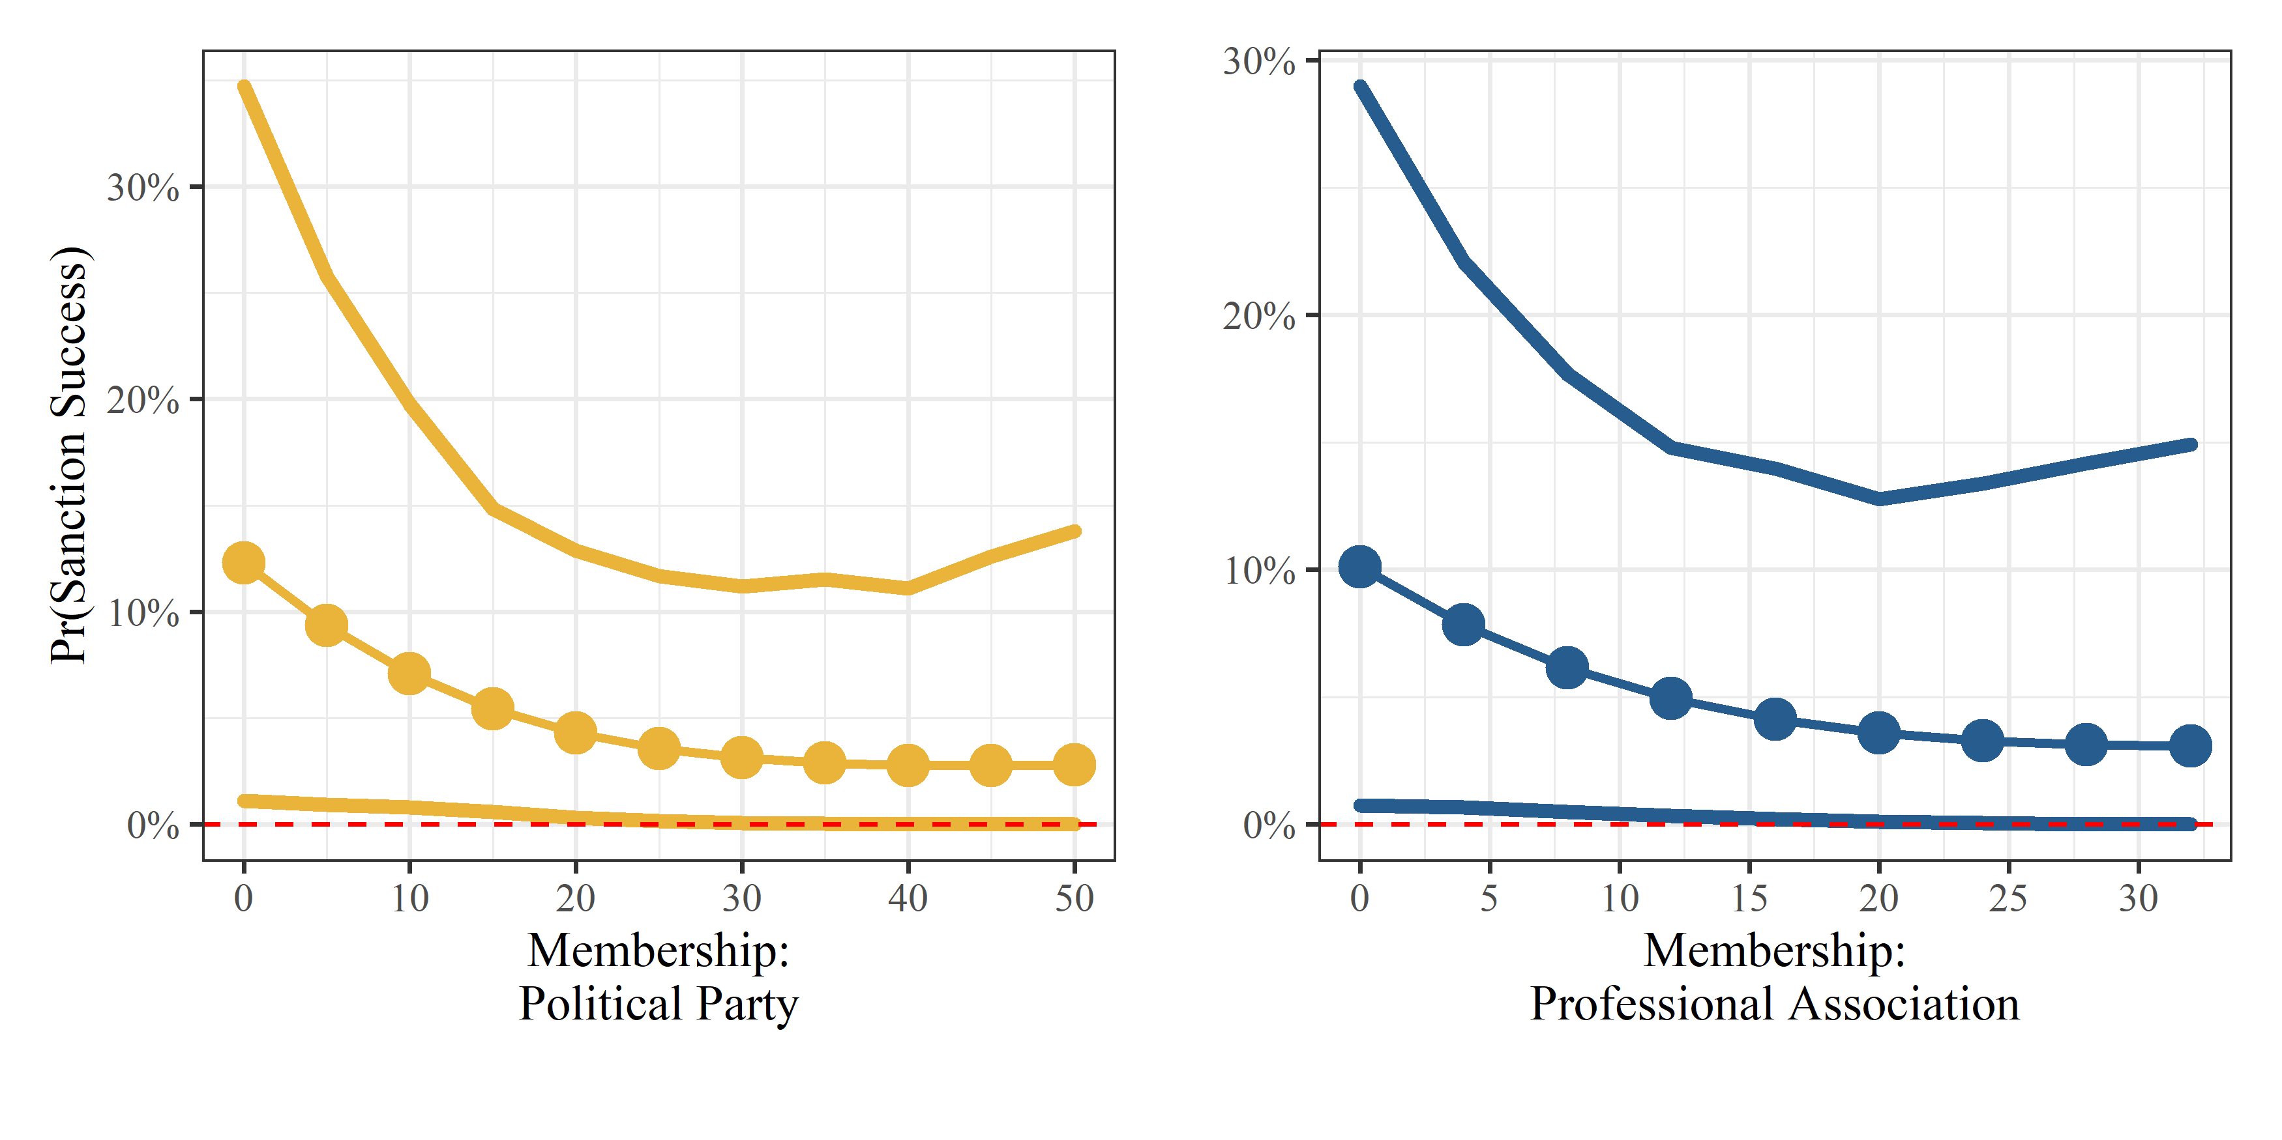

**Figure 3**. Predicted probability of successful sanctions as a function of *Membership: Political Party and Professional Association.*

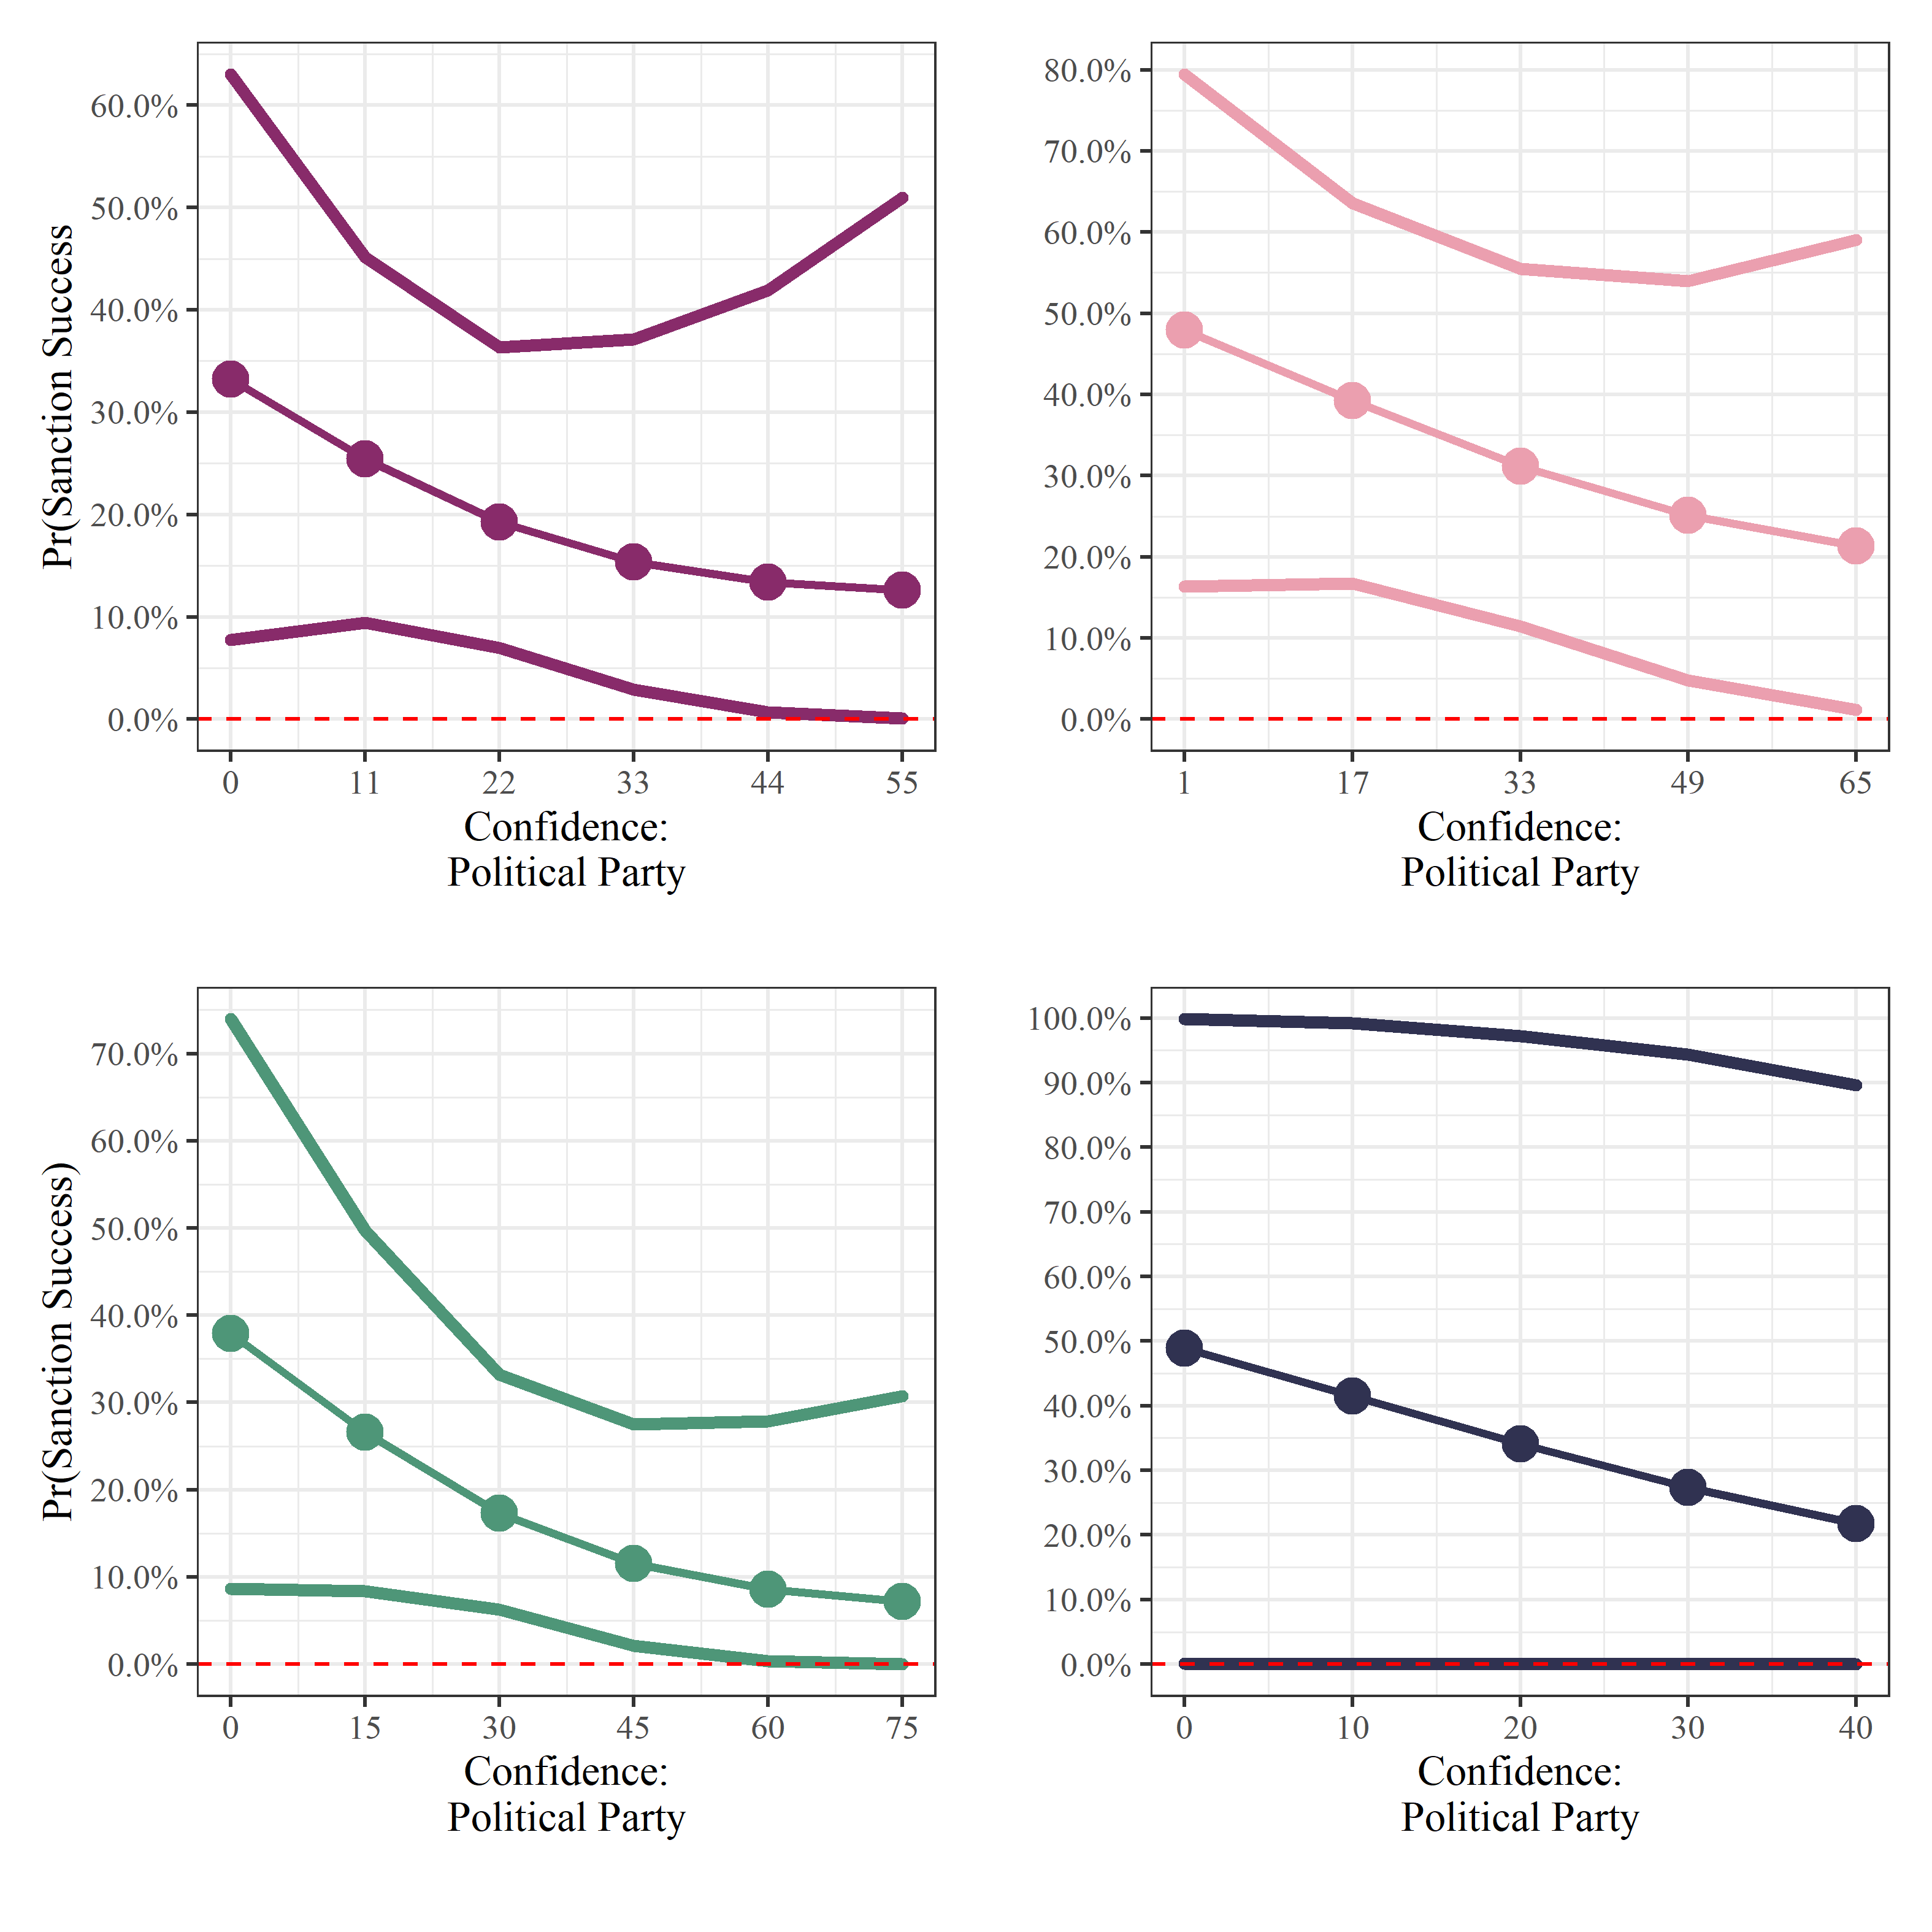

**Figure 4.** Predicted probability of successful sanctions as a function of confidence: *Professional Party, Government, Parliaments,* and *Courts.*