User’s Guide

By Pierre-Yves Hervo

V 0.1

11/09/2013

# Introduction

This document explains how to use the Java application I designed during my four month internship. This application allows controlling Praat by finding the values for the speech synthesis of a vowel using a genetic Algorithm and generates a script containing those values.

Here is the table of content:

Contents

Introduction 2

Installation 3

Getting started 3

The run 5

After the run 6

# Installation

To get the project go to this link : <https://github.com/phervo/ProjetEte2013> and download the zip file in the folder “exec”. You just have to unzip it in an empty folder and you will be allowed to use the application without installing anything.

Note: you can download the whole project if you want but only the zip is necessary to run the application.

# Getting started

Once you double click on the application button you will arrive on the following frame:

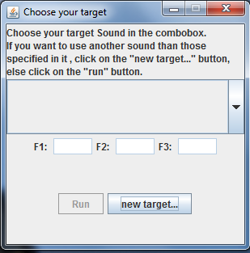

You can see that the “Run” button is enabled and the formants values are empty until you select a target.

You have two possibilities there. You can choose one of the existing targets by selecting it in the combobox like in the following picture:

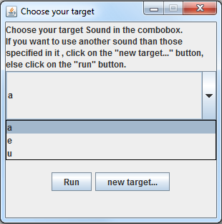

Or if the target you want isn’t defined, you can create your own target by selecting the “new target…” button.

If you do it, a new frame will open.

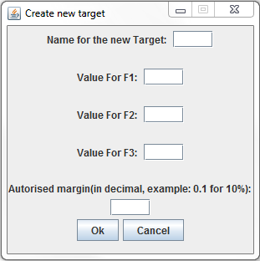

Fill in the different fields with the corresponding values and then select Ok. Just be sure that you don’t let any field empty and that you don’t insert a 0.0 value for the formants.

Click Cancel to close the window if you select it wrong.

If you select Ok, your new target will be added to the previous combobox and automatically selected. Like in the example below:

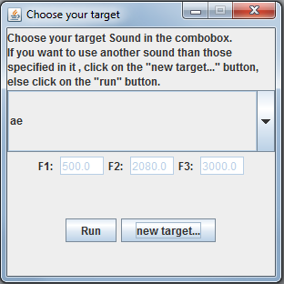

Whatever the way you choose to select your target, once it is done, its name will appear on the combobox and the values for its formants will be displayed in the corresponding fields.

You just have to click on run to launch the algorithm.

# The run

After clicking on Run in the previous frame, a new one will appear. In this one, you get a area with text. The different information about the run will be displays on it, like the candidate which is currently evaluated, its fitness score, the best candidate of the generation, the score the algorithm must achieve to stop, etc. It is filled in dynamically.

You will also had Praat windows that will open from time to time. Unfortunately it can’t be helped. You can close the pink one when it appears and put the others in background.

Now that the run is launched, it will take a long time to found a solution, you can work on another thing or take the time for a coffee.

Once the run is finished, a message indicates you were the results are stored and that you have to save the monitoring curves if you want to keep them on your computer.

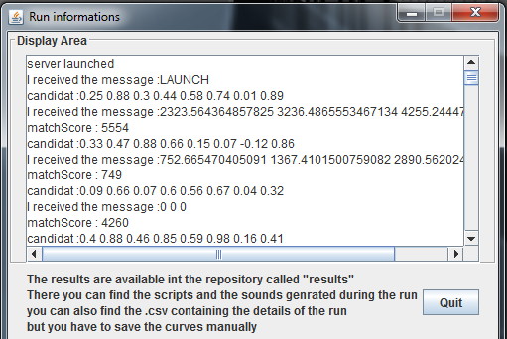

# After the run

At the end of the run, some monitoring information appears on the screen. You have the difference between each formant and the target’s formant you defined. You also get a frame which shows you the global evolution of the population fitness among time.

Here are some examples:

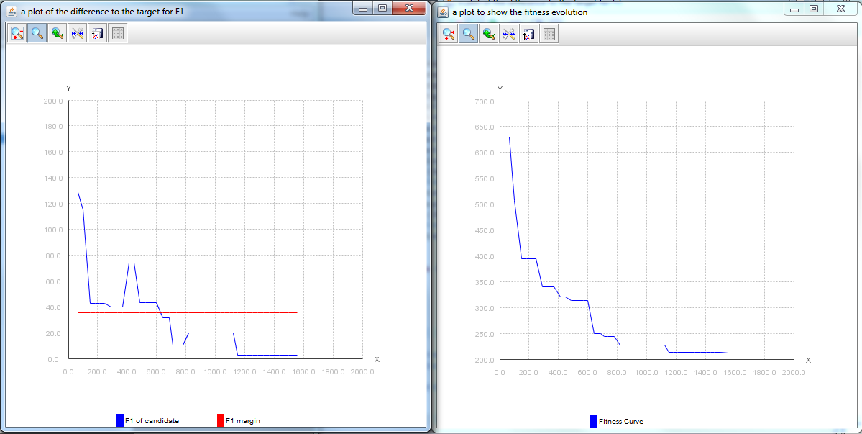

Click on the “Ok” button to close the application.