# Black-Box Testing

**EQUIVALENCE CLASSES** (Use as many rows as needed)

|  |  |  |  |  |
| --- | --- | --- | --- | --- |
| Input Parameter | Name for equivalence class | Equivalence class range | Test case(s) inside | Boundary cases |
| **userID** | **valid** | UserID > 0 | 3, 10 | 1 |
| **UserID** | **invalid** | UserID <= 0 | -3,-10 | 0,-1 |
| **Password** | **invalid** | Password.isEmpty() == true || Password == null || Password.contains(“ “) | the password, “ “, null | thepassword(space at the start) |
| **Password** | **valid** | Password.isEmpty() == false && Password == null == false && Password.contains(“ “) == false | goodPassword123, dogcat | d(testing just a single character as boundary) |
|  |  |  |  |  |
|  |  |  |  |  |
|  |  |  |  |  |
|  |  |  |  |  |

**TEST CASES** (Use as many rows as needed)

|  |  |  |  |
| --- | --- | --- | --- |
| **Description** | **input *userId*** | **input *password*** | **Expected Output** |
| **valid userID and valid password** | **1** | **d** | **0** |
| **Invalid userID and valid password** | **0** | goodPassword123 | -1 |
|  | **-10** | **dogcat** | **-1** |
| **Valid userID and invalid password** | **3** | **thepassword(space at the start)** | -3 |
|  | **10** | the password | **-3** |
| **Invalid userID and invalid password** | **-1** | null | -1 |
|  | **-3** | **“ “** | **-1** |

# White-Box Testing

**FLOW CHART** (Paste your flow chart image below)

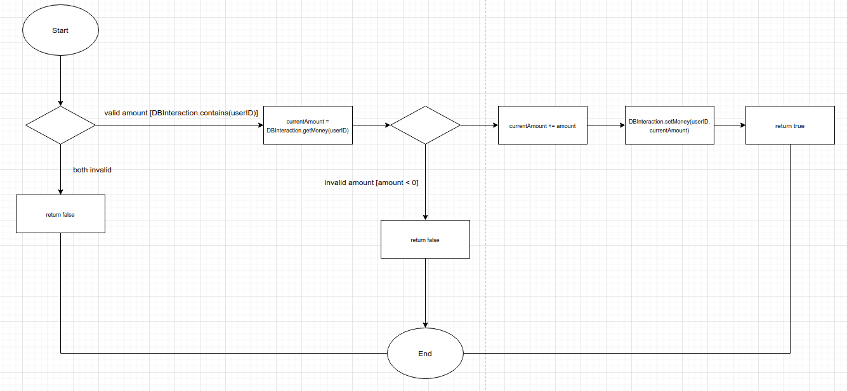

**TEST CASES** (Use as many rows as needed)

|  |  |  |  |
| --- | --- | --- | --- |
| **Path Description** | **input *userId*** | **input *amount*** | **Expected Output** |
| **Invalid userID** | -3 | 1 | false |
|  | -10 | 1 | false |
| **Invalid amount**  **with valid ID** | 3 | -.01 | false |
|  | 10 | -2 | false |
| **Both valid** | 3 | 1 | true |
|  | 10 | 1 | true |
|  |  |  |  |
|  |  |  |  |
|  |  |  |  |
|  |  |  |  |
|  |  |  |  |