Twinkle Star Day Care Center

End Of Third Term Examination

Subject: Creative Arts

Class: Nursery One

Name: ………………………………………..……… Date: …………………………

Match and colour the shapes

Sing and do the actions of the rhythm.

A lion , a lion has a tail

it has a big head

and a very small waist

and a very small waist

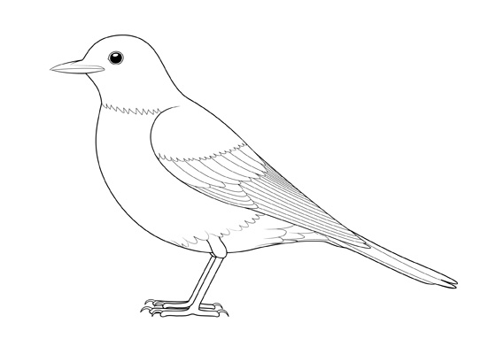Colour the bird.