chronicle Showcase

Philippe Heymans Smith

2021-03-03

# This is how a chronicle report looks

This is a showcase of the outputs possible with the {chronicle} R package. For a complete how-to, please refer to the package’s [github page](https://github.com/pheymanss/chronicle).

# Barplots

### chronicle::add_barplot()

## Simple bar plot

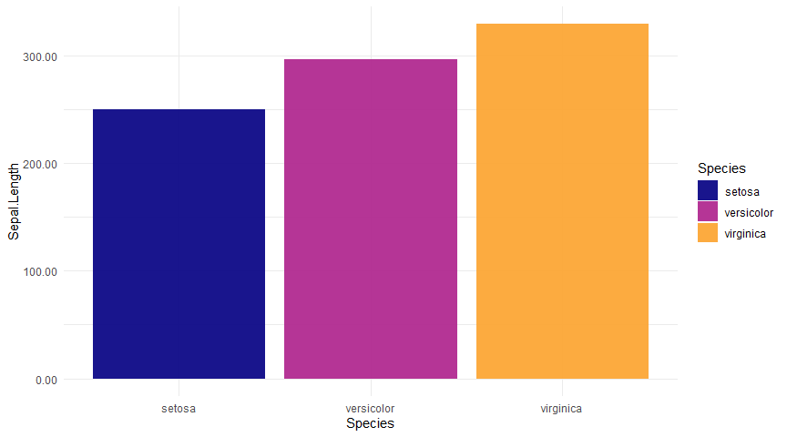

## Bars broken by other group

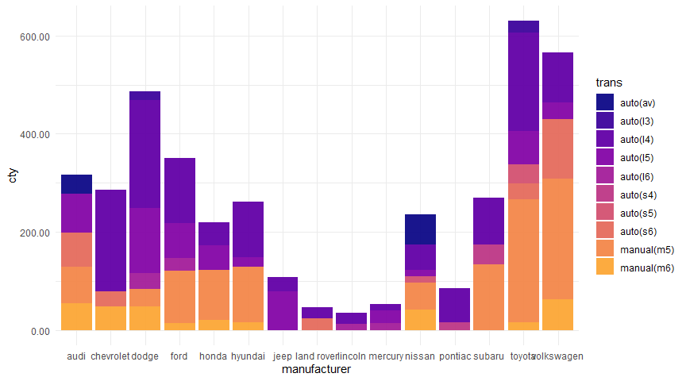

## Bars sorted by value

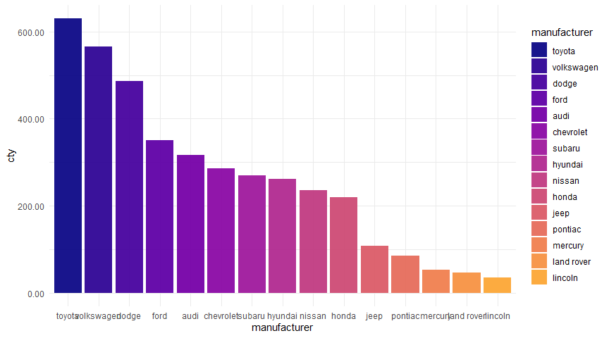

## Bars sorted by value and broken by another column

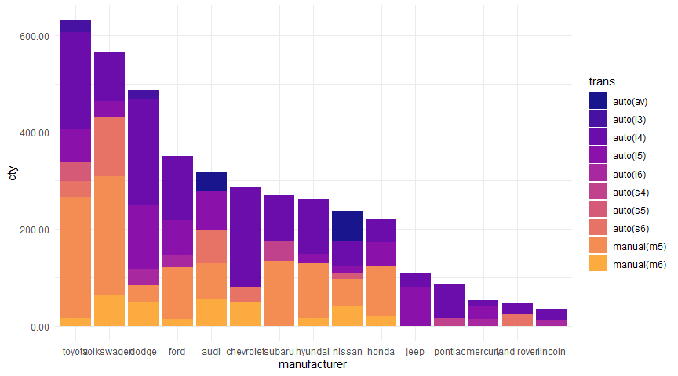

## Horizontally

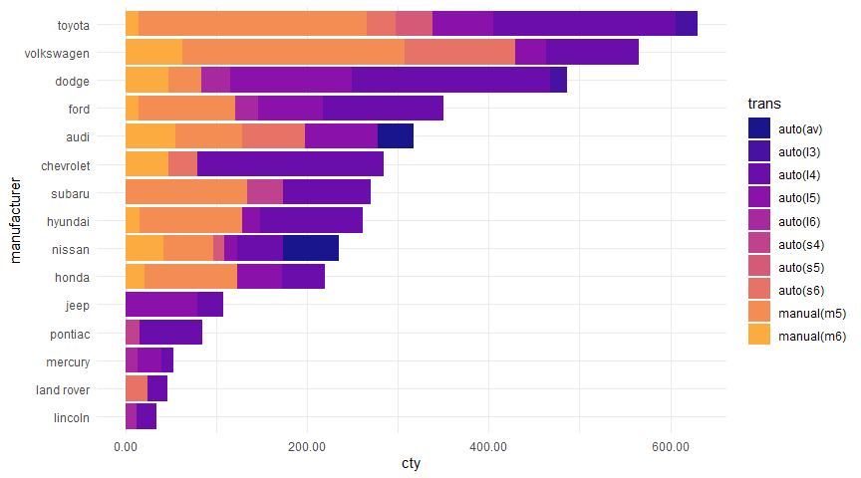

# Boxplots

### chronicle::add_boxplot()

## Simple box plot

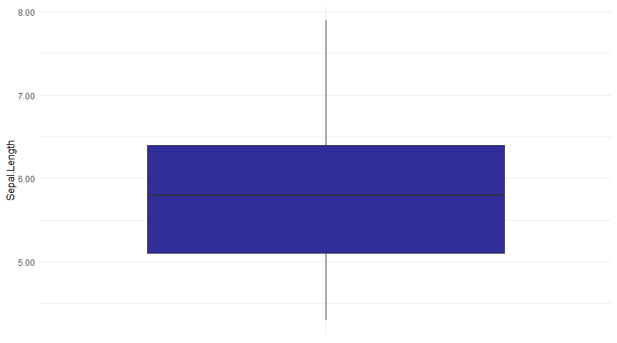

## Box plot by groups

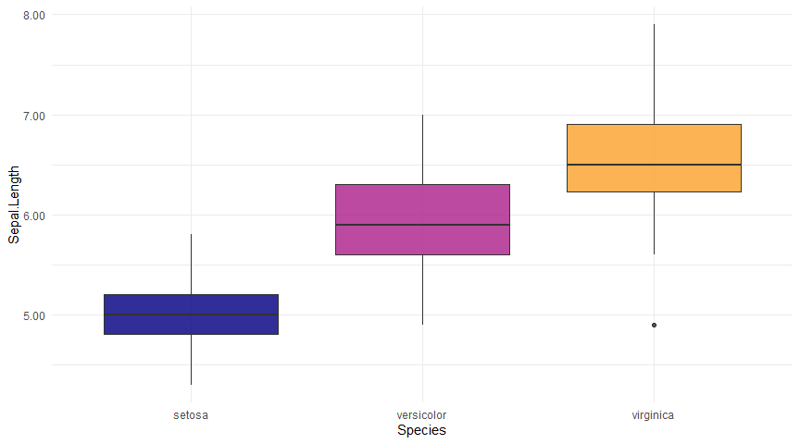

## Box plot with jitter

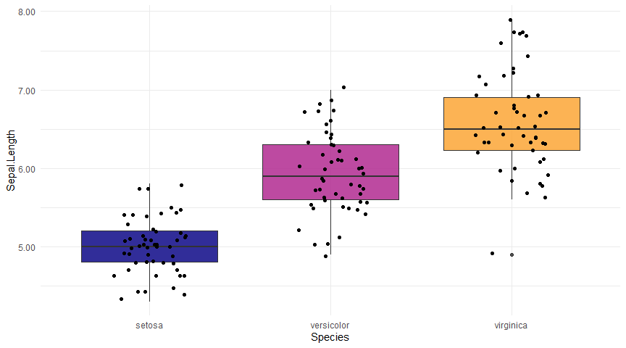

# Code

### chronicle::add_code()

This is an empty canvas for you to include any code you want.

### This is some code:

data.table(iris)[, .N, Species]

### It can also be evaluated!

library(data.table)  
data.table(iris)[, .N, Species]

## Species N  
## 1: setosa 50  
## 2: versicolor 50  
## 3: virginica 50

# Densities

### chronicle::add_density()

## Basic density

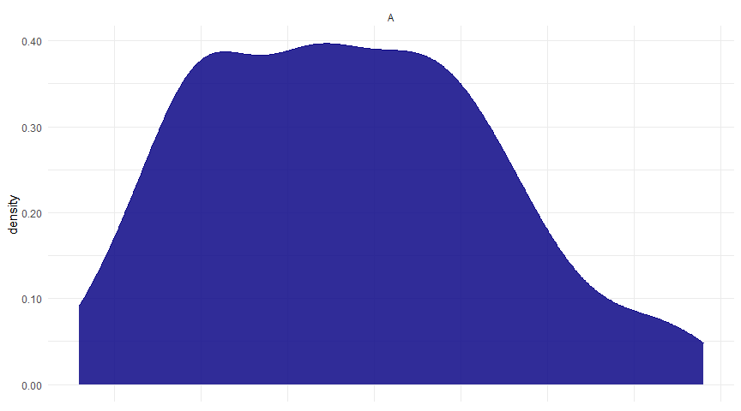

## Density by group

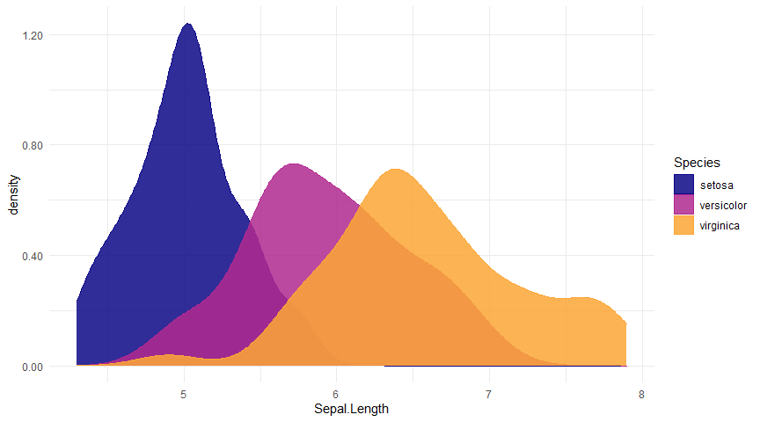

## Faceted densities

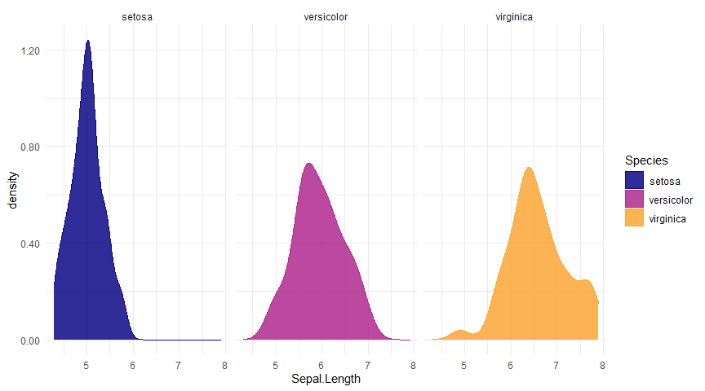

# dygraphs

### chronicle::add_dygraph()

## Simple dygraph (in static outputs it will be replaced by line plots)

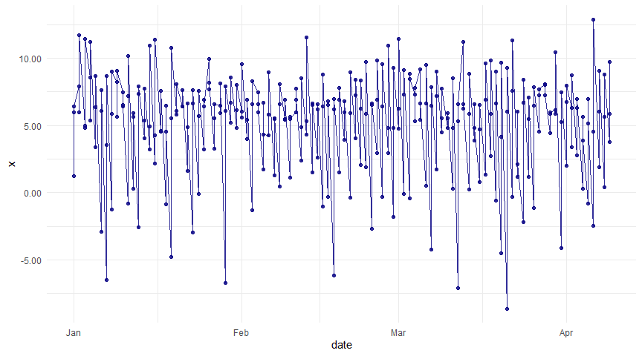

## Dygraph by groups

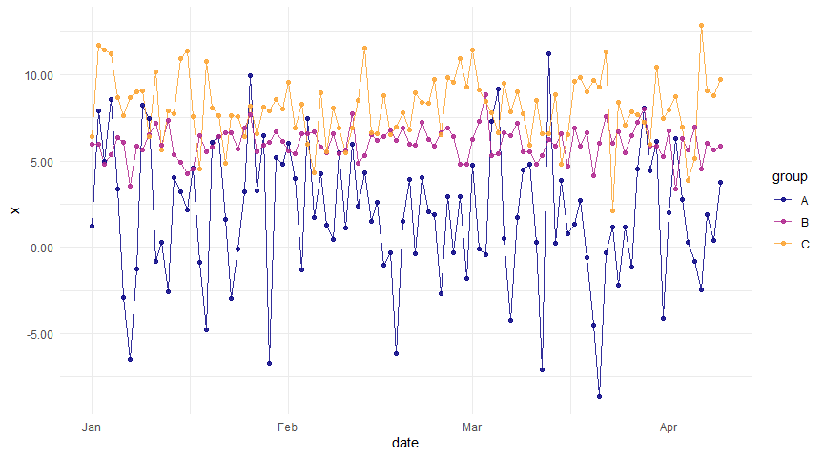

# Histograms()

### chronicle::add_histogram

## Basic histogram

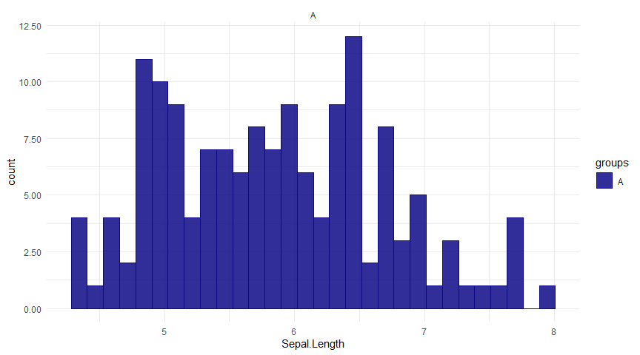

## Faceted histogram by groups

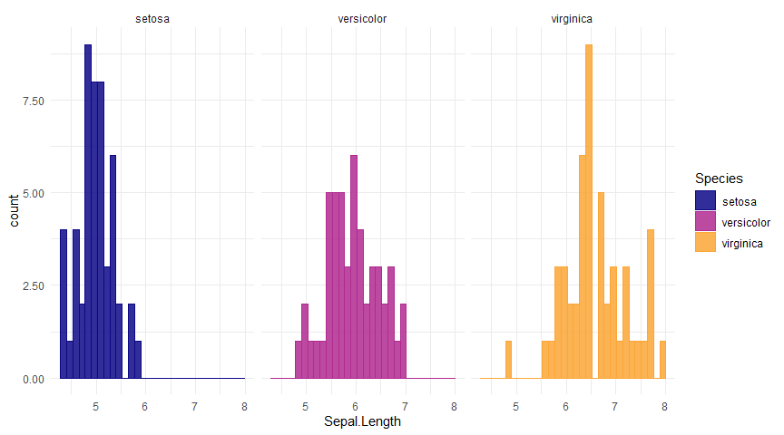

# Line plots

### chronicle::add_lineplot()

## Simple line plot



## Line plot with trend

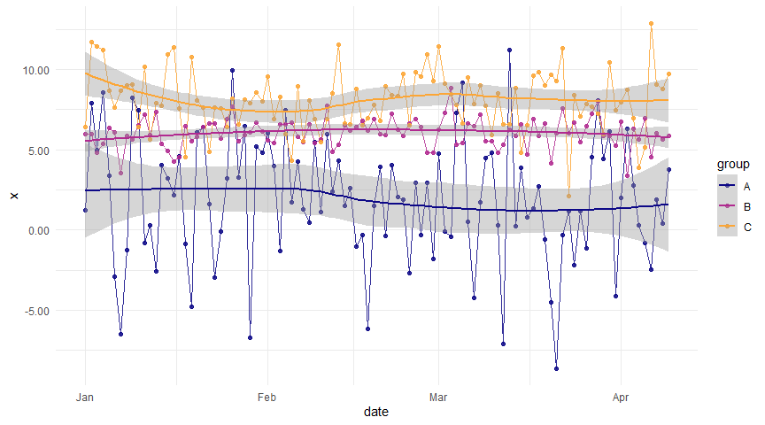

## Line plot with linear trend

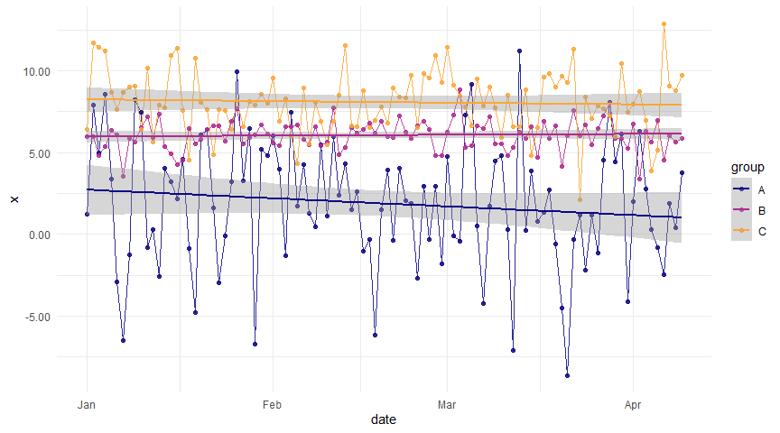

## Faceted line plot

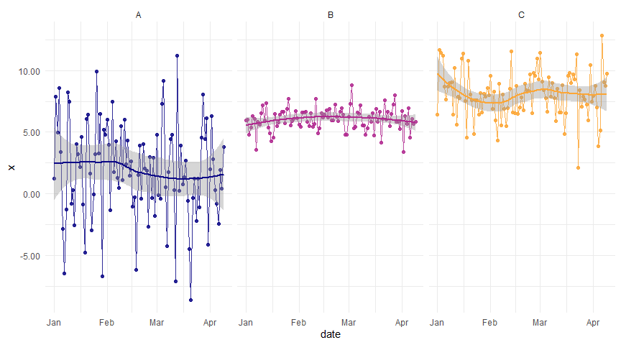

# Rain cloud plots

### chronicle::add_raincloud()

## Simple rain cloud

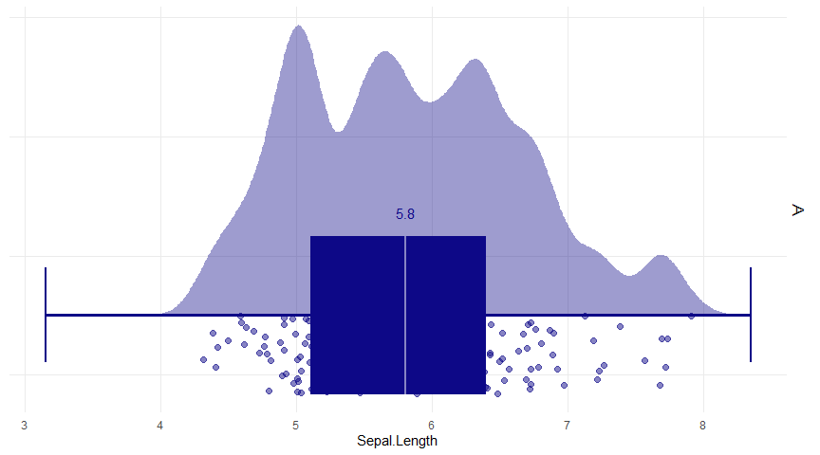

## Rain cloud by group

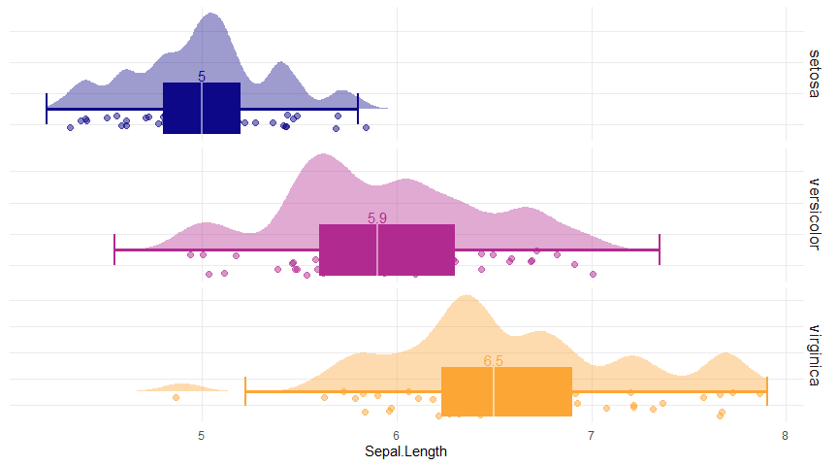

## Larger denisty kernel

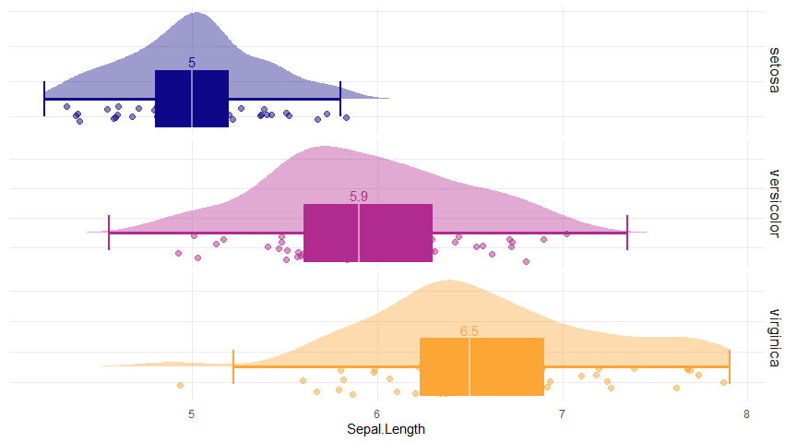

## No boxplot, just the median

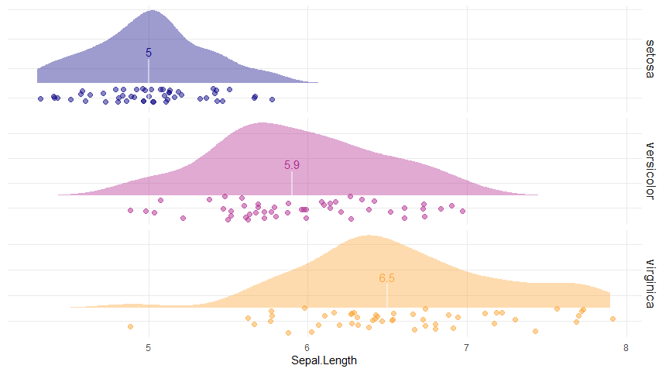

## With the mean instead of the boxplot

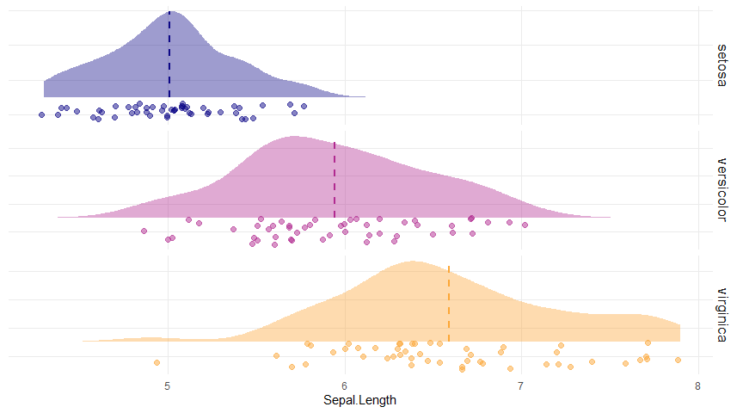

# Scatter plots

### chronicle::add_scatterplot()

## Simple scatter plot

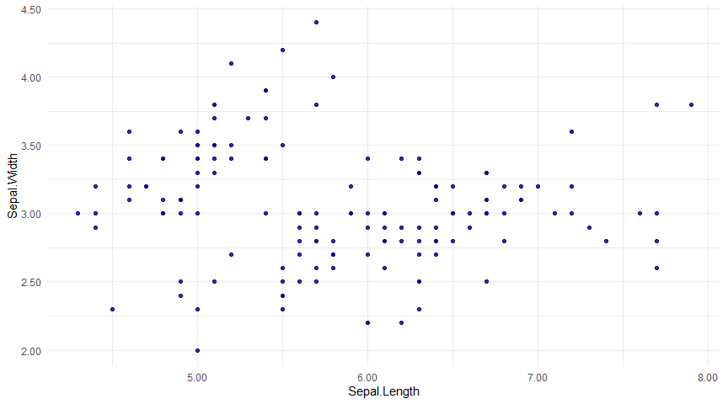

## Scatter plot with groups

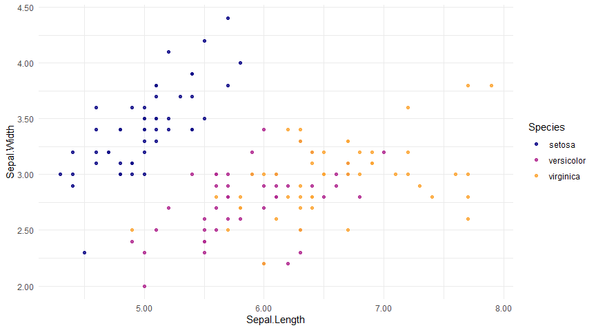

## Faceted scatter plot with trend

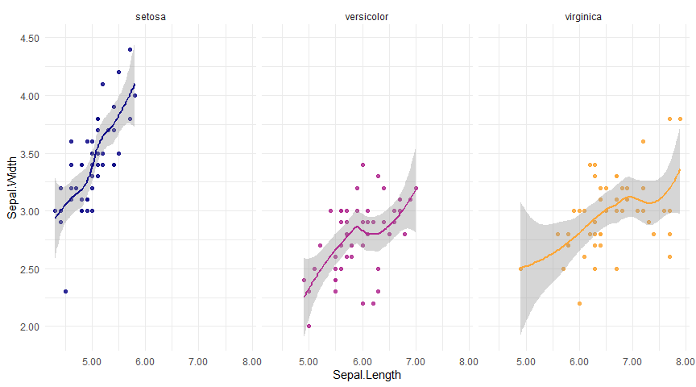

# Tables

### chronicle::add_table()

### kable

|  |  |  |  |  |
| --- | --- | --- | --- | --- |
| Sepal.Length | Sepal.Width | Petal.Length | Petal.Width | Species |
| 5.1 | 3.5 | 1.4 | 0.2 | setosa |
| 4.9 | 3.0 | 1.4 | 0.2 | setosa |
| 4.7 | 3.2 | 1.3 | 0.2 | setosa |
| 4.6 | 3.1 | 1.5 | 0.2 | setosa |
| 5.0 | 3.6 | 1.4 | 0.2 | setosa |
| 5.4 | 3.9 | 1.7 | 0.4 | setosa |

### DT

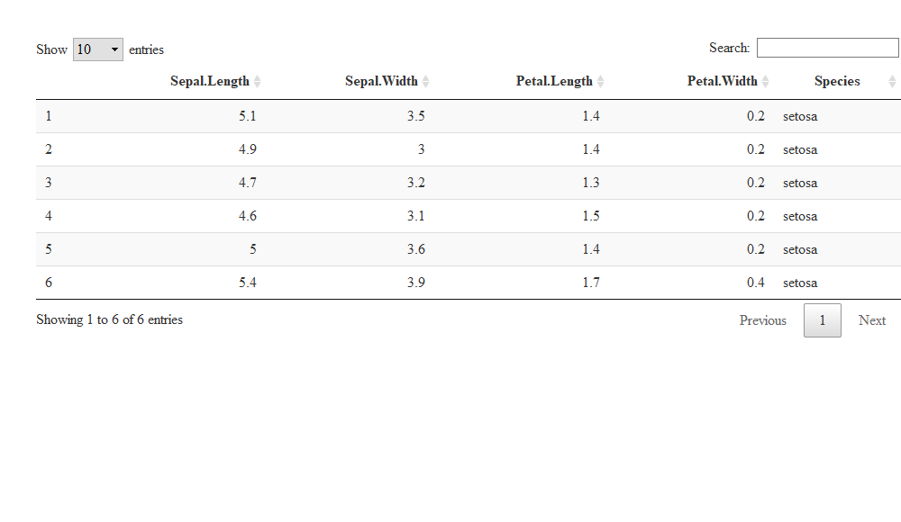

# Violins

### chronicle::add_violin()

## Simple violin plot

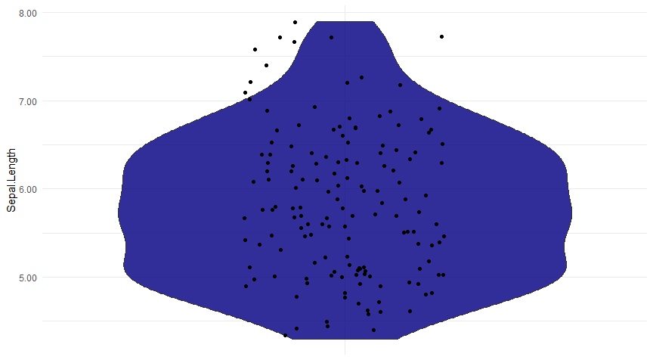

## Violin plot by group

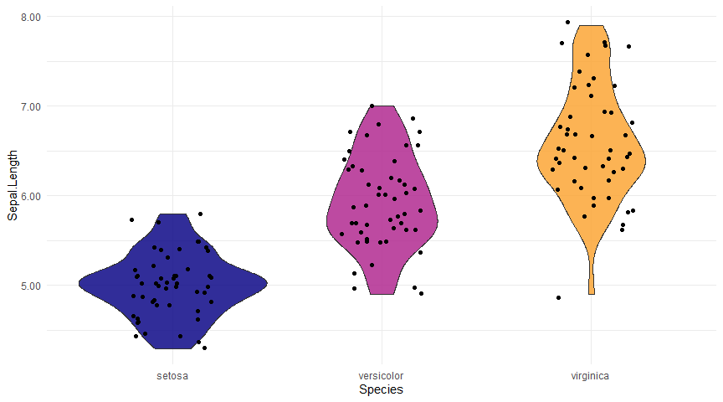

# Big Bonus! report_columns()

chronicle also includes a function called report_columns(), that will create an entire chronicle report for a single dataset. It includes a comprehensive summary of the data through the skimr::skim() function, along with one plot for each column present in the data: bar plots for categorical variables and rain cloud plots for numerical variables. This gives you an immediate view of a dataset with a single line of code!

report_columns(dt = palmerpenguins::penguins,  
 by_column = 'species')

you can see the example of this output [here](https://pheymanss.github.io/chronicle-demos/report_columns)

## sessionInfo

sessionInfo()

## R version 4.0.3 (2020-10-10)  
## Platform: x86_64-w64-mingw32/x64 (64-bit)  
## Running under: Windows 10 x64 (build 19042)  
##   
## Matrix products: default  
##   
## locale:  
## [1] LC_COLLATE=English_United States.1252 LC_CTYPE=English_United States.1252 LC_MONETARY=English_United States.1252  
## [4] LC_NUMERIC=C LC_TIME=English_United States.1252   
##   
## attached base packages:  
## [1] stats graphics grDevices utils datasets methods base   
##   
## other attached packages:  
## [1] stringr_1.4.0 chronicle_0.2.5 data.table_1.13.6 magrittr_2.0.1 rlang_0.4.10   
##   
## loaded via a namespace (and not attached):  
## [1] tufte_0.9 lattice_0.20-41 tidyr_1.1.2 ps_1.5.0 zoo_1.8-8 digest_0.6.27   
## [7] R6_2.5.0 evaluate_0.14 httr_1.4.2 xaringan_0.19 ggplot2_3.3.3 highr_0.8   
## [13] pillar_1.4.7 tictoc_1.0 lazyeval_0.2.2 rstudioapi_0.13 callr_3.5.1 Matrix_1.2-18   
## [19] DT_0.17 rmarkdown_2.6 labeling_0.4.2 splines_4.0.3 webshot_0.5.2 flexdashboard_0.5.2  
## [25] rolldown_0.1 readr_1.4.0 htmlwidgets_1.5.3 munsell_0.5.0 tinytex_0.28 compiler_4.0.3   
## [31] xfun_0.20 pkgconfig_2.0.3 mgcv_1.8-33 htmltools_0.5.0 tidyselect_1.1.0 tibble_3.0.4   
## [37] gridExtra_2.3 bookdown_0.21 viridisLite_0.3.0 crayon_1.3.4 dplyr_1.0.2 withr_2.3.0   
## [43] grid_4.0.3 nlme_3.1-151 jsonlite_1.7.2 gtable_0.3.0 lifecycle_0.2.0 scales_1.1.1   
## [49] rmdformats_1.0.1 stringi_1.5.3 farver_2.0.3 viridis_0.5.1 dygraphs_1.1.1.6 ellipsis_0.3.1   
## [55] xts_0.12.1 generics_0.1.0 vctrs_0.3.6 tools_4.0.3 glue_1.4.2 purrr_0.3.4   
## [61] hms_0.5.3 crosstalk_1.1.0.1 prettydoc_0.4.1 processx_3.4.5 yaml_2.2.1 colorspace_2.0-0   
## [67] plotly_4.9.3 knitr_1.31 pagedown_0.13