BrightMarkdown text | Result (Style dependend on your CSS settings)
*+_Table of Contents:_+*
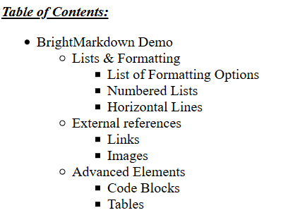
{TOC}
# BrightMarkdown Demo | 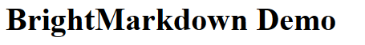
## Lists & Formatting
### List of Formatting Options
- Plain text
- *Bold* text
- _italic_ text
- +unterlined+ text
- ~strikethrough~ text
- {c:red}red{c} text
- text with {bc:yellow}background color{bc}

### Numbered Lists
. One
. Two
. Three

### Horizontal Lines
Here's a horizontal line:
-------

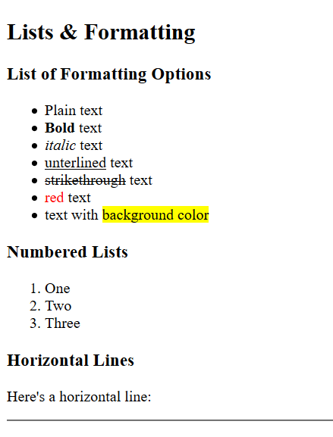
## External references
### Links
This is a link to [Wikipedia][https://www.wikipedia.org/].

### Images
It is also possible to add images:
![img1.jpg height=30mm] ![img1.jpg height=60mm] ![img1.jpg height=120mm]

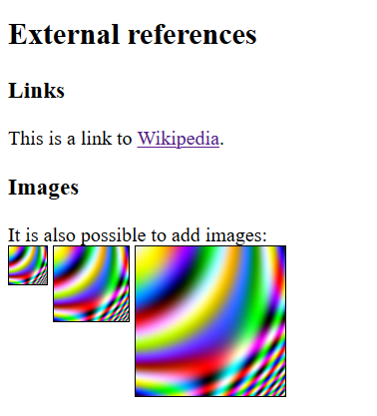
## Advanced Elements
### Code Blocks
It is also possible to have code blocks like ´´´java x="hello";´´´ or longer code blocks such as
´´´java
public String myFunction(int a, int b){
// compare both values
if (a == b){
return "equals";
} else {
return "different";
}
}
´´´
### Tables
Fruit|Color
====
Banana|{bc:yellow}yellow{bc}
Cherry|{bc:red}{c:white}red{c}{bc}
Pear|{bc:green}{c:white}pear{c}{bc}
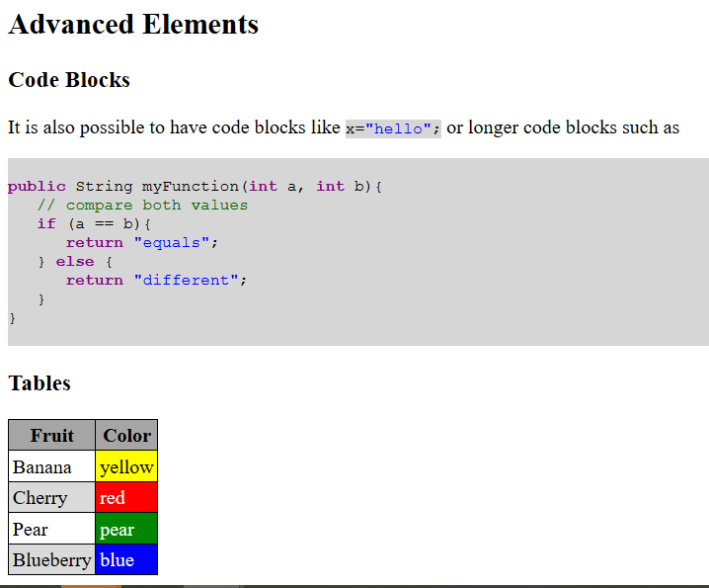
Blueberry|{bc:blue}{c:white}blue{c}{bc}

