Leinwand Graphics Framework

What is it?
The Leinwand Graphics Framework – short Leinwand GF or just LGF is a 2D graphics framework for Android and Java Desktop (Windows, Linux, Mac). „Leinwand“ is the German word for canvas.

Features and purpose
- The framework is very easy to use
- LGF provides many features such as
  - Screen scaling
  - Images, fonts and animations
  - Running in Android and on Java Desktop (e.g. for faster development and testing)
  - collision detection
  - Scrolling
  - Text effects
  - Saving and loading states
  - User input via touch mouse
  - and many more

Using the framework

Android

Setup
In the dependencies section of the „build.gralde“ file simply add this line:
implementation 'de.bright-side.lgf:lgf-android:1.0.0'
(Please replace „1.0.0“ with the current framwork version.)

Needed classes
- A main activity that extends LandroidActivity
  - Specify size
  - Initialize the platform class
  - create the first screen presenter
- A plaform class that extends LandroidPlatform
  - implement functions such as accessing the local directory
- A resource access class that extends LandroidResourceAccess
  - Provide access to images, animations and fonts (which e.g. are located in the „res“ and „asset“ directories in the Android project)

For further details about the three classes please check the section below that explains the demo project.

Java Desktop (Windows, Linux, Mac)

Setup
Add this dependency:
<dependency>
<groupId>de.bright-side.lgf</groupId>
<artifactId>lgf-pc</artifactId>
<version>1.0.0</version>
</dependency>

(Please replace „1.0.0“ with the current framwork version.)

Needed classes
- An instance class which extends LInstance
  - Specify size
  - Initialize the platform-tools
  - create the first screen presenter
- A resource access class extending LPcResourceDAO
  - Provide access to images, animations and fonts which are probably located in src/main/resources directory of the Java project

Check of the demo project and read next sections to understand how to use the framework.

The Demo Projects for Android and Desktop
Both demo projects are located in the directory „DemoProjects“.
They have 3 components:
- Desktop specific classes (in package de.bright_side.lgfdemo.pconly)
- Android specific classes (in package de.bright_side.lgfdemo.androidonly)
- Classes that are independed of Desktop and Android.
The approach is – of course – to be able to have most of the Java classes to be independend to Desktop or Anroid.

All classes of the Demo project have the prefix „Demo“ while all classes of LGF have the prefix „L“. An excption is the class „MainActivity“ which is also part of the demo.

Demo Project: Desktop classes
The maven project is called „pc-demo“. As it is also used for development of the LGF it is a sub-module of the LGF parent maven project. However if you wand to create an application that just uses LGF, you just need to add the „lgf-pc“ dependency in the group „de.bright-side.lgf“ (see section „Setup“ in chapter „Java Desktop (PC, Linux, Mac)“.

To start the Desktop demo project run „DemoLInstance“ in the package de.bright_side.lgfdemo.pconly“.

Class „DemoLInstance“
The vector WINDOW_CONTENT_SIZE contains the amount of virtual pixels int the application which is used in the constructor with the option „FIT_BOTH“ to ensure there are at least as many pixels as specified for X and Y and additional pixels if needed for the aspect ratio. See section „Virtual pixels“ for more details.
The main method calls new DemoLInstance().run(resume); to start the application.
The constructor also refers to a new instance of DemoResourceDAO to access resources.
The overwritten method „createFirstScreenPresenter“ creates and returns the first screen presenter.

Class „DemoResourceDAO“
The class overwrites these methods to access the different types of resources:
- createImageResourceMap
- createRawResourceMap
- createAnimationResourceMap
- createFontResourceMap
It also overwrites „getImageInputStream“ and „getRawResourceInputStream“ to read from the class path (so from inside the jar file).
All resources such as „DemoImage.STAR_YELLOW“ are located in the de.bright_side.lgfdemo.model package and are independent of the Desktop or Android implementation.

Demo Project: Android classes
There are 3 Android specific classes in the project. The other classes are independent of Desktop/Android.
For purposes of the development of the LGF all other classes are simply copied from the Desktop project. This can be conveigniently done by using the „_copyPcDemoCodeToThisProject“ target in the section „other“ in Gradle:

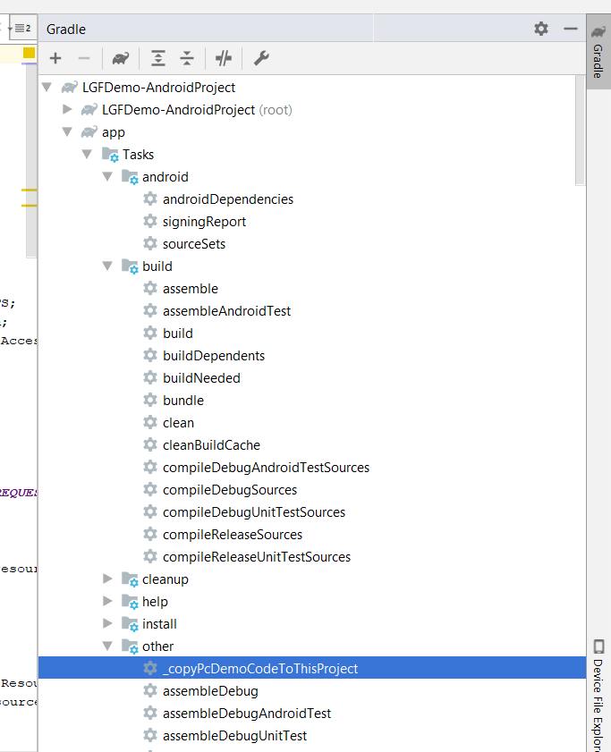

Classs „MainActivity“
The overwritten method „createFirstScreenPresenter“ creates and returns the first screen presenter.
In the „onCreate“ method a new platform is created and „initOnCreate“ is called to initialize LGF.

Class“DemoResourceAccess“
Just like the Desktop equivalent this class overwrites methods to return images, animations, fonts, etc. However the Android version uses different mechanisms to do so as the resources are not located in the jar file but in the res and assets directories of the Android project.

Class „DemoPlatform“
This class overwrites some application specific methods such as accessing the file system of the application.

Demo Project: classes that are independent of Desktop/Android
The idea of LGF is to make most of the classes independent of Desktop/Android.

Packages:
- de.bright_side.lgfdemo.base: contains DemoConstants which contains the virtual size of the application etc.
- de.bright_side.lgfdemo.model: contains the different resources such as images, fonts and animations so that they can be used in the rest of the application – independent from Desktop/Android
- de.bright_side.lgfdemo.presenter cointains all presenter classes. The application is divided into different screens. Each screen is handeled by a different presenter which contains
  - definition for all objects such as images
  - all the logic of movement, collitions, input
  - all „business logic“ or „game logic“ what should happen on input, collisions, etc.
Hence a presenter contains everything needed of a screen. Of course in a larger application or game you probably want to use more classes which are called by the presenter.
The remaining screen management such as menu button creation which is the same for every screen is located in DemoPresenterUtil in the de.bright_side.lgfdemo.presenter package.

StartScreen (DemoScreenStartPresenter)
Stars are created in the method createScreenModel and their movement is updated in the update() method. Whenever a star moves outside of the scrreen it is located in the middle again and a random direction is set.

Usage and Concepts
All Leinwand GF classes have the prefix „L“.
There are several general objects (platform independent: PC or Android):
- LVector: contains and x and y value. It may be used for positions and sizes
- LScreenPresenter: contains all presenter logic, like updating the view, calling business/game logic, etc.
- LScreenModel: contains all objects of the screen
  - backgroundColor
  - backgroundObjects, enemyObjects, playerObjects, foregroundObjects: drawn in this order.
  - uiObjects: drawn on top, never scrolled
- LObject: an object in the framework with different properties. Most important
  - pos, size: position and size in the virtual screen
  - image: image of the object
  - animation: animationFrames, animationFrameIndex, remainingSecondsInAnimationFrame
  - speed, rotation: by which the object is moved
  - visible
  - opacity: 1 means fully visible while 0 means fully transparent
  - collisionPolygon: optional polygon to check collisions. Otherwise pos and size are used and the shape is assumed to be a rectangle
  - text: textFont, textColor, textOutlineColor, textShadowColor, textShadowOffset, textSize
  - path movement: path, nextPathItem, maximumRotationPerSecond
  - actions (e.g. for buttons): touchable, touchAction
  - panelObjects, panelSize: the panelObjects list can be null or contain a list of LObjects. In the latter case the LObject acts as a panel which contains sub-items. Position, size, font size and opacity are relative to the paren object. If panelSize is null, the size of the panel is the same as the size of the LObject. If it is specified then the panelSize contains the available space from the child items point of view. E.g. if the panel size is 100x100 then the position [100, 100] is the bottom right corner on the panel object - even if the panel object only has a size of e.g. 10x20.

Virtual Pixels
As the device screens may have a different amount of pixels and the game or tool that uses the framework should not have to deal with this. LGF uses virtual pixels. As there are different aspect ratios and some screens have more pixels on the x-axis than on the y-axis and vice versa (e.g. a mobile phone that is rotated by the user) another logic is applied to make sure that the original aspect ratio makes sense and images don‘t appear streched on the x- or y-axis. There are these different modes.
Let‘s say you ask for a virtual size of 180 pixels on the x- and 100 pixels on the y-axis.
Mode:
- FIT_BOTH (recommended): It is made sure that there are at least 180 pixels on the x- and 100 pixels on the y-axis. However depending on the aspect ratio and actual number of pixels on x- and y-axis there may be more than the requested number of pixels on the x- or y-axis.
- MATCH_X: It is made sure that there are 180 virtual pixels on the x-axis. Depending on the aspect ratio and number of pixels on the x- and y-axis the right amount of virtual pixels on the y-axis is calculated. It may be more or less than 100 virtual pixels.
- MATCH_Y: The same as MATCH_X but only ensuring that the amount of 100 pixels on the y-axis is met.
- NONE: the same amount as requested (180x100) is returned and no scaling logic is applied. This may cause the resulting view to look streched on the x- or y-axis.

Complete LGF Projects Setup

Project Modules:
- General
  - lgf-core: General Framework (used by PC and Andoird part)
- PC & Android specific
  - lgf-pc: PC specific part (for Java Desktop: Windows, Linux, Mac)
  - LGF-AndroidProject: Android specific part
- Demos
  - LGF-DemoAndroidProject
  - pc-demo: Demo that runs on a desktop

Maven Module Locations
- Because of the Maven logic, all project that depend on each other (like LGF-PC depends on LGF-Core) must be located in the same Maven Parent POM project:
  - pc-parent-project (location: Framework/LGF-ParentPOM)
  - lgf-core (location: Framework/LGF-Core)
  - lgf-pc (location: Framework/LGF-Pc)
  - pc-demo (location: DemoProjects/LGFDemo-PcProject)

Android Projects
- Project „LGF-Android-Project“ is located in the Framework directory. It requires the lgf-core-<version>.jar. This jar is simply build with maven (mvn package) and then copied in the „libs“ directory of the module „lgf_android“
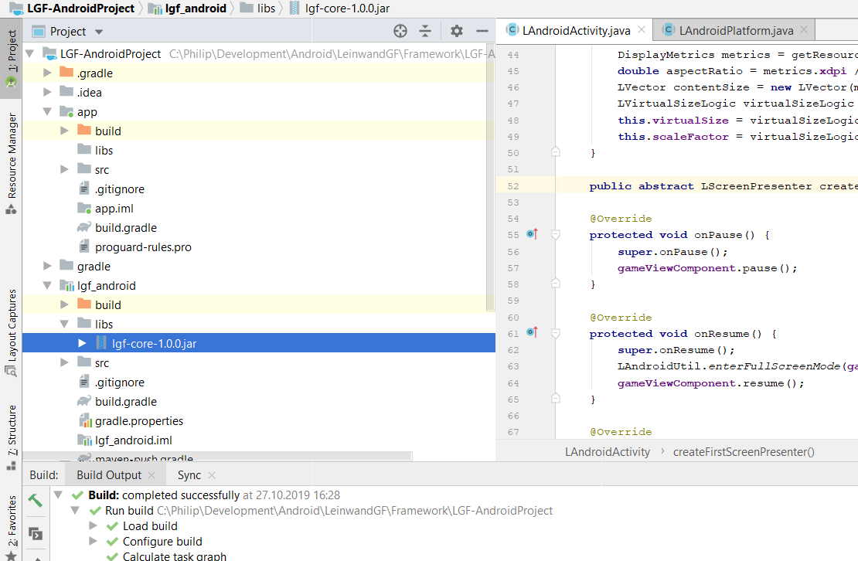

- Project „LGFDemo“ is located in the „DemoProjects“ directory. It requires the „lgf_android“ module from the „LGF-Android-Project“. In order to update the module simple go to the „LGF-Android-Project“ and run the Gradle target „_buildAndCopyToDemoProject“ and rebuild the „LGFDemo“ project afterwards.

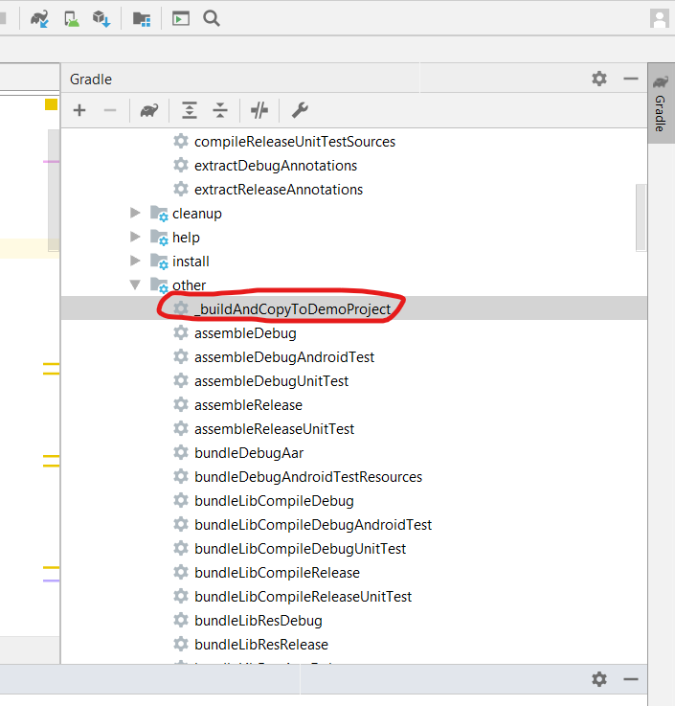

creating PC-Demo jar (with all dependencies)

Creating via Maven
- Just call „mvn clean package“ in the root dir of the parent pom (Framework\LGF-ParentPOM)
- Logic:
  - in the parent POM
    - the plugin „maven-assembly-plugin“ is used and the main class (of the demo!).
    - Also it is specified via „<skipAssembly>${skip.assembly}</skipAssembly>“ that the assembly should be skipped
    - In the properties section „skip.assembly“ is set to true as a default (<skip.assembly>true</skip.assembly>“)
  - In the pom.xml of the demo project in the properties section skip.assembly is set to false: <skip.assembly>false</skip.assembly>

Manually creating PC-Demo jar with all dependencies
- Export all jars into a temp folder
- export FileSystemFacade jar to the temp folder
- put all dirs and class files into folder „all“
- add/overwrite META-INF/manifest.mf with [LINE-BREAK AT THE END!]
  - Manifest-Version: 1.0
  - Archiver-Version: Plexus Archiver
  - Built-By: pheyse
  - Created-By: Apache Maven 3.6.2
  - Build-Jdk: 1.8.0_131
  - Main-Class: de.bright_side.lgfpcdemo.pconly.DemoLInstance
- select all directories in „all“ dir and create a zip file
- (optionally: rename ending to jar)
- run via „java -jar all.zip“ („java -jar all.jar“)

