Locations
Open page locally:
- http://localhost:8080/

Open H2 Console:
- http://localhost:8080/h2-console
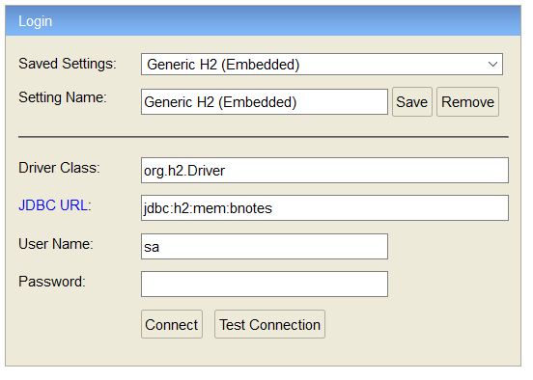

Resources:

Interesting videos
- https://www.youtube.com/watch?v=YywLS8XdxLQ&list=PLADt2LpCB_ikN6t_oHwUAM6zcKNhvQEfi
  - https://github.com/navinreddy20/Spring-Boot/tree/master/bootjpa
- https://www.youtube.com/watch?v=dVTh--j1suI
  - https://github.com/navinreddy20/Spring-Boot/tree/master/bootjpa1
- https://www.youtube.com/watch?v=WTEGvLXxyOY

Url for CSS:
- https://www.w3schools.com/w3css/tryit.asp?filename=tryw3css_material_download
- https://www.w3schools.com/w3css/w3css_material.asp

Windows PowerShell: export data via curl
- curl.exe -X POST "http://localhost:8080/exportItem?userName=u&password=p&itemName=entities.json" -o "C:\DA1D\data.json"
- "curl.exe" must be used as "curl" is an alias for another tool
- via command line
  - powershell "curl.exe -X POST 'http://localhost:8080/exportItem?userName=u&password=p&itemName=entities.json' -o 'C:\DA1D\data.json'"

Local application.properties file for testing.
Currently disabled, because 1. it caused problems on the prod server and 2. it is not needed for development because there the application.properties file location is provided via parameter.
Location:
- file:///C:/Users/phhey/.ph-app-config/bnotes/application.properties
content:
- spring.datasource.username=bnotes_db_user
spring.datasource.password=ThePassword
spring.datasource.url=jdbc:mysql://localhost:3306/bnotes_001?serverTimezone=UTC&useLegacyDatetimeCode=false

Creating MySQL database for testing
- Setup
  - create database bnotes_001;
  - create user 'bnotes_db_user'@'%' identified by 'ThePassword';
  - grant all on bnotes_001.* to 'bnotes_db_user'@'%'
- Initial data:
  - just use the h2 testing data "h2-test-data.sql" in "src/main/resources"

application.properties for production
A file called "application.properties" with the following content must be placed in
"${user.home}/.build-app-config/bnotes" where "${user.home}" is the user home directory such as "C:\Users\userabc\.build-app-config\bnotes"
server.port=80
server.ssl.enabled=true
server.ssl.protocol=TLS
#server.error.whitelabel.enabled=false
server.error.whitelabel.enabled=true

server.connection-timeout=5s
server.tomcat.max-swallow-size=10MB
server.tomcat.max-http-post-size=10MB
server.tomcat.accesslog.directory=logs
server.tomcat.accesslog.file-date-format=yyyy-MM-dd
server.tomcat.accesslog.prefix=access_log
server.tomcat.accesslog.suffix=.log

#: specify the driver name. Otherwise spring tries to determine it automatically, fails and the application won't start
spring.datasource.driver-class-name=com.mysql.jdbc.Driver
spring.datasource.platform=mysql
spring.jpa.database-platform=org.hibernate.dialect.MySQL5InnoDBDialect

#: disable Hibernate validator (Hibernate Validator - Jakarta Bean Validation).
#: It works fine locally, but on the tomcat server it causes an exception:
#: java.security.AccessControlException: access denied ("org.hibernate.validator.HibernateValidatorPermission" "accessPrivateMembers")
#: Otherwise a policy file may be needed such as "04webapps.policy" located in the "policy.d" folder
#: (which may not be accessible for non admin users on the server)
spring.jpa.properties.javax.persistence.validation.mode=none

#: create or update table ddl: none means not
spring.jpa.hibernate.ddl-auto=none
spring.jpa.properties.hibernate.jdbc.time_zone=UTC

#: show sql or not (true/false)
spring.jpa.show-sql=true
logging.level.root=INFO
logging.level.de.brightside.bnotes.controller=INFO

# credentials
spring.datasource.username=<username>
spring.datasource.password=<password>
spring.datasource.url=jdbc:mysql:<database url>?serverTimezone=UTC&useLegacyDatetimeCode=false

building the war file
- see also chapter "application.properties for production"
- with tests (maybe doesn't work due to database credentials in application.properties file that are for the production server)
  - mvn clean package
- without tests
  - mvn clean package -Dmaven.test.skip=true

Exporting all data from the server (on Windows)
Run the file "ExportServerData.bat" located in the "scripts" directory. The file will execute "ExportServerData.ps1" (reason for this setup: ps1-files cannot be run directly in windows, but only via "Run with PowerShell" from the context menu).
The file will read the configuration properties from the sub path "\.app-config\bnotes-export\main.properties" in the user directory. Example content of the properties file:
- Example content:
- username=u
- password=pw
- host=http://localhost:8080
- outputDir=C:\\DA1D\\export-test

Login code
- In order for the browser to recognize that username and password are entered the following is done
  - A form is used
  - a submit button calls submit
  - the input fields have the ids "username" and "password"
  - To make things "smooth"
    - when the form is submitted it just calls login but doesn't actually send the event @submit.prevent="login()"
    - when enter is pressed or the submit text is clicked (text used instead of button to make it look nicer) then the submit button click() method is executed. Code: >>v-on:keyup.enter="$refs.loginButton.click()"<<
    - the actual submit button is hidden via >>style="display: none;"<<

