Analog output
Power supply range : 10V~30V DC (0-10V output supply voltage needs 24VDC)
Output : 4-20mA, 0-5V, 0-10V
Maximum power consumption
Current output: 0.08W
Voltage output: 0.08W
Working humidity: 0%~100%RH
Working temperature :-40 C ~ 60 C
Spectral range :0.3~3μm
Measuring range: 0~1800W/m2
Resolution :1W/m2
Response time <=10S
Nonlinear <+-2%
Annual stability <+-2%
Cosine response <+-10%
Line length 60cm

Installation method
1. After the installation is complete, remove the protective cover
2. Make sure the bracket is installed and the radiation sensor is parallel to the ground.
3. Secure the sensor to the mounting bracket by using a screw through the mounting hole on the sensor.
4. Please note that the dust cover should not be damaged during the installation process, so as not to affect the measurement accuracy.

Wiring
 | Wire color | Description
Power | Brown | Power supply (10~30V DC)
Power | black | Power-
Communication | blue | Signal+
Communication | green | Signal-

Calculation formula
3.1 Current type signal output calculation method
For example, the range is 0~1800W/m2, 4~20mA output. When the output signal is 12mA, the current solar radiation value is calculated.
The solar radiation range spans 1800 W/m2 and is expressed by a 16 mA current signal, 1800 W/m2/16 mA = 112.5 W/m2/mA, that is, current 1mA represents solar radiation change 112.5W/m2, measured value 12mA-4mA=8mA, 8mA*112.5W/M2/mA = 900W/m2, the current solar radiation value is 900W/m2.
3.2 Voltage type signal output conversion calculation
For example, the range is 0~1800W/m2, 0-10V output. When the output signal is 5V, the current solar radiation value is calculated. sun
The span of the radiation range is 1800W/m2, expressed by a 10V voltage signal, 1800W/m2/10V=180W/m2/V, that is, electricity
Pressure 1V represents solar radiation change 180W/m2, measured value 5V-0V=5V, 5V*180W/m2/V=900W/m2, current sun
The radiation value is 900 W/m2.

RS485 Output

Power supply range :10V~30V DC
Output : RS 485 (standard Modbus-RTU protocol)
Power consumption :0.08W
Working humidity: 0%~100%RH
Working temperature: -40 C ~ 60 C
Spectral range: 0.3~3μm
Measuring range : 0~1800W/m2
Resolution :1W/m2
Response time :≤ 10S
Nonlinear: <±2%
Annual stability :≤ ± 2%
Cosine response: ≤ ± 10%
Line length : 60cm

Installation method
1. After the installation is complete, remove the protective cover
2. Make sure the bracket is installed and the radiation sensor is parallel to the ground.
3. Secure the sensor to the mounting bracket by using a screw through the mounting hole on the sensor.
4. Please note that the dust cover should not be damaged during the installation process, so as not to affect the measurement accuracy.

Wiring
 | Wire color | Description
Power | Brown | Power supply (10~30V DC)
Power | black | Power-
Communication | yellow | 485+
Communication | blue | 485-

how to change device address and baud rate ?
1. pls choose the right COM port . ( my computer-Device Manager-port(COM and IPT )
check
2. connect a PC and click software to check the baud rate ( 4800bit/s ) Address ( 0X01 )
3. change thge baud rate and the address you need .
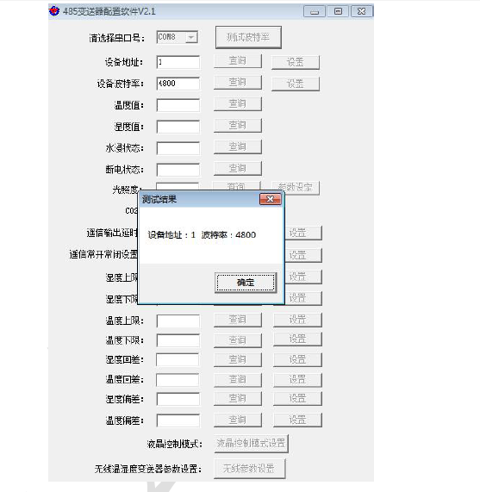
1. communication protocol
Code | 8 bit binary system
Data bits | 8bits
parity check bit | NO
stop bit | 1BIT
Error checking | CRC
baud rate | 2400bit/s、4800bit/s、9600 bit/s （4800bits by default）

2. Using Modbus-RTU communication protocol, the format is as follows:
The initial structure is more than 4 bytes of time
Address code = 1 bytes
Function = 1 bytes
Data area = N bytes
Error check = 16 bit CRC code
The end of the structure is greater than or equal to 4 bytes of time
Address code: the address of the transmitter, which is unique in the communication network (factory default 0x01).
Function code: the instruction function instruction from the host. The transmitter only uses the function code 0x03 (read register data).
Data area: data area is specific communication data, pay attention to 16bits data before the high byte!

Host query frame structure:
Address code | Function code | Register start address | Register length | check code low | Check code high
1 bytes | 1 bytes | 2 bytes | 2 bytes | 1 bytes | 1 bytes
Slave transponder frame structure
Address code | Function code | effective byte | No 1 Data area | NO2 Data area | No N Data area | Check code
1 bytes | 1 bytes | 1 bytes | 2 bytes | 2 bytes | 2 bytes | 2 bytes

Register address
Register address | content | Operation (hexadecimal) | Specification and definition
0000 H | Solar radiation value | 03 | actual value
0052H | Deviation | 03/06 | Solar radiation deviation  (0~1800)
07D0 H | Device address | 03/06 | 1~254 (factory default 1)
07D1H | Device baud rate | 03/06 | 0 represents 2400  1 represents 4800  2 represents 9600

Communication protocol example and explanation
4.4.1 Reading the current solar radiation value
Inquiry frame

Address code | Function code | Start address | Data length | check code low | Check code high
0x01 | 0x03 | 0x00 0x00 | 0x00 0x01 | 0x84 | 0x0A

Response frames
Address code | Function code | effective byte | Solar radiation value | check code low | Check code high
0x01 | 0x03 | 0x02 | 0x00 0x64 | 0x9B | 0xAF

Solar radiation value:
0064 (hexadecimal) =100=> solar radiation value = 100W/m2

Write bias value
Inquiry frame

Address code | Function code | Register start address | Modify value | check code low | Check code high
0x01 | 0x06 | 0x00 0x00 | 0x00 0x0A | 0x09 | 0xCD

Response frame
Address code | Function code | Register start address | Modify value | check code low | Check code high
0x01 | 0x06 | 0x00 0x00 | 0x00 0x0A | 0x09 | 0xCD

Write current solar radiation deviation value
000A (hexadecimal) =10=> Solar radiation deviation value = 10W/m2 The deviation value is 10W/m2

Modify current address
Inquire frame (modify current address is 0x02)
Address code | Function code | Register start address | Modify value | check code low | Check code high
0x01 | 0x06 | 0x07 0xD0 | 0x00 0x02 | 0x08 | 0x86

Response frame
Address code | Function code | Register start address | Modify value | check code low | Check code high
0x01 | 0x06 | 0x07 0xD0 | 0x00 0x02 | 0x08 | 0x86

Modify the current baud rate
Address code | Function code | Register start address | Modify value | check code low | Check code high
0x01 | 0x06 | 0x07 0xD1 | 0x00 0x02 | 0x59 | 0x46

Response frame
Address code | Function code | Register start address | Modify value | check code low | Check code high
0x01 | 0x06 | 0x07 0xD1 | 0x00 0x02 | 0x59 | 0x46

Query current address
Inquiry frame
Address code | Function code | Start address | Data length | check code low | Check code high
0xFF | 0x03 | 0x07 0xD0 | 0x00 0x01 | 0x91 | 0x59

Response frame
Address code | Function code | Returns the number of valid bytes | address | check code low | Check code high
0xFF | 0x03 | 0x02 | 0x00 0x01 | 0x50 | 0x50

The address code read is the real address of the device: 01

Precautions and troubleshooting
Precautions:
1. When the customer receives the product, please confirm the product model, etc.
2. Do not electrify the wiring. After the wiring check is correct, the power can be turned on.
3. The sensor is a precision device. Do not disassemble the protective transparent cover.
Troubleshooting:
1. If the read value is displayed as 0, check if the product protection cover is removed.
2. Please check if the 485 wiring is correct.
3. Check if the power supply meets the label
4. Equipment damage
6. Product maintenance
1. The dust cover should be kept clean, often with a soft cloth or wipe
2. There should be no water in the dust cover. If you encounter heavy rain, snow, ice, etc. for a long time, it is recommended to cover it.

