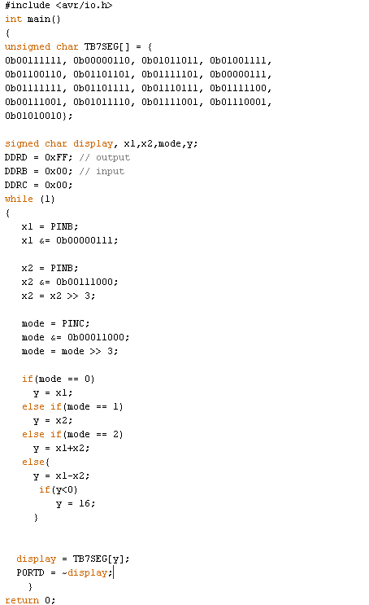

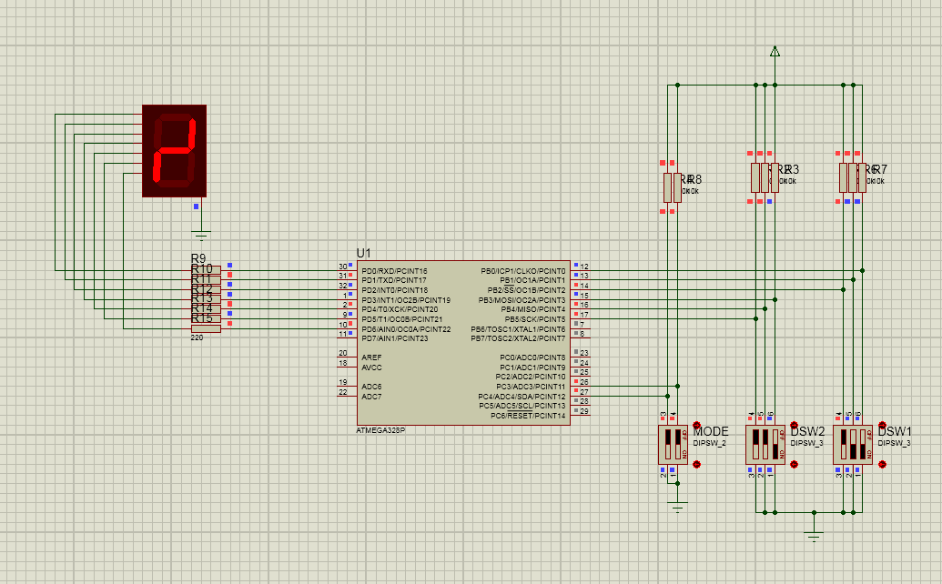

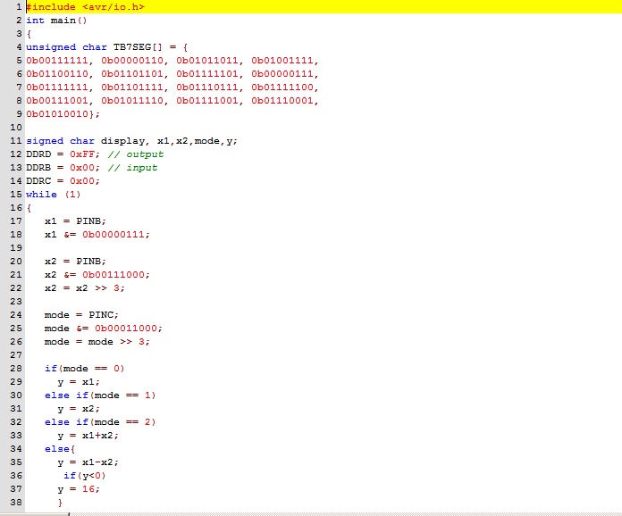

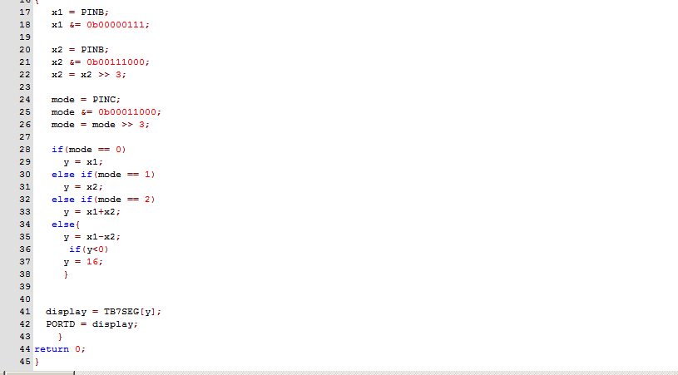

**Proteus**

#include <avr/io.h>

int main()

{

unsigned char TB7SEG[] = {

0b00111111, 0b00000110, 0b01011011, 0b01001111,

0b01100110, 0b01101101, 0b01111101, 0b00000111,

0b01111111, 0b01101111, 0b01110111, 0b01111100,

0b00111001, 0b01011110, 0b01111001, 0b01110001,

0b01010010};

signed char display, x1,x2,mode,y;

DDRD = 0xFF; // output

DDRB = 0x00; // input

DDRC = 0x00;

while (1)

{

x1 = PINB;

x1 &= 0b00000111;

x2 = PINB;

x2 &= 0b00111000;

x2 = x2 >> 3;

mode = PINC;

mode &= 0b00011000;

mode = mode >> 3;

if(mode == 0)

y = x1;

else if(mode == 1)

y = x2;

else if(mode == 2)

y = x1+x2;

else{

y = x1-x2;

if(y<0)

y = 16;

}

display = TB7SEG[y];

PORTD = display;

}

return 0;

}

**Arduino**

#include <avr/io.h>

int main()

{

unsigned char TB7SEG[] = {

0b00111111, 0b00000110, 0b01011011, 0b01001111,

0b01100110, 0b01101101, 0b01111101, 0b00000111,

0b01111111, 0b01101111, 0b01110111, 0b01111100,

0b00111001, 0b01011110, 0b01111001, 0b01110001,

0b01010010};

signed char display, x1,x2,mode,y;

DDRD = 0xFF; // output

DDRB = 0x00; // input

DDRC = 0x00;

while (1)

{

x1 = PINB;

x1 &= 0b00000111;

x2 = PINB;

x2 &= 0b00111000;

x2 = x2 >> 3;

mode = PINC;

mode &= 0b00011000;

mode = mode >> 3;

if(mode == 0)

y = x1;

else if(mode == 1)

y = x2;

else if(mode == 2)

y = x1+x2;

else{

y = x1-x2;

if(y<0)

y = 16;

}

display = TB7SEG[y];

PORTD = ~display;

}

return 0;

}