Tái hiện lỗi:
- Thực hiện bắn 1000000000 messages liên tục vào topics: Connector_Flex_SmsEmail -> xuất hiện lỗi : Expiring 38 record(s) for Connector_Flex_SmsEmail-0:120298 ms has passed since batch creation
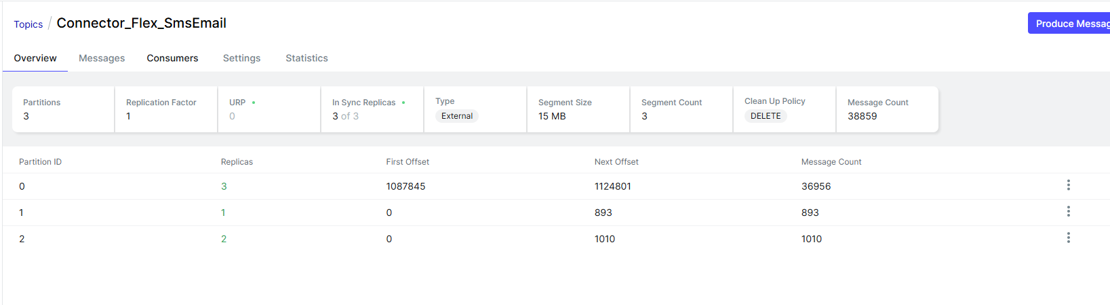

2026-01-15 12:00:06.935 DEBUG 1 --- [ad | producer-1] v.c.v.s.kafka.impl.EmailHandlerImpl : Updated email log
2026-01-15 12:00:06.935 DEBUG 1 --- [ad | producer-1] v.c.vpbanks.configs.KafkaProducerConfig : Successful push data to kafka, data: KafkaNotificationMessage(autoId=FLEX_9842753_5cd13488-6e38-49a4-b7d0-aed439146a08, emailOrPhone=0002022056@vpbanks.com.vn, accountNo=null, type=EMAIL, templateId=T0003, data=T0003Message(fullname=TAI KHOAN 0002022056, custodycd=116C596839, cdcontent=Ký quỹ, forcedate=16/12/2025, marginrate=130.12, ovdamount=983,235,136, shortbank=null, fullbank=null), attachment=null, ccEmails=[]), topic: Connector_Flex_SmsEmail; partition: 0 with offset 1122000
2026-01-15 12:00:06.935 DEBUG 1 --- [ad | producer-1] v.c.v.repository.impl.EmailDAOImpl : [updateEmailLog] : requestId 298fd5cd-3be2-4a71-a24f-73bb1dfd3a71, autoId : 9842754, status : S , message Flex Connector sent message successfully
2026-01-15 12:00:06.966 DEBUG 1 --- [ad | producer-1] v.c.v.repository.impl.EmailDAOImpl : [updateEmailLog] updated email log
2026-01-15 12:00:06.966 DEBUG 1 --- [ad | producer-1] v.c.v.service.kafka.impl.SmsHandlerImpl : Updated email log
2026-01-15 12:00:06.966 DEBUG 1 --- [ad | producer-1] v.c.vpbanks.configs.KafkaProducerConfig : Successful push data to kafka, data: KafkaNotificationMessage(autoId=FLEX_9842754_78a753f7-03f6-4a75-bcf1-1b76df8c6a46, emailOrPhone=0005000199, accountNo=null, type=SMS, templateId=T003S, data=T003SMessage(custodycd_acctno=237474.Ky quy, custodycd=116C237474, marginrate=26.9, ovdamount=94,793,496, shortbank=null, fullbank=null), attachment=null, ccEmails=null), topic: Connector_Flex_SmsEmail; partition: 0 with offset 1122001
2026-01-15 12:00:06.967 DEBUG 1 --- [ad | producer-1] v.c.v.repository.impl.EmailDAOImpl : [updateEmailLog] : requestId f473eab4-9f87-4d60-8754-de15efd13156, autoId : 9842945, status : E , message Failed to send; nested exception is org.apache.kafka.common.errors.TimeoutException: Expiring 38 record(s) for Connector_Flex_SmsEmail-0:120298 ms has passed since batch creation
2026-01-15 12:00:07.003 DEBUG 1 --- [ad | producer-1] v.c.v.repository.impl.EmailDAOImpl : [updateEmailLog] updated email log
2026-01-15 12:00:07.003 ERROR 1 --- [ad | producer-1] v.c.vpbanks.configs.KafkaProducerConfig : error while push data to kafka, data KafkaNotificationMessage(autoId=FLEX_9842945_7f3bab79-8276-4dc5-aef7-97fc2734ec83, emailOrPhone=0004017398@vpbanks.com.vn, accountNo=null, type=EMAIL, templateId=T0003, data=T0003Message(fullname=TAI KHOAN 0004017398, custodycd=116C837968, cdcontent=Ký quỹ, forcedate=16/12/2025, marginrate=93.42, ovdamount=1,555,578,633, shortbank=null, fullbank=null), attachment=null, ccEmails=[]), topic: Connector_Flex_SmsEmail, exception Expiring 38 record(s) for Connector_Flex_SmsEmail-0:120298 ms has passed since batch creation
2026-01-15 12:00:07.003 DEBUG 1 --- [ad | producer-1] v.c.v.repository.impl.EmailDAOImpl : [updateEmailLog] : requestId 935736ce-41e2-42e6-875a-6a93396326af, autoId : 9842946, status : E , message Failed to send; nested exception is org.apache.kafka.common.errors.TimeoutException: Expiring 38 record(s) for Connector_Flex_SmsEmail-0:120298 ms has passed since batch creation
2026-01-15 12:00:07.034 DEBUG 1 --- [ad | producer-1] v.c.v.repository.impl.EmailDAOImpl : [updateEmailLog] updated email log
2026-01-15 12:00:07.034 ERROR 1 --- [ad | producer-1] v.c.vpbanks.configs.KafkaProducerConfig : error while push data to kafka, data KafkaNotificationMessage(autoId=FLEX_9842946_26ec06ca-6301-43ff-af31-5b187e0afa74, emailOrPhone=0004017371, accountNo=null, type=SMS, templateId=T003S, data=T003SMessage(custodycd_acctno=888616.Ky quy, custodycd=116C888616, marginrate=113.16, ovdamount=44,917,612, shortbank=null, fullbank=null), attachment=null, ccEmails=null), topic: Connector_Flex_SmsEmail, exception Expiring 38 record(s) for Connector_Flex_SmsEmail-0:120298 ms has passed since batch creation
2026-01-15 12:00:07.034 DEBUG 1 --- [ad | producer-1] v.c.v.repository.impl.EmailDAOImpl : [updateEmailLog] : requestId a00142a4-876e-4666-8080-71fa101e429d, autoId : 9842947, status : E , message Failed to send; nested exception is org.apache.kafka.common.errors.TimeoutException: Expiring 38 record(s) for Connector_Flex_SmsEmail-0:120298 ms has passed since batch creation

Phân tích nguyên nhân:
- Message tồn tại quá lâu trong producer batch (chưa kịp gửi hoặc đang retry)
  - Luồng thực tế có thể là:
    - send()
    - → RecordAccumulator
    - → batch creation
    - → sender thread chậm
    - → batch nằm chờ
    - → delivery.timeout.ms hết
    - → ❌ EXPIRED
- Message đã gửi đi nhưng không nhận được ACK từ broker trong thời gian cho phép
  - Luồng thực tế có thể:
    - send()
    - → network send
    - → broker ghi chậm / replica lag
    - → ACK về trễ
    - → delivery.timeout.ms hết
    - → ❌ EXPIRED
Giải pháp:
- Giảm tải số lượng message bắn vào broker bằng cách
  - Set key cho mỗi message bắn vào broker -> rải message ra các partition, không dẫn đến tình trạng hot partition
  - Tăng linger time từ 0ms -> 5ms -> do đang gặp vấn đề với số lượng message, tang linger sẽ giảm số lượng message gửi đến broker
- Tách thread update email để giải phóng thread producer -> các message đã batch sẽ được gửi không phải chờ update DB xong mới được gửi
  - BEFORE
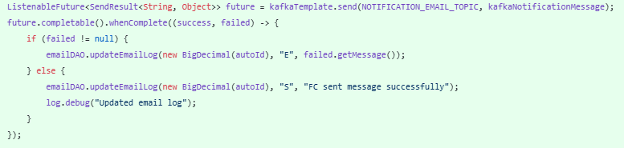
  - AFTER
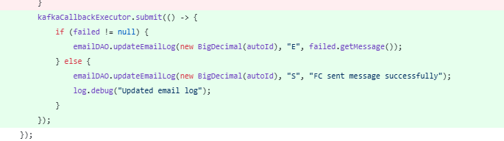
- Kafka Producer gửi message nhanh hơn khả năng xử lý thực tế của broker, trong khi producer KHÔNG có cơ chế tự giới hạn
- Giới hạn số message đang “in-flight” bằng Semaphore

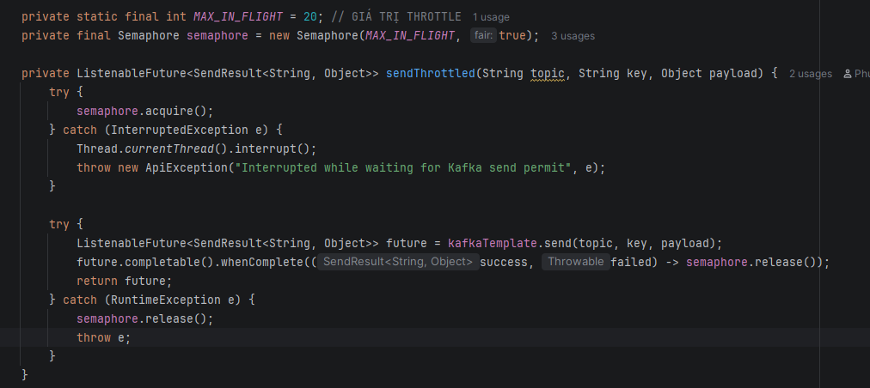
- tại mọi thời điểm chỉ tối đa 20 send pending, send thứ 21 sẽ chờ cho đến khi có 1 send trước đó complete.

Kết quả:
- Với cùng cách bắn 100000000 messages như ban đầu nhưng đã success toàn bộ

