Karnel Travel Guide – Project Plan & Task Sheet
Oct 30, 2026 · @Ha Pham
A team of three builds the site in 30 days, from 29 Oct to 27 Nov 2026, with each member owning one area end to end.

1. Team and Roles
Work is split by feature area so that each member builds their own pages from database to screen, and the workload stays roughly equal.
Member | Name | Role | Owns
A | ________ | Team leader, back-end lead | Project plan, Search and Advanced Search, Admin area, status reports, final report and ZIP
B | ________ | Database and content lead | ERD, SQL scripts, sample data, Information page and its 5 sub-pages, detail pages
C | ________ | Front-end and QA lead | GUI standards, wireframes, shared layout and menu, Home, About Us, Contact Us and Feedback, testing
All three members write comments in their own code, test their own pages, and write the documents for their area.

2. Schedule
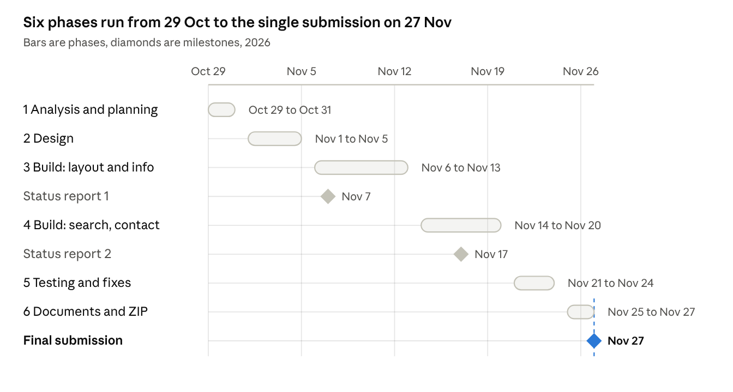
project schedule · 6 phases, 3 milestones
Building takes the middle 15 days (6 to 20 Nov); status reports fall on 7 Nov and 17 Nov, and the project is submitted once on 27 Nov.

3. Task Sheet
Owners update the Status column as they work; dates assume the 30-day schedule above.
ID | Phase | Task | Owner | Start | End | Status
T01 | 1 | Analyse the assignment and list requirements | All | 29 Oct | 29 Oct | Done
T02 | 1 | Problem Definition | A | 29 Oct | 30 Oct | Done
T03 | 1 | Customer Requirement Specification | A | 29 Oct | 30 Oct | Done
T04 | 1 | Choose technology: ASP.NET Core MVC + SQL Server | All | 30 Oct | 30 Oct | Done
T05 | 1 | Project Plan and Task Sheet | A | 30 Oct | 31 Oct | In progress
T06 | 1 | Create Git repository and folder structure | A | 30 Oct | 31 Oct | Not started
T07 | 1 | Collect sample content and images | B | 30 Oct | 05 Nov | Not started
T08 | 2 | ERD and table design | B | 01 Nov | 02 Nov | Not started
T09 | 2 | SQL create and seed scripts | B | 03 Nov | 05 Nov | Not started
T10 | 2 | Sitemap and wireframes | C | 01 Nov | 03 Nov | Not started
T11 | 2 | GUI Standards Document | C | 03 Nov | 04 Nov | Not started
T12 | 2 | Interface Design Document | C | 04 Nov | 05 Nov | Not started
T13 | 2 | Algorithms for search and booking | B | 03 Nov | 05 Nov | Not started
T14 | 3 | Set up ASP.NET Core MVC project, EF Core and database connection | A | 06 Nov | 07 Nov | Not started
T15 | 3 | Configure hosts file for www.karneltravelguide.com | C | 07 Nov | 07 Nov | Not started
T16 | 3 | Status report #1 (STATUS:) | A | 07 Nov | 07 Nov | Not started
T17 | 3 | Admin login | B | 08 Nov | 13 Nov | Not started
T18 | 3 | Shared layout, menu and footer | C | 06 Nov | 08 Nov | Not started
T19 | 3 | Home Page | C | 08 Nov | 10 Nov | Not started
T20 | 3 | About Us | C | 10 Nov | 11 Nov | Not started
T21 | 3 | Information Page with new places and packages | B | 06 Nov | 08 Nov | Not started
T22 | 3 | Tourist Spots and Travel Information pages | B | 08 Nov | 10 Nov | Not started
T23 | 3 | Hotel, Restaurant and Resort pages with detail pages | B | 10 Nov | 13 Nov | Not started
T24 | 4 | Search tourist spots by type | A | 14 Nov | 15 Nov | Not started
T25 | 4 | Search hotels, restaurants and resorts by location, price, quality, quantity, availability | A | 15 Nov | 18 Nov | Not started
T26 | 4 | Advanced Search with sorting and paging | A | 18 Nov | 20 Nov | Not started
T27 | 4 | Status report #2 (STATUS:) | A | 17 Nov | 17 Nov | Not started
T28 | 4 | Contact Us order form with validation | C | 14 Nov | 17 Nov | Not started
T29 | 4 | Feedback form | C | 17 Nov | 18 Nov | Not started
T30 | 4 | Admin pages: manage data, orders and feedback | B | 14 Nov | 20 Nov | Not started
T31 | 5 | Unit Testing Check List and test run | C | 21 Nov | 23 Nov | Not started
T32 | 5 | Responsive and browser checks | C | 22 Nov | 23 Nov | Not started
T33 | 5 | Bug fixing, each owner in their own area | All | 21 Nov | 24 Nov | Not started
T34 | 5 | Code comment review | B | 23 Nov | 24 Nov | Not started
T35 | 5 | Project Review and Monitoring Report | A | 23 Nov | 24 Nov | Not started
T36 | 6 | Assemble the Project Report | A | 25 Nov | 26 Nov | Not started
T37 | 6 | Login credentials and setup guide | B | 25 Nov | 25 Nov | Not started
T38 | 6 | Database backup (.bak) and final SQL script | B | 25 Nov | 26 Nov | Not started
T39 | 6 | Screenshots and eProjects Feedback Form | C | 25 Nov | 26 Nov | Not started
T40 | 6 | Final Check List, ZIP, test on another PC | All | 26 Nov | 27 Nov | Not started
T41 | 6 | Submit once with PROJECT SUBMISSION: | A | 27 Nov | 27 Nov | Not started
Workload: A has 13 tasks, B has 12, C has 12, and 4 are shared by all three.

4. Working Rules
- Back up the database and project files every day.
- Each member works on their own Git branch and pushes at the end of every session; A merges into main.
- A short team check-in each day: what was done, what is next, what is blocking.
- B and C send A their progress, screenshots and blockers one day before each status report.
- Questions to the eProjects Team go by email with the subject starting DOUBT:.
- A task is Done only when its page works with real data from the database and its code is commented.

