<https://github.com/phhduc/lap_trinh_co_so_du_lieu/tree/main/baitaptuan3/bttuan3>

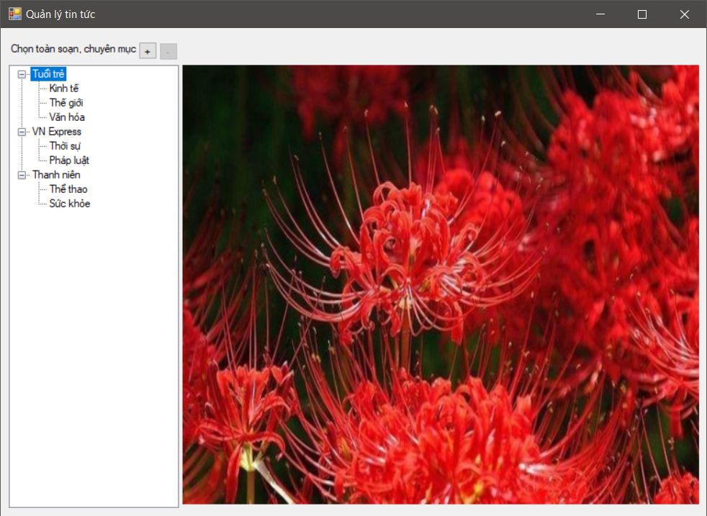

using bttuan3.RSSFeed;

using System;

using System.Collections.Generic;

using System.Linq;

using System.Text;

using System.Threading.Tasks;

namespace bttuan3

{

public class NewsFeedManager

{

private readonly INewsRepository _newsRepository;

private List<Publisher> _publishers;

private readonly RssReader _rssReader;

public NewsFeedManager(INewsRepository newsRepository, RssReader rssReader)

{

_newsRepository = newsRepository;

_rssReader = rssReader;

}

public List<Publisher> GetNewsFeed()

{

if (_publishers == null)

{

_publishers = _newsRepository.GetNews();

}

return _publishers;

}

public void SaveChanged()

{

_newsRepository.Save(_publishers);

}

public void RemovePublisher(string publisherName)

{

_publishers.RemoveAll(x => x.Name == publisherName);

SaveChanged();

}

public void RemoveCategory(string publisherName, string categoryName)

{

var publisher = _publishers.Find(x => x.Name == publisherName);

if (publisher == null) return;

publisher.RemoveCategory(categoryName);

SaveChanged();

}

public bool AddCategory(string publisherName, string categoryName, string rsslink, bool updateIfExisted)

{

var publisher = _publishers.Find(x => x.Name == publisherName);

if(publisher == null)

{

publisher = new Publisher()

{

Name = publisherName

};

_publishers.Add(publisher);

}

return publisher.AddCategory(categoryName, rsslink, updateIfExisted);

}

public List<Article> GetNews(string publisherName, string categoryName)

{

var publisher = _publishers.Find(x => x.Name == publisherName);

if (publisher == null) return new List<Article>();

var category = publisher.Categories.Find(x => x.Name == categoryName);

if (category == null) return new List<Article>();

if (category.Articles.Count == 0)

{

category.Articles = _rssReader.GetNews(category.RssLink);

}

return category.Articles;

}

}

}

using System;

using System.Collections.Generic;

using System.ComponentModel;

using System.Data;

using System.Drawing;

using System.Linq;

using System.Text;

using System.Threading.Tasks;

using System.Windows.Forms;

namespace bttuan3

{

public partial class AddFeedForm : Form

{

public readonly NewsFeedManager _newManager;

public bool HasChanges { get; set; }

public AddFeedForm(NewsFeedManager newManager)

{

_newManager = newManager;

InitializeComponent();

}

private void AddFeedForm_Load(object sender, EventArgs e)

{

var publishers = _newManager.GetNewsFeed();

foreach(var p in publishers)

{

cbbPublishers.Items.Add(p.Name);

}

}

private void btnAdd_Click(object sender, EventArgs e)

{

var pName = cbbPublishers.Text;

var cName = txtCategoryName.Text;

var rssl = txtRssLink.Text;

if(string.IsNullOrWhiteSpace(pName) ||

string.IsNullOrWhiteSpace(cName) ||

string.IsNullOrWhiteSpace(rssl))

{

MessageBox.Show("Bạn phải nhập đủ dữ liệu", "Lỗi");

return;

}

HasChanges = true;

var success = _newManager.AddCategory(pName, cName, rssl, false);

if (success)

{

ClearForm();

return;

}

if(MessageBox.Show("Chuyên mục này đã tồn tại, bạn có muốn cập nhật RSS Link không?","Thông báo", MessageBoxButtons.YesNo)==DialogResult.Yes)

{

_newManager.AddCategory(pName, cName, rssl, true);

}

ClearForm();

}

private void ClearForm()

{

cbbPublishers.Text = "";

txtCategoryName.Text = "";

txtRssLink.Text = "";

}

private void btnClose_Click(object sender, EventArgs e)

{

this.Close();

}

}

}

using System;

using System.Collections.Generic;

using System.Linq;

using System.Net;

using System.Text;

using System.Threading.Tasks;

namespace bttuan3.RSSFeed

{

public class RssReader

{

private readonly NewsParser _parser;

public RssReader(NewsParser parser)

{

_parser = parser;

}

public List<Article> GetNews(string rssLink)

{

var feedData = DownloadFeed(rssLink);

return _parser.ParseXml(feedData);

}

private string DownloadFeed(string rssLink)

{

var client = new WebClient()

{

Encoding = Encoding.UTF8

};

return client.DownloadString(rssLink);

}

}

}

using System;

using System.Collections.Generic;

using System.Linq;

using System.Text;

using System.Text.RegularExpressions;

using System.Threading.Tasks;

using System.Xml;

namespace bttuan3.RSSFeed

{

public class NewsParser

{

public List<Article> ParseXml(string xmlContent)

{

var document = new XmlDocument();

document.LoadXml(xmlContent);

var articles = new List<Article>();

var itemNode = document.SelectNodes("//item");

foreach(XmlNode node in itemNode)

{

var news = new Article()

{

Title = node.SelectSingleNode("title").InnerText,

Description = StripHtml(node.SelectSingleNode("description").InnerText),

Link = node.SelectSingleNode("link").InnerText,

PublishedDate = ParseDate(node.SelectSingleNode("pubDate").InnerText)

};

articles.Add(news);

}

return articles;

}

private DateTime ParseDate(string innerText)

{

try

{

return DateTime.Parse(innerText);

}

catch

{

return DateTime.Now;

}

}

private string StripHtml(string content)

{

return Regex.Replace(content, "<.*?>", String.Empty).Trim();

}

}

}