Implementation of Blockchain in Financial Sector to Improve Scalability

In this paper author is describing advantages Blockchain over traditional centralized banking application as all bank servers runs on centralized server and this server maintain data only in one place and attackers can hack this server and if this happen then entire bank server will be crashed and to overcome from this problem author is suggesting to revert or add Blockchain to banking application.

Blockchain support decentralized storage which means its data will be stored at multiple nodes as a peer to peer network and Blockchain store each record as BLOCK/transaction and associate each block with unique hash code and before storing any new record then Blockchain will verify hash code of each Block and if this Block not changed then only new Block will be added so it’s impossible to change any Blockchain backend record which make Blockchain as immutable.

Blockchain cannot be inspected by POLICE or any other law so its transaction cannot be traced. Blockchain has low maintenance cost compare to traditional cost and Blockchain has inbuilt support data cryptography or encryption or data security.

Above advantages of Blockchain are making almost all application to divert to Blockchain so author suggesting to include Blockchain functionality for banking application where user can send and receive money.

All Blockchain bank account can be access by using SOLIDITY code often called as SMART CONTRACT and this code can be deployed on Ethereum tool and then using python WEB3 API we can access that solidity code or function to create use account or to deposit and transfer amount. Below screen showing SOLIDITY code for Bank SMART CONTRACT

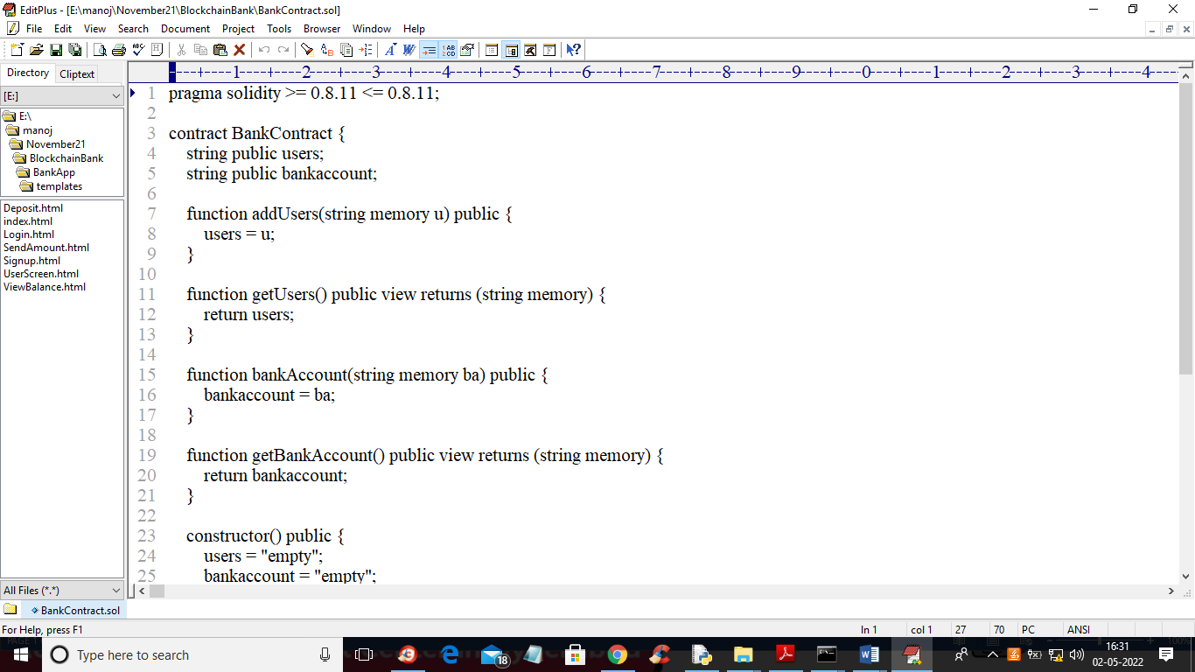

In above screen we have created BANKCONTRACT solidity code which has 2 functions called ‘addUsers’ and “bankAccount”. Blockchain stores all user signup details by calling ‘addUsers’ function and store all bank transactions details by calling ‘bankAccount’ function.

Now to deploy above solidity code on Ethereum just go inside “hello-eth/node_modules/.bin folder and double click on ‘runBlockchain.bat’ file to get below screen

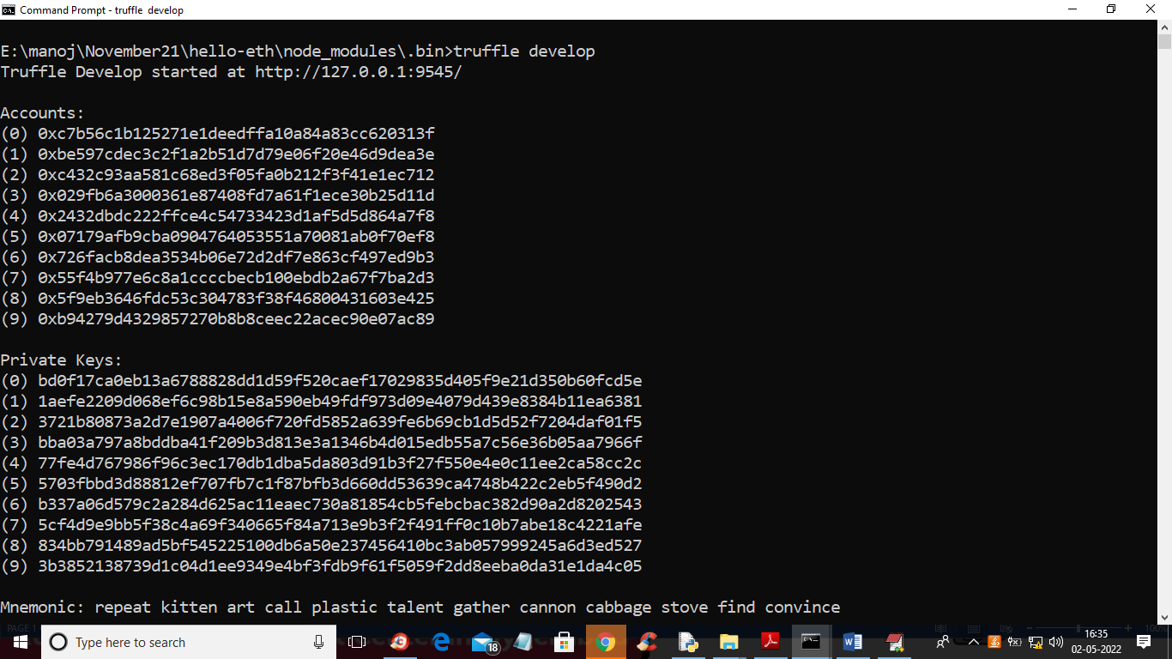

In above screen Ethereum created some accounts and private keys and then press enter key on above console to deployed contract and get below output

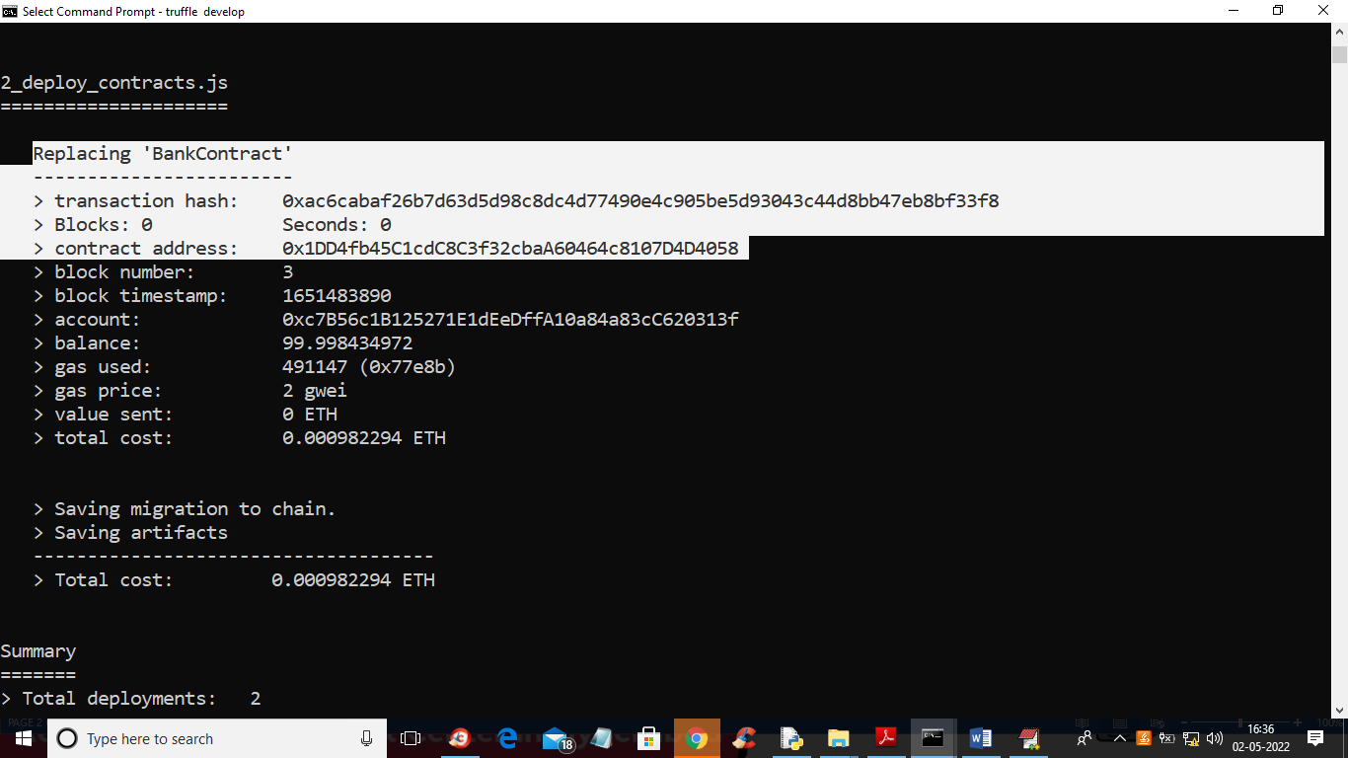

In above screen in white colour text we can see ‘BankContract” deployed and we got contract address also and this contract address can be specified in python WEB3 function to access that deployed contract and in below screen you can see that python code

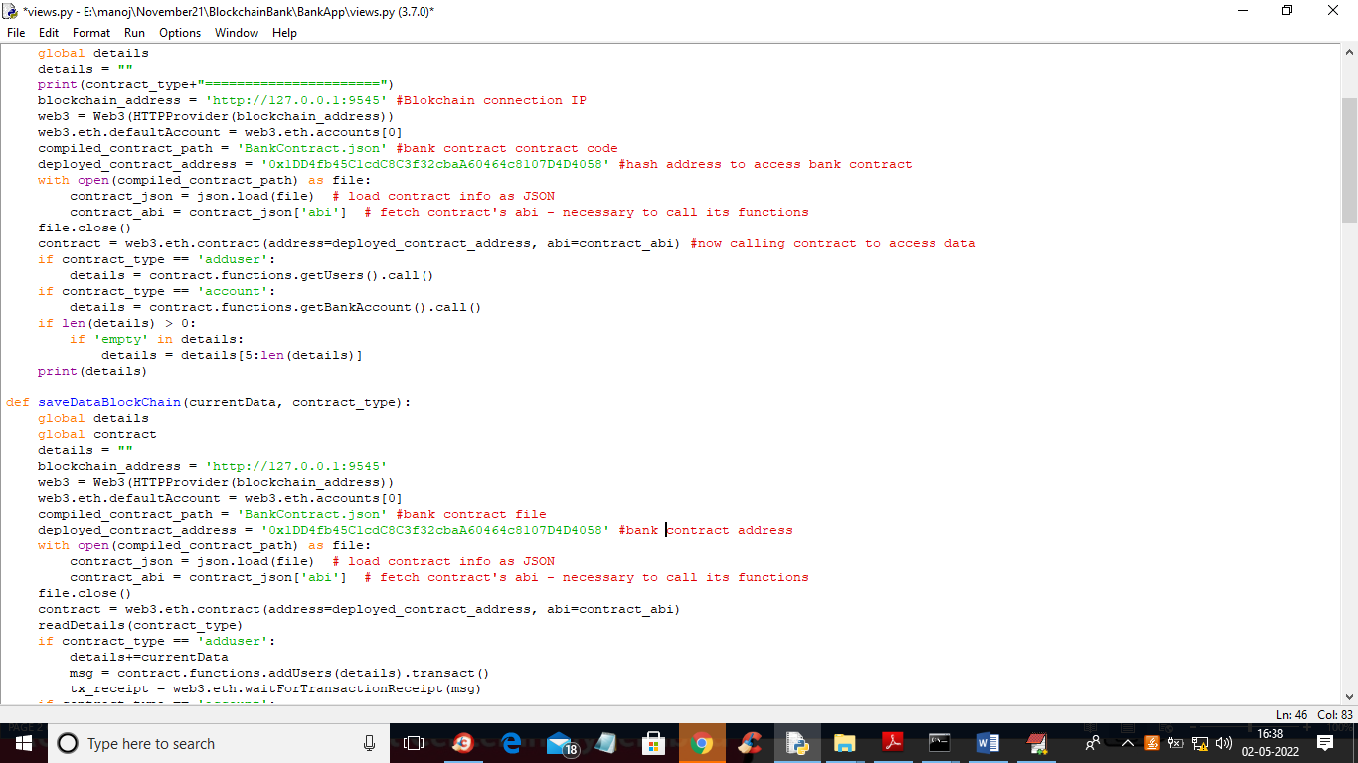

In above screen read red colour comments to know about calling Ethereum Blockchain contract to store and retrieve USERS and bank transactions details.

SCREEN SHOTS

Double click on ‘run.bat’ file to start ‘DJANGO’ web server like below screen

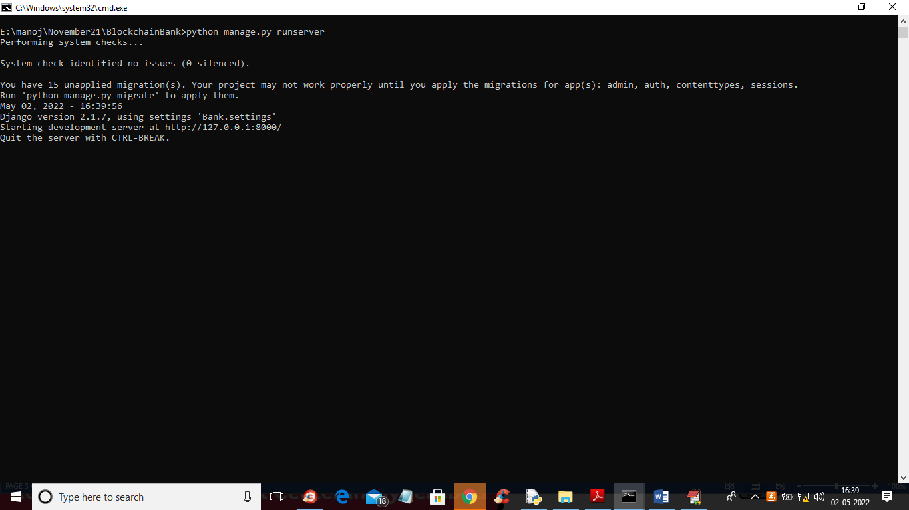

In above screen DJANGO server started and now open browser and enter URL as <http://127.0.0.1:8000/index.html> and press enter key to get below page

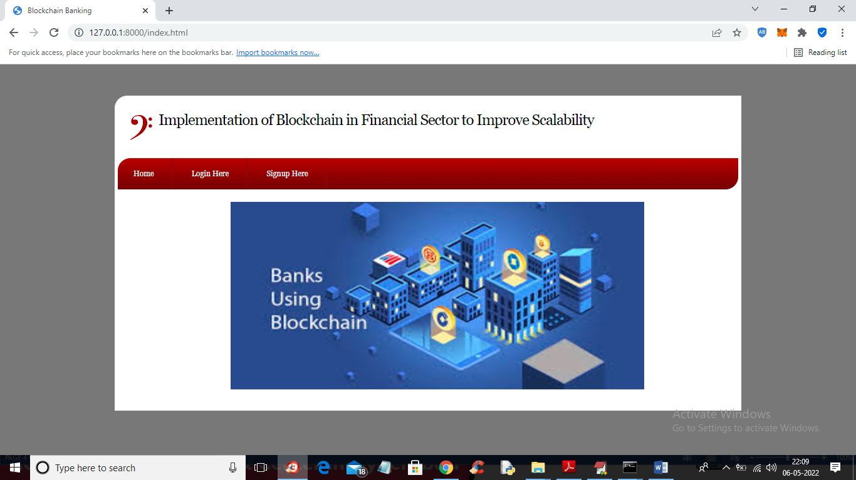

In above screen click on ‘Signup Here’ link to get below screen

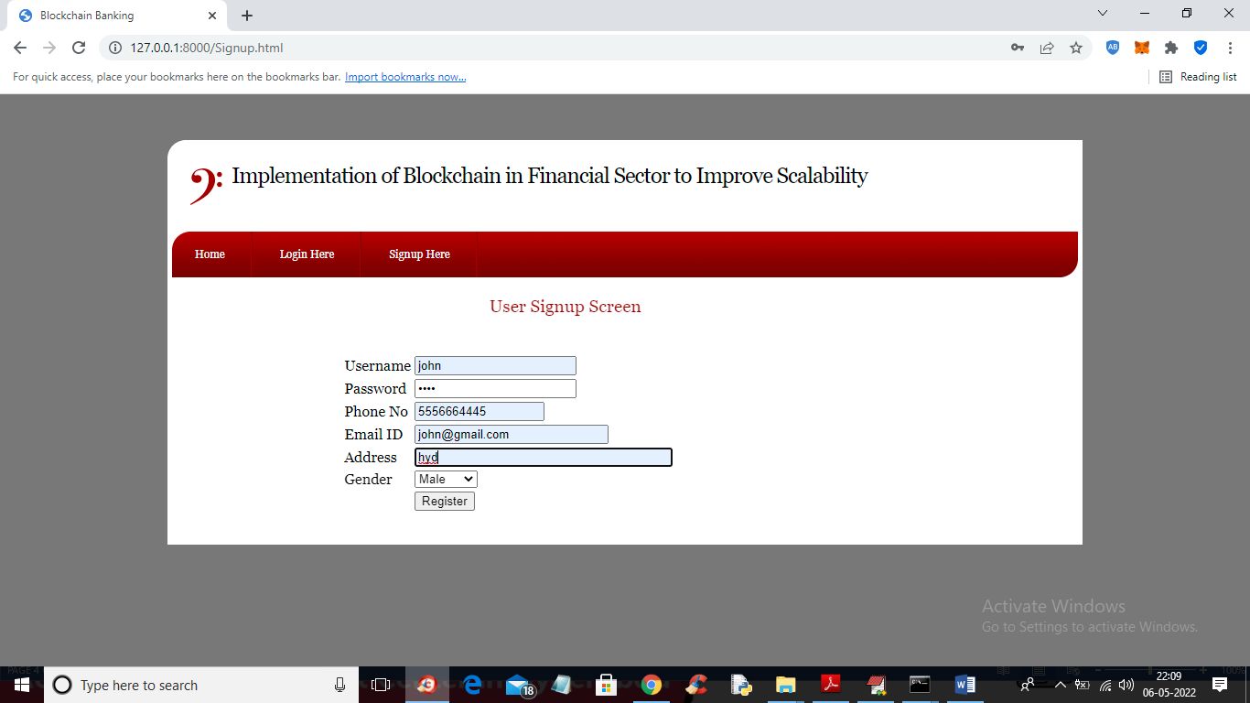

In above screen user is entering signup details and then press button to get below output

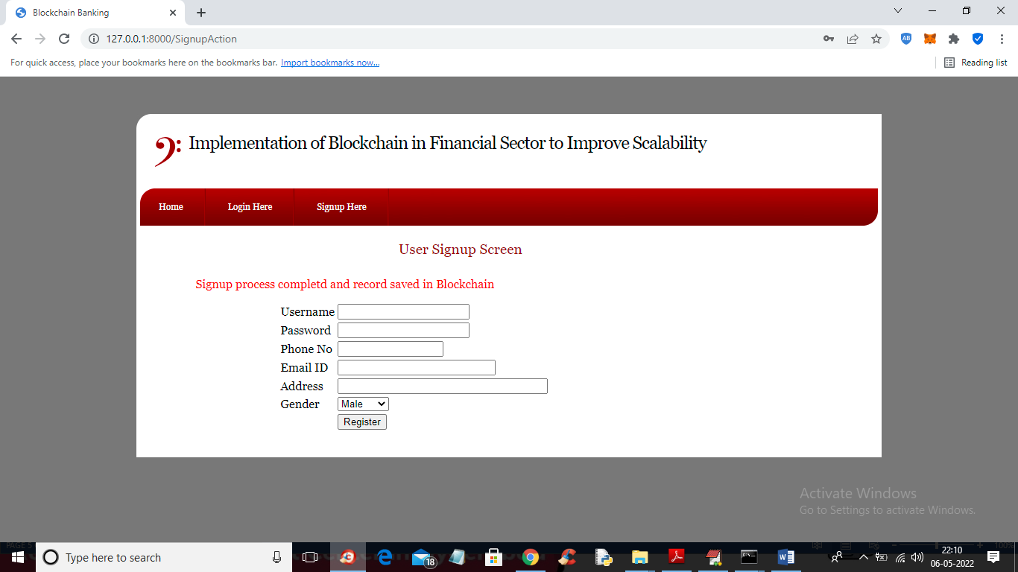

In above screen user signup details saved in Blockchain and now click on ‘Login Here’ link to get below login screen

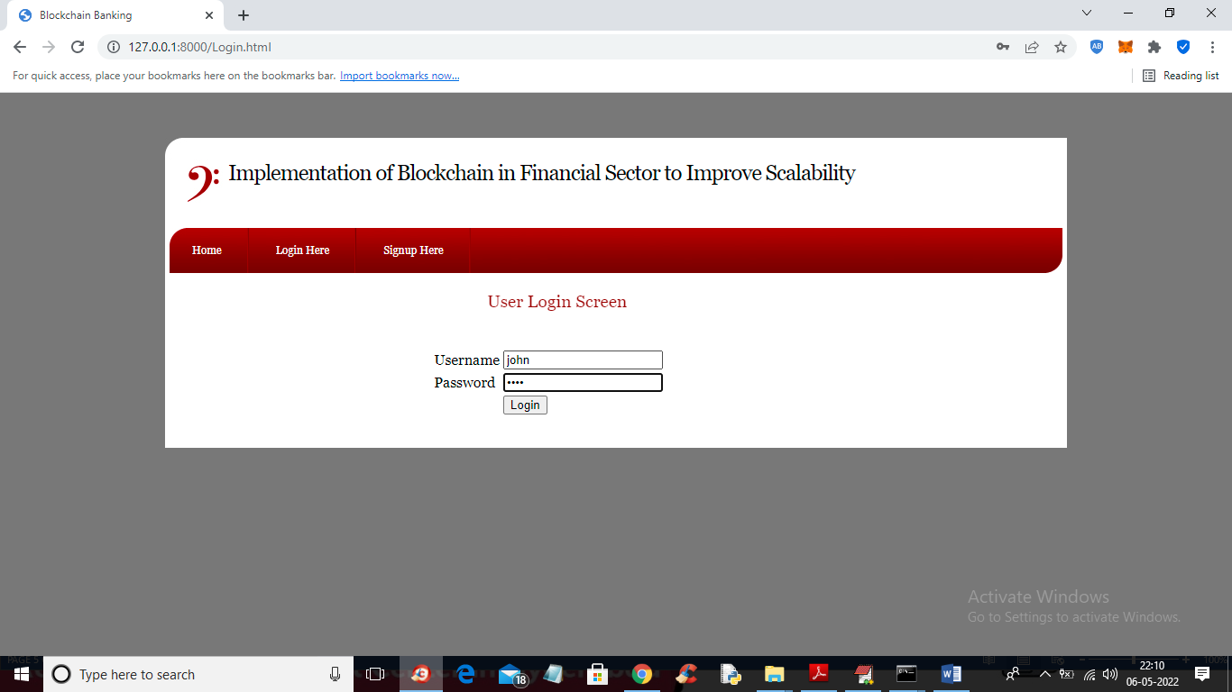

In above screen user is login and after login will get below output

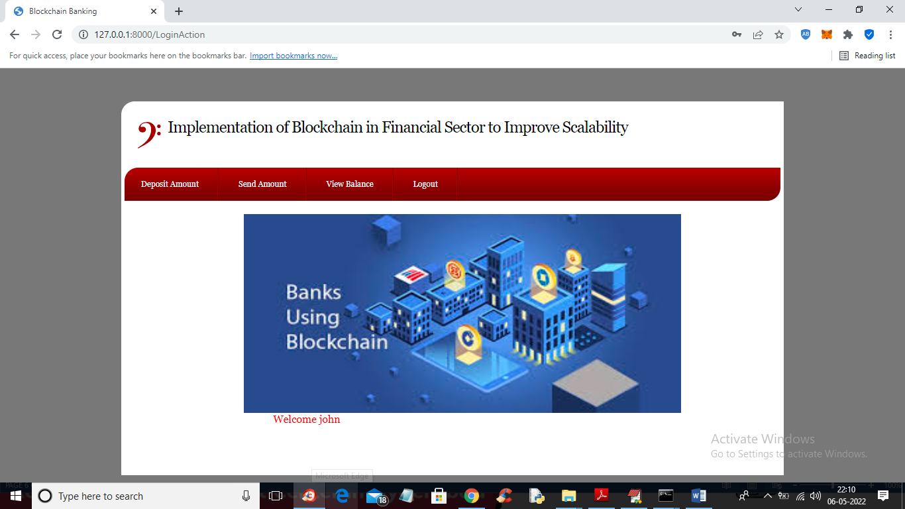

In above screen user can click on ‘Deposit Amount’ link to add amount to his account

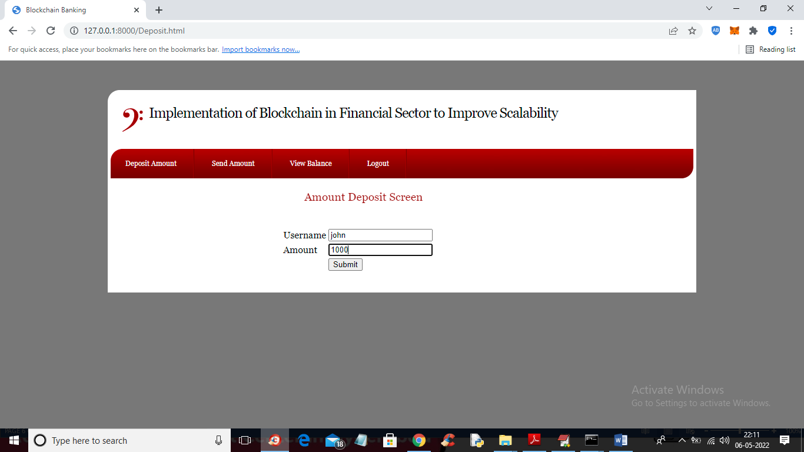

In above screen user will enter amount and press button to add amount to his account

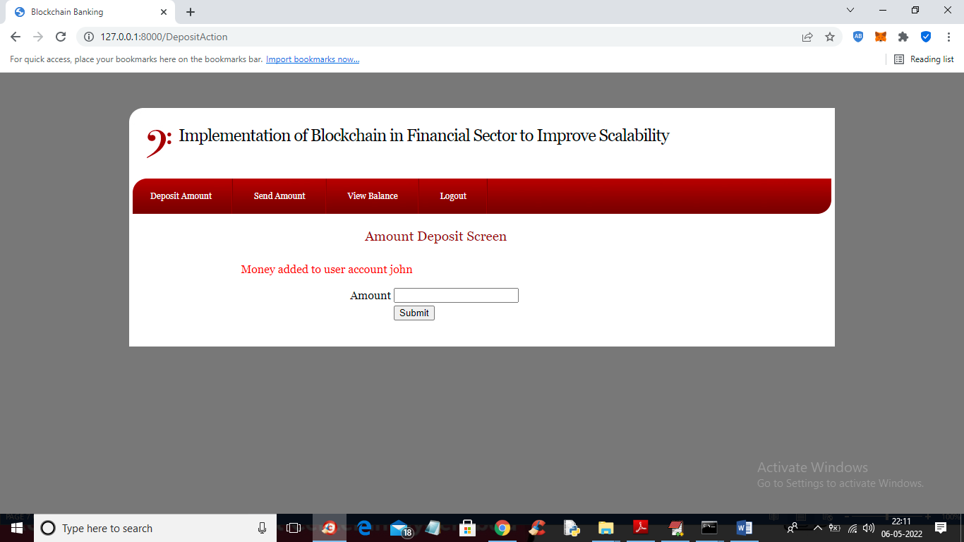

In above screen money added to user account and now click on ‘View Balance’ link to view his balance

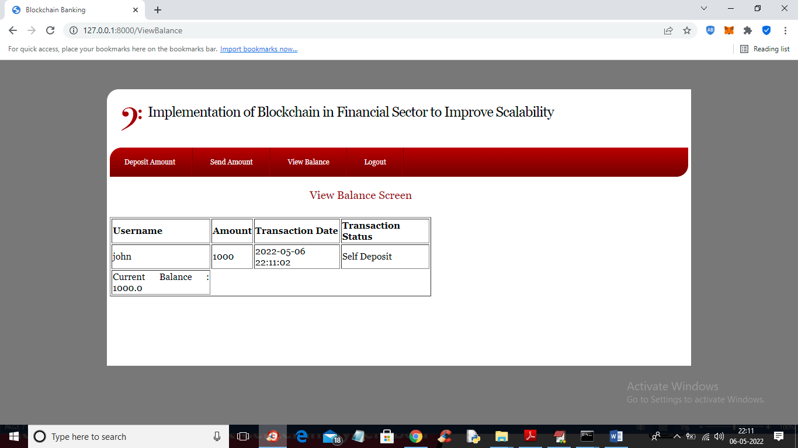

In above screen user has current balance 1000 and now click on ‘Send Amount’ link to get below screen

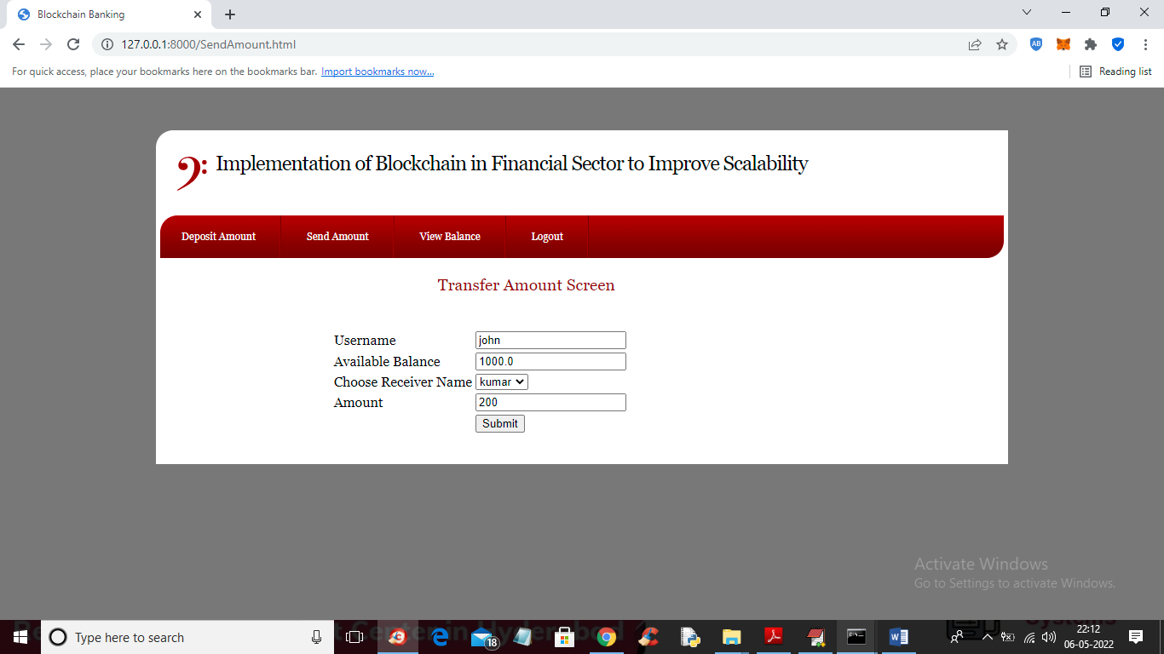

In above screen user ‘John’ selecting receiver name ‘kumar’ to send amount 200 and his current balance is 1000 and now press button to send amount and get below output

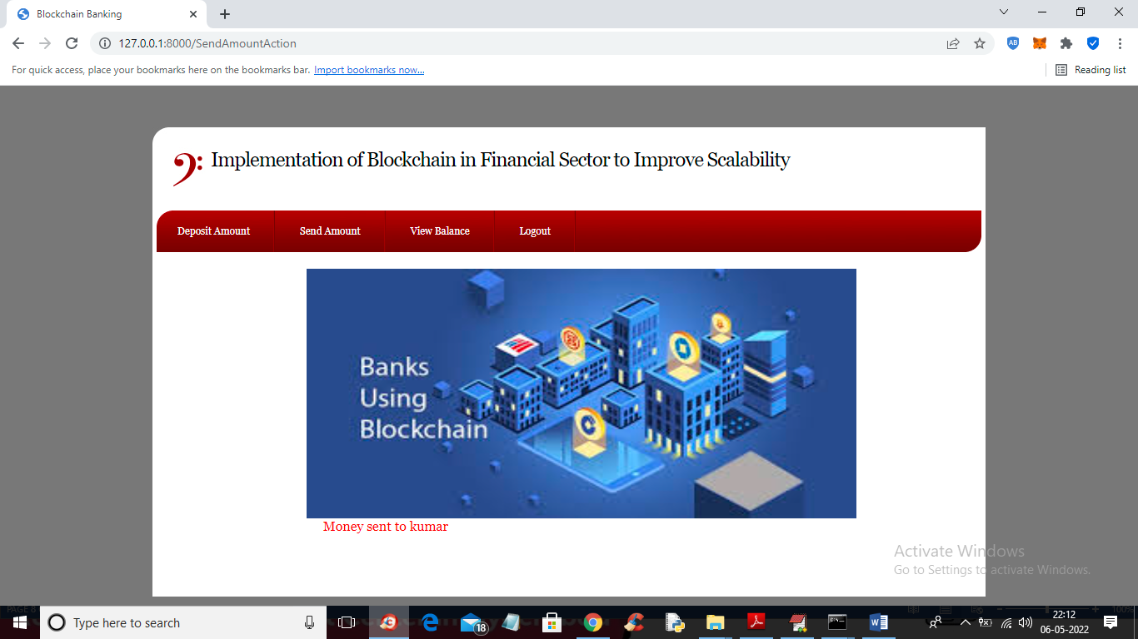

In above screen in red colour text we can see money sent and now click on ‘View Balance’ link again to view his current balance

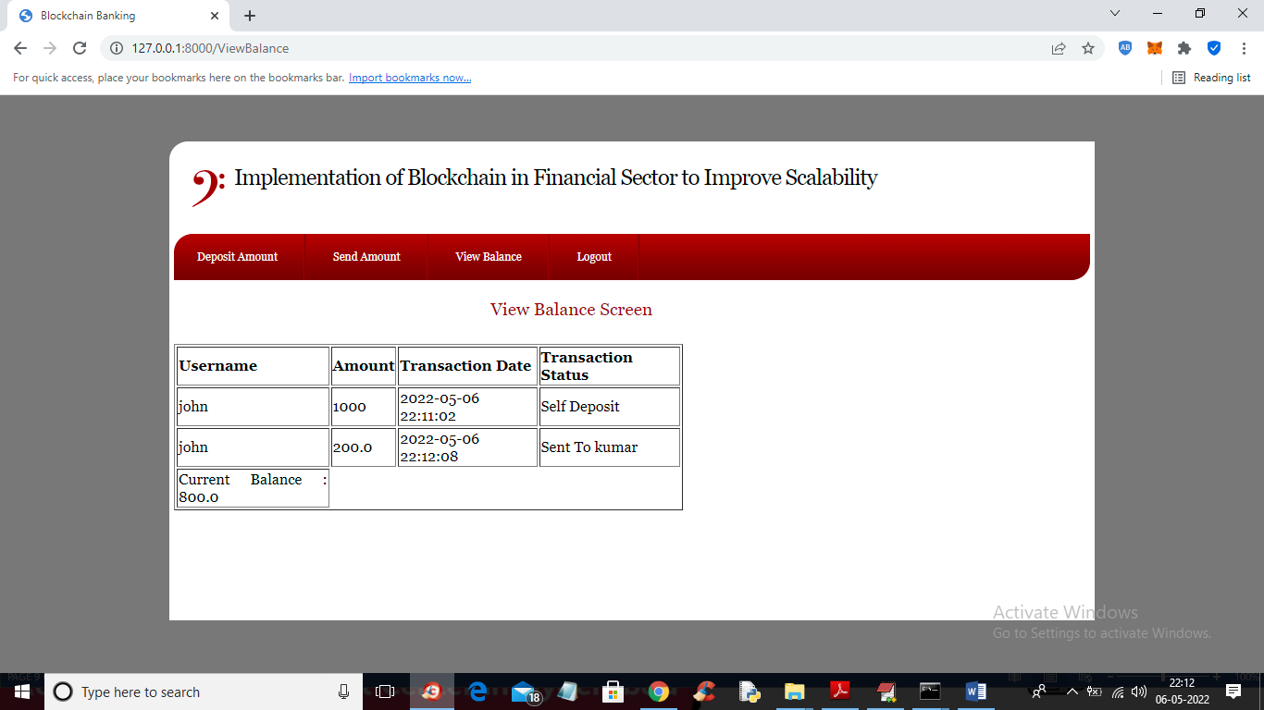

In above screen user balance reduced to 800 after sending 200 to kumar and similarly you can create any number of accounts and make transaction using Blockchain Bank accounts. In below user kumar screen we can see 200 credited from user John

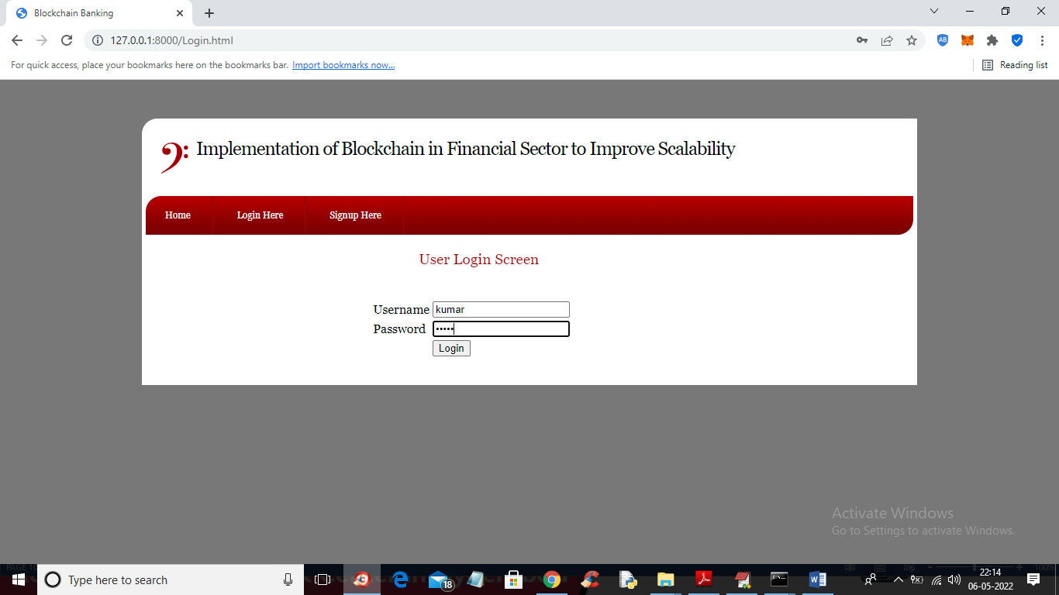

In above screen kumar user is login and after login click on ‘View Balance’ link to get below output

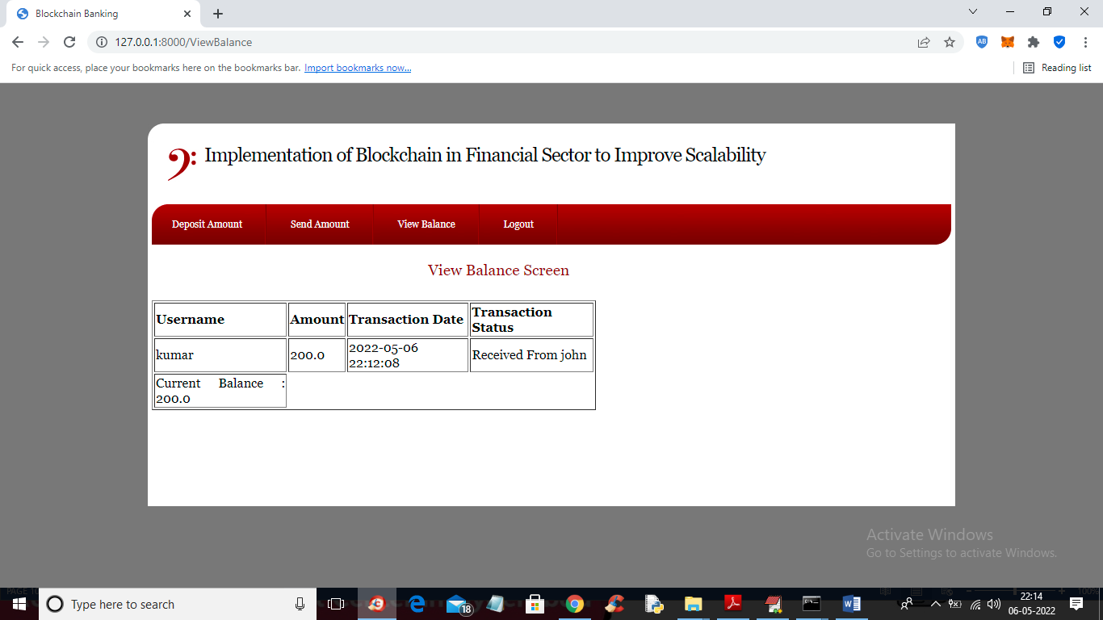

In above screen we can see user kumar received 200 from user John

Similarly you can create N users and send money which running code TRUFFLE ETHEREUM tool and DJANGO SERVER must be running and this server I am showing below screen

