Notebook Summary
Our team, 4322 Phi Omega, is a team that consists of a mixture of homeschooled and private schooled teens. Twice a week, we all meet in an Antelope Valley home-garage. Our focus being on God, as we are a Christian-based team, we always aim to begin our flurry of programming and building with prayer. This year, along with the progress and success, we have faced some problems and delays along our journey, but we make it a point to keep going despite what is thrown at us. Overall, though, I think it’s safe to say that we would all consider this year to have been a year of learning teamwork, gracious professionalism, and the processes of always moving forward.
This year we worked a lot on our ball intake system. We had to go through several designs before we came up with one that worked consistently, but when we finally came up with our conveyer belt intake system design, which works really well, it caused great excitement!
Some of the best times of this year included our competitions. Our first tournament took place in Perris, CA. We had difficulties with our robot early in the day, but we worked through our issues so that we were able to end with a few good runs. Even though we didn’t place, we were given the opportunity to graciously accept an alliance. The second competition we have competed in, so far, was in Palmdale, CA. Our suspension proved to work excellently, and we did overall better at this tournament. We had success in judging, and our autonomies worked beautifully. Again, we didn’t place in the top, but we were yet again picked for an alliance.
We would also consider our work on the promote award video to be a fun aspect of our year. It was something we haven’t done in past years, so it proved to be refreshing for us to work on. Our fundraising was exciting as well. We were able to have a garage sale in our local area, and gained a decent amount of funding between that and our holiday Yankee Candle sales.
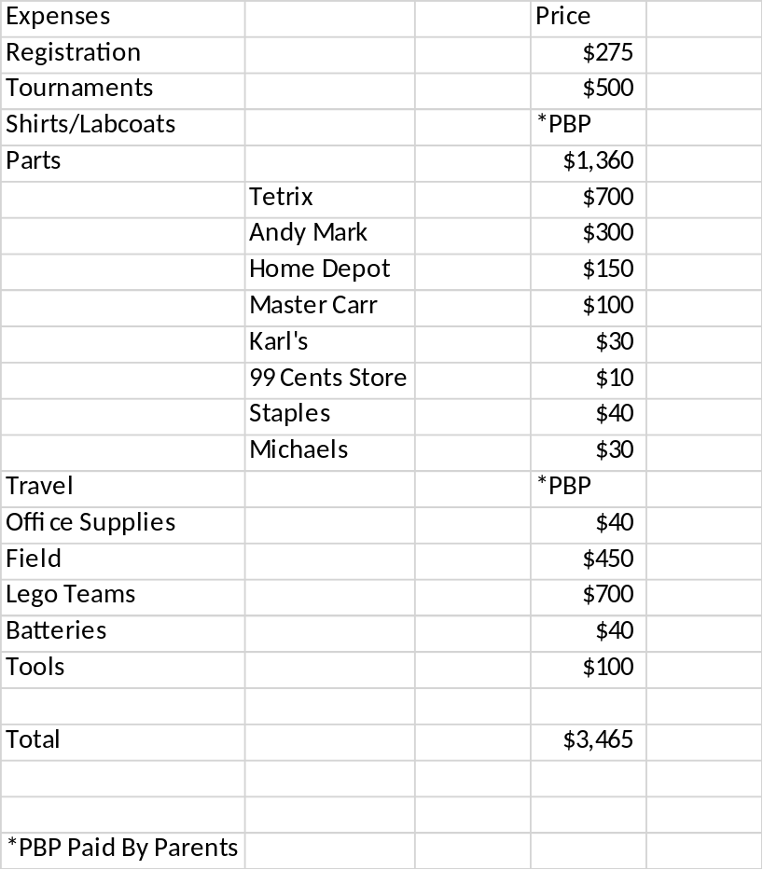
Our Expenses, this year, have mostly consisted of team registration, parts for our robot, tools, and travel. In the near future, we intend to use our budget to fund Super-Regionals, and possibly Worlds. We also continue to keep funding our two FLL teams, and expect to pay for more parts and tools as they become necessary.

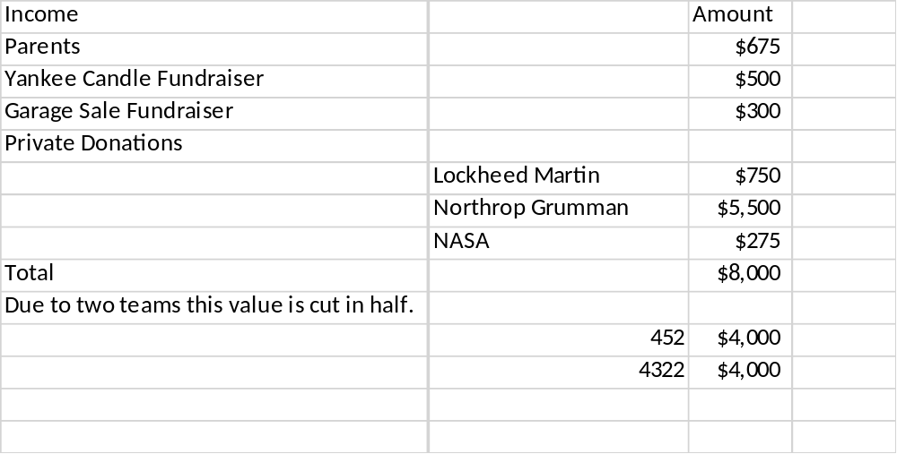
Our income this year has

