<LOGO>

<Name of the project>
Use Case Specification

Project Code: <Code of the project>
Document Code: <Code of the document >– v<x.x>

<Location, issued date of the Document>

Record of change

*A - Added M - Modified D - Deleted
Effective Date | Changed Items | A*  M, D | Change Description | New Version

SIGNATURE PAGE

ORIGINATOR: <Name> <Date>
<Position>

REVIEWERS: <Name> <Date>
<Position>

<Name, if it’s needed> <Date>
<Position>

APPROVAL: <Name> <Date>
<Position>
TABLE OF CONTENTS
1 Introduction 5
1.1 Purpose 5
1.2 Scope 5
1.3 Definitions, Acronyms, and Abbreviations 5
1.4 Assumptions And Constraints 6
1.5 References 6
1.6 Overview 6
2 Function specification 7
2.1 Overview 7
2.2 Entity Description 7
2.3 Business Process 7
2.4 Use Case Diagram 7
2.5 Use Case Details 7
2.5.1.1 <Use Case ID> - <Use Case Name> 7
2.5.1.2 <Function 2/Use-case 2> 9
2.5.1.3 <Function 3/Use-case 3> 10
3 Supporting Information 11

Introduction
[The introduction of the Software Requirements Specification (SRS) provides an overview of the entire SRS. It includes the purpose, scope, definitions, acronyms, abbreviations, references, and overview of the SRS.]
[Note: The SRS document captures the complete software requirements for the system, or a portion of the system. Following is a typical SRS outline for a project using only traditional, natural-language style requirements—with no use-case modeling. It captures all requirements in a single document, with applicable sections inserted from the Supplementary Specifications (which would no longer be needed). For a template of an SRS using use-case modeling, which consists of a package containing Use Cases of the use-case model and applicable Supplementary Specifications and other supporting information.]
[Many different arrangements of an SRS are possible. Refer to [IEEE830-1998] for further elaboration of these explanations, as well as other options for SRS organization.]

Purpose
[Specify the purpose of this SRS. The SRS fully describes the external behavior of the application or subsystem identified. It also describes nonfunctional requirements, design constraints, and other factors necessary to provide a complete and comprehensive description of the requirements for the software.]

Scope
[A brief description of the software application that the SRS applies to, the feature or other subsystem grouping, what Use-Case model(s) it is associated with, and anything else that is affected or influenced by this document.]

Definitions, Acronyms, and Abbreviations
[This subsection provides the definitions of all terms, acronyms, and abbreviations required to properly interpret the SRS. This information may be provided by reference to the project’s Glossary.]

Assumptions And Constraints
<Mô tả các giả định và ràng buộc liên quan đến use case/nhóm use cases>

References
[This subsection provides a complete list of all documents referenced elsewhere in the SRS. Identify each document by title, report number if applicable, date, and publishing organization. Specify the sources from which the references can be obtained. This information may be provided by reference to an appendix or to another document.]

Overview
[This subsection describes what the rest of the SRS contains and explains how the document is organized.]
customer’s organization will be responsible for maintaining the delivered software).>

Function specification
[This section of the SRS contains all software requirements to a level of detail sufficient to enable designers to design a system to satisfy those requirements, and testers to test that the system satisfies those requirements. When using use-case modeling, these requirements are captured in the Use Cases and the applicable supplementary specifications. If use-case modeling is not used, the outline for supplementary specifications may be inserted directly into this section, as shown below.]

Overview
<Mô tả tổng quan các nghiệp vụ cho chức năng/Nhóm chức năng được đặc tả trong tài liệu>

Entity Description
<Mô tả các thực tể liên quan đến các UCs được mô tả trong tài liệu>

Business Process
<Mô tả các qui trình nghiệp vụ kinh doanh mà các UCs của phầm mềm tham gia vào>

Use Case Diagram
<sơ đồ UC và mô tả tóm tắt của các UCs>

Use Case Details

<Use Case ID> - <Use Case Name>

Screen Definition

Login
User name
Password

Figure 3-1: Screen Design of Login

Table 3-1: Screen Definition
# | Field Name | Type | Mandatory | Max Length | Description
1 | User Name | Text | Yes | 20
2 | Password | Text | Yes | 20 | Display "*" instead of clear character
3 | Login | Button |  |  | Go to home page
4 | Close | Button

Use-case specification

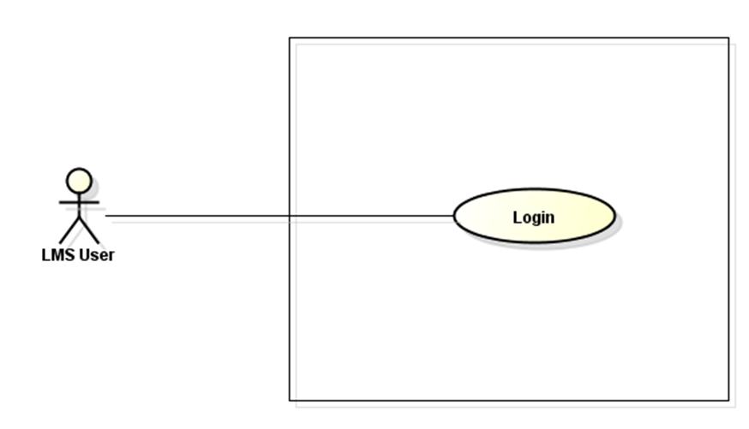
LMS

Use-Case Description/Scenarios
Use-case ID |  | UC001 | Author
Use-case Name |  | Login | Created Date
Actor |  | User | Secondary Actor
Description |  | <Mô tả khái quát chức năng của hệ thống, và tình huống bắt đầu (initial desc) của UC  Description of use case, what use will do  >
Precondition |  | <Mô tả điều kiện cần để UC có thể được thực hiện  It is necessary condition for use-case to be operated  >
Trigger condition |  | <Mô tả điều kiện đủ để UC được thực hiện  - Sufficient condition for use to be operated  >
Post-condition |  | <Điều kiện UC cân thỏa mãn sau khi thực hiên.  The additional condition that use-case must meet after it have been operated>
Assumptions
Other
Business rules
Main flows (normal flows)
Step | Actor | Action Description
1 | User | Type URL of FAP into location field of Internet Browser and enter
2 | Software | Display Login screen with the following fields:  - User name  - Password  - Login button  - Close button
3 | User | Enter the user name & password into Login screen then click on "Login" button
4 | Software | Validate the entered user name & password, then display Home page

Exception/(What went wrong)
# | Description
1 | When the user type a wrong username or a wrong password, the system shall display an error message on the Login screen.

<Function 2/Use-case 2>

Screen Definition

Use-case Specification

<Function 3/Use-case 3>

Supporting Information
[The supporting information makes the SRS easier to use. It includes:
- Table of contents
- Index
- Appendices
These may include use-case storyboards or user-interface prototypes. When appendices are included, the SRS should explicitly state whether or not the appendices are to be considered part of the requirements.]

