**Free ebook made by Blender lovers**

**BLENDER**

**FOR BEGINNERS**



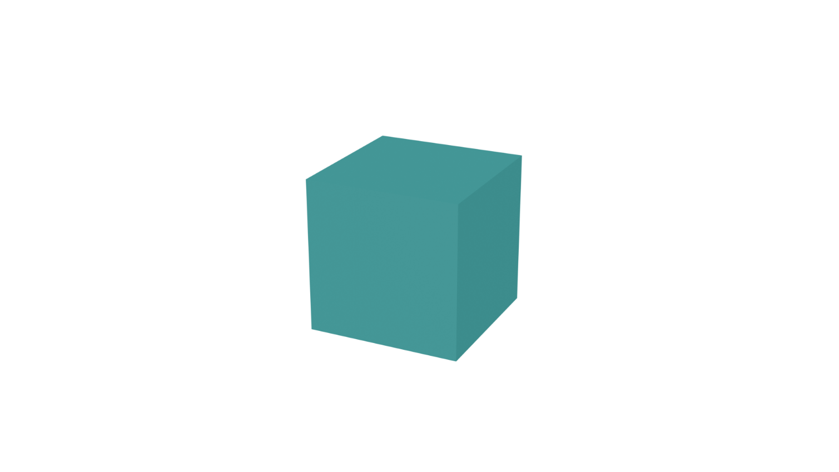

Version 1.0

# Here we start

Download and install blender software from <https://www.blender.org/>

## Default settings

File >> Defaults >> Load Factory Settings

# Blender shortcuts 1

|  |  |
| --- | --- |
| Shortcut | Description |
| Num5 | Orthographic / Perspective View toggle |
| Num0 | Camera View toggle |
| Num1, Num3, Num 7 | Front, Right, Top View |
| Mouse3 | Orbit the scene |
| Shift + Mouse3 | Pan the scene |
| N | Sidebar toggle |
| F12 | Render Image |
| Shift + A | Add object |
| G, R, S | Transform (position, rotation, scale) |
| Ctrl + A | Apply menu |
| Tab | Object Mode / Edit Mode toggle |
| E | Extrude (edit mode) |
| I | Inset faces (edit mode) |
| Ctrl + B | Bevel (edit mode) |
| Ctrl + R | Loop Cut (edit mode) |
| K | Knife (edit mode) |
| V | Rip region (edit mode) |
| L | Select linked (edit mode) |
| Alt + Mouse1 | Select loop (edit mode) |
| Ctrl +/- | Increase / decrease selection (edit mode) |
| . | Focus |
| Ctrl + P, Alt + P | Parent object / Unparent |
| Ctrl + J | Join objects |
| Shift + D | Duplicate |
| Shift + S | Snap menu |
| P | Object separation (edit mode) |
| F | Inset faces (edit mode) |

# Orthographic / perspective view

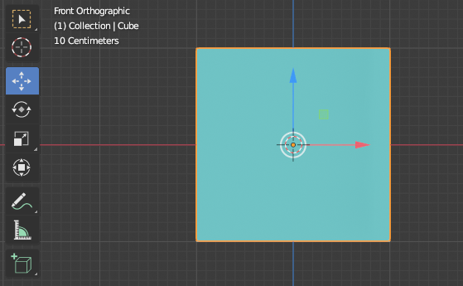 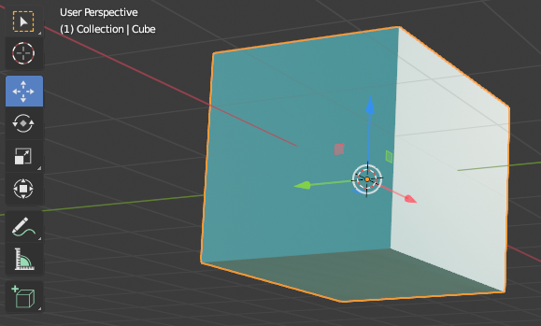

Turning Orbit Around Selection and Zoom to Mouse Position options might be useful.

You can find them in Preferences / Navigation