1. Enable PG6 as GPIO_output for toggle the LED.

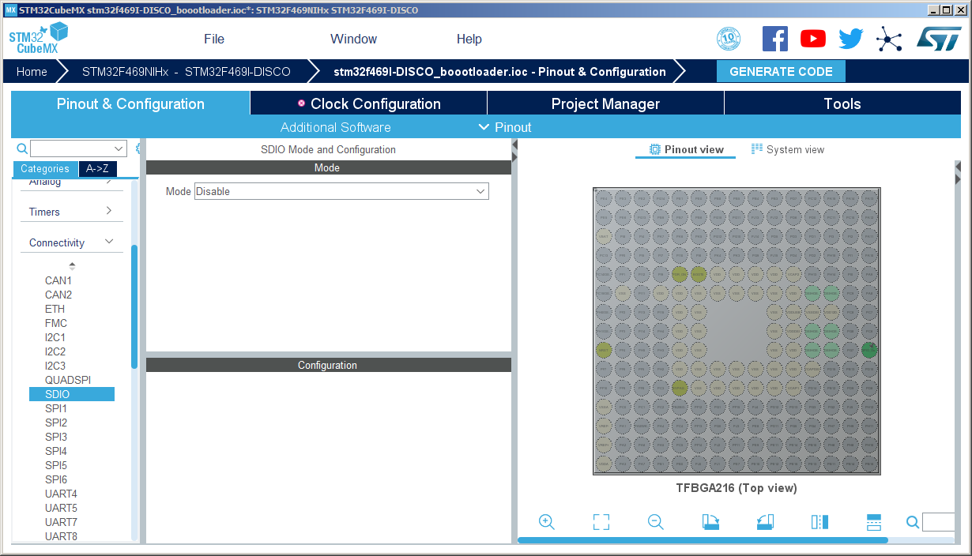

2. Set RCC to Crystal Resonator

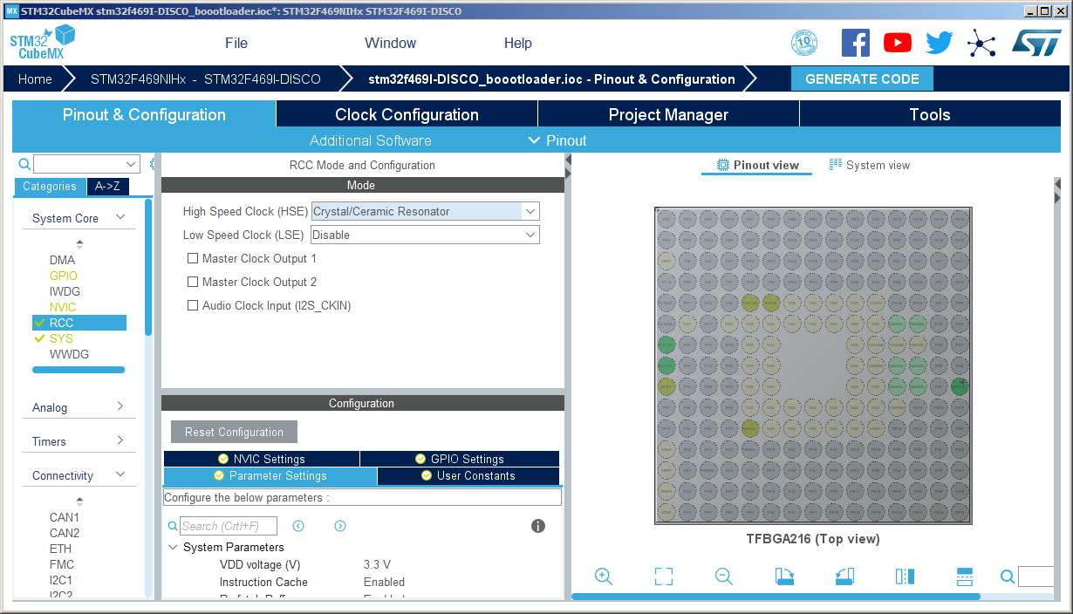

3. Set SDIO to SD 4 Bits Wide Bus

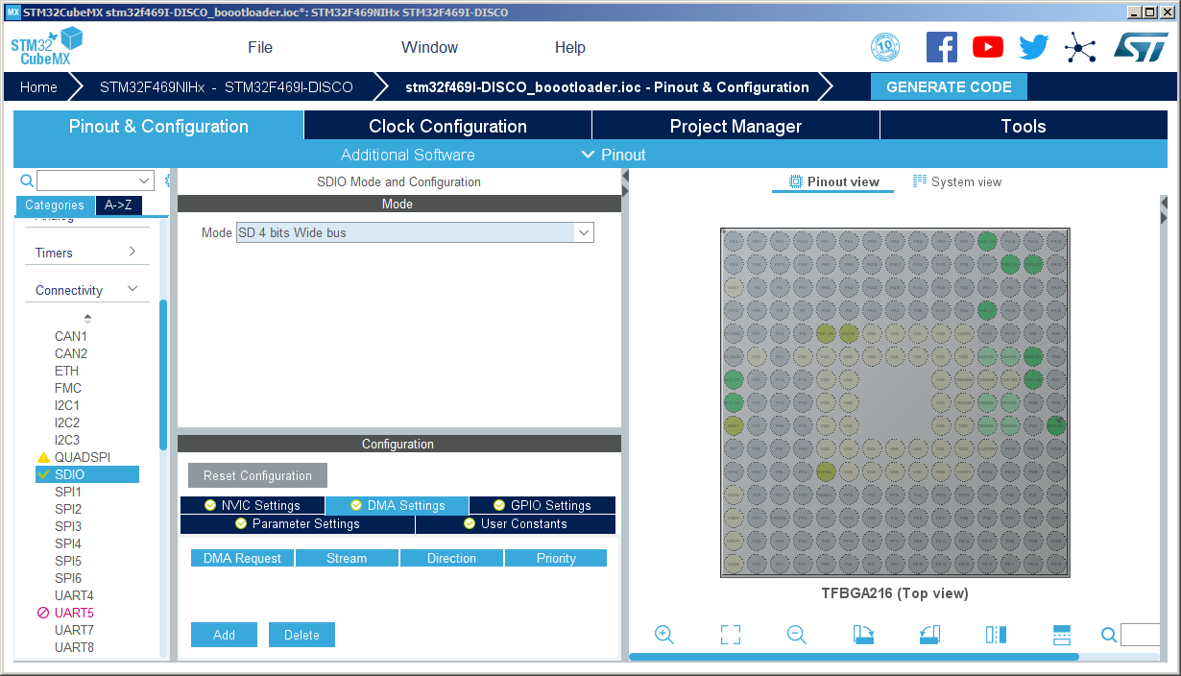

4. Go to DMA Settings add SDIO_RX/SDIO_TX

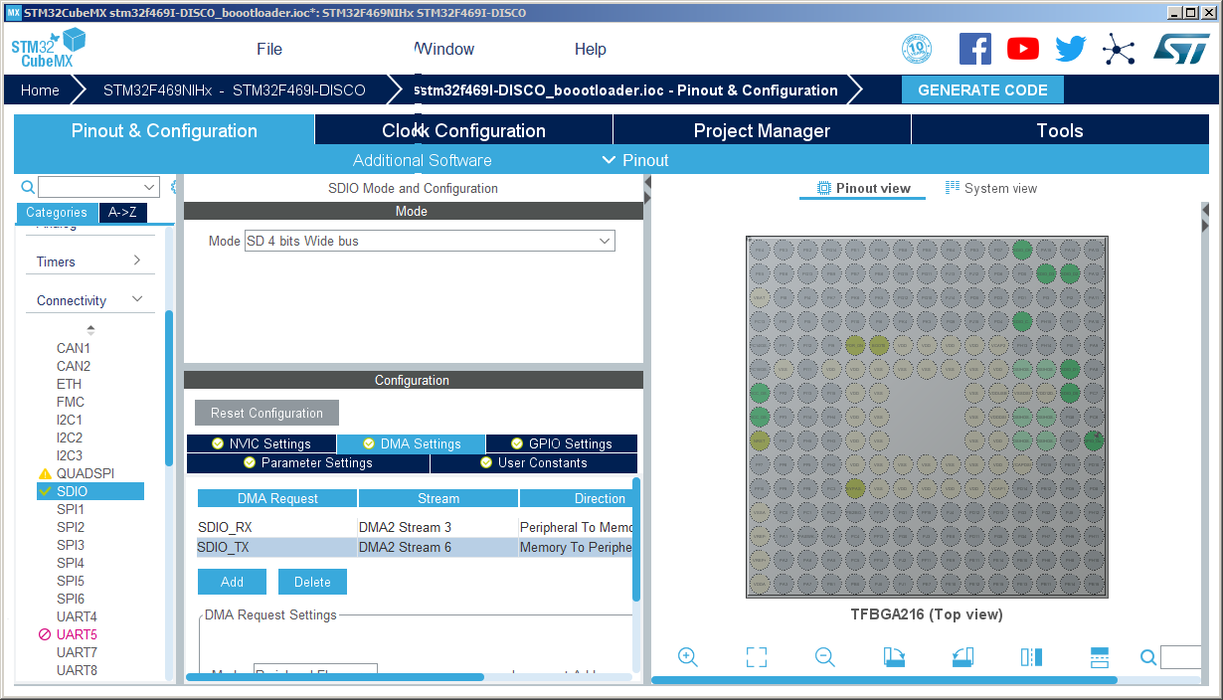

5. Go to NVIC Setting check SDIO global interrupt.

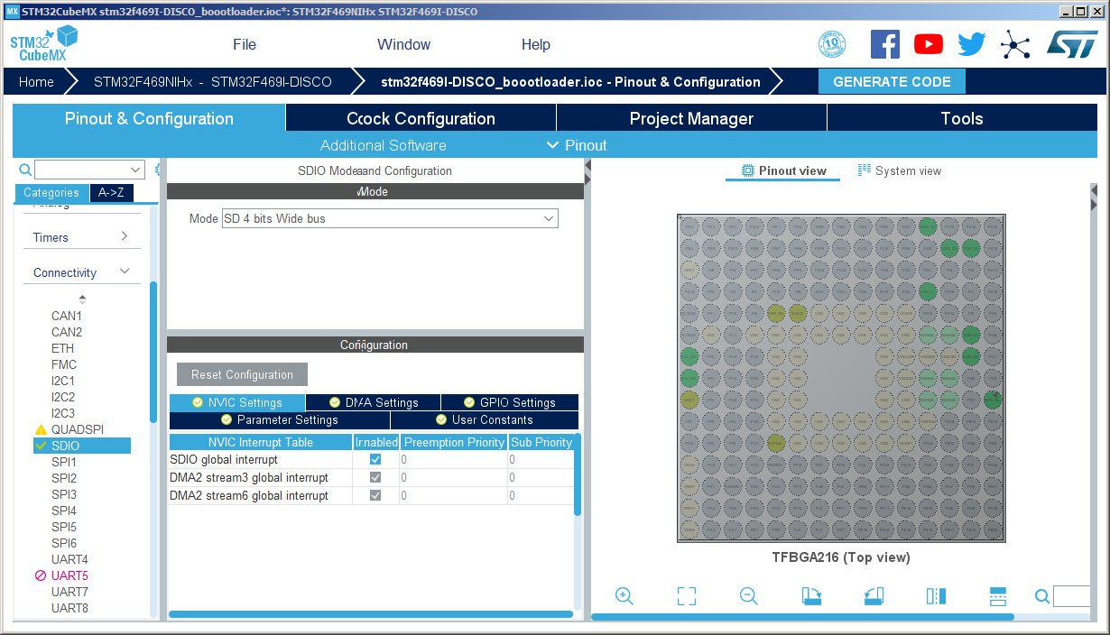

6. Select SD Card

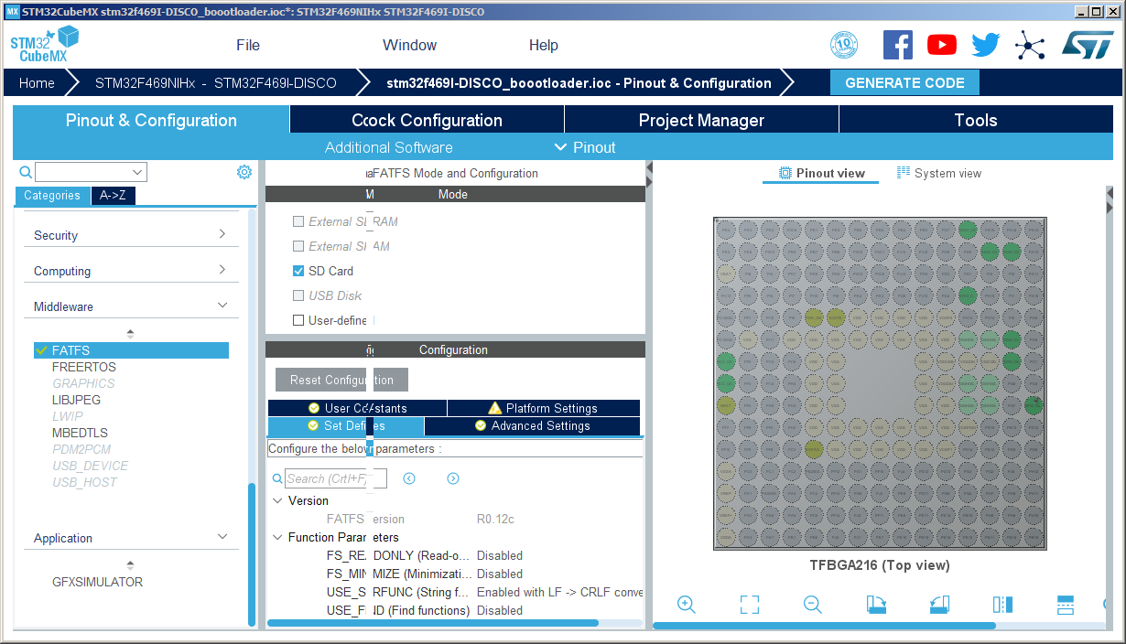

7. Go to Advance Settings set Use dma template to enable.

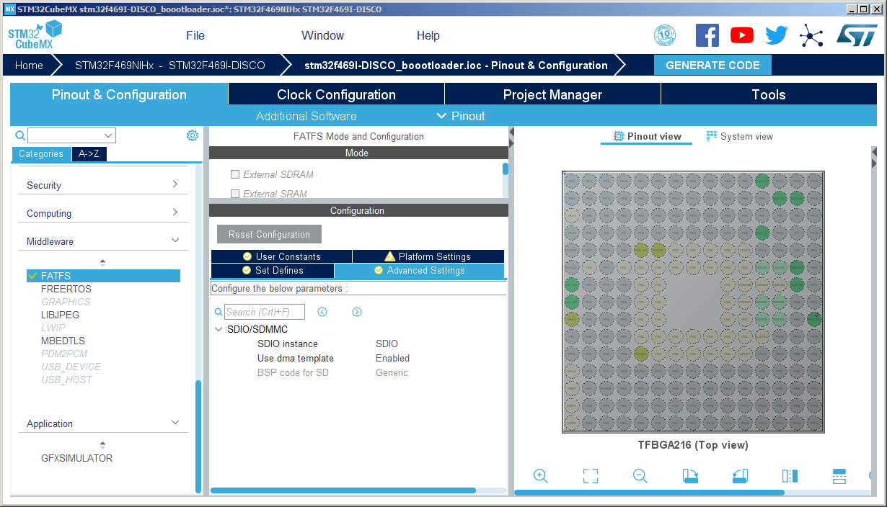

8. Set MAX_SS to 4096

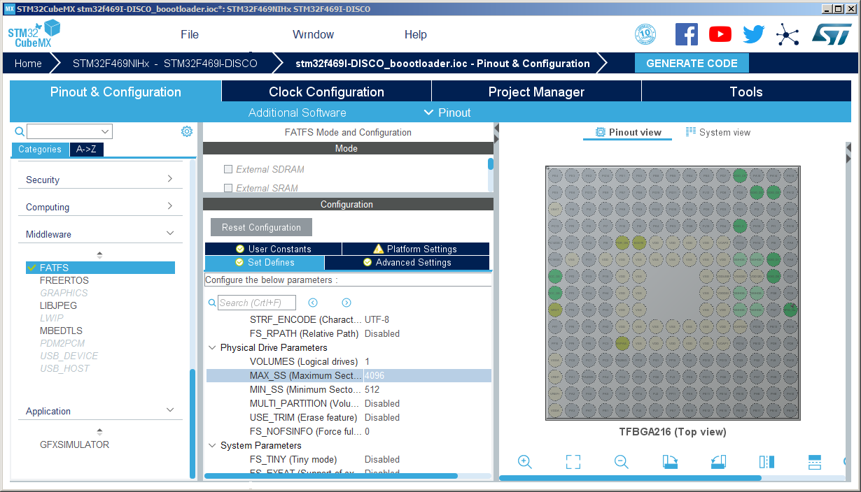

9. Set FreeRtos

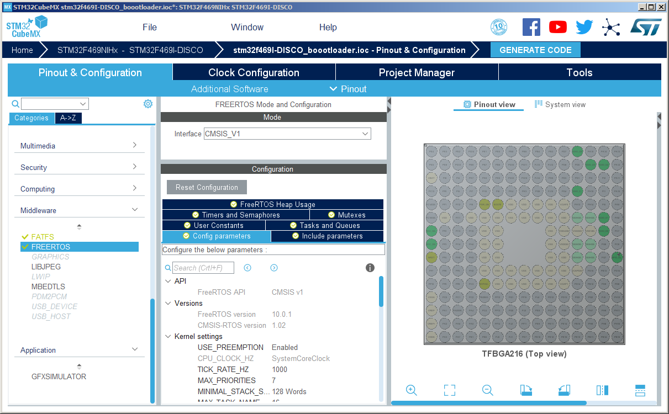

10. Select TIM6 for FreeRtos,

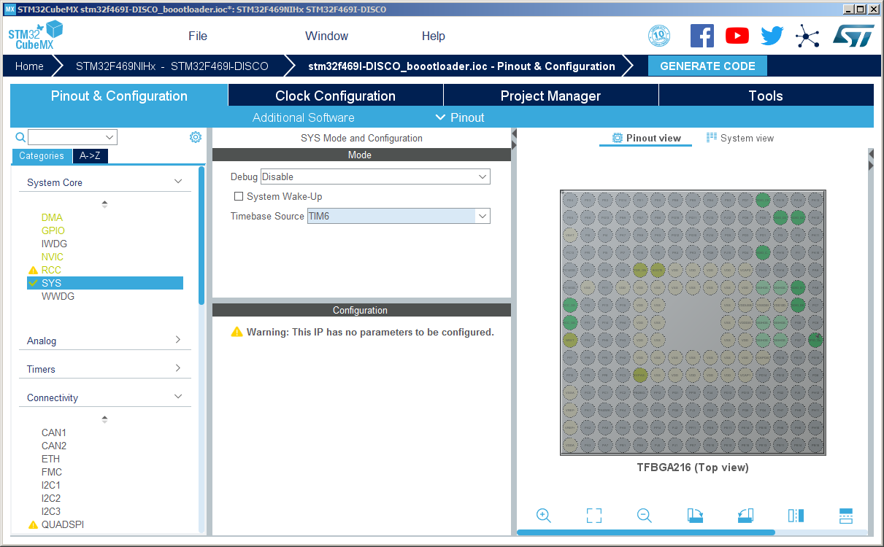

11. Select TrueStudio and generate the code.

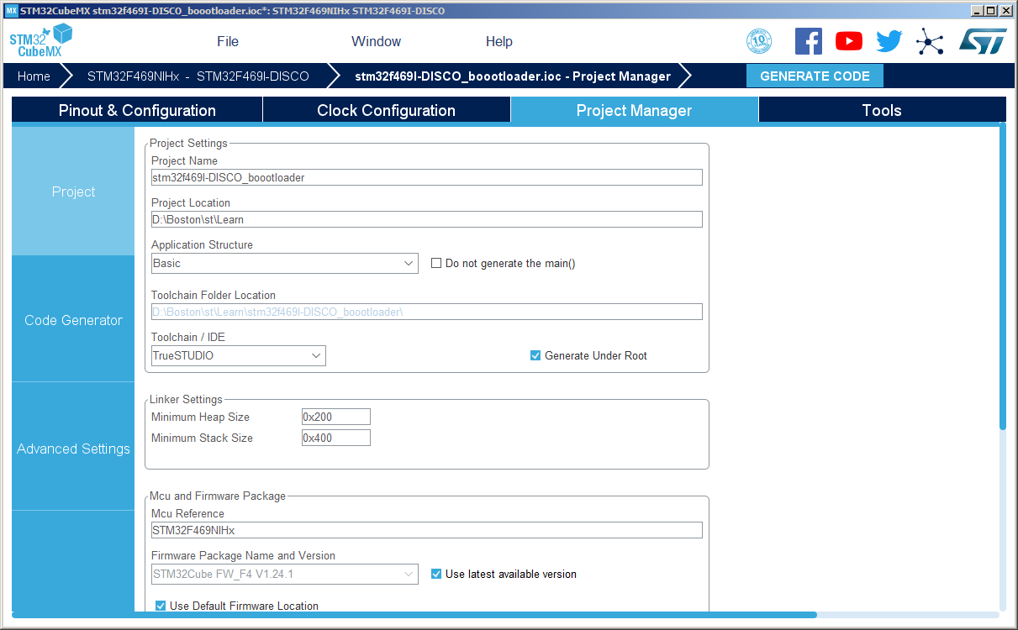

12. Click Yes to generate the code.

