User Manual   
ROOTDataLogger I & II Version March 2025 (ahp1)

**Caution:**

Always use a 12 V battery. Depending on the type of the 12 V battery, it must be removed for transport; gel/liquid can leak if stored incorrectly.

The AGM battery currently installed should be leak-proof.

**Before data collection:**

Charge the battery (ON/OFF switch to OFF.)  
Delete old files on the SD card.

**Data Collection:**

1. Insert the SD card.
2. Connect the sensors:   
   Load Cell to LOAD socket (6),  
   Draw-wire sensor to CABLE socket (5)
3. Choose the correct Loadcell 2kN/20kN (8)
4. Set the ON/OFF switch (4) to ON.

(When switching on and off, a new .csv is generated in each case).

1. Note the exact time of the measurement.
2. BT-MON/LOG switch (1)
   * When the green LED (3) flashes, the measured values are written directly to the SD.
   * When the blue LED flashes (2), the measurement values can be read out via Bluetooth module (HC-05-ii) or displayed on the laptop via USB cable using the USB socket (7).
   * If no LED flashes. See if the SD has been inserted correctly.  
       
     **ATTENTION: The data is not written to the SD card. When the blue LED flashes.**

**Apps (only Android devices for now (not iPhone compatible))**

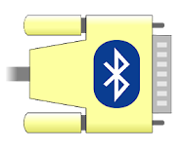

App for Android:

Serial Bluetooth by Kai Morich



App for Windows

Serial port monitor (free version)– not yet tested

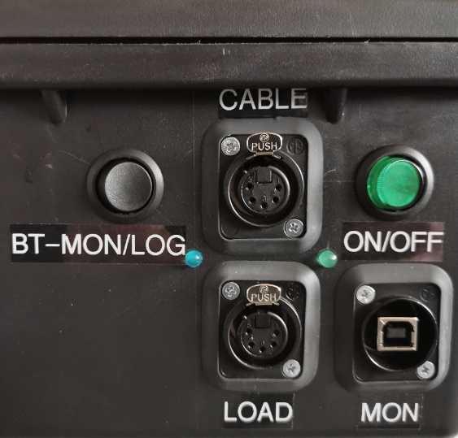

**2**

**1**

**2**

**3**

**4**

**5**

**6**

**7**

**Read out the data**

|  |  |  |  |  |
| --- | --- | --- | --- | --- |
| Time elapsed since start [ms] | Unix Time Stamp | Cable [cm] | Load [N] | Battery voltage [V] |
| 29239 | 1652178932 | 25 | -167.545 | 12.38 |
| 29249 | 1652178932 | 25 | -170.112 | 12.38 |
| … | … | … | … | … |

**Unix time stamp to date/time**

The time stamp is stored via the internal battery of the SD Shield.

**In Python:**

import datetime

dt = datetime.datetime.fromtimestamp(1652178932)

# Don’t forget to set the time zone.

**Technical data**

At 12.2 volts, an average of 140 mA (1.16 mA idle),   
i.e., a fully charged battery with, for example, 6 Ah, lasts theoretically for   
approx. 40 hours (6 Ah/0.14A = 42.9 h).

Note that the lead-acid battery (AGM) is fully charged at a terminal voltage of 12.8 V (100 %) and discharged at a terminal voltage of approx. 11.8 V (0 %).

**Schematic diagram**

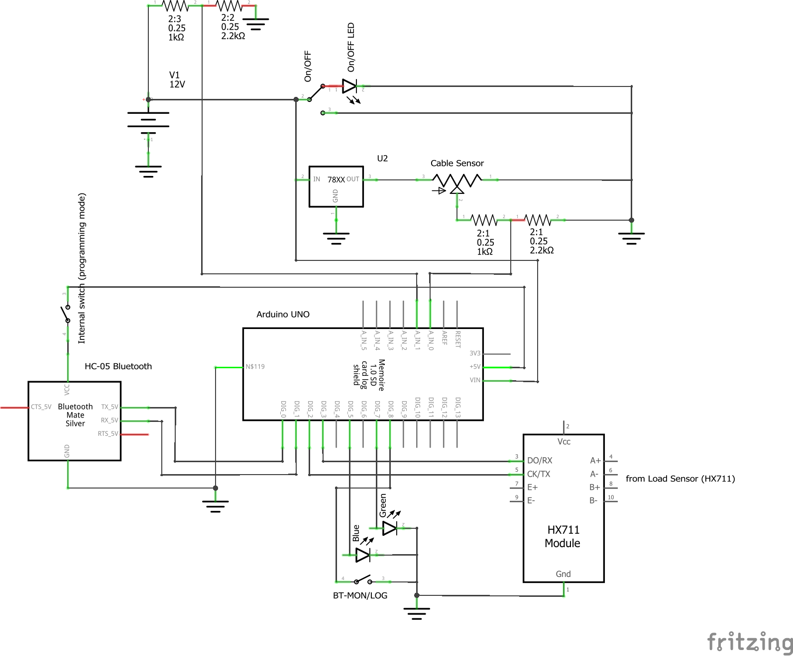

**Calibration:**

LEANE – DBBE 200 kg: factor **10050** – calibrated with a 20 kg and 40 kg load – **May 2022**

ME-Systeme - 5000 kg_ (factor **660** – measured with a 40 kg and 80 kg load – **May 2022**

**Pin assignment**

|  |  |
| --- | --- |
| LoadCell Leane DBBE (small – 200 kg) to HX711 | |
| blue (Pin 1) | E+ |
| black (Pin 2) | E- |
| White (Pin 3) | A- |
| Red (Pin 4) | A+ |

|  |  |
| --- | --- |
| LoadCell Leane DBBE (large – 2000 kg) to HX711 | |
| blue (Pin 1) | E+ |
| black (Pin 2) | E- |
| White (Pin 3) | A- |
| Red (Pin 4) | A+ |

For more information check: https://learn.sparkfun.com/tutorials/load-cell-amplifier-hx711-breakout-hookup-guide/all)

**Parts List**

|  |  |  |  |
| --- | --- | --- | --- |
| No° | Article | Description | Seller |
| 1 | Basetech Outdoor IP67 | Case 460 x 360 x 175 mm | conrad.ch |
| 2 | Neutrik NC5FD-LX-B | 5-Pol socket | conrad.ch |
| 3 | Neutrik NC5MX | 5- Pol plug | conrad.ch |
| 1 | Neutrik NAUSB-W-B | USB plug | conrad.ch |
| 1 | Neutrik SCDP-0CON | Seal for sockets | conrad.ch |
| 1 | TC-R13-208B-02 12 V/DC 20 A | Switch (green LED) | conrad.ch |
| 1 | TC-R13-208A-02 250 V/AC 10 A | Switch (no LED) | conrad.ch |
| 1 | Arduino Uno | Microcontroller | conrad.ch |
| 1 | TC-9927152 | HC-05 Bluetooth module (Android only) | conrad.ch |
| 1 | Joy-it SEN-HX711-20 | HX 711 - Amplifier board for the load cell | conrad.ch |
| 1 | Adafruit Assembled Data Logging shield | SD Shield Logger for Arduino Uno | conrad.ch |
| 1 | SD Card | 32 GB | conrad.ch |
| 1 | Motobatterie YTX7A-BS Okay | Battery 12 V / 6Ah | Landi.ch |
| 1 | Kemo Spannungswandler (3 - 15 V/DC 1.5 A) | Voltage transformer/stabilizer | conrad.ch |
| 1 | 110x80x70mm IP67 | Transparent plastic housing Arduino | bastelgarage.ch |