**DDD Object Models**

**I have created 2 DDD models 1 has fetcher scrapper object as entity**

**Other has it as value object**

**-1 fetcher as entity**

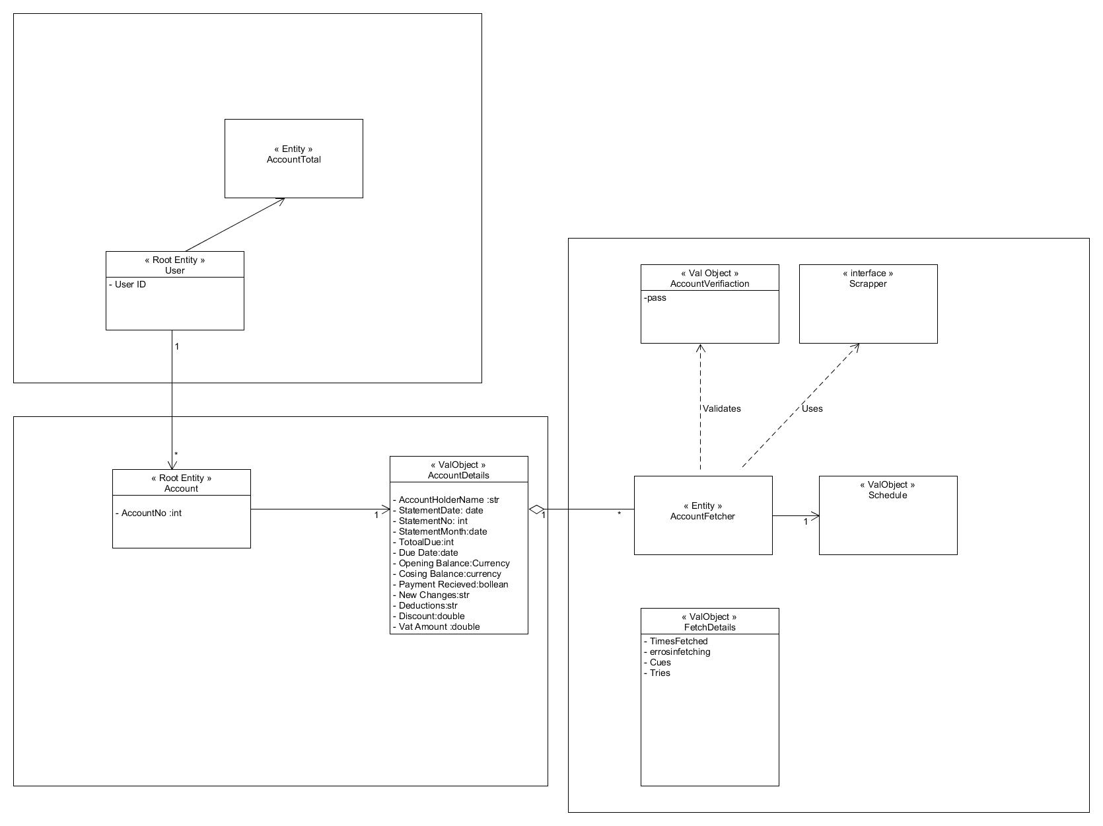

**DDD Object Model -2 fetcher as Val Object**

