# **I : Client side**

* 1. Description :
* Customers can register information
  1. Guide to admin page
     1. Customer login to the web

Case 1: if account and correct password ->(1.2.2) navigate to profile registration page

Case 2: if the account and password are correct -> notification : Login Failed!

### Customers enter each personal information

* **customer enter first and last name** ( not null) - if the customer does not enter this box ->when you click the "register" button ->The system will give a warning: Please fill out this field -> Refuse to perform the registration function.
* **customers enter age** ( not null) -if the customer does not enter this box -> box ->when you click the "register" button ->The system will give a warning: Please fill out this field -> Refuse to perform the registration function.
* **customer enters address** ( not null) - if the customer does not enter this box -> box ->when you click the "register" button ->The system will give a warning: Please fill out this field -> Refuse to perform the registration function.
* **customer enters username** ( not null) - if the customer does not enter this box -> box ->when you click the "register" button ->The system will give a warning: Please fill out this field -> Refuse to perform the registration function.
* **customer enters password** ( not null) - if the customer does not enter this box -> box ->when you click the "register" button ->The system will give a warning: Please fill out this field -> Refuse to perform the registration function.
  + 1. The system will check if the username already exists -> if so, it will notify "username already exists"-> Refuse to perform the registration function.
    2. the system takes customers to another page
  1. Usecase
* Register: register information.
* Logout : log out account.

Note (Customer can't access admin page)

**Mock ups :**

**Mock up 1** : page “login”

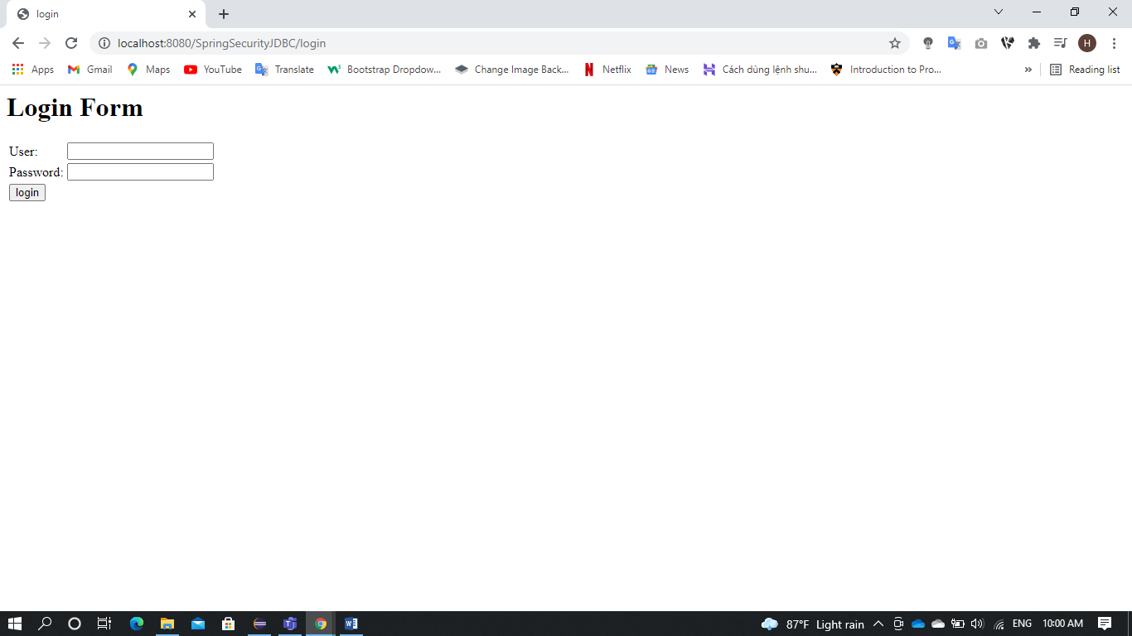

**Mock up 2** : page “login” when login error

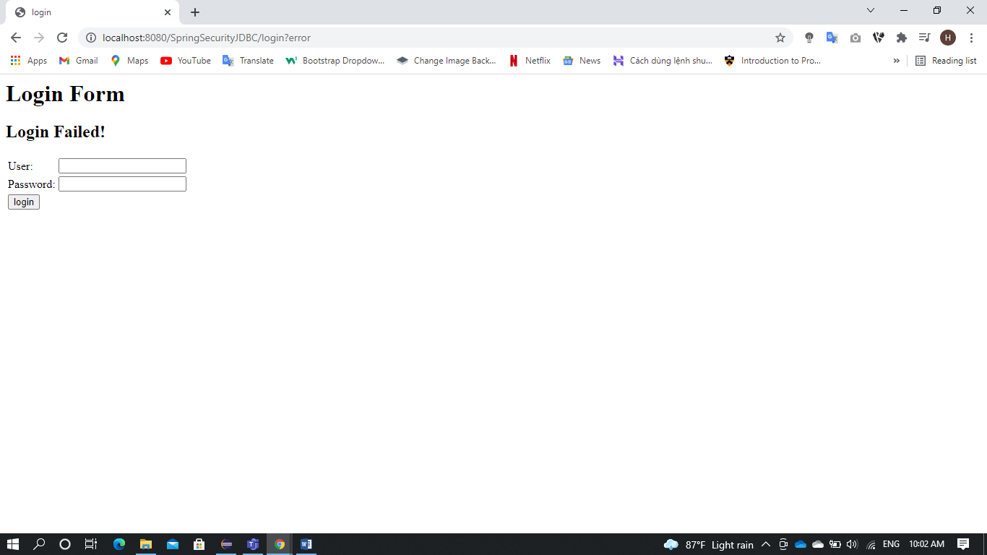

**Mock up 3** : page “ Thông Tin cá Nhân ”

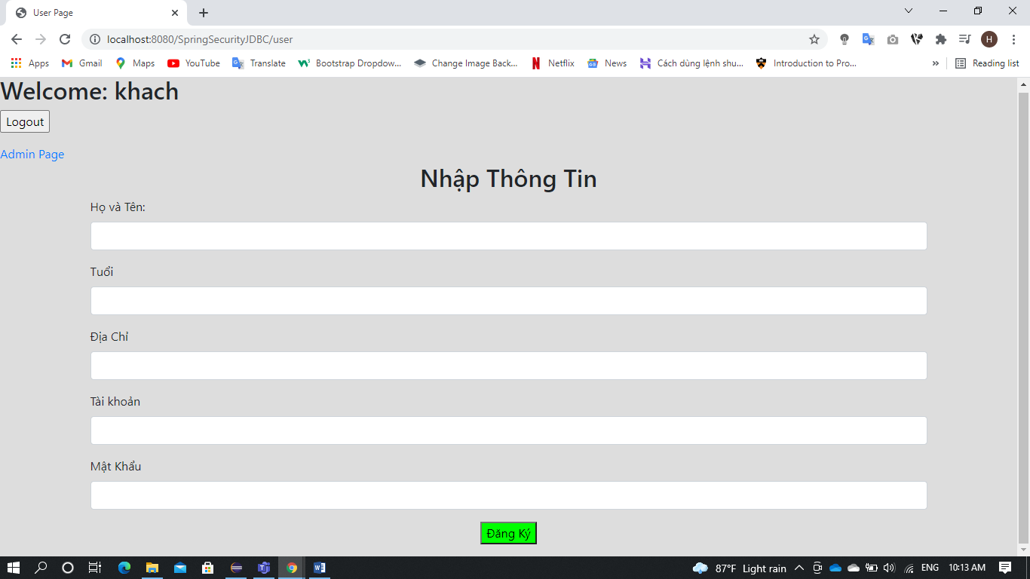

**Mock up 4**: Messenger

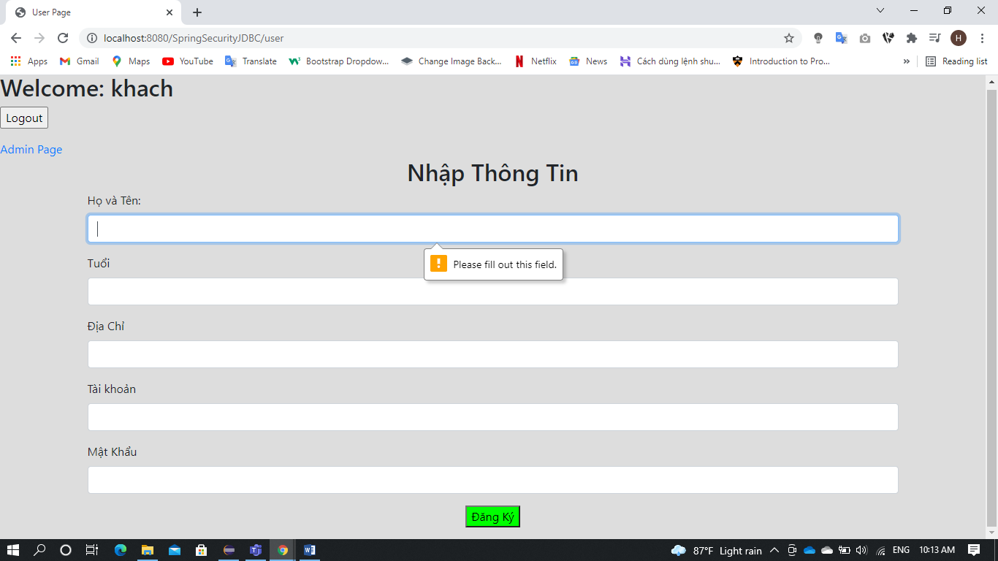

Mock up 5 : page “Thank You”

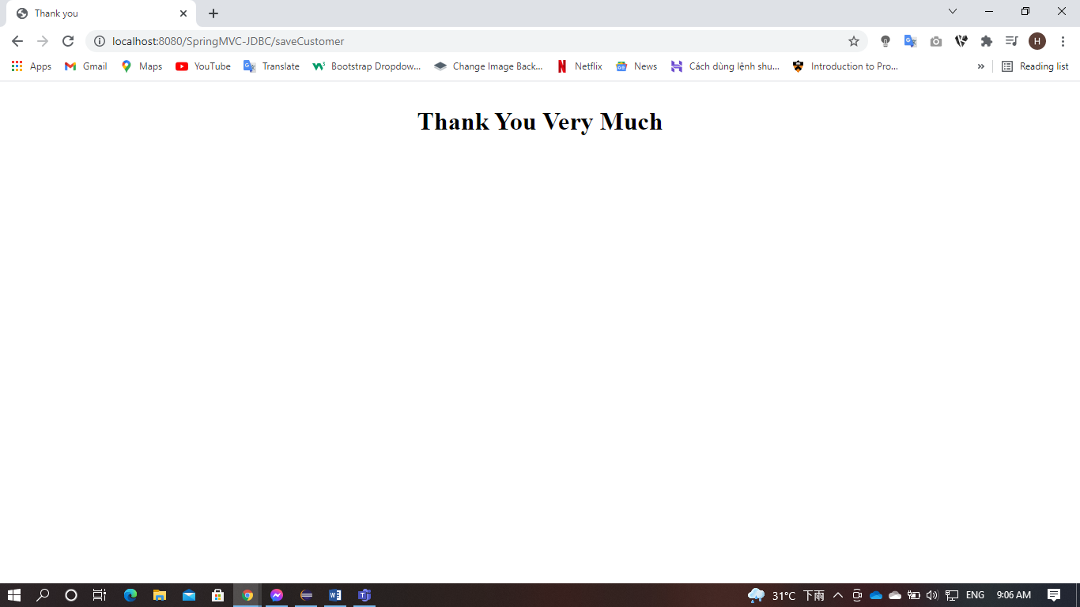

# **II : Admin page**

* 1. Description :
* Admin can see all customer information on this page.
* The page refreshes every 30 seconds to update data
* admin can also register information
  1. Guide to admin page
     1. Admin login to the web

Case 1: if account and correct password -> navigation(2.2.2) to profile page

Case 2: if the account and password are correct -> notification : Login Failed!

### Admin has been redirected to the homepage

### Admin click hyperlink *Admin Page*->Admin has been redirected to the admin page

* 1. usercase
* View : Show complete information of customers
* Logout : log out account

**Mock ups :**

Mock up 4 : page Admin

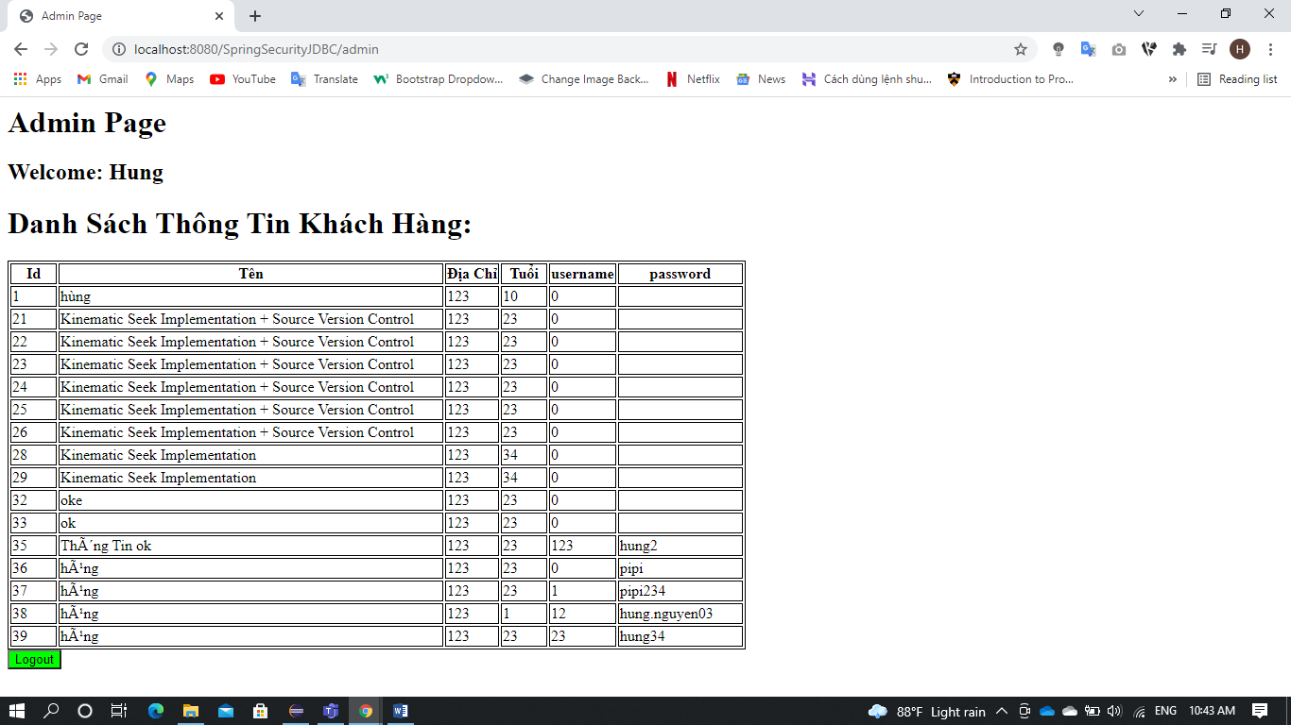

**III : code description**

* 1. Setup code
     1. Techlonogies Used
* Spring 5.0.2.RELEASE
* Spring Security 5.0.2.RELEASE
* [Maven](https://stackjava.com/install/maven-phan-1-maven-la-gi-cai-dat-maven.html)
* [Tomcat](https://stackjava.com/install/tomcat-la-gi-cai-dat-va-cau-hinh-tomcat.html): Tomcat v8.5 Server at localhost
* JDK 15.0.1
* [Eclipse](https://stackjava.com/install/cai-dat-spring-tool-suite-cho-eclipse.html) 
  + 1. Database

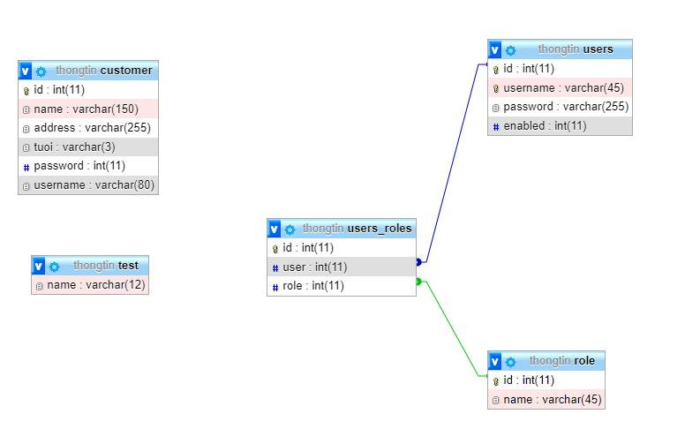

* + 1. Maven Project

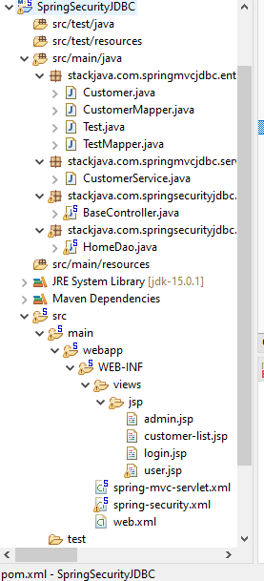

* File Customer.java : in this contains the attributes corresponding to the specific database table: customer
* File CustomerMapper.java : This file is used to collect data returned from the database
* File Test.java và File TestMapper.java same as customer , but table : Test
* File Home Dao : used to interact with the database.
* File BaseController : used to navigate requests.
* File Pom.xml , File spring-mvc-servlet.xml, File web.xml : config cho Project, and to run project.
* File spring-security.xml : connect with database
  1. Setup local
* Set up Apache Tomcat for the computer : create new TOMCAT_HOME in “ Environment Variables ” and create new path : %TOMCAT_HOME%\bin .
* Add Tomcat to the project

Add a new Runtime Server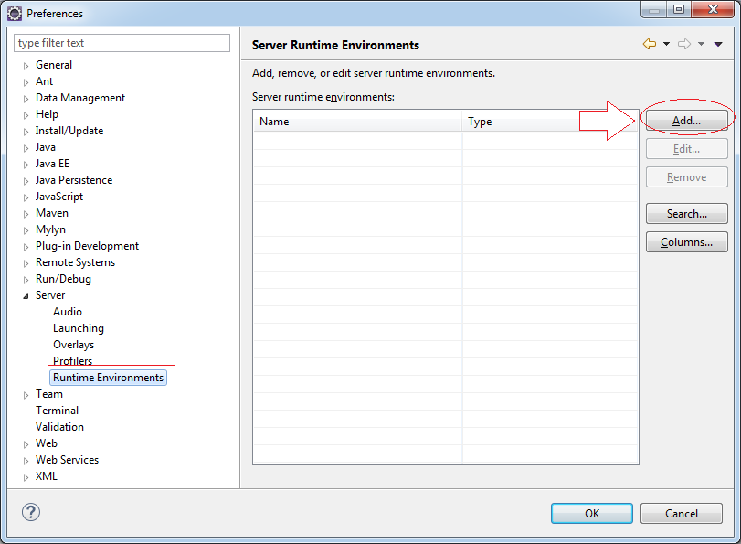

Select WebServer type is Tomcat 8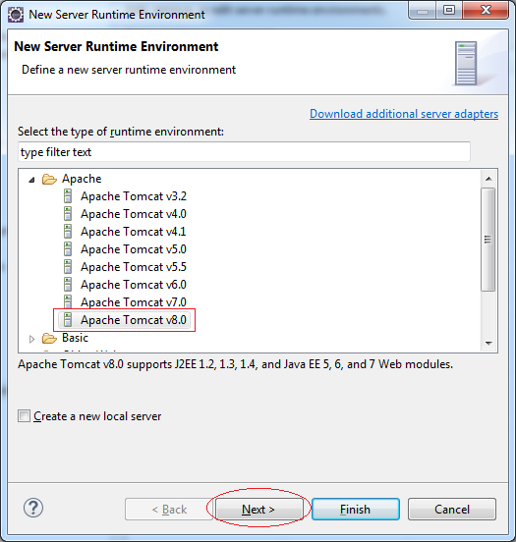

Declare tomcat the location you just unzipped on your hard drive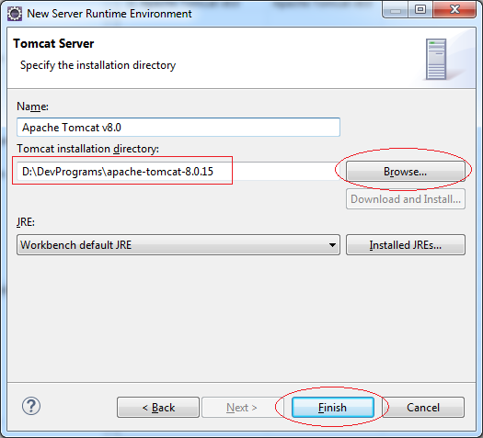

Click ok to finish.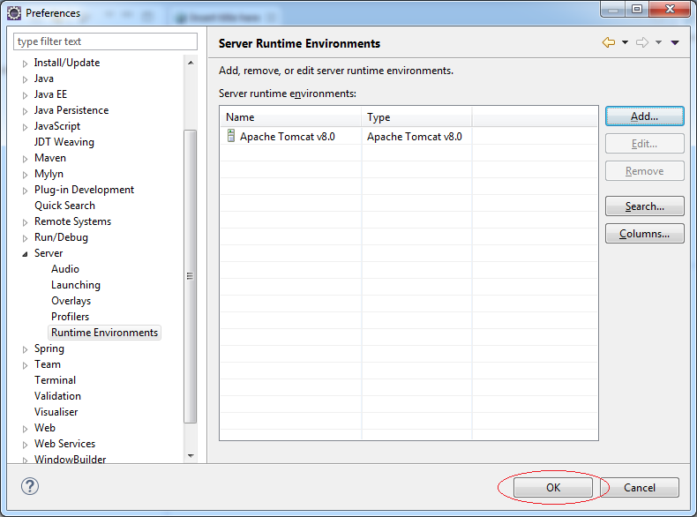

after finished, your screen will show the following

