Abstract
- Evidence-based conservation has the potential to improve biodiversity outcomes. Yet many conservation decisions do not explicitly incorporate scientific evidence, despite efforts to promote its use. To strengthen the role of scientific evidence in informing conservation decisions, it is vital to understand which factors influence its use by decision-makers. However, to date, there has been no comprehensive attempt to characterise the scientific literature on this topic.
- To fill this knowledge gap, we conducted a systematic map to synthesise the literature on factors that impact evidence use in conservation decision-making, including identifying where research has been conducted and which actors have been studied. Our searches and screening identified 169 relevant primary studies.
- We identified an apparent bias in the evidence use literature towards English-speaking countries in the Global North. Few studies reported focal ecosystems, or threats, but those that did often focused on marine, forest, or freshwater systems. The majority of studies investigated practitioners and researchers as actors, with relatively few studies focused on policymakers or other actors.
- The most commonly reported factors influencing evidence use were relationships between scientists and decision makers, the relevance of evidence, and the capacity and resources of conservation organisations. Factors relating to the characteristics of evidence and practitioners/policymakers, including their organisations and decision contexts, were frequently referenced. However, few studies identified factors relating to researchers and research organisations.
- Synthesis and applications. Researchers should move from characterising factors impacting scientific evidence use, to identifying and testing interventions to facilitate its use by conservation decision-makers. Since these factors are interlinked, implementation and testing of actions that tackle multiple barriers should be prioritised. Decision-makers and researchers should engage with each other early on when defining management, policy, and research synthesis questions, define knowledge needs clearly, and, where possible, invest in mechanisms to facilitate dialogue and interpretation of evidence. Together, these approaches offer the potential to promote evidence-based conservation practice and policy, resulting in improved biodiversity outcomes.

Keywords: Evidence-based conservation, evidence-informed conservation, evidence use, knowledge co-production, knowledge exchange, knowledge transfer, science-practice gap, barriers, facilitators

Introduction
For more than two decades, the concept of evidence-based conservation has been promoted as a means to improve outcomes for biodiversity (Cook, Mascia, et al., 2013; Sutherland et al., 2004). This approach was originally defined as the use of scientific evidence to inform and improve conservation decision making, in keeping with its inspiration by evidence-based medicine (Pullin & Knight, 2005; Sutherland et al., 2004). To support this goal, numerous initiatives have been launched to advocate for the use of evidence-based approaches in conservation, such as Conservation Evidence (Sutherland et al., 2019) and the Collaboration for Environmental Evidence (Collaboration for Environmental Evidence, 2025). However, despite these efforts, the use of scientific evidence in decision making remains limited and poorly understood (Busbridge et al., 2021; Fabian et al., 2019; Lemieux et al., 2018). Research has shown that conservation practitioners and policymakers often rely on multiple forms of knowledge, such as personal experience (Virk et al., 2023), the advice of colleagues (Cook et al., 2012; Fabian et al., 2019) (Cook et al., 2012; Fabian et al., 2019), and Indigenous and local knowledge (Brondízio et al., 2021; Wheeler et al., 2020). While considering multiple forms of knowledge as part of the decision-making process for conservation is essential, the failure to use scientific evidence risks producing suboptimal outcomes for biodiversity and reducing cost-effectiveness (Sutherland, 2022).
This persistent gap between research and practice is known as a ‘science-practice gap’, ‘knowing-doing gap’, or ‘research-implementation gap/space’ (Hulme, 2014; Knight et al., 2008; Toomey et al., 2017). Natural scientists have tended to assume linearity in how evidence and practice interact, where knowledge is generated through research and then passed on to decision-makers, either in the form of scientific publications or by translating information into non-technical language (Bertuol-Garcia et al., 2018). In reality, however, the process by which evidence informs decision making is complex and messy, as are the factors that influence whether scientific evidence is used and applied (Adams & Sandbrook, 2013; Cairney, 2015; Kadykalo, Buxton, et al., 2021). Recognition of this complexity has led to the increasing popularity of strategies to facilitate the use of scientific evidence in conservation, such as knowledge co-production. In this collaborative process, scientists and practitioners jointly decide about the relevant questions to be investigated as research partners, and then integrate plural knowledge into the investigation and decision-making process to tackle conservation problems (Nel et al., 2016). However, the linear model persists as the predominant way in which this problem is viewed (Bertuol-Garcia et al., 2018).
The research community’s response to the science-practice gap reflects this linear thinking (Oliver et al., 2022). Past research has investigated the barriers and solutions to improve evidence use in conservation (Rose et al., 2018; Walsh et al., 2019). These include availability and accessibility of the evidence (Cook et al., 2012; Taft et al., 2020), language barriers (Fabian et al., 2019), difference in time frames and priorities (Rose et al., 2020), and lack of political will (Kadykalo, Cooke, et al., 2021; Smith et al., 2017), among others. In addition, there is good evidence from fields such as policy studies, health, and education that scientific evidence use also depends on the capacities, cultures, and incentives of the individuals and organisations involved and the relationships between them (Boaz et al., 2019). For example, practitioners may lack the training or technical capacity to interpret or apply scientific evidence (Busbridge et al., 2021; Cook et al., 2010; Sunderland et al., 2009) and institutions may lack the staff or time to integrate scientific evidence into decision making (Fabian et al., 2019; Pullin et al., 2004).
A substantial body of research now examines the factors that influence the use of scientific evidence in biodiversity conservation, yet this literature remains fragmented. Existing syntheses focus on specific aspects of the problem, such as: the role of knowledge brokers (Cvitanovic et al., 2025), or boundary-spanning organisations (Posner & Cvitanovic, 2019); on particular systems or types of management, such as marine resource management (Cvitanovic et al., 2015; Karcher et al., 2024) or fire management (Hunter et al., 2020); or lack comprehensiveness. This fragmentation also constrains interdisciplinary learning, as researchers often work within disciplinary silos. Furthermore, we have limited understanding of which areas are well-studied and which are not (knowledge clusters and knowledge gaps), and how these relate to the geographies, biomes, actors, organisations, and evidence types that have been investigated. Consequently, we lack a comprehensive overview of what the key factors influencing scientific evidence use in conservation are. This limits the ability of researchers, practitioners, and policymakers to draw on existing work and identify solutions to current barriers - producing a more comprehensive overview of the literature will enable us to produce a road-map to prioritise future research efforts (i.e. more in-depth syntheses and targeted primary studies). To address these gaps, we undertook a systematic map to answer the following questions:

- In which decision-making contexts (e.g. geographic regions, biomes, conservation problems) has the science-practice interface been investigated?
- Which actors (e.g. conservation practitioners, policymakers, researchers, or other stakeholders) and types of organisations (e.g. government/statutory bodies, non-governmental organisations) have been the focus of studies?
- What are the most commonly reported factors affecting scientific evidence use in decision making for conservation?

Methods

Searches and screening
Our systematic map focused on primary studies that reported factors influencing the use of scientific evidence in decision making for conservation practice and policy. To guide the scope of the work, we defined five key elements: scientific evidence, evidence use, factors influencing evidence use, the populations of interest, and the geographic context. We considered evidence as “information used to assess one or more hypotheses related to a question of interest” (Salafsky et al., 2019), and so we defined scientific evidence as evidence generated using scientific methodologies, including both quantitative and qualitative information. Examples of types of evidence we considered relevant include peer-reviewed studies, data generated using scientific methods, and decision-making tools based on scientific evidence. We acknowledge that other forms of information are also vitally important for informing conservation practice, such as practitioners’ experience, Indigenous and local knowledge, and people’s values; however, these were considered beyond the scope of this systematic map. We follow the approach of Walsh et al. (2019) by using a broad definition of what constitutes the ‘use’ of scientific evidence, including: (i) instrumental - the direct application of information to help make a specific decision or solve a problem; (ii) conceptual - influencing thinking, perspectives, or the understanding of an issue; and (iii) symbolic - the use of evidence to provide credibility to a predetermined position (Nutley et al., 2007; Weiss, 1979). For the factors influencing the use of scientific evidence we used a modified version of the typology of Walsh et al.(2019), which identified 230 factors that facilitate or limit scientific evidence use in conservation management (more detail on this is provided in the data extraction section). The populations of interest were any person involved in the conservation science-practice/policy interface, including researchers, practitioners, policymakers, and other groups (e.g. community groups, Indigenous groups, research funders, and knowledge broker). Regarding geographic context, we made no restrictions of where a study could be undertaken.
To identify search terms, we created an initial search and then refined it using a benchmark list of ten studies deemed essential to be included in our searches (Table S1). Refinement continued until all benchmark studies were returned by our searches to improve the comprehensiveness of our search (Collaboration for Environmental Evidence, 2018; Foo et al., 2021). Once final search terms were identified, we performed platform-specific searches in Web of Science and Scopus (see details in Table S2), with no restrictions on the year in which studies were published. We combined our search results with 630 studies related to environmental decision making found in the systematic map of Oliver et al (2026), which identified studies reporting factors impacting evidence use across all policy domains, including public health, education, and environmental management. The final searches were carried out on 25/01/2025. Once collated, all references were uploaded onto the Rayyan platform (Ouzzani et al., 2016) for article screening, where semi-automated deduplication was carried out.
We used Rayyan to screen articles against the following inclusion criteria: articles (1) were written in English, (2) focused on biodiversity conservation, (3) focused on policy and practice, (4) focused on the use of scientific evidence in decision making, (5) identified factors that influence evidence use, (6) constituted a primary study, and (7) identified factors influencing evidence use using interviews, surveys, workshops, or documentary analysis (see the supplementary methods section for more details). The screening process consisted of two stages: first titles and abstracts were reviewed, and then, the full texts of the studies retained at this stage were assessed. At the title and abstract screening stage, studies had to meet criteria 1-5; at the full text stage, they had to meet all seven criteria. For articles excluded at the full-text screening stage, we provided reasons for the exclusion in accordance with ROSES guidelines (Haddaway et al., 2018 ; Figure S1). We focused only on English-language literature to simplify consistency checks between reviewers. We acknowledge that excluding literature written in non-English languages is a shortcoming that may lead to biases (Amano et al., 2021; Konno et al., 2020). Our detailed screening instructions can be seen in the supplementary methods section.
To ensure consistency at the screening stage, all reviewers first screened the titles and abstracts of 100 randomly selected studies using the inclusion criteria. All decisions were compared to those of the lead researcher. Any disagreements between the two people were discussed, and eligibility criteria were revised where appropriate. Cohen’s Kappa scores were calculated to test the agreement between the two people (Cohen, 1960). If Kappa scores fell below 0.6, another 100 titles and abstracts were screened by the same two team members, with the process repeated until Kappa scores were >0.6, signifying substantial agreement (McHugh, 2012). The same process was followed for the full texts of publications that met the inclusion criteria, but this time using 10 full texts. After screening, mean Kappa score was 0.67 for titles and abstracts, and 0.71 for full texts.
Searches generated 29,422 individual studies(Figure S1). To reduce screening workload, we used Rayyan’s AI model to identify studies unlikely to meet our inclusion criteria, which we then automatically excluded. Rayyan’s AI classification model uses a machine learning classifier based on Support Vector Machine to represent each abstract as a data point in a multidimensional space, attempting to define boundaries between different inclusion classifications and uses this to predict the inclusion/exclusion of unclassified abstracts (Bolaños et al., 2024; Suthaharan, 2016). While the classifier requires only two studies to be included and five to be excluded to allow for initial training of this model, its accuracy increases with a larger set of seed studies (Bolaños et al., 2024). As such, the lead researcher first screened 1,000 papers at the title and abstract stage and, using this as a training set, ran the AI tool to classify studies as ‘Highly unlikely to include’ or ‘Unlikely to include.’ This identified 13,087 articles eligible for exclusion. We only focused on excluding studies with the AI tool, rather than identifying studies to include, because previous tests have shown it is much better at classifying irrelevant studies than those that are relevant (Valizadeh et al., 2022). To test the sensitivity of this classification, the lead researcher screened a random sample of 5% (n=654) of studies classified as being likely to be excluded, finding only one potentially relevant article, equating to a false negative rate of 0.15%. Extrapolated to all automatically excluded records, likely led to around 20 potentially relevant studies being excluded at the title and abstract screening stage. Given that 23% of studies considered relevant at the title and abstract stage were included after reading their full texts, we estimate that our automatic exclusion may have led to the erroneous exclusion of 4-5 primary studies, representing around 3% of all studies. The remaining 16,498 titles and abstracts were screened manually, with 15,762 of these excluded and 736 retained for full-text screening. Following full text screening, 169 studies were retained for synthesis (Figure S1).

Data extraction
Data extraction focused on collecting information on the factors reported in each study as influencing the use of scientific evidence, following the framework we detail above, as well as contextual information. To characterise included studies, we extracted information on (a) their geographic and ecological settings, as well as the conservation threats; (b) the actors involved in decision-making processes and the organisations they represented, and (c) the factors influencing the use of scientific evidence. Specifically, we recorded the country or countries of focus, ecosystem type (e.g. freshwater, marine, forest), the scale of studies, focal taxonomic group, and the conservation problem being addressed. We also documented the focal population(s) as people involved in the decision-making processes (including conservation practitioners, policymakers, scientists, and other stakeholders) and the organisation types represented. In addition, we extracted information on the type of scientific evidence, the discipline from which the scientific evidence was drawn, the study design, and the type of data collected by researchers. Further details on the data extraction protocol are provided in the supplementary methods section.

To categorise the factors influencing the use of scientific evidence in conservation we adapted the typology of Walsh et al (2019). This typology groups factors influencing the use of scientific evidence into: (i) the nature of the evidence itself, (ii) research-practice links; (iii) decision contexts; (iv) researchers and research organisations; (v) practitioners; (vi) management organisations; (vii) other stakeholders; and (viii) the wider community. To aid with communication, we simplified this to four categories (see Table 1): (i) evidence characteristics, including factors such as the existence of evidence, how accessible the evidence is, how relevant the evidence is; (ii) relationships, such as those between scientists and practitioners/policymakers or those between colleagues; (iii) researchers and research organisations, including academic demands on researchers or their skills and awareness of practice and policy; and (iv) practitioners/policymakers, organisations, and decision contexts, such as capacity and resources of organisations such as staff, time, and funding, the research skills of practitioners/policymakers, and their attitude towards evidence use. We also reduced the 230 factors identified by Walsh et al (2019), to 35 more broadly-defined factors. This involved rephrasing the factors so that they were neutral, rather than identified as barriers or facilitators. This aided more reproducible identification and classification of factors identified in primary studies by members of the review team.

Table 1 - Factors influencing evidence use that we extracted from the relevant primary studies based on the framework of Walsh et al. (2019). This is a hierarchical structure, with Category the highest level and factor the lowest, most precise level.
Category | Factor name | Description
Characteristics of scientific evidence | Existence | Whether the evidence exists or not
 | Accessibility | How accessible the evidence is (e.g. whether paywalls impede access)
 | Format and language | The format and style of language in which evidence is presented
 | Time lag | The time taken to produce research outputs
 | Quantity of information | The quantity of scientific evidence (e.g. information overload)
 | Language barrier | Information is in a language other than that of the native language of decision-makers
 | Difficult to find | Difficulty in finding scientific evidence (e.g. when using search platforms)
 | Relevance | The relevance of existing scientific evidence to the context of decision making
 | Rigour | The rigorousness or trustworthiness of the scientific evidence
 | Uncertainty | Uncertainty associated with the scientific evidence
 | Lack of uncertainty | Scientific evidence does not assess uncertainty
 | Inconclusive | Research is inconclusive, or there are contradicting results
 | Source of evidence | The researcher or organisation that produced the research
Characteristics of practitioners and policymakers, organisations, and decision contexts | Decision-maker characteristics | Alignment with the personal beliefs of decision-maker or their ecological knowledge
 | Nature of decision | The nature of the decision being made, such as the time pressure, goals, importance of the issues, and whether it is a chronic and long-term problem vs an acute and short-term problem
 | Social, political, and economic context | Alignment of evidence with social, political, or economic interests
 | Implementation capacity | The feasibility of recommendations, their costs, and the resources needed to implement recommendations
 | Practitioner/policymaker attitude towards evidence use | The attitude of practitioners or policymakers towards the use of scientific evidence, such as willingness or interest
 | Practitioner/policymaker research skills | The research skills of practitioners or policymakers, such as scientific training, understanding of research, ability to read research papers, and skills to search for papers
 | Practitioner/policymaker personal characteristics | The characteristics of practitioners or policymakers, such as openness to new ideas, aversion to risk, level of education, and role within an organisation
 | Practitioner/policymaker decision process | Features of the process involved in the decision-making process
 | Culture of practitioner/policymaker | The culture of practitioner and policymaker communities
 | Practitioner/policymaker awareness of evidence | The awareness of practitioners and policymakers about scientific evidence
 | Capacity and resources | Resources and capacity, such as staff and personnel, funding, time, and turnover
 | Management | Features of management, such as managerial support for evidence use, legislative support, and communication channels with management
 | Timeliness of evidence | Evidence is available at the right time for the decision-making process
 | Other stakeholders values and beliefs | The values and beliefs of stakeholders who are not scientists, practitioners, or policymakers
Relationships | Scientist-actor relationships | Relationships between scientists and practitioners/policymakers influence evidence use
 | Relationship between colleagues | Relationships between fellow policymakers/practitioners
 | Practitioner/policymaker-stakeholder relationships | Relationships between policymakers and practitioners with actors other than scientists
Characteristics of researchers and research organisations | Researcher attitude towards evidence use | Attitude of the researcher towards the use of evidence in conservation decision making
 | Researcher skills and awareness | Skills and awareness of a researcher related to policy/practice, as well as their communication and dissemination skills
 | Academic demands on researchers | Constraints and demands on researchers, such as time constraints and incentives to publish papers
 | Culture of researchers | Cultural factors related to researchers, such as resistance to advocacy or recognition of experiential knowledge
Other | Other stakeholders’ values and beliefs | The values and beliefs of stakeholders who are not scientists, practitioners, or policymakers

Analyses
Our analyses had two major aims: (i) the identification of themes that have been well-studied, those that have been studied rarely, and any biases present in the literature on the factors influencing the use of scientific evidence in conservation policy and practice, and (ii) the quantification of the factors most frequently cited in studies. Themes that have been well-studied, referred to as knowledge clusters, represent opportunities for in-depth synthesis, such as systematic review and meta-analysis. Those that have been studied relatively rarely, referred to as knowledge gaps, represent potentially useful topics for future primary research (James et al., 2016).
Our analysis focused on describing patterns in the contextual variables for which we extracted data and the different factors influencing the use of scientific evidence. All analyses were carried out in R version 4.5.0 (R Core Team, 2022). Data were cleaned and formatted using tidyverse R packages (Wickham et al., 2019) , and the packages rnaturalearth (South et al., 2024), countrycode (Arel-Bundock et al., 2018), ggplot2 (Wickham, 2016), ComplexUpset (Krassowski, 2020), cowplot (Wilke, 2024), and lemon (Edwards, 2024) were used to produce figures.

Results
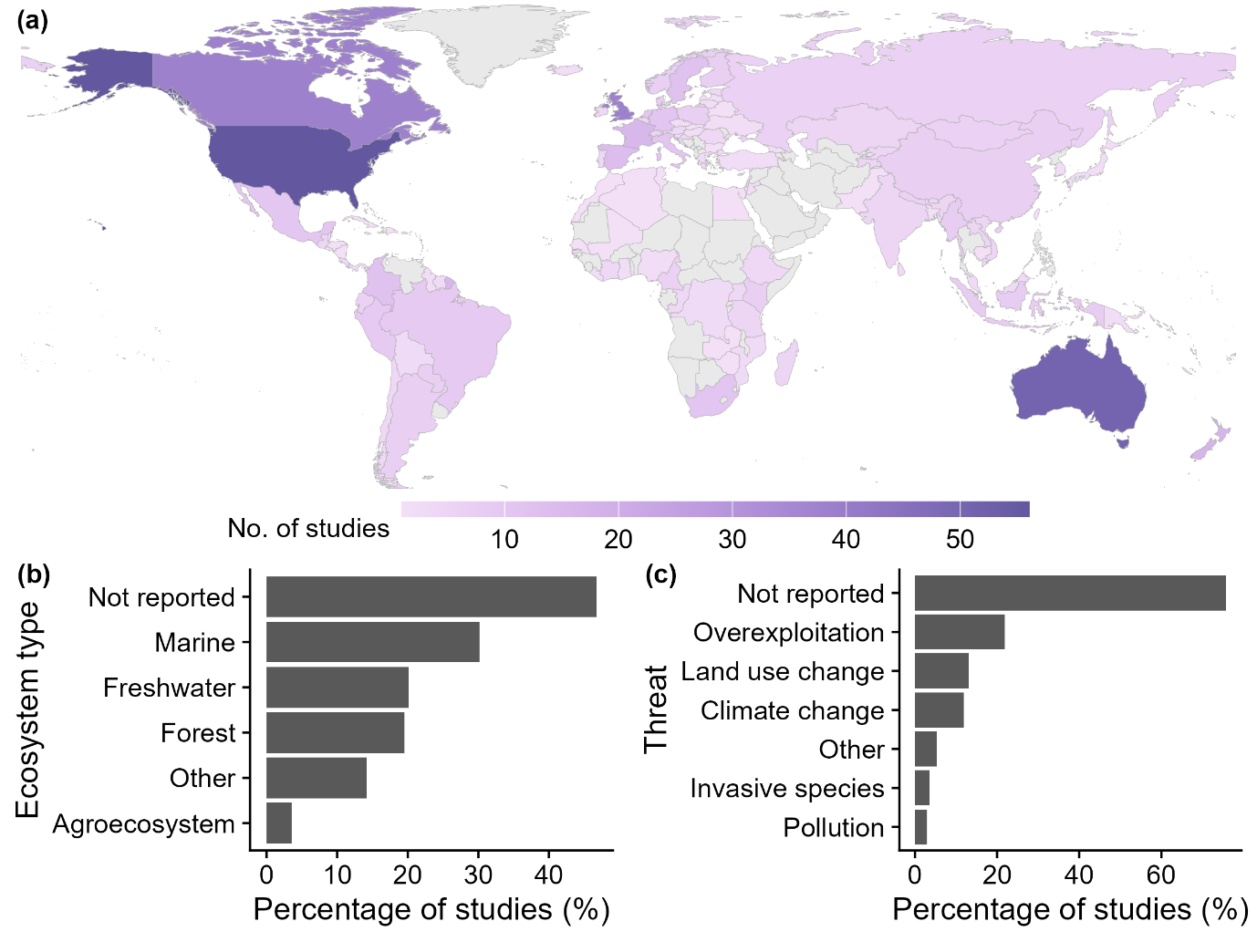
Figure 1 – The country, ecosystem type, and conservation threat of the synthesised studies: (a) the number of studies on factors influencing evidence use found in each country (light grey indicates countries with no studies); (b) the percentage of studies related to different ecosystem types; (c) the percentage of studies addressing particular threats to biodiversity.
Our searches identified a total of 29,585 studies, of which 736 were retained after screening of titles and abstracts, with 16,498 studies excluded manually at this stage and 13,087 excluded using automated methods (Figure S1). At the full-text screening stage, 547 studies were excluded. The most common reasons for exclusion were that they: (1) were not primary studies (282 studies, Figure S1); (2) included study designs other than interviews, questionnaires, workshops, or documentary analysis (70 studies); and (3) were on topics other than biodiversity conservation (79 studies). After screening, 169 studies were retained for synthesis.
For the 169 studies included in our systematic map, 474 different countries mentions were recorded (studies could include more than one focal country). The mean number of focal countries per study was 3.2 (SD=6.7). There was an apparent bias towards Global North English-speaking countries, with the USA, Australia, Canada, and the UK representing 26.5% (n=126) of all country mentions (Figure 1a). It should be noted that we only searched for literature in English. The Americas (150 country mentions, 31.6%) were the most studied continent, closely followed by Europe (148 mentions, 31.2%). Oceania and Africa were equally studied with 58 country mentions each (12.2%), while Asia was marginally less studied (56 mentions, 11.8%). Regarding the scale at which studies were undertaken, the largest group was represented by those that focused on multiple organisations within the same sub-national region (30.8%, n=52), while a similar number of studies focused on organisations in multiple countries (30.2%, n=51). Fewer studies focused on multiple regions within a single country (21.3%, n=36) and on single organisations (13.0%, n=22). Many studies did not report the spatial scale at which decisions were being made (30.8%), with a similar number reporting regional-scale decision making (27.2%), fewer at local and national scales (18.9% and 15.4% respectively) and even fewer at an international scale (7.1%).
Many studies (46.7%, n=79) did not report a focal ecosystem type (Figure 1b), with the most studied ecosystems being marine (30.2%, n=51), freshwater (20.1%, n=34), and forest systems (19.5%, n=33). All other ecosystems - such as agroecosystems, grasslands, and shrublands - were represented by 17.7% of studies (n=30). Numerous studies focused on more than one biome type, and so percentages do not sum to 100%. Similarly, most studies (75.7%, n=128) did not focus on a particular threat to biodiversity (Figure 1c), while overexploitation (21.9%, n=37), land use change (13.0%, n=22), and climate change (11.8%, n=20) were the most commonly studied threats.
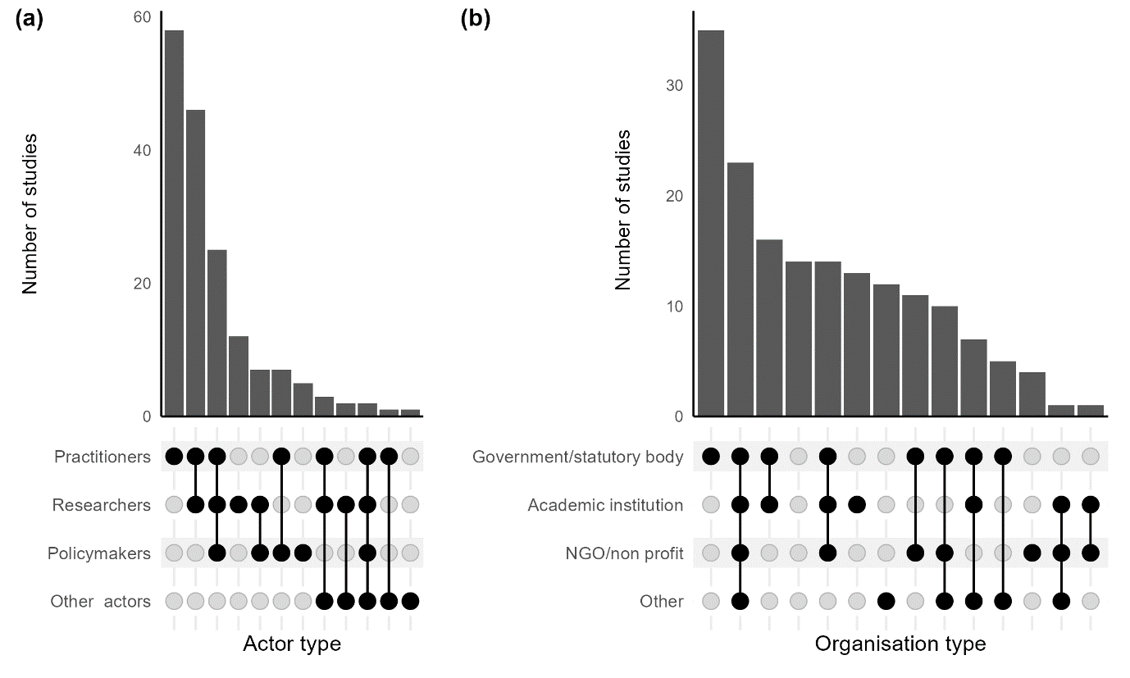
Figure 2 – The mix of (a) actors and (b) related organisations investigated in each study. In each figure, the lower part represents the different mixes of actors/organisations studied, with a dark dot representing occasions where they have been studied, and grey dots those where they have not, lines indicate the combinations of these different mixes. The bars above each combination indicate the number of studies represented by each mix.
The vast majority of studies included practitioners as actors (84.0%, n=142), with a majority of studies also including researchers (57.4%, n=97). Relatively few studies included policymakers (27.2%, n=46) and other actors, such as research funders or citizens (5.3%, n=9). Most studies included more than one category of actor (55.0%), typically both practitioners and researchers (27.2%, n=46, figure 2a) - and less so practitioners, policymakers, and researchers (14.8%, n=25) and policymakers and researchers (4.1%, n=7).
Government and statutory bodies were the most studied organisation type (71.5%, n=121, Figure 2b), with academic institutions (44.4%, n=75), and NGOs and non-profits (37.9%, n=64) also frequently studied, while other types of organisations, such as Indigenous organisations, community groups, and private companies, were studied less regularly (34.3% for all other organisations combined, n=58). Similar to the results for actors, most organisation types were typically studied in conjunction with other organisations such as; academic institutions, NGOs and non-profit organisations, and other groups (Figure 2b).
Most studies (52.1%) did not provide details of the format of the scientific evidence they considered. The most commonly mentioned types of scientific evidence related to peer reviewed studies (16.0%), decision-making tools (5.9%) and research data (5.9%). Many studies focused on evidence from the natural sciences (48.5%, Figure S2) while in 36.1% of studies it was unclear what discipline the scientific evidence used in decision making was drawn from. Relatively few studies explicitly considered the use of both natural and social science evidence in conservation decision making (14.2%) and studies that focused exclusively on the use of evidence generated by the social sciences were very rare (1.2%).

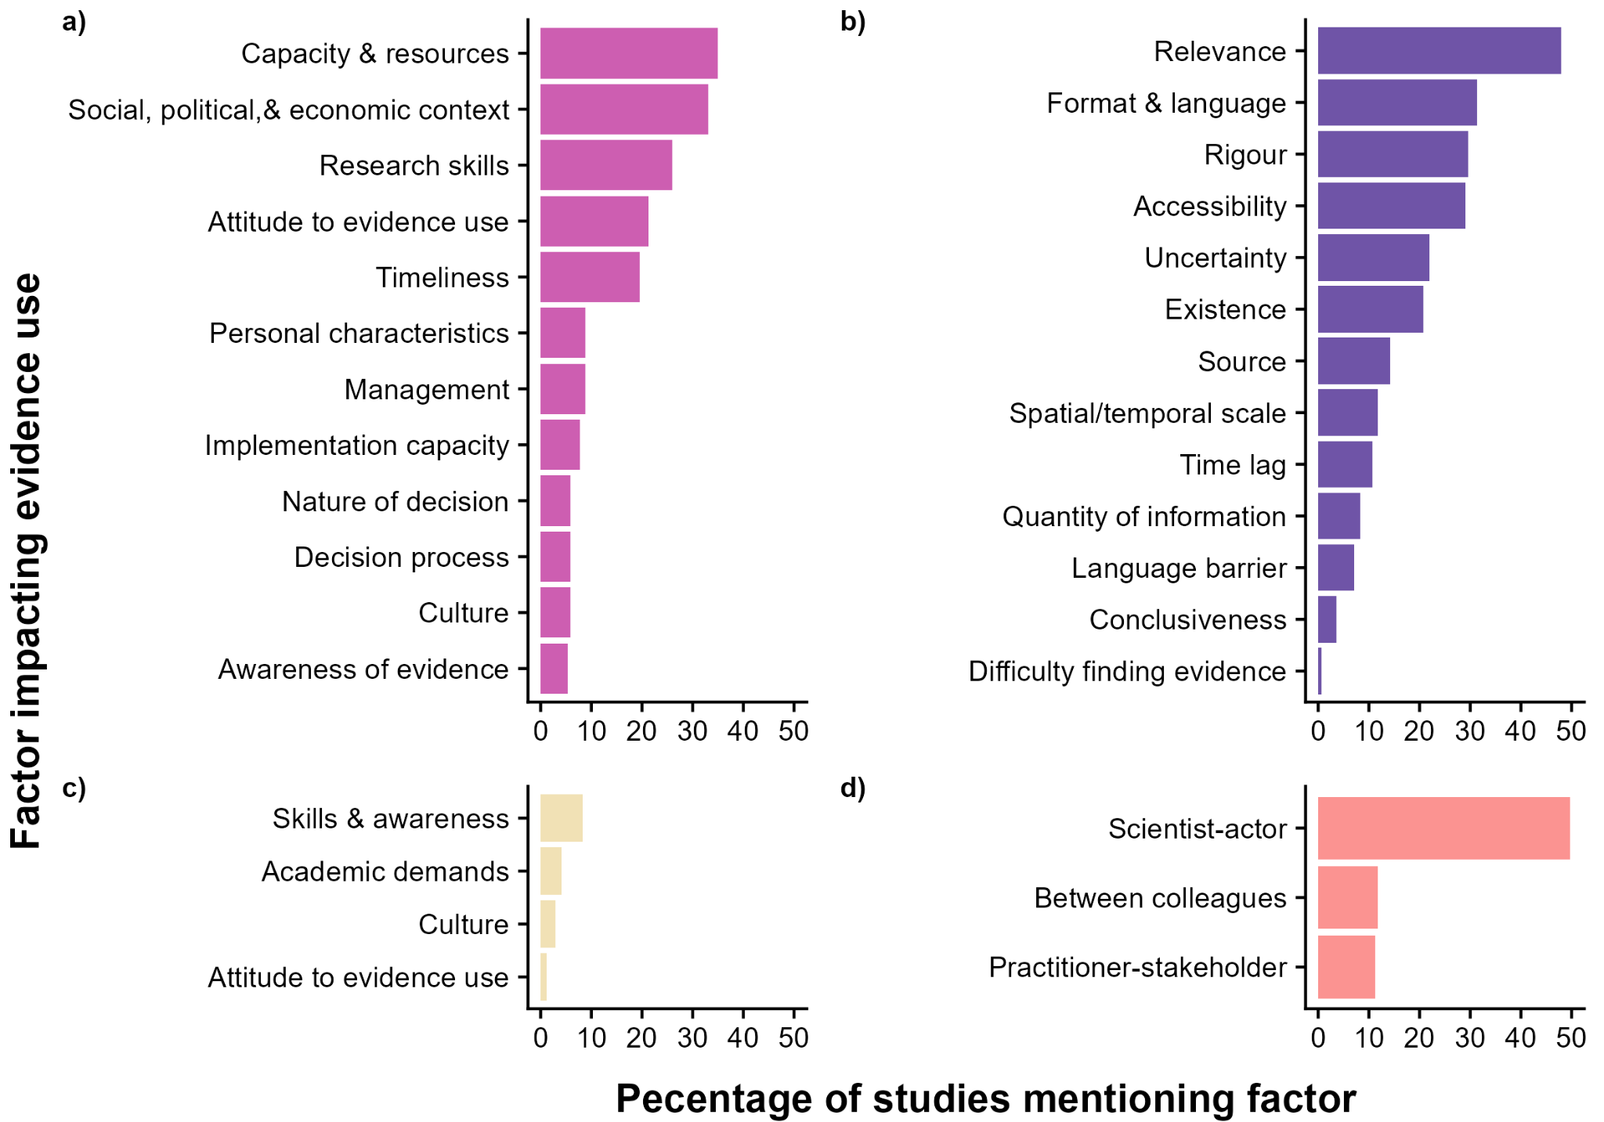
Figure 3 – The percentage of studies (n=169) that mention individual factors that influence scientific evidence use in biodiversity conservation. Factors are divided into broad thematic categories to facilitate interpretation: (a) characteristics of practitioners and policymakers, organisations, and decision contexts, (b) characteristics of scientific evidence, (c) characteristics of researchers and research organisations, and (d) relationships.
The most commonly reported factor affecting evidence use was scientist-actor relationships, which were mentioned in around half of studies (49.7%, n=84, Figure 3d), closely followed by the relevance of the scientific evidence (47.9%, n=81, Figure 3b) and the capacity and resources of policy or practice organisations (34.9%, n=59, Figure 3a). The mean number of factors identified per study was 5.1 (SE=0.3), with 20.4% of studies identifying ≤2 factors and 9.0% of studies identifying ≥10 factors
In addition to capacity and resources, the social, economic, and political context (33.1%, n=56, Figure 3a), practitioner/policymaker research skills (26%, n=44), the attitude of practitioners and policymakers to the use of scientific evidence (21.3%, n=36), and the timeliness of the evidence (19.5% n=33) were all commonly reported factors influencing evidence use of policy or practice organisations.
Factors relating to the characteristics of scientific evidence were the most commonly studied, compared to other thematic categories. Approximately half of studies identified relevance of the evidence as important (47.9%, n=81 studies, Figure 3b). The format and language (i.e. the format - such as peer-reviewed studies, reports, or presentations - and style of language in which evidence is presented, 31.4%, n=53), rigour (29.6%, n=50), the accessibility of evidence (29.0%, n=49), and uncertainty (21.9%, n=37) were also frequently mentioned in studies. Factors such as the existence of evidence, the source of the evidence, the spatial or temporal scale of the evidence and time lags associated with evidence production were mentioned with moderate frequency, with 10-20% studies citing them as factors influencing evidence use (Figure 3b). Meanwhile, the quantity of information, language barriers, conclusiveness, and difficulty in finding the evidence were mentioned in fewer than 10% of studies (Figure 3b).
Factors associated with the characteristics of researchers were rarely identified in studies (Figure 3c), with the skills and awareness of researchers related to policy and practice receiving most attention (8.3%, n=14) while the other factors in this category were identified in fewer than 5% of studies. Regarding relationships, scientist-other actor relationships were the most commonly cited factor (Figure 3d, 49.7%, n=84), whilst relationships that practitioners and policymakers have with their colleagues (11.8%, n=20), and relationships between practitioners/policymakers and other actor groups (11.2%, n=19) were identified less frequently.
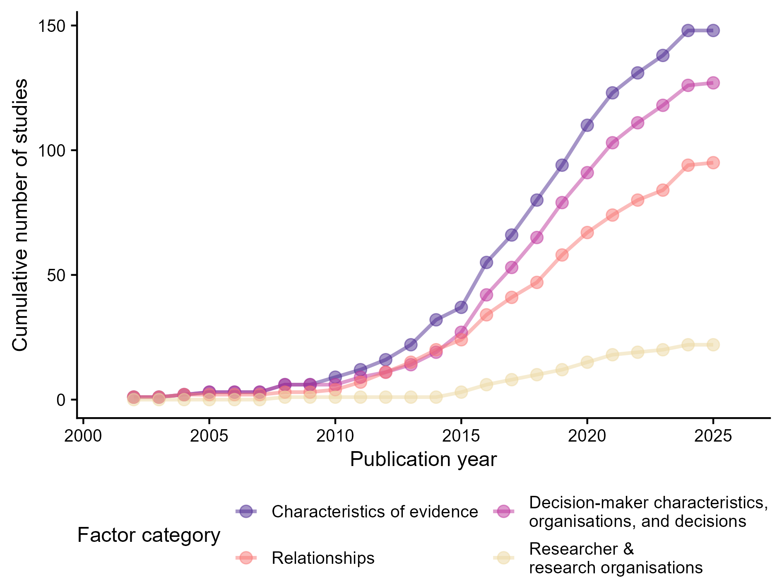
Figure 4 – Temporal changes in the cumulative number of studies that have addressed different broad categories of factors impacting scientific evidence use in conservation. Dots represent the cumulative total number of studies for each broad category of factors for a given year. Note that the data for 2025 is incomplete due to the date of the literature searches.
We did not find any studies on the factors influencing scientific evidence use in conservation prior to the early 2000’s (Figure 4). The relative attention paid to the four broad categories of factor impacting evidence use has remained consistent since the mid 2010’s (Figure 4), with characteristics relating to evidence the most commonly identified (mean = 7.1 studies per year), followed by the characteristics of decision-makers, their organisations, and decisions (6.1 studies per year), relationships (4.5 studies per year), and researcher and research organisations (1.1 studies per year). There was a noticeable increase in the number of studies from 2015 onwards.
Discussion
Our results show that the most frequently identified factors impacting the use of scientific evidence in conservation practice and policy are relationships between scientists and practitioners/policymakers, the relevance of scientific evidence, and the capacity and resources of policy or practice organisations users of the evidence - each mentioned in ≥35% of studies. Beyond this top three, studies often noted the importance of practitioner and policymaker characteristics, such as their technical skills and attitude towards evidence use, as well as factors associated with the broader decision-making context, such as social, economic, and political conditions. Evidence-related factors were also commonly reported, particularly accessibility, rigour, and the format and style of language in which the information is communicated. In contrast, relatively few studies identified factors associated with researchers as impacting the use of scientific evidence.

These results are remarkably consistent with those of the larger review of Oliver et al (2026), who synthesised factors influencing evidence use from 2199 studies across a broad range of fields such as public health, health care, climate change policy, and education. Consistent with our findings, Oliver et al (2026) identified relevance, staff and resources, communication and relations between practitioners and scientists, and accessibility of evidence as key to evidence being used to inform policy and practice. Together, these patterns suggest that evidence use is shaped less by the availability of scientific knowledge than by how evidence is embedded within organisational settings, decision processes, and professional relationships. The results of our study are also similar to those of the smaller review of Kadykalo et al (2021) who found that evidence relevance, accessibility, organisational capacity and resources, time limitations, and researchers' communication skills were all common barriers to the use of evidence in conservation. Our findings also broadly align with the framework of Cash et al. (2003), which argues that in order to be successful, interfaces between science, practice, and policy critically depend on salience, credibility, and legitimacy. Relevance emerged as one of the most frequently reported factors in our synthesis and closely corresponds to salience, while perceptions of rigour and evidence quality contribute to credibility. Our findings also suggest that relationships between researchers and decision-makers, together with broader organisational and political contexts, are central to establishing the legitimacy of evidence. Consistent with Cash et al. (2003), this highlights that barriers to evidence use often arise not simply because evidence lacks these attributes, but because different actors often value and perceive salience, credibility, and legitimacy differently.

Our results also indicate biases in the evidence-use literature, with an apparent focus on Global North English-speaking countries such as the USA, Australia, and Canada; a tendency for studies to focus primarily on practitioners, with policymakers consulted relatively rarely; and a predominance of studies examining governmental and statutory bodies. However, we also acknowledge that the relative lack of studies in non-English speaking countries may be partially attributable to our study methods, which only searched for literature in English. In addition, Global North English-speaking countries include a large number of research-intensive universities and conservation organisations, which may partially explain the patterns seen. Despite the relative lack of studies, practitioners and policymakers in the Global South may experience similar barriers to evidence use to those found in English-speaking countries in the Global North. However, future research should aim to identify whether there are unique factors that impede the use of evidence in the Global South, such as political and resource constraints, limited access to databases and scientific studies, or poor internet connectivity.

Many of the studies we identified did not report the ecosystem type or conservation threat that organisations focused on. Rather than purely being indicative of a lack of reporting by researchers, this likely reflects the breadth of most primary studies, which normally focused on multiple conservation organisations that worked in a wide range of different ecosystems and dealt with a variety of conservation threats. This is reflected by the large number of government and statutory bodies which were the focus of studies and that around 50% of decision contexts studied were related to regional to international scales. However, given the importance of context in how evidence is used, we urge researchers on this topic to provide more detailed descriptions of the contexts in which studies were undertaken. Doing this would allow for a comparison of how the factors impacting the use of scientific evidence vary across contexts and identification of topics for which more research is needed, or not needed, thereby reducing research waste (Grainger et al., 2020; Purgar et al., 2022).

Factors influencing scientific evidence use
A large proportion of primary studies identified characteristics of scientific evidence itself as influencing its use. Relevance was particularly prominent amongst these and is a recurring theme in conservation, where biodiversity outcomes from management can be highly context dependent (Cook, Possingham, et al., 2013). What determined relevance was rarely defined, but studies often mentioned that data available at large scales were not relevant to local scale decisions (Gagné et al., 2020; Jacaban et al., 2022; Miljand & Eckerberg, 2022; Rasmussen et al., 2017). As such, relevance is likely influenced by the ecological, cultural and socioeconomic similarities between the contexts in which scientific evidence is generated and the decision context (Adams & Sandbrook, 2013; Christie et al., 2020, 2023). The format and style of language used to communicate scientific evidence was frequently cited as influencing evidence use, which reflects scientists’ training to write for disciplinary specialists using technical language (Fazey et al., 2005), but can limit the interpretability and usability of evidence for practitioners and policymakers (Barrett & Rodriguez, 2021; Cvitanovic et al., 2016; Karam-Gemael et al., 2018). Accessibility of evidence was frequently mentioned in studies and reviews and has long been recognised as influencing evidence use (Pullin et al., 2004), but remains a problem due both to paywalls and difficulties in finding information (Cook et al., 2012; Fabian et al., 2019; Walsh et al., 2019). The rigour of evidence was regularly highlighted as influencing its uptake, mainly noting the perceived trustworthiness of scientific evidence (Lemieux et al., 2018). However, in contrast, a number of studies highlighted the concerns of decision-makers that data generated by models (Peters et al., 2018) and by citizen science (Suskevics et al., 2021) may be less trustworthy than empirical data collected by trained scientists.

The importance of relationships in shaping decision processes is well recognised (Gray, 2016; Noble & Fulton, 2020; Walsh et al., 2019) and our results reflect the vital role of relationships between researchers and practitioners/policymakers. Decisions are not made through neutral application of information, but are embedded within social interactions, norms, and expectations between actors (Lejano, 2021). One key aspect of relationships between scientists and practitioners/policymakers was simply whether there was any contact and communication at all (Yocum et al., 2022), which often facilitated overcoming barriers such as lack of access to evidence or difficulty in understanding technical language (Noble & Fulton, 2020). Additionally, trust in researchers and the research they produce plays an important role in shaping perceptions of the credibility and legitimacy of scientific evidence and the recommendations derived from it (Durant et al., 2019; Younger-Khan, 2026). Our findings therefore align with broader literature suggesting that relationships act as an enabling condition for evidence use, rather than a substitute for evidence quality or relevance.

Our results indicate that organisational factors, individual capacity, and decision context play key roles in shaping the use of scientific evidence. In particular, the influence of organisational capacity and resources is likely to be a major constraint. Most conservation organisations operate with limited funding and small teams (Armsworth et al., 2012), leaving staff with little time to search for, interpret, and apply scientific evidence. Linked to this, many staff in conservation organisations also feel that they lack the technical skills to read and interpret scientific evidence, with evidence use often more common among practitioners with higher levels of formal education or scientific training (Lemieux et al., 2018). The social, political, and economic context was also frequently cited in studies we found, reflecting the fact that the wider decision-context is important in determining whether scientific evidence informs practice and policy. Use of evidence on topics that are politically contentious in some contexts, such as the use of climate change data for conservation strategies in US states, highlight this issue (Peters et al., 2018; Rasmussen et al., 2017; Yocum et al., 2022).
Relatively few studies identified factors associated with the characteristics of researchers and research organisations as influencing the use of scientific evidence. This is somewhat surprising given long-standing concerns that academic incentive structures prioritise novel findings and high-impact journals (Shanley & López, 2009) and disadvantage the production of policy- or practice-relevant evidence (Dedeurwaerdere et al., 2026). We found that researchers’ knowledge of policy and practice was relatively frequently cited, aligning with previous work showing that researchers’ perceptions of what constitutes relevant or useful evidence often differ substantially from those of practitioners and policymakers (Cook, Mascia, et al., 2013). However, the limited attention paid to researcher and research organisation characteristics in the conservation evidence-use literature does not indicate that they are unimportant, but, rather, should be seen as a knowledge gap and research priority.

Potential solutions
Given the diversity and interrelatedness of the factors influencing the use of scientific evidence, the conservation sector must focus on delivering solutions that address multiple barriers at the same time. One such widely recognised cross-cutting solution is the use of knowledge co-production and participatory approaches (Nel et al., 2016), which can promote improved scientist-other actor relationships, increased evidence relevance, and build capacity both for researchers and practitioners/policymakers. However, such approaches also have trade-offs: they may be time consuming, expensive, or impractical in many situations, and may generate questions that researchers find uninteresting (Sutherland et al., 2017; Walsh et al., 2019). While addressing specific issues such as accessibility, resources and capacity, and scientist-other actor relationships (as discussed below) could be beneficial, ultimately, a systemic shift in how evidence is valued and applied in conservation decisions is required to overcome the underlying causes.

In the conservation literature there is a strong focus on initiating and improving relationships via bridging or connecting the research and practice/policy communities (Kadykalo, Buxton, et al., 2021; Wyborn, 2015), the use of knowledge brokers (Duncan et al., 2020), or boundary spanners (Posner & Cvitanovic, 2019). At the same time, while interventions that aim to build strong relationships may facilitate communication and trust, they cannot on their own overcome structural constraints such as limited organisational capacity, misaligned incentives, or political and institutional pressures. As such, relationships should be understood as part of a wider system of conditions shaping evidence use, interacting with organisational, contextual, and evidentiary factors rather than operating independently.

Solutions relating to evidence characteristics are perhaps the most tractable of the issues we identified in this study, since they largely relate to how researchers produce research outputs. Attempts to improve relevance and accessibility include synthesising primary studies and making the resulting information freely available through initiatives such as Conservation Evidence (Sutherland et al., 2019) and the Collaboration on Environmental Evidence. However, accessibility and relevance are insufficient, as evidence use is often impeded by the technical language and format used to communicate it. Conservation Evidence addresses this through structured, plain-language summaries of scientific publications on management effectiveness, while dedicated sections highlighting management implications in journals such as Journal of Applied Ecology, complement this approach (Groves et al., 2024). We encourage more journals that publish applied biodiversity research to follow this example. Emerging tools such as generative artificial intelligence may further address problems of technical language by allowing more conversational, user-tailored access to evidence, although careful testing is required to manage risks related to bias and error (Iyer et al., 2025).

The importance of organisational factors such as capacity, leadership, incentives, and resourcing is well-established in the broader evidence use literature (Criado-Perez et al., 2020; Currie et al., 2020) and addressing these factors can improve both evidence use and societal benefits (Boaz et al., 2024). Despite this, much of the conservation literature focuses on factors more amenable to alteration, such as the formatting or dissemination of evidence. However, there are important structural reasons for this. Biodiversity conservation is chronically underfunded (Guénard et al., 2025; Waldron et al., 2013). As such, while interventions that aim to increase capacity and resourcing are often desirable, in many cases they may be unrealistic. This is in contrast with fields such as public health or education where organisations are typically larger and better resourced. Additionally, the use of scientific evidence may impose further costs on organisations (Fabian et al., 2019; Walsh et al., 2019), although the relative costs and benefits depend on the nature of conservation decision being made (Sutherland, 2022; Taylor et al., 2026; White et al., 2026).

Biases and methodological limitations
Our study has a number of important caveats relating to the conceptualisation of the factors influencing evidence use and the methods we used. First, the frequency with which factors are mentioned does not necessarily indicate their relative importance, whether they were presented as barriers or enablers to evidence use, or their magnitude of influence. We recommend that future syntheses assess in which contexts each specific factor impedes or facilitates the use of evidence as well as more focused syntheses that address a specific conservation context or topic (e.g. Kapoor et al., 2025). Most studies in the systematic map elicited people’s opinions about factors influencing evidence use and so responses could be subject to availability bias, resulting in examples that come easily to mind being assumed to be more important than they are in reality (Tversky & Kahneman, 1974). Future studies could reduce the risk of such biases by combining open-ended questions with more structured prompts, asking about recent specific decisions, and using proven structured expert elicitation methods such as the Delphi technique and IDEA protocol (Hemming et al., 2018; Martin et al., 2012). Equally, the factors we identified are interlinked, not independent of each other meaning that once one barrier is overcome, other factors are likely to become more important.

While we largely followed best-practice guidelines for conducting systematic maps (Collaboration for Environmental Evidence, 2018), time and resource constraints to our project meant that it was necessary to drop some elements, such as a publicly available a priori protocol. We did however share a screening protocol within the review team (see supplementary methods). We did not search for or include studies in non-English languages or grey literature and this likely magnified the bias towards studies being conducted in Global North English-speaking countries (Hannah et al., 2024; Nuñez & Amano, 2021), as well as leading to an underestimation of the proportion of studies citing the importance of language barriers. Finally, we did not conduct critical appraisal - a process which assesses the robustness and validity of studies included in synthesis (Collaboration for Environmental Evidence, 2018; Stanhope & Weinstein, 2022). Given the wide variation in the robustness of qualitative research in conservation (Moon et al., 2016; O’Brien et al., 2014; Young et al., 2018), we recommend such an assessment in future follow-up studies.

Conclusions
In order to improve the use of scientific evidence, it is vital that researchers move beyond documenting barriers towards identifying and explicitly testing solutions. The complex, interlinked nature of the different factors impacting evidence use means that interventions that address multiple barriers at once are particularly important. Approaches such as knowledge co-production, embedding scientists within organisations, and knowledge brokering have the potential to simultaneously improve relationships between scientists and decision-makers, increase the relevance and accessibility of evidence, and foster organisational cultures that support evidence use (Cvitanovic et al., 2015; Norström et al., 2020). Although these approaches are increasingly used in conservation (Rosemartin et al., 2023), there are relatively few explicit evaluations of their effectiveness. Future research should prioritise testing interventions using quasi-experimental counterfactual approaches, comparative case studies of different interventions, and evaluations of organisational change over time. Doing this would facilitate a shift from advocating for the importance of evidence-based conservation to identifying how scientific evidence can be effectively incorporated into conservation decision making (Taylor et al., 2026).

For researchers, our findings highlight the importance of engaging with practitioners, policymakers, and other relevant stakeholder groups early on to help shape research questions and methods, to ensure relevance, as well as providing feedback on how evidence can be communicated most effectively. Even when these relationships do not exist, conservation researchers can increase the practical impact of their work by translating their research into forms that more accessible, such as policy briefs, which have been shown to help overcome communication barriers (Arnautu & Dagenais, 2021; see Balian et al., 2016 for guidance on producing policy briefs).

For practitioners and policymakers, our findings reinforce the value of sustained relationships and collaboration with researchers throughout the decision-making process. As with researchers, we recommend that decision-makers and researchers engage early when defining management, policy, and research questions, clearly articulate priority knowledge needs, and invest in mechanisms that facilitate dialogue and interpretation of evidence, such as knowledge-brokering, embedded scientists, and long-term researcher-practitioner partnerships. However, our synthesis also underscores that expectations around evidence-informed practice must be realistic given the chronic under-resourcing of conservation organisations (Guénard et al., 2025; Waldron et al., 2013). Given this context, efforts to improve evidence use should be prioritised based on the potential consequences of incorrect decisions and the degree of uncertainty associated with them (Taylor et al., 2026). Where risks and uncertainty are relatively low, a lack of investment in evidence use may be justified. In contrast, where decisions are associated with high uncertainty or potentially large conservation or social consequences, greater investment in improving evidence use is likely to be beneficial (Taylor et al., 2026). There are also clear opportunities for AI to remove barriers to accessing evidence (e.g. time and cost) - although these come with risks of their own (Ammar et al., 2026; Iyer et al., 2025).

Finally, improving evidence use requires institutional support and conducive political conditions. Recent reductions in research funding in some countries, including the massive cuts to research spending in the USA (Donald, 2025), threaten the long-term capacities needed to support evidence-based decisions. At the same time, there is increasing recognition of the importance of Indigenous leadership and diverse knowledge systems in conservation. Although our review focused specifically on scientific evidence, future work should continue to explore how different ways of knowing can be combined transparently, since, despite much work on this topic, this is still challenging to do in practice (Tengö et al., 2017). Addressing the science-practice gap in conservation will ultimately require not only better evidence, but supportive institutions, inclusive processes, and a sustained commitment to learning across knowledge systems.

Positionality statement
We would like to state our position because we believe that who is performing the research and how an issue is conceptualised and analysed depends on who is defining the problem and their visions and preferences about possible solutions. In this case, we are mostly natural and social scientists working in nature conservation, who believe that the use of scientific evidence to inform nature conservation decision-making processes is desirable. Our collective experience working at the science-practice interface has informed the research question of this study. We understand that our analysis and conclusions are inseparable from our aspiration to contribute to better nature conservation outcomes.

References
Adams, W. M., & Sandbrook, C. (2013). Conservation, evidence and policy. Oryx: The Journal of the Fauna Preservation Society, 47(3), 329–335.
Amano, T., Berdejo-Espinola, V., Christie, A. P., Willott, K., Akasaka, M., Báldi, A., Berthinussen, A., Bertolino, S., Bladon, A. J., Chen, M., Choi, C.-Y., Bou Dagher Kharrat, M., de Oliveira, L. G., Farhat, P., Golivets, M., Hidalgo Aranzamendi, N., Jantke, K., Kajzer-Bonk, J., Kemahlı Aytekin, M. Ç., … Sutherland, W. J. (2021). Tapping into non-English-language science for the conservation of global biodiversity. PLoS Biology, 19(10), e3001296.
Ammar, E., Sharma, A., August, T., Bicknell, J. E., Boughey, K., Dunford, C. E., Driscoll, D. A., Fiennes, S., Lopatin, J., Hartley, M., Hillier, J., Martin, P. A., O’Connor, R. S., Parodi, F., Simmons, B. I., Struebig, M. J., Thompson, R. M., Ardiantiono, Yoh, T., … Gordon, R. (2026). Artificial intelligence and decision support in applied ecology. The Journal of Applied Ecology, 63(6), e70455.
Arel-Bundock, V., Enevoldsen, N., & Yetman, C. J. (2018). countrycode: An R package to convert country names and country codes. Journal of Open Source Software, 3(28), 848.
Armsworth, P. R., Fishburn, I. S., Davies, Z. G., Gilbert, J., Leaver, N., & Gaston, K. J. (2012). The size, concentration, and growth of biodiversity-conservation nonprofits. Bioscience, 62(3), 271–281.
Arnautu, D., & Dagenais, C. (2021). Use and effectiveness of policy briefs as a knowledge transfer tool: a scoping review. Humanities & Social Sciences Communications, 8(1), 211.
Balian, E. V., Drius, L., Eggermont, H., Livoreil, B., Vandewalle, M., Vandewoestjine, S., Wittmer, H., & Young, J. (2016). Supporting evidence-based policy on biodiversity and ecosystem services: recommendations for effective policy briefs. Evidence & Policy: A Journal of Research, Debate and Practice, 12(3), 431–451.
Barrett, K., & Rodriguez, S. L. (2021). What sources are natural resource managers using to make decisions? The Journal of Wildlife Management, 85(8), 1543–1553.
Bertuol-Garcia, D., Morsello, C., N El-Hani, C., & Pardini, R. (2018). A conceptual framework for understanding the perspectives on the causes of the science-practice gap in ecology and conservation. Biological Reviews of the Cambridge Philosophical Society, 93(2), 1032–1055.
Boaz, A., Davies, H., Fraser, A., & Nutley, S. (2019). What works now?: Evidence-informed policy and practice (A. Boaz, H. Davies, A. Fraser, & S. Nutley, Eds.). Policy Press.
Boaz, A., Goodenough, B., Hanney, S., & Soper, B. (2024). If health organisations and staff engage in research, does healthcare improve? Strengthening the evidence base through systematic reviews. Health Research Policy and Systems, 22(1), 113.
Bolaños, F., Salatino, A., Osborne, F., & Motta, E. (2024). Artificial intelligence for literature reviews: opportunities and challenges. Artificial Intelligence Review, 57(10), 259.
Brondízio, E. S., Aumeeruddy-Thomas, Y., Bates, P., Carino, J., Fernández-Llamazares, Á., Ferrari, M. F., Galvin, K., Reyes-García, V., McElwee, P., Molnár, Z., Samakov, A., & Shrestha, U. B. (2021). Locally based, regionally manifested, and globally relevant: Indigenous and local knowledge, values, and practices for nature. Annual Review of Environment and Resources, 46(1), 481–509.
Busbridge, S., Clarkson, B. D., & Wallace, K. J. (2021). A tenuous link: Information transfer between urban ecological research and restoration practice. Urban Forestry & Urban Greening, 60(127019), 127019.
Cairney, P. (2015). The politics of evidence-based policy making (1st ed.) [PDF]. Palgrave Pivot.
Cash, D., Clark, W. C., Alcock, F., Dickson, N., Eckley, N., & Jäger, J. (2003). Salience, credibility, legitimacy and boundaries: Linking research, assessment and decision making. SSRN Electronic Journal. https://doi.org/10.2139/ssrn.372280
Christie, A. P., Amano, T., Martin, P. A., Petrovan, S. O., Shackelford, G. E., Simmons, B. I., Smith, R. K., Williams, D. R., Wordley, C. F. R., & Sutherland, W. J. (2020). Poor availability of context-specific evidence hampers decision-making in conservation. Biologicals: Journal of the International Association of Biological Standardization, 248, 108666.
Christie, A. P., Morgan, W. H., Salafsky, N., White, T. B., Irvine, R., Boenisch, N., Chiaravalloti, R. M., Kincaid, K., Rezaie, A. M., Yamashita, H., & Sutherland, W. J. (2023). Assessing diverse evidence to improve conservation decision‐making. Conservation Science and Practice, 5(10), e13024.
Cohen, J. (1960). A Coefficient of Agreement for Nominal Scales. Educational and Psychological Measurement, 20(1), 37–46.
Collaboration for Environmental Evidence. (2018). Guidelines and Standards for Evidence synthesis in Environmental Management. Version 5.0 (Pullin, A.S., Frampton, G.K., Livoreil, B., Petrokofsky, G., Ed.). www.environmentalevidence.org/information-for-authors. [Accessed 6/10/21].
Collaboration for Environmental Evidence. (2025). Environmental Evidence – Reliable evidence, informed decisions, better environment. Collaboration for Environmental Evidence. https://environmentalevidence.org/
Cook, C. N., Carter, R. W. B., Fuller, R. A., & Hockings, M. (2012). Managers consider multiple lines of evidence important for biodiversity management decisions. Journal of Environmental Management, 113, 341–346.
Cook, C. N., Hockings, M., & Carter, R. W. (bill). (2010). Conservation in the dark? The information used to support management decisions. Frontiers in Ecology and the Environment, 8(4), 181–186.
Cook, C. N., Mascia, M. B., Schwartz, M. W., Possingham, H. P., & Fuller, R. A. (2013). Achieving conservation science that bridges the knowledge-action boundary. Conservation Biology: The Journal of the Society for Conservation Biology, 27(4), 669–678.
Cook, C. N., Possingham, H. P., & Fuller, R. A. (2013). Contribution of systematic reviews to management decisions. Conservation Biology: The Journal of the Society for Conservation Biology, 27(5), 902–915.
Criado-Perez, C., Collins, C. G., & Jackson, C. (2020). Enablers of evidence-based management: Clues from the absorptive capacity literature. Australian Journal of Management, 45(3), 468–487.
Currie, G., Kiefer, T., & Spyridonidis, D. (2020). From what we know to what we do: enhancing absorptive capacity in translational health research. BMJ Leader, 4(1), 18–20.
Cvitanovic, C., Hobday, A. J., van Kerkhoff, L., Wilson, S. K., Dobbs, K., & Marshall, N. A. (2015). Improving knowledge exchange among scientists and decision-makers to facilitate the adaptive governance of marine resources: A review of knowledge and research needs. Ocean & Coastal Management, 112, 25–35.
Cvitanovic, C., Karcher, D. B., Breen, J., Badullovich, N., Cairney, P., Dalla Pozza, R., Duggan, J., Hoffmann, S., Kelly, R., Meadow, A. M., & Posner, S. (2025). Knowledge brokers at the interface of environmental science and policy: A review of knowledge and research needs. Environmental Science & Policy, 163(103973), 103973.
Cvitanovic, C., McDonald, J., & Hobday, A. J. (2016). From science to action: Principles for undertaking environmental research that enables knowledge exchange and evidence-based decision-making. Journal of Environmental Management, 183(Pt 3), 864–874.
Dedeurwaerdere, T., Jahn, S., & Newig, J. (2026). Governing the trade-off between the co-production of actionable knowledge and academic publishing in transdisciplinary sustainability research. Environmental Science & Policy, 176(104318), 104318.
Donald, P. (2025). Trump proposes massive cuts to research spending. Science (New York, N.Y.), 388(6747), 566–567.
Duncan, R., Robson-Williams, M., & Edwards, S. (2020). A close examination of the role and needed expertise of brokers in bridging and building science policy boundaries in environmental decision making. Palgrave Communications, 6(1), 64.
Durant, S. M., Groom, R., Kuloba, B., Samna, A., Muzuma, U., Gadimang, P., Mandisodza-Chikerema, R., Ipavec, A., Mitchell, N., Ikanda, D., & Msuha, M. (2019). Bridging the divide between scientists and decision-makers: How behavioural ecologists can increase the conservation impact of their research? Philosophical Transactions of the Royal Society of London. Series B, Biological Sciences, 374(1781). https://doi.org/10.1098/rstb.2019.0011
Edwards, S. M. (2024). lemon: Freshing Up your `ggplot2’ Plots. https://CRAN.R-project.org/package=lemon
Fabian, Y., Bollmann, K., Brang, P., Heiri, C., Olschewski, R., Rigling, A., Stofer, S., & Holderegger, R. (2019). How to close the science-practice gap in nature conservation? Information sources used by practitioners. Biological Conservation, 235, 93–101.
Fazey, I., Fischer, J., & Lindenmayer, D. B. (2005). What do conservation biologists publish? Biological Conservation, 124(1), 63–73.
Foo, Y. Z., O’Dea, R. E., Koricheva, J., Nakagawa, S., & Lagisz, M. (2021). A practical guide to question formation, systematic searching and study screening for literature reviews in ecology and evolution. Methods in Ecology and Evolution / British Ecological Society, 12(2041-210X.13654), 1705–1720.
Gagné, S. A., Bryan-Scaggs, K., Boyer, R. H. W., & Xiang, W.-N. (2020). Conserving biodiversity takes a plan: How planners implement ecological information for biodiversity conservation. Ambio, 49(9), 1490–1505.
Grainger, M. J., Bolam, F. C., Stewart, G. B., & Nilsen, E. B. (2020). Evidence synthesis for tackling research waste. Nature Ecology & Evolution, 4(4), 495–497.
Gray, N. J. (2016). The role of boundary organizations in co-management: examining the politics of knowledge integration in a marine protected area in Belize. International Journal of the Commons, 10(2), 1013.
Groves, L., Gordon, R., Siqueira, T., Macinnis-Ng, C., Marini, L., Nuñez, M. A., Suryawanshi, K., & Barlow, J. (2024). Sixty years of ecology with impact. The Journal of Applied Ecology, 61(12), 2864–2872.
Guénard, B., Hughes, A. C., Lainé, C., Cannicci, S., Russell, B. D., & Williams, G. A. (2025). Limited and biased global conservation funding means most threatened species remain unsupported. Proceedings of the National Academy of Sciences of the United States of America, 122(9), e2412479122.
Haddaway, N. R., Macura, B., Whaley, P., & Pullin, A. S. (2018). ROSES RepOrting standards for Systematic Evidence Syntheses: pro forma, flow-diagram and descriptive summary of the plan and conduct of environmental systematic reviews and systematic maps. Environmental Evidence, 7(1), 7.
Hannah, K., Haddaway, N. R., Fuller, R. A., & Amano, T. (2024). Language inclusion in ecological systematic reviews and maps: Barriers and perspectives. Research Synthesis Methods, 15(3), 466–482.
Hemming, V., Burgman, M. A., Hanea, A. M., McBride, M. F., & Wintle, B. C. (2018). A practical guide to structured expert elicitation using the IDEA protocol. Methods in Ecology and Evolution, 9(1), 169–180.
Hulme, P. E. (2014). EDITORIAL: Bridging the knowing-doing gap: know-who, know-what, know-why, know-how and know-when. The Journal of Applied Ecology, 51(5), 1131–1136.
Hunter, M. E., Colavito, M. M., & Wright, V. (2020). The use of science in wildland fire management: A review of barriers and facilitators. Current Forestry Reports, 6(4), 354–367.
Iyer, R., Christie, A. P., Madhavapeddy, A., Reynolds, S., Sutherland, W., & Jaffer, S. (2025). Careful design of Large Language Model pipelines enables expert-level retrieval of evidence-based information from syntheses and databases. PloS One, 20(5), e0323563.
Jacaban, E., Rytwinski, T., Taylor, J. J., Young, N., Nguyen, V. M., & Cooke, S. J. (2022). Do environmental systematic reviews impact policy and practice? Author perspectives on the application of their work. Environmental Science & Policy, 129, 159–167.
James, K. L., Randall, N. P., & Haddaway, N. R. (2016). A methodology for systematic mapping in environmental sciences. Environmental Evidence, 5(1), 1–13.
Kadykalo, A. N., Buxton, R. T., Morrison, P., Anderson, C. M., Bickerton, H., Francis, C. M., Smith, A. C., & Fahrig, L. (2021). Bridging research and practice in conservation. Conservation Biology: The Journal of the Society for Conservation Biology. https://doi.org/10.1111/cobi.13732
Kadykalo, A. N., Cooke, S. J., & Young, N. (2021). The role of western-based scientific, Indigenous and local knowledge in wildlife management and conservation. People and Nature, 3(3), 610–626.
Kapoor, T., Cvitanovic, C., Klenk, K., & Nguyen, V. M. (2025). Taking knowledge exchange to practice: A scoping review of practical case studies to identify enablers of success in environmental management. Environmental Policy and Governance, 35(1), 114–131.
Karam-Gemael, M., Loyola, R., Penha, J., & Izzo, T. (2018). Poor alignment of priorities between scientists and policymakers highlights the need for evidence-informed conservation in Brazil. Perspectives in Ecology and Conservation, 16(3), 125–132.
Karcher, D. B., Tuohy, P., Cooke, S. J., & Cvitanovic, C. (2024). Knowledge exchange at the interface of marine science and policy: A review of progress and research needs. Ocean & Coastal Management, 253(107137), 107137.
Knight, A. T., Cowling, R. M., Rouget, M., Balmford, A., Lombard, A. T., & Campbell, B. M. (2008). Knowing but not doing: selecting priority conservation areas and the research-implementation gap. Conservation Biology: The Journal of the Society for Conservation Biology, 22(3), 610–617.
Konno, K., Akasaka, M., Koshida, C., Katayama, N., Osada, N., Spake, R., & Amano, T. (2020). Ignoring non-English-language studies may bias ecological meta-analyses. Ecology and Evolution, 10(13), 6373–6384.
Krassowski, M. (2020). ComplexUpset. https://doi.org/10.5281/zenodo.3700590
Lejano, R. P. (2021). Relationality: an alternative framework for analysing policy. Journal of Public Policy, 41(2), 360–383.
Lemieux, C. J., Groulx, M. W., Bocking, S., & Beechey, T. J. (2018). Evidence-based decision-making in Canadas protected areas organizations: Implications for management effectiveness. Facets (Ottawa), 3(1), 392–414.
Martin, T. G., Burgman, M. A., Fidler, F., Kuhnert, P. M., Low-Choy, S., McBride, M., & Mengersen, K. (2012). Eliciting expert knowledge in conservation science. Conservation Biology: The Journal of the Society for Conservation Biology, 26(1), 29–38.
McHugh, M. L. (2012). Interrater reliability: the kappa statistic. Biochemia Medica, 22(3), 276–282.
Miljand, M., & Eckerberg, K. (2022). Using systematic reviews to inform environmental policy-making. Evaluation, 28(2), 210–230.
Moon, K., Brewer, T. D., Januchowski-Hartley, S. R., Adams, V. M., & Blackman, D. A. (2016). A guideline to improve qualitative social science publishing in ecology and conservation journals. Ecology and Society: A Journal of Integrative Science for Resilience and Sustainability, 21(3). https://www.jstor.org/stable/26269983?seq=1
Nel, J. L., Roux, D. J., Driver, A., Hill, L., Maherry, A. C., Snaddon, K., Petersen, C. R., Smith-Adao, L. B., Van Deventer, H., & Reyers, B. (2016). Knowledge co-production and boundary work to promote implementation of conservation plans: Conservation Planning for Implementation. Conservation Biology: The Journal of the Society for Conservation Biology, 30(1), 176–188.
Noble, M. M., & Fulton, C. J. (2020). Pathways to impact for aquatic conservation science via multi-modal communication and stakeholder engagement. Aquatic Conservation: Marine and Freshwater Ecosystems, 30(9), 1791–1797.
Norström, A. V., Cvitanovic, C., Löf, M. F., West, S., Wyborn, C., Balvanera, P., Bednarek, A. T., Bennett, E. M., Biggs, R., de Bremond, A., Campbell, B. M., Canadell, J. G., Carpenter, S. R., Folke, C., Fulton, E. A., Gaffney, O., Gelcich, S., Jouffray, J.-B., Leach, M., … Österblom, H. (2020). Principles for knowledge co-production in sustainability research. Nature Sustainability, 3(3), 182–190.
Nuñez, M. A., & Amano, T. (2021). Monolingual searches can limit and bias results in global literature reviews. Nature Ecology & Evolution. https://doi.org/10.1038/s41559-020-01369-w
Nutley, S. M., Walter, I., & Davies, H. T. O. (2007). Using evidence: How research can inform public services (1st ed.). Policy Press.
O’Brien, B. C., Harris, I. B., Beckman, T. J., Reed, D. A., & Cook, D. A. (2014). Standards for reporting qualitative research: a synthesis of recommendations. Academic Medicine: Journal of the Association of American Medical Colleges, 89(9), 1245–1251.
Oliver, K., Hopkins, A., Boaz, A., Guillot-Wright, S., & Cairney, P. (2022). What works to promote research-policy engagement? Evidence & Policy: A Journal of Research, Debate and Practice, 18(4), 691–713.
Oliver, K., Malin, J., Akerlof, K. L., Day, E., Grant, S., McGill, E., Lorenc, T., Castellano Pleguzuel, V., Martin, P., Lam, J., Williamson, L., Mouthaan, M., Iqbal, S., Jaques, L., Nyanchoka, M., Alejandre, J. C., Lane, L., Persson, E., Forde, H., … Falconer, J. (2026). What factors influence policy? An updated systematic map. Humanities and Social Sciences Communications.
Ouzzani, M., Hammady, H., Fedorowicz, Z., & Elmagarmid, A. (2016). Rayyan—a web and mobile app for systematic reviews. Systematic Reviews, 5(1), 210.
Peters, C. B., Schwartz, M. W., & Lubell, M. N. (2018). Identifying climate risk perceptions, information needs, and barriers to information exchange among public land managers. The Science of the Total Environment, 616–617, 245–254.
Posner, S. M., & Cvitanovic, C. (2019). Evaluating the impacts of boundary-spanning activities at the interface of environmental science and policy: A review of progress and future research needs. Environmental Science & Policy, 92, 141–151.
Pullin, A. S., & Knight, T. M. (2005). Assessing conservation management’s evidence base: A survey of management-plan compilers in the United Kingdom and Australia. Conservation Biology, 19(6), 1989–1996.
Pullin, A. S., Knight, T. M., Stone, D. A., & Charman, K. (2004). Do conservation managers use scientific evidence to support their decision-making? Biological Conservation, 119(2), 245–252.
Purgar, M., Klanjscek, T., & Culina, A. (2022). Quantifying research waste in ecology. Nature Ecology & Evolution, 6(9), 1390–1397.
R Core Team. (2022). R: A Language and Environment for Statistical Computing. R Foundation for Statistical Computing. https://www.R-project.org/
Rasmussen, L. V., Kirchhoff, C. J., & Lemos, M. C. (2017). Adaptation by stealth: climate information use in the Great Lakes region across scales. Climatic Change, 140(3–4), 451–465.
Rose, D. C., Mukherjee, N., Simmons, B. I., Tew, E. R., Robertson, R. J., Vadrot, A. B. M., Doubleday, R., & Sutherland, W. J. (2020). Policy windows for the environment: Tips for improving the uptake of scientific knowledge. Environmental Science & Policy, 113, 47–54.
Rose, D. C., Sutherland, W. J., Amano, T., González-Varo, J. P., Robertson, R. J., Simmons, B. I., Wauchope, H. S., Kovacs, E., Durán, A. P., Vadrot, A. B. M., Wu, W., Dias, M. P., Di Fonzo, M. M. I., Ivory, S., Norris, L., Nunes, M. H., Nyumba, T. O., Steiner, N., Vickery, J., & Mukherjee, N. (2018). The major barriers to evidence-informed conservation policy and possible solutions. Conservation Letters, 11(5), e12564.
Rosemartin, A., Crimmins, T. M., Gerst, K. L., Posthumus, E. E., Ramirez, A. R., Wallace, C. S. A., & Morelli, T. L. (2023). Lessons learned in knowledge co-production for climate-smart decision-making. Environmental Science & Policy, 141, 178–187.
Salafsky, N., Boshoven, J., Burivalova, Z., Dubois, N. S., Gomez, A., Johnson, A., Lee, A., Margoluis, R., Morrison, J., Muir, M., Pratt, S. C., Pullin, A. S., Salzer, D., Stewart, A., Sutherland, W. J., & Wordley, C. F. R. (2019). Defining and using evidence in conservation practice. Conservation Science and Practice, 1(5), e27.
Shanley, P., & López, C. (2009). Out of the loop: Why research rarely reaches policy makers and the public and what can be done: Biological research beyond academy. Biotropica, 41(5), 535–544.
Smith, T., Gibbs, K., Westwood, A., Taylor, S., & Walsh, K. (2017). Oversight at risk: The state of government science in British Columbia, an assessment of research capacity, communication and independence in British Columbia provincial ministries and departments. Evidence for Democray.
South, A., Michael, S., & Massicotte, P. (2024). rnaturalearthdata: World Vector Map Data from Natural Earth Used in `rnaturalearth’. https://doi.org/10.32614/CRAN.package.rnaturalearthdata
Stanhope, J., & Weinstein, P. (2022). Critical appraisal in ecology: What tools are available, and what is being used in systematic reviews? Research Synthesis Methods. https://doi.org/10.1002/jrsm.1609
Sunderland, T., Sunderland-Groves, J., Shanley, P., & Campbell, B. (2009). Bridging the gap: How can information access and exchange between conservation biologists and field practitioners be improved for better conservation outcomes?: Bridging the gap. Biotropica, 41(5), 549–554.
Suskevics, M., Raadom, T., Vanem, B., Kana, S., Roasto, R., Runnel, V., & Kulvik, M. (2021). Challenges and opportunities of engaging biodiversity-related citizen science data in environmental decision-making: Practitioners’ perceptions and a database analysis from Estonia. Journal for Nature Conservation, 64. https://doi.org/10.1016/j.jnc.2021.126068
Suthaharan, S. (2016). Support vector machine. In Integrated Series in Information Systems (pp. 207–235). Springer US.
Sutherland, W. J. (2022). Transforming conservation. Open Book.
Sutherland, W. J., Pullin, A. S., Dolman, P. M., & Knight, T. M. (2004). The need for evidence-based conservation. Trends in Ecology & Evolution, 19(6), 305–308.
Sutherland, W. J., Shackelford, G., & Rose, D. C. (2017). Collaborating with communities: co-production or co-assessment? Oryx: The Journal of the Fauna Preservation Society, 51(4), 569–570.
Sutherland, W. J., Taylor, N. G., MacFarlane, D., Amano, T., Christie, A. P., Dicks, L. V., Lemasson, A. J., Littlewood, N. A., Martin, P. A., Ockendon, N., Petrovan, S. O., Robertson, R. J., Rocha, R., Shackelford, G. E., Smith, R. K., Tyler, E. H. M., & Wordley, C. F. R. (2019). Building a tool to overcome barriers in research-implementation spaces: The Conservation Evidence database. Biologicals: Journal of the International Association of Biological Standardization, 238, 108199.
Taft, H. R., McCoskey, D. N., Miller, J. M., Pearson, S. K., Coleman, M. A., Fletcher, N. K., Mittan, C. S., Meek, M. H., & Barbosa, S. (2020). Research–management partnerships: An opportunity to integrate genetics in conservation actions. Conservation Science and Practice, 2(9), e218.
Taylor, N. G., Morgan, W. H., Sutherland, W. J., & Christie, A. P. (2026). On the evidence for evidence‐based conservation. Ecological Solutions and Evidence, 7(2), e70255.
Tengö, M., Hill, R., Malmer, P., Raymond, C. M., Spierenburg, M., Danielsen, F., Elmqvist, T., & Folke, C. (2017). Weaving knowledge systems in IPBES, CBD and beyond—lessons learned for sustainability. Current Opinion in Environmental Sustainability, 26–27, 17–25.
Toomey, A. H., Knight, A. T., & Barlow, J. (2017). Navigating the space between research and implementation in conservation: Research-implementation spaces. Conservation Letters, 10(5), 619–625.
Tversky, A., & Kahneman, D. (1974). Judgment under uncertainty: Heuristics and biases: Biases in judgments reveal some heuristics of thinking under uncertainty. Science (New York, N.Y.), 185(4157), 1124–1131.
Valizadeh, A., Moassefi, M., Nakhostin-Ansari, A., Hosseini Asl, S. H., Saghab Torbati, M., Aghajani, R., Maleki Ghorbani, Z., & Faghani, S. (2022). Abstract screening using the automated tool Rayyan: results of effectiveness in three diagnostic test accuracy systematic reviews. BMC Medical Research Methodology, 22(1), 160.
Virk, S., Papworth, A., & Papworth, S. (2023). What should we do? An explanatory analysis of the decision-making process in biodiversity conservation. Environmental Science & Policy, 149(103562), 103562.
Waldron, A., Mooers, A. O., Miller, D. C., Nibbelink, N., Redding, D., Kuhn, T. S., Roberts, J. T., & Gittleman, J. L. (2013). Targeting global conservation funding to limit immediate biodiversity declines. Proceedings of the National Academy of Sciences of the United States of America, 110(29), 12144–12148.
Walsh, J. C., Dicks, L. V., Raymond, C. M., & Sutherland, W. J. (2019). A typology of barriers and enablers of scientific evidence use in conservation practice. Journal of Environmental Management, 250, 109481.
Weiss, C. H. (1979). The Many Meanings of Research Utilization. Public Administration Review, 39(5), 426–431.
Wheeler, H. C., Danielsen, F., Fidel, M., Hausner, V., Horstkotte, T., Johnson, N., Lee, O., Mukherjee, N., Amos, A., Ashthorn, H., Ballari, Ø., Behe, C., Breton-Honeyman, K., Retter, G.-B., Buschman, V., Jakobsen, P., Johnson, F., Lyberth, B., Parrott, J. A., … Vronski, N. (2020). The need for transformative changes in the use of Indigenous knowledge along with science for environmental decision‐making in the Arctic. People and Nature (Hoboken, N.J.), 2(3), 544–556.
White, T. B., Prescott, G. W., Jobson, B., Morgan, W., Smith, R. K., Starkey, M., & Sonter, L. J. (2026). Evidence‐based practice in consultancy settings is a win–win for business and nature. Ecological Solutions and Evidence, 7(2), e70176.
Wickham, H. (2016). ggplot2: Elegant Graphics for Data Analysis. Springer-Verlag New York. https://ggplot2.tidyverse.org
Wickham, H., Averick, M., Bryan, J., Chang, W., McGowan, L. D., François, R., Grolemund, G., Hayes, A., Henry, L., Hester, J., Kuhn, M., Pedersen, T. L., Miller, E., Bache, S. M., Müller, K., Ooms, J., Robinson, D., Seidel, D. P., Spinu, V., … Yutani, H. (2019). Welcome to the tidyverse. In Journal of Open Source Software (Vol. 4, Issue 43, p. 1686). https://doi.org/10.21105/joss.01686
Wilke, C. O. (2024). cowplot: Streamlined Plot Theme and Plot Annotations for “ggplot2.” https://CRAN.R-project.org/package=cowplot
Wyborn, C. (2015). Connectivity conservation: Boundary objects, science narratives and the co-production of science and practice. Environmental Science & Policy, 51, 292–303.
Yocum, H. M., Sassorossi, D. M., & Ray, A. J. (2022). Assessing the use of climate change information in State Wildlife Action Plans. Conservation Science and Practice, 4(3). https://doi.org/10.1111/csp2.608
Young, J. C., Rose, D. C., Mumby, H. S., Benitez-Capistros, F., Derrick, C. J., Finch, T., Garcia, C., Home, C., Marwaha, E., Morgans, C., Parkinson, S., Shah, J., Wilson, K. A., & Mukherjee, N. (2018). A methodological guide to using and reporting on interviews in conservation science research. Methods in Ecology and Evolution, 9(1), 10–19.
Younger-Khan, S. (2026). Mapping patterns of trust in science and scientists. Current Opinion in Psychology, 67(102203), 102203.

