Supplementary materials

Supplementary methods
Screening protocol for evidence factors synthesis

This protocol outlines the process used to screen articles for a systematic review examining the factors that influence evidence use in biodiversity conservation. This is a living document and will be updated in order to resolve any disagreements between members of the review team. The protocol is divided into the two sections, each linked to a phase of the screening: (i) title and abstract level screening; (ii) full-text screening.

Although the screening process is divided into yes/no questions there are situations in which the answer is not clear - representing a ‘maybe’ response. In these cases, reviewers should seek to include studies in order to not risk excluding potentially relevant material.

Title and abstract screening stage
- Is the abstract in English?
  - Yes - Go to 2.
  - No - Mark ‘Exclude with reasons’ as ‘Abstract not in English’ and click ‘Apply’.
- Does the abstract mention biodiversity conservation?
  - Yes - Go to 3
  - No - Mark ‘Exclude with reasons’ as ‘Not about conservation’ and click ‘Apply’
- Does the abstract mention policy or practice?
  - Yes - Go to 4
  - No - Mark ‘Exclude with reasons’ as ‘Not about policy or practice’ and click ‘Apply’
- Does the abstract focus on the use of scientific evidence in decision-making about policy and practice?
  - Yes - Go to 5
  - No - Mark ‘Exclude with reasons’ as ‘Not about Evidence use’ and click ‘Apply’.
- Does the abstract mention factors that influence evidence use?
  - Click ‘Include’
  - No - Mark ‘Exclude with reasons’ as ‘Not about factors that influence evidence use’ and click ‘Apply’.

Full text screening
- Can you find a pdf of the article online?
  - Yes - Go to 2.
  - No - Mark ‘Exclude with reasons’ as ‘pdf not available online’
- Do you have access to the pdf online?
  - Yes - Download the pdf of the article and upload it to Rayyan by clicking on the ‘Upload’ button. Go to 3.
  - No - Mark ‘Exclude with reasons’ as ‘pdf not accessible online’
- Is the full text of the article in English?
  - Yes - Go to 4
  - No - Mark ‘Exclude with reasons’ as ‘Not in English’
- Is it a primary study (i.e. not an opinion piece or review of academic literature)? A primary study has to have collected information of some sort.
  - Yes - Go to 5.
  - No - Mark ‘Exclude with reasons’ as ‘Not a primary study’
- Does the study involve the collection or analysis of empirical data from stakeholders or decision-making contexts? This includes surveys, interviews, or workshops with stakeholders and/or documentary analysis of original policy, planning, or management documents. The stakeholders could be practitioners, policymakers, scientists, or anyone else involved in the process.
  - Yes – Go to 6.
  - No – Mark ‘Exclude with reasons’ as ‘Not relevant study design’.
- Does the study explicitly focus on biodiversity conservation? We can afford to be quite strict about this E.g. Studies that look at general resource management without mentioning that this relates to biodiversity should be excluded.
  - Yes - Go to 7.
  - No - Mark ‘Exclude with reasons’ as ‘Not about conservation’
- Is the study about conservation policy or practice? We can be a little generous about this, including anything that might relate to policy or practice.
  - Yes - Go to 8
  - No - Mark ‘Exclude with reasons’ as ‘Not about policy or practice’
- Is the study about the use of scientific evidence in decision-making?
  - Yes - Go to 9
  - No - Mark ‘Exclude with reasons’ as ‘Not about scientific evidence use’.
- Does the study identify factors that influence scientific evidence use in conservation management and/or policy? These factors could include, but are not limited to, difficulties in understanding technical scientific language, lack of relevant evidence, lack of time to consult evidence, or lack of contact/relationship with scientists.
  - Yes - Click ‘Include’
  - Mark ‘Exclude with reasons’ as ‘Not about factors that influence evidence use’

Data extraction protocol

1. Study details

Below is the workflow for filling out the Google form with which to extract data from the primary studies. This will ensure data extraction is relatively simple, will help to standardise inputs, and reduce errors. Tables 1 and 2 give detail about the data to be extracted and a description of each variable.

- Add your name under the reviewer name field
- Add the ‘rayyan key’ for the study you are extracting data for. This allows for unique identification of each study
- Enter the details of the country or countries in which the study was conducted If the study was conducted in more than one country separate these with a comma (e.g. France, Spain, UK). Where regions (e.g. South America) have been studied, enter this. If studies cover the entire world enter ‘Global’ in this field. If there are no details provided about the location of the study enter ‘No details’ in this field.
- Enter the details of the Scale of the study. This variable captures whether the study was done at a small or large scale. This only refers to the study itself rather than the scale of decision making. Enter one of the following values:
  - Not reported: No reported scale or not clear
  - Single (one organisation, one municipality, one ministry).
  - Multi-unit (several units in the same state/region/country).
  - Multi-region within one country (several states/provinces/regions).
  - Multi-country (respondents from more than one country).
- Enter information on the biome or biomes that are the focus of the study. If the biome studied is not represented enter these details
- Enter information on the taxonomic group or groups that are the focus of the study. If the taxonomic group studied is not represented enter these details
- Enter information on the conservation problem that is the focus of the study. If the conservation problem studied is not represented enter these details
- Enter a description of the type of decision that is the focus of the study. This could include things like protected area management, fisheries management, or forest restoration planning. If there are no details about this enter ‘No details’ in this field.
- Enter the details of the stakeholder populations which were the focus of the study. If the type of stakeholder is not listed then enter this detail.
- Enter details of the type of organisations studied, these can include:
  - Government/statutory bodies
  - NGOs/non-profits
  - Community/local organisations
  - Intergovernmental organisations
  - Private sector
  - Academic institution
  - Other - enter details
- Enter details of the scale of decision-making, this can include:
  - Local: local/municipal government site-level managers;
  - Regional: States/provinces
  - National: country level NGOs or government departments
  - International: Intergovernmental bodies, multinational NGOs
- Enter details of the type of scientific evidence related to the decision-making that was investigated. If no information is provided on this select ‘No description provided’. If the type of evidence investigated is not in the options provided enter this information under the ‘Other’ option. Here we refer to ‘Peer-reviewed studies’ as scientific studies of any sort that have been through a peer-reviewed process and are published in some format. ‘Research data’ refers to the data generated by scientific research which may be of interest to decision-makers. ‘Decision-making tools’ refers to tools that aid with this decision making process that are based on scientific evidence of some form.
- Enter details on the discipline represented by the scientific evidence which is being used by stakeholders. If there are no details of this enter ‘Not mentioned’. Here ‘Natural sciences’ refers to science that investigates the physical world such as biology, geology, chemistry or physics. ‘Social sciences’ refers to science that investigates human societies, relationships, and culture, such as sociology, psychology, economics, anthropology, and political science.
- Enter details on the study design used to collect information on factors influencing evidence use, such as surveys, interviews, focus groups, workshops, and documentary analysis.
- Enter details on the data collected by researchers such as stakeholder perceptions, document-based information, or mixed data.

Factors affecting evidence use

- Enter data on the factors influencing evidence use. These could be factors that positively influence scientific evidence use (e.g. good relationships between researchers and practitioners) or negatively influence scientific evidence use (e.g. a lack of relationships between researchers and practitioners). In this study we make no distinction between whether these factors were barriers or facilitators. Refer to Table 2 for a detailed description of these factors.
- Click submit and start extracting data for the next study

Table S1 - Benchmark studies used in the design of search strings
Author | Year | Title | Journal | doi
Walsh et al. | 2019 | A typology of barriers and enablers of scientific evidence use in conservation practice. | Journal of Environmental Management | https://doi.org/10.1016/j.jenvman.2019.109481
Lemieux et al. | 2018 | Evidence-based decision-making in Canada’s protected areas organizations: Implications for management effectiveness. | FACETS | https://doi.org/10.1139/facets-2017-0107
Karam-Gemael et al. | 2018 | Poor alignment of priorities between scientists and policymakers highlights the need for evidence-informed conservation in Brazil. | Perspectives in Ecology and Conservation | https://doi.org/10.1016/j.pecon.2018.06.002
Arias et al. | 2021 | Use of evidence for decision‐making by conservation practitioners in the illegal wildlife trade. | People and Nature | https://doi.org/10.1002/pan3.10258
Fabian et al. | 2019 | How to close the science-practice gap in nature conservation? Information sources used by practitioners. | Biological Conservation | https://doi.org/10.1016/j.biocon.2019.04.011
Cvitanovic et al., | 2015 | Overcoming barriers to knowledge exchange for adaptive resource management; the perspectives of Australian marine scientists. | Marine Policy | https://doi.org/10.1016/j.marpol.2014.10.026
Nguyen et al. | 2019 | What is “usable” knowledge? Perceived barriers for integrating new knowledge into management of an iconic Canadian fishery. | Canadian Journal of Fisheries and Aquatic Sciences | https://doi.org/10.1139/cjfas-2017-0305
Pullin & Knight | 2005 | Assessing conservation management’s evidence base: A survey of management‐plan compilers in the United Kingdom and Australia. | Conservation Biology | https://doi.org/10.1111/j.1523-1739.2005.00287.x
Young & Van Aarde | 2011 | Science and elephant management decisions in South Africa. | Biological Conservation | https://doi.org/10.1016/j.biocon.2010.11.023
Gossa et al. | 2015 | The research–implementation gap: how practitioners and researchers from developing countries perceive the role of peer-reviewed literature in conservation science. | Oryx | https://doi.org/10.1017/s0030605313001634

Table S2 - Search strings used for each of the platforms used to find literature
Platform | Search string | Number of results
Web of Science | TS=((evidence* OR ("knowledge NEAR/5 use*") OR ("scientific NEAR/5 information"))  AND (barrier* OR facilitat* OR uptake* OR utilis* OR utiliz* OR implement* OR adopt* OR "research translation"  OR "science-practice gap" OR "science-implementation gap" OR "knowing-doing gap" OR "decision making" OR "decision-making")  AND (conservation OR biodiversity OR ecosystem* OR fishery OR fisheries OR marine OR freshwater OR "natural resource management")) | 23415
Scopus | TITLE-ABS-KEY ((evidence* OR (knowledge W/5 use*) OR (scientific w/5 information)) AND (barrier* OR facilitat* OR use OR used OR uptake* OR utilis* OR utiliz* OR "science$practice gap" OR "science$implementation gap" OR "knowing$doing gap" OR "decision making" OR "decision-makin  g") AND ( conservation OR fishery OR fisheries OR marine)) | 13893

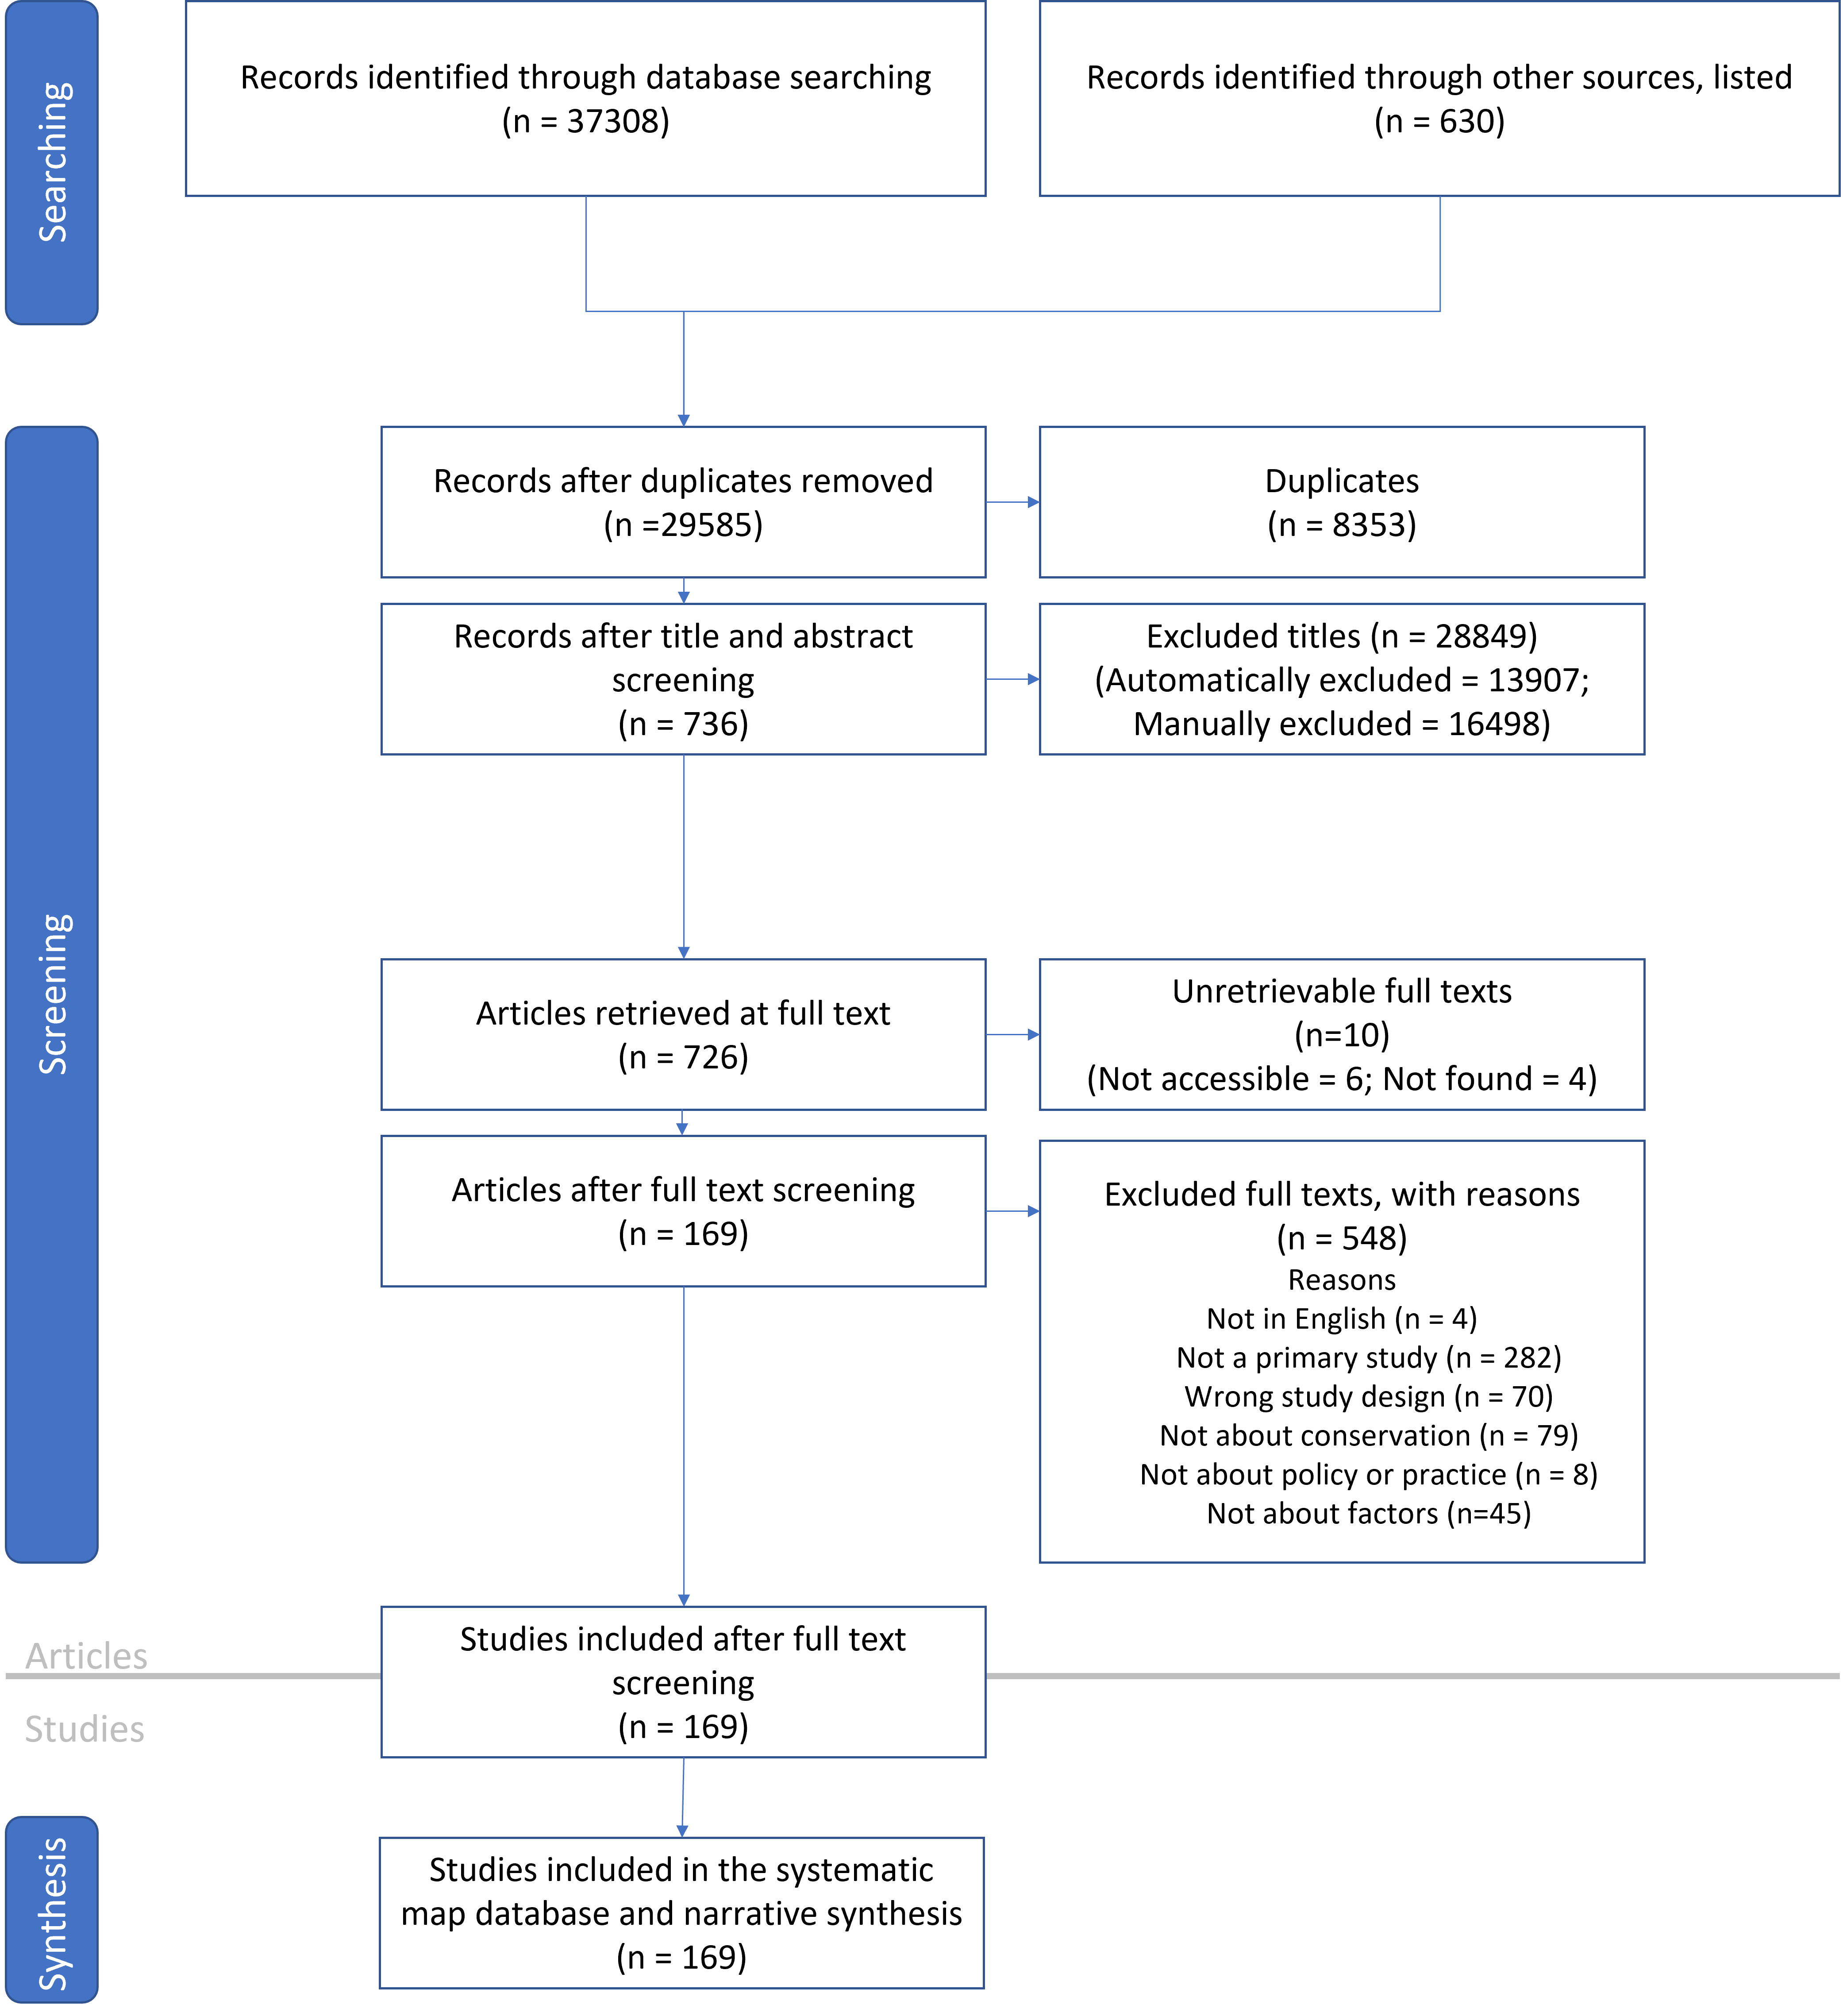
Figure S1 - ROSES diagram representing the searching and screening process carried out to construct the systematic map

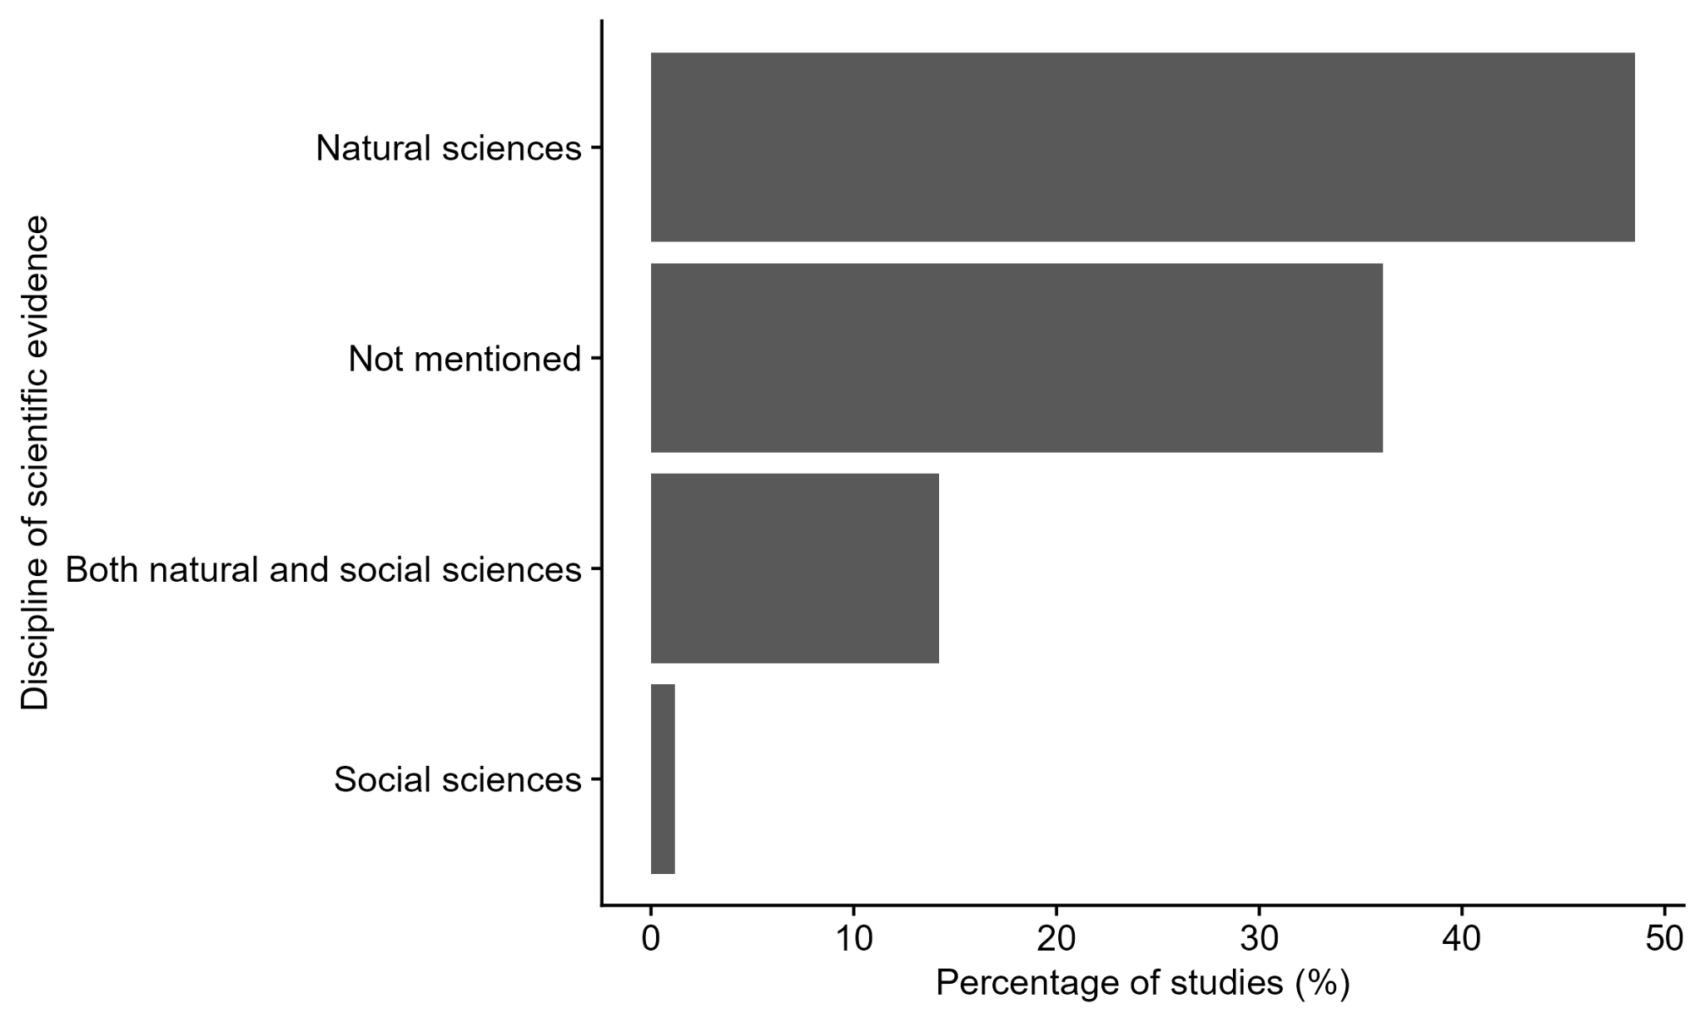
Figure S2 - The frequency with which different disciplines of scientific evidence were investigated in studies assessing factors impacting the use of scientific evidence in conservation decision-making

Studies used in systematic map

Ainsworth, G. B., Redpath, S. M., Wilson, M., Wernham, C., & Young, J. C. (2020). Integrating scientific and local knowledge to address conservation conflicts: Towards a practical framework based on lessons learned from a Scottish case study. Environmental Science & Policy, 107, 46–55. https://doi.org/10.1016/j.envsci.2020.02.017
Arias, M., Hinsley, A., & Milner-Gulland, E. J. (2021). Use of evidence for decision-making by conservation practitioners in the illegal wildlife trade. People and Nature, 3(5), 1110–1126. https://doi.org/10.1002/pan3.10258
Coll, M., Cury, P., Azzurro, E., Bariche, M., Bayadas, G., Bellido, J. M., Chaboud, C., Claudet, J., El-Sayed, A.-F., Gascuel, D., Knittweis, L., Pipitone, C., Samuel-Rhoads, Y., Taleb, S., Tudela, S., & Valls, A. (2013). The scientific strategy needed to promote a regional ecosystem-based approach to fisheries in the Mediterranean and Black Seas. Reviews in Fish Biology and Fisheries, 23(4), 415–434. https://doi.org/10.1007/s11160-013-9305-y
Cook, C. N., & Sgrò, C. M. (2019). Poor understanding of evolutionary theory is a barrier to effective conservation management. Conservation Letters, 12(2). https://doi.org/10.1111/conl.12619
Cooke, S. J., Nguyen, V. M., Wilson, A. D. M., Donaldson, M. R., Gallagher, A. J., Hammerschlag, N., & Haddaway, N. R. (2016). The need for speed in a crisis discipline: perspectives on peer-review duration and implications for conservation science. Endangered Species Research, 30, 43405. https://doi.org/10.3354/esr00721
Cvitanovic, C., Mackay, M., Shellock, R. J., van Putten, E. I., Karcher, D. B., & Dickey-Collas, M. (2021). Understanding and evidencing a broader range of successes that can occur at the interface of marine science and policy. Marine Policy, 134. https://doi.org/10.1016/j.marpol.2021.104802
Cvitanovic, C., Shellock, R. J., Mackay, M., Van, P. E. I., Karcher, D. B., Dickey-Collas, M., & Ballesteros, M. (2021). Strategies for building and managing “trust” to enable knowledge exchange at the interface of environmental science and policy. Environmental Science & Policy, 123, 179–189.
Davies, A. L., Colombo, S., & Hanley, N. (2014). Improving the application of long-term ecology in conservation and land management. The Journal of Applied Ecology, 51(1), 63–70. https://doi.org/10.1111/1365-2664.12163
Denny, S., & Fanning, L. (2016). Balancing community autonomy with collective identity: Mi’kmaq decision-making in Nova Scotia. The Canadian Journal of Native Studies, 36(2), 81–106.
Dharmawan, B., Böcher, M., & Krott, M. (2017). Endangered Mangroves in Segara Anakan, Indonesia: Effective and Failed Problem-Solving Policy Advice. Environmental Management, 60(3), 409–421. https://doi.org/10.1007/s00267-017-0868-6
Eschen, R., Mbaabu, P. R., Ramamonjisoa, B. S., & Robledo-Abad, C. (2021). Factors enhancing the level of utilisation of research knowledge on ecosystems. PloS One, 16(7). https://doi.org/10.1371/journal.pone.0254752
Ferré, M., Martin-Ortega, J., Di Gregorio, M., & Dallimer, M. (2022). How do information flows affect impact from environmental research?-An analysis of a science-policy network. Journal of Environmental Management, 321. https://doi.org/10.1016/j.jenvman.2022.115828
Foster, C. N., O’Loughlin, L. S., Sato, C. F., Westgate, M. J., Barton, P. S., Pierson, J. C., Balmer, J. M., Catt, G., Chapman, J., Detto, T., Hawcroft, A., Jones, G., Kavanagh, R. P., McKay, M., Marshall, D., Moseby, K. E., Perry, M., Robinson, D., Seddon, J. A., … Lindenmayer, D. B. (2019). How practitioners integrate decision triggers with existing metrics in conservation monitoring. Journal of Environmental Management, 230, 94–101. https://doi.org/10.1016/j.jenvman.2018.09.067
Gagné, S. A., Bryan-Scaggs, K., Boyer, R. H. W., & Xiang, W. N. (2020). Conserving biodiversity takes a plan: How planners implement ecological information for biodiversity conservation. Ambio, 49(9), 1490–1505. https://doi.org/10.1007/s13280-019-01281-z
Gardiner, N. B., Liggett, D., Gilbert, N., & Cvitanovic, C. (2024). Practitioners’ perspectives on the enablers and barriers to successful Antarctic science-policy knowledge exchange. Environmental Policy and Governance. https://doi.org/10.1002/eet.2143
Giebels, D., van Buuren, A., & Edelenbos, J. (2015). Using knowledge in a complex decision-making process - Evidence and principles from the Danish Houting project’s ecosystem-based management approach. Environmental Science & Policy, 47, 53–67. https://doi.org/10.1016/j.envsci.2014.10.015
Giehl, E. L. H., Moretti, M., Walsh, J. C., Batalha, M. A., & Cook, C. N. (2017). Scientific evidence and potential barriers in the management of Brazilian protected areas. PloS One, 12(1). https://doi.org/10.1371/journal.pone.0169917
Goggin, C. L., Barrett, T., Leys, J., Summerell, G., Gorrod, E., Waters, S., Littleboy, M., Auld, T. D., Drielsma, M. J., & Jenkins, B. R. (2019). Incorporating social dimensions in planning, managing and evaluating environmental projects. Environmental Management, 63(2), 215–232. https://doi.org/10.1007/s00267-018-01131-w
González, A., Keneghan, D., Fry, J., & Hochstrasser, T. (2014). Current practice in biodiversity impact assessment and prospects for developing an integrated process. Impact Assessment and Project Appraisal, 32(1), 31–42. https://doi.org/10.1080/14615517.2013.850839
Gootee, R. S., Blatner, K. A., Baumgartner, D. M., Carroll, M. S., & Weber, E. P. (2010). Choosing What to Believe About Forests: Differences Between Professional and Non-Professional Evaluative Criteria. Small Scale Forestry, 9(2), 137–152. https://doi.org/10.1007/s11842-010-9113-3
Gossa, C., Fisher, M., & Milner-Gulland, E. J. (2015). The research-implementation gap: How practitioners and researchers from developing countries perceive the role of peer-reviewed literature in conservation science. Oryx: The Journal of the Fauna Preservation Society, 49(1), 80–87. https://doi.org/10.1017/S0030605313001634
Grand, L., Messer, K. D., & Allen, W. (2017). Understanding and Overcoming the Barriers for Cost-effective Conservation. Ecological Economics, 138, 139–144. https://doi.org/10.1016/j.ecolecon.2017.03.027
Greggor, A. L., Berger-Tal, O., Swaisgood, R. R., Cooke, S. J., DeVault, T. L., Fernández-Juricic, E., Gienapp, A., Hall, S., Hostetter, C., Owen, M. A., Rankin, S., Ruppert, K. A., Swaddle, J. P., & Blumstein, D. T. (2021). Using Change Models to Envision Better Applications of Animal Behavior Research in Conservation Management and Beyond. Frontiers in Conservation Science, 2. https://doi.org/10.3389/fcosc.2021.653056
Juhola, S., Huotari, E., Kolehmainen, L., Silfverberg, O., & Korhonen-Kurki, K. (2024). Knowledge brokering at the environmental science-policy interface - examining structure and activity. Environmental Science & Policy, 153. https://doi.org/10.1016/j.envsci.2024.103672
Karam-Gemael, M., Loyola, R., Penha, J., & Izzo, T. (2018). Poor alignment of priorities between scientists and policymakers highlights the need for evidence-informed conservation in Brazil. Perspectives in Ecology and Conservation, 16(3), 125–132. https://doi.org/10.1016/j.pecon.2018.06.002
Karcher, D. B., Cvitanovic, C., Colvin, R. M., van Putten, I., Pozza, R. D., & Posner, S. (2025). Key attributes for effective knowledge brokering at the interface of environmental science and management. Sustainability Science, 20(1), 117–133. https://doi.org/10.1007/s11625-024-01575-6
Kartez, J. D., & Casto, M. P. (2008). Information Into Action Biodiversity Data Outreach and Municipal Land Conservation. Journal of the American Planning Association. American Planning Association, 74(4), 467–480. https://doi.org/10.1080/01944360802378096
Koehn, J. D., Balcombe, S. R., & Zampatti, B. P. (2019). Fish and flow management in the Murray-Darling Basin: Directions for research. Ecological Management & Restoration, 20(2), 142–150. https://doi.org/10.1111/emr.12358
Kuiper, T., Ngwenya, N., Kavhu, B., Mandisodza-Chikerema, R., & Milner-Gulland, E. J. (2023). Making adaptive management more user friendly to encourage manager buy-in. People and Nature, 5(2), 684–698. https://doi.org/10.1002/pan3.10440
Lalor, B. M., & Hickey, G. M. (2014). Strengthening the Role of Science in the Environmental Decision-Making Processes of Executive Government. Organization & Environment, 27(2), 161–180. https://doi.org/10.1177/1086026614525641
Lapointe, N. W. R., Tremblay, M. A., & Barna, H. (2016). Tools for Improving the Effectiveness of Academic Partnerships in Informing Conservation Practices. Natural Areas Journal, 36(1), 93–100. https://doi.org/10.3375/043.036.0116
Lonsdale, J. A., Gill, A. B., Alliji, K., Birchenough, S. N. R., Blake, S., Buckley, H., Clarke, C., Clarke, S., Edmonds, N., Fonseca, L., Goodsir, F., Griffith, A., Judd, A., Mulholland, R., Perry, J., Randall, K., & Wood, D. (2022). It Is a Balancing Act: The Interface of Scientific Evidence and Policy in Support of Effective Marine Environmental Management. Sustainability, 14(3). https://doi.org/10.3390/su14031650
McConney, P., Fanning, L., Mahon, R., & Simmons, B. (2016). A first look at the science-policy interface for ocean governance in the Wider Caribbean Region. Frontiers in Marine Science, 2. https://doi.org/10.3389/fmars.2015.00119
Messmer, T. A., Hasenyager, R., Burruss, J., & Liguori, S. (2013). Stakeholder contemporary knowledge needs regarding the potential effects of tall structures on sage-grouse. Human-Wildlife Interactions, 7(2), 273–298.
Murray, G., Randall, C., & Rollins, R. (2020). Informing Protected Area Decision Making through Academic-Practitioner Collaborations. The Land, 9(10). https://doi.org/10.3390/land9100375
Neeff, T., & Piazza, M. (2020). How countries link forest monitoring into policy-making. Forest Policy and Economics, 118. https://doi.org/10.1016/j.forpol.2020.102248
Ormerod, S. J., Barlow, N. D., Marshall, E. J. P., & Kerby, G. (2002). The uptake of applied ecology. The Journal of Applied Ecology, 39(1), 46204. https://doi.org/10.1046/j.0021-8901.2001.00705.x
Pelletier, D. (2020). Assessing the Effectiveness of Coastal Marine Protected Area Management: Four Learned Lessons for Science Uptake and Upscaling. Frontiers in Marine Science, 7. https://doi.org/10.3389/fmars.2020.545930
Petheram, L., Stacey, N., Campbell, B. M., & High, C. (2012). Using visual products derived from community research to inform natural resource management policy. Land Use Policy, 29(1), 46296. https://doi.org/10.1016/j.landusepol.2011.04.002
Pfaeffle, T., Moore, M. A., Cravens, A. E., McEvoy, J., & Bamzai-Dodson, A. (2022). Murky waters: divergent ways scientists, practitioners, and landowners evaluate beaver mimicry. ECOLOGY AND SOCIETY, 27(1). https://doi.org/10.5751/ES-13006-270141
Polejack, A., Ramírez-Monsalve, P., & Wisz, M. S. (2023). What does integrated ecosystem assessment mean to policy-makers and scientists working in the Atlantic? Implications for ocean science diplomacy. Frontiers in Marine Science, 10. https://doi.org/10.3389/fmars.2023.1004740
Ramirez, L. F., & Belcher, B. M. (2019). Stakeholder perceptions of scientific knowledge in policy processes: A Peruvian case-study of forestry policy development. Science & Public Policy, 46(4), 504–517. https://doi.org/10.1093/scipol/scz003
Rittenhouse, J., Leites, L., Derham, K., & Miller, S. (2018). Insights on the use of decision-support tools to sustain forest ecosystems from a case study in Pennsylvania, USA. Journal of Forestry, 116(4), 391–395. https://doi.org/10.1093/jofore/fvy016
Siggery, B., Bennion, H., Morse, S., Murphy, R., & Waite, M. (2023). Practitioner perspectives on the application of palaeoecology in nature conservation. Frontiers in Ecology and Evolution, 11. https://doi.org/10.3389/fevo.2023.1304510
Stevens, M., & Norris, D. R. (2022). A mixed methodology for evaluating use of evidence in conservation planning. Conservation Biology, 36(4). https://doi.org/10.1111/cobi.13876
Tambe, S., Rawat, G. S., Bhutia, N. T., Sherpa, P. N., Dhakal, S., Pradhan, S., Kulkarni, H., & Arrawatia, M. L. (2020). Building sustainability in the Eastern Himalaya: linking evidence to action. Environment Development and Sustainability, 22(6), 5887–5903. https://doi.org/10.1007/s10668-019-00456-8
Valdez, J. W., Pereira, H. M., Morejón, G. F., Acosta-Muñoz, C., Bonet Garcia, F. J., Castro Vergara, L., Claros, X. R., Gill, M. J., Josse, C., Lafuente-Cartagena, I., Langstroth, R., Sheppard, S. N., Orihuela, G., Prieto-Albuja, F. J., Quillahuaman, N., Terán, M. F., Zambrana-Torrelio, C. M., Navarro, L. M., & Fernandez, M. (2023). Tailoring evidence into action: Using a co-design approach for biodiversity information in the Tropical Andes. Conservation Science and Practice, 5(12). https://doi.org/10.1111/csp2.13035
Vimal, R., Gatiso, T., & Mathevet, R. (2018). Monitoring in Tropical National Parks: The Power of Knowledge. Conservation & Society, 16(1), 76–90. https://doi.org/10.4103/cs.cs_17_12
Young, K. D., & Van Aarde, R. J. (2011). Science and elephant management decisions in South Africa. Biological Conservation, 144(2), 876–885. https://doi.org/10.1016/j.biocon.2010.11.023
Zavaleta, E., Miller, D. C., Salafsky, N., Fleishman, E., Webster, M., Gold, B., Hulse, D., Rowen, M., Tabor, G., & Vanderryn, J. (2008). Enhancing the engagement of U.S. private foundations with conservation science. Conservation Biology, 22(6), 1477–1484. https://doi.org/10.1111/j.1523-1739.2008.01046.x

We are interested in studies that focus on the preservation, protection, management, or restoration of wild biodiversity at any level (e.g. species, habitat, or ecosystem). Studies that mention terms that could include conservation such as natural resource management or fisheries, without any further detail should be considered relevant. Studies that focus on general environmental issues (e.g. pollution, agriculture, forestry) without any clear link to biodiversity conservation are not relevant. Additionally, we do not consider ecosystem services to be relevant.
We consider ‘policy’ to represent formal guidelines, strategies, laws, regulations, and frameworks developed by governments, ranging from local to national, or intergovernmental organisations.
We consider ‘practice’ to be the on-the-ground actions, behaviours, or management techniques applied by conservation practitioners, land managers, NGOs, or local communities.
We define scientific evidence as information that is systematically generated through scientific methodologies (such as experiments, systematic observations, or surveys) and documented in a transparent and reproducible manner. This includes both quantitative and qualitative data. For our purposes, scientific evidence does not include anecdotal or traditional knowledge.
We are interested in both barriers and enablers to evidence use which could include a wide range of different issues. These could include, but is not limited to, difficulties in understanding technical scientific language, lack of relevant evidence, lack of time to consult evidence, or lack of contact with scientists.
We are interested in studies that focus on the preservation, protection, management, or restoration of biodiversity at any level (e.g. species, habitat, or ecosystem). Studies that do not have an explicit link to biodiversity conservation are not relevant. Additionally, we do not consider ecosystem services to be relevant.
We consider ‘policy’ to represent formal guidelines, strategies, laws, regulations, and frameworks developed by governments, ranging from local to national, or intergovernmental organisations.
We consider ‘practice’ to be the on-the-ground actions, behaviours, or management techniques applied by conservation practitioners, land managers, NGOs, or local communities.
We define ‘use’ as use that informs a specific action, use that indirectly influences people’s understanding, and use of evidence to justify a position or action
We define scientific evidence as information that is generated using scientific methodologies that could be used to assess a hypothesis/question, including both quantitative and qualitative data. For our purposes, scientific evidence does not include anecdotal or traditional knowledge. It does however, include citizen science.
We are interested in both barriers and enablers to evidence use which could include a wide range of different issues. These could include, but is not limited to, difficulties in understanding technical scientific language, lack of relevant evidence, lack of time to consult evidence, or lack of contact with scientists.

