

**Figure S1.** Fulla-priori conceptual structural equation model (SEM) evaluating the effects of rainfall exclusion on the abundance of different nematode trophic groups mediated by changes in soil abiotic, microbial and plant drivers. Hexagons indicate composite variables: soil abiotic properties were expressed in terms of soil water content and organic matter, and microbial biomass in terms of carbon (C) and nitrogen (N). Plant drivers were included as three independent observed variables: litter biomass, root phenols and root non-structural carbohydrates (NSC). Numbers in circles represent the different paths and hypothesised mechanisms explained in Table S1.

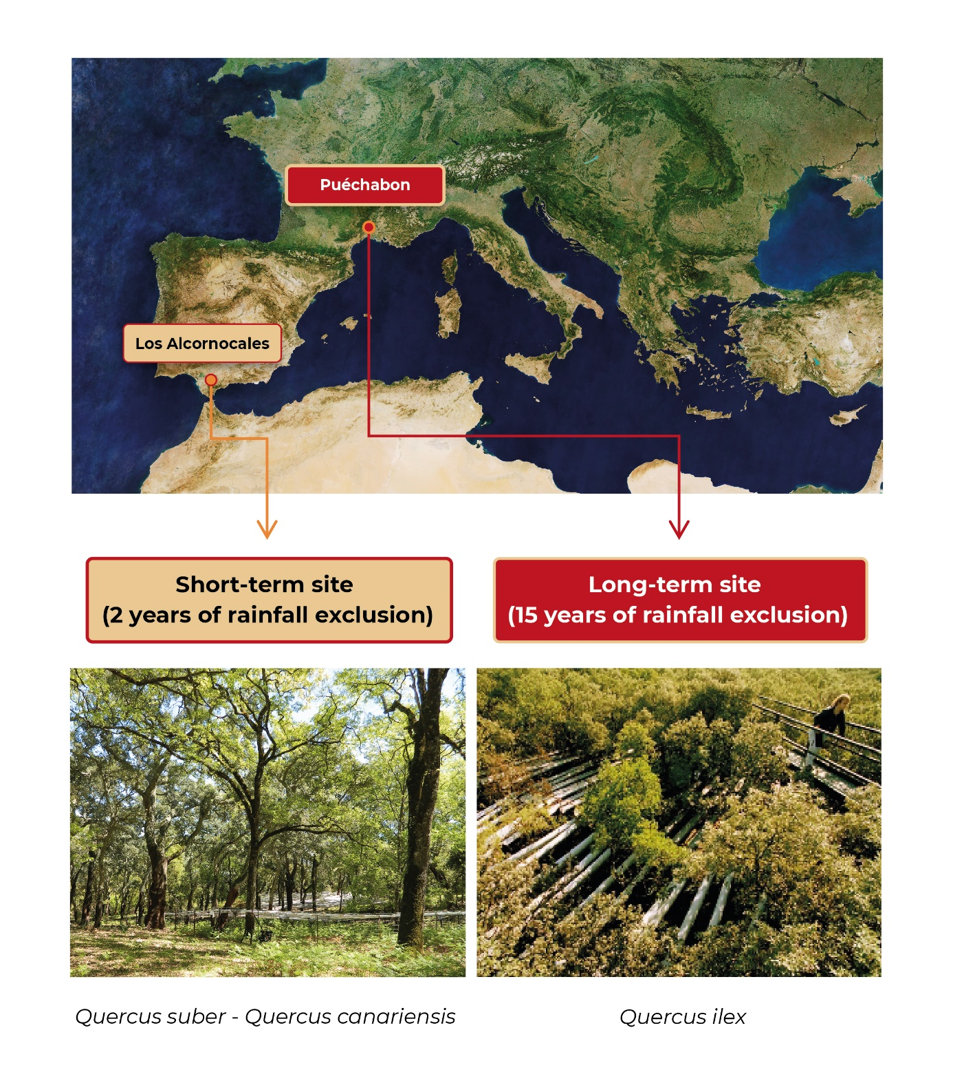

**Figure S2.** Locationof the two experimental sites in southern Europe.

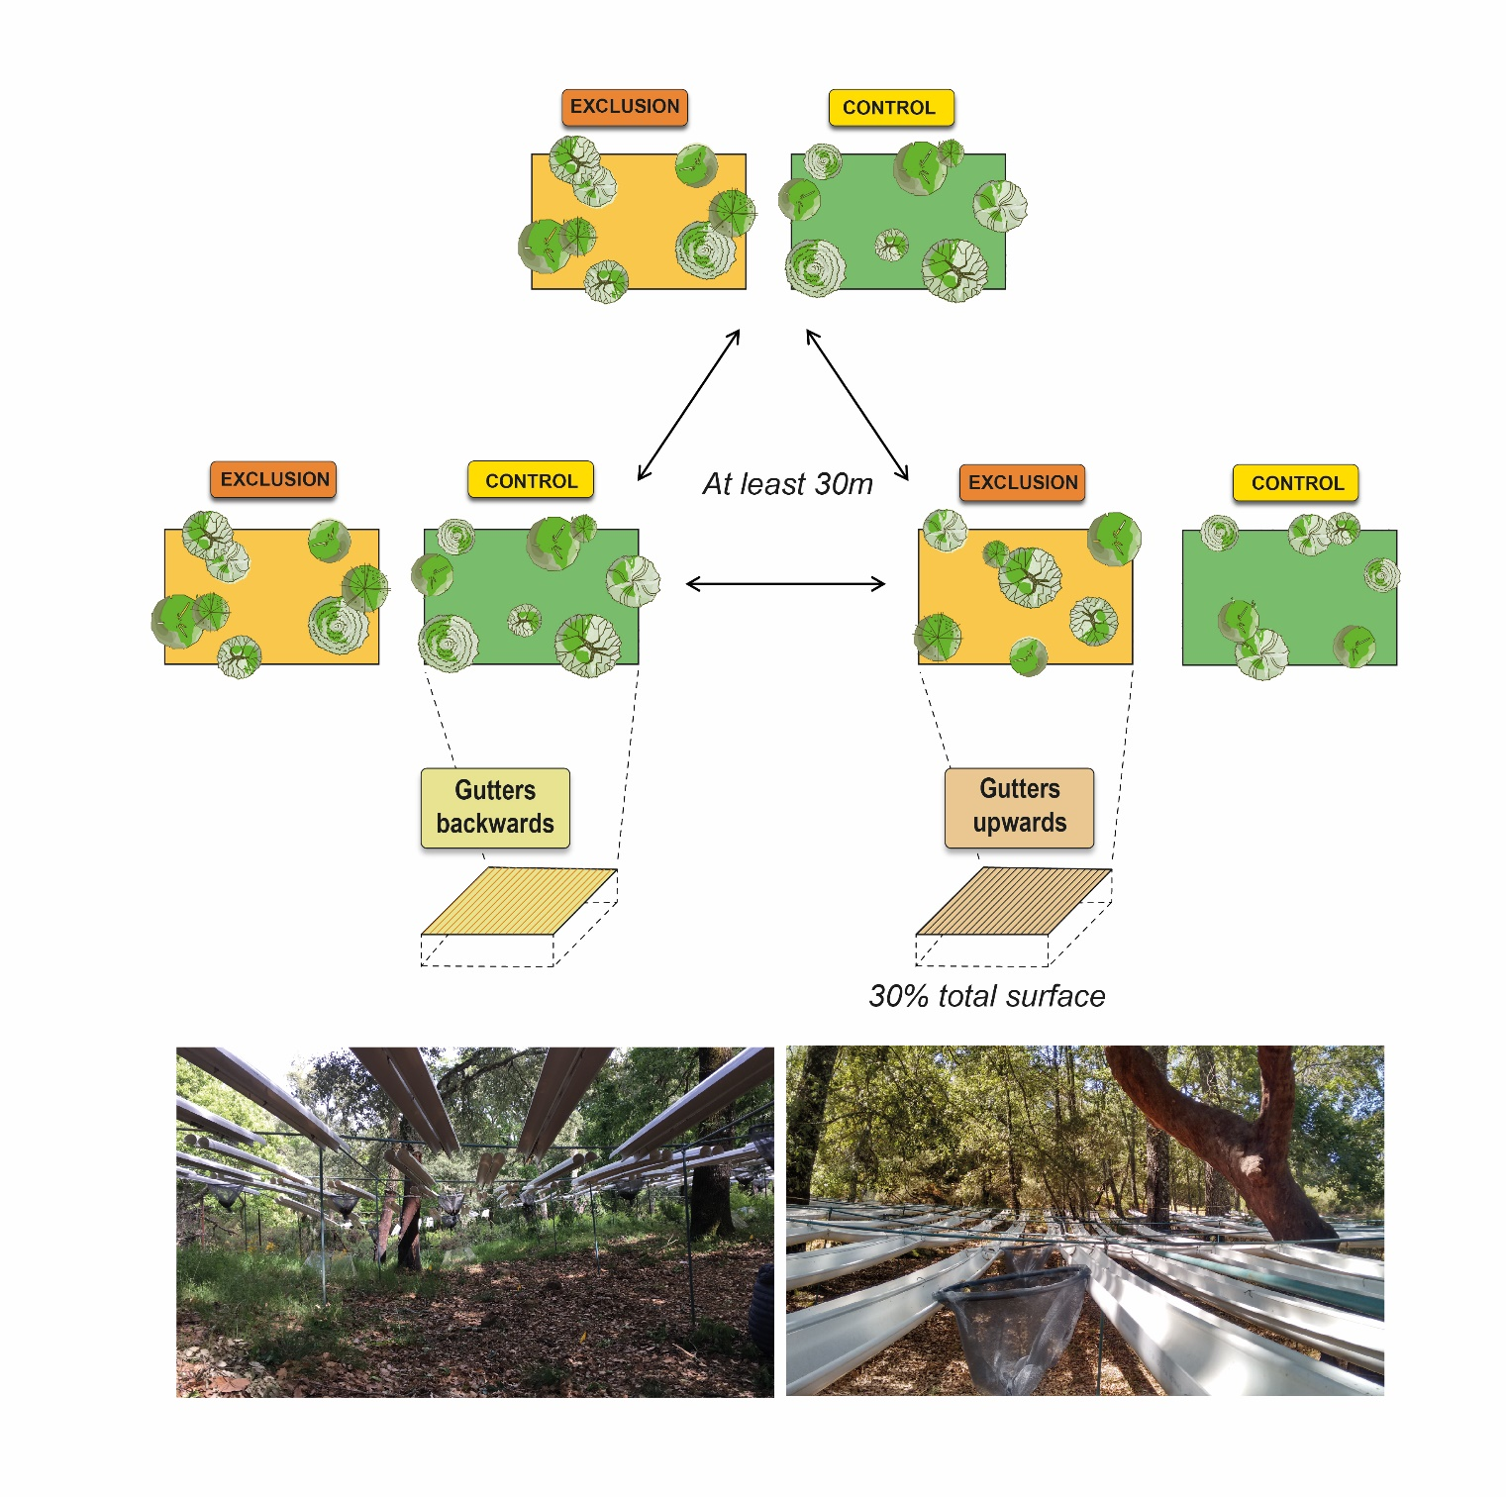

1

**Figure S3.** Experimental design oftherainfall exclusion infrastructures. Photographs below the figure were taken at the Spanish short-term experimental site and show control (left) and rainfall exclusion plots (right).

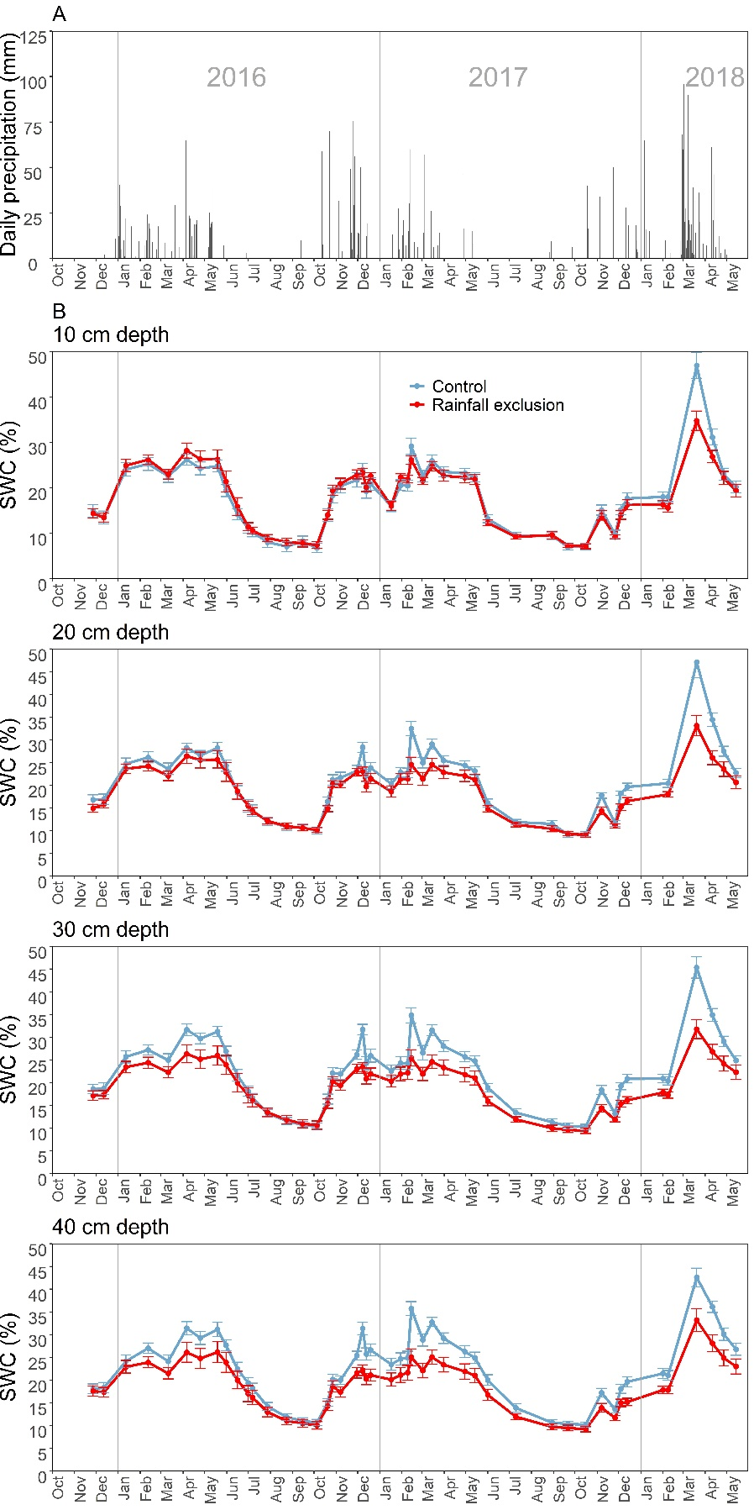

**Figure S4.** A)Daily precipitation at the short-term experimental site in southern Spain; B) Average soil water content (SWC) at different soil depths (10, 20, 30 and 40 cm) in rainfall exclusion and control plots (mean ± SE). Vertical grey lines separate different years. The rainfall exclusion infrastructure was built and start working on March 2016.

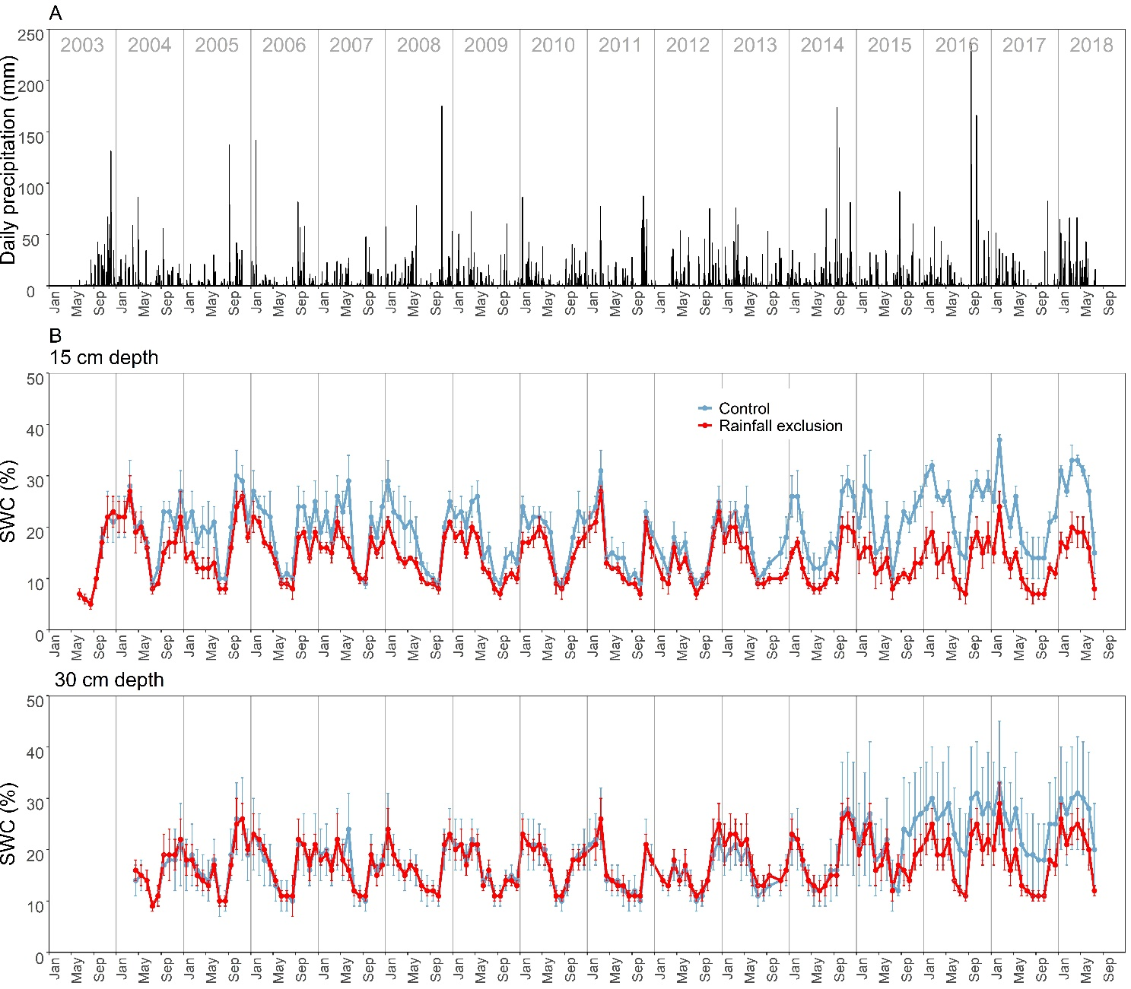

**Figure S5.** A)Daily precipitation at the long-term experimental site in France; B) Average soil water content (SWC) at different soil depths (0-15 cm, and 0-30 cm) in rainfall exclusion and control plots (mean ± SE) since rainfall exclusion structure installation. Vertical grey lines separate different years. The rainfall exclusion infrastructure was built and start working on March 2003.

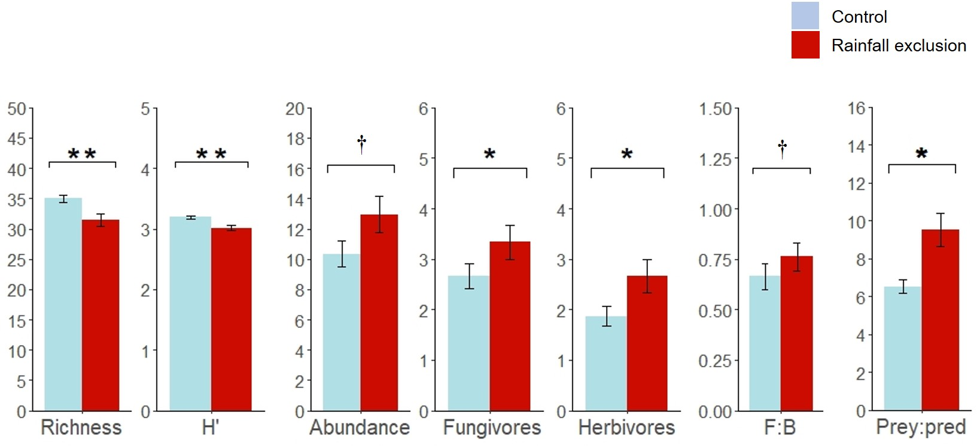

**Figure S6.** Pre-treatment differences at the short-term site in the richness, diversity (H’) and total abundance of soil nematodes, as well as on the abundance of different trophic groups (fungivores and herbivores), the F:B ratio (fungivores:bacterivores ratio) and the prey:predator ratio. Only variables that showed significant pre-treatment differences are shown. Abundances are represented as number of individuals per gram of soil (ind/g). Error bars represent ±SE. Asterisks denote significant effects: **p < 0.01, *p < 0.05, †p < 0.1

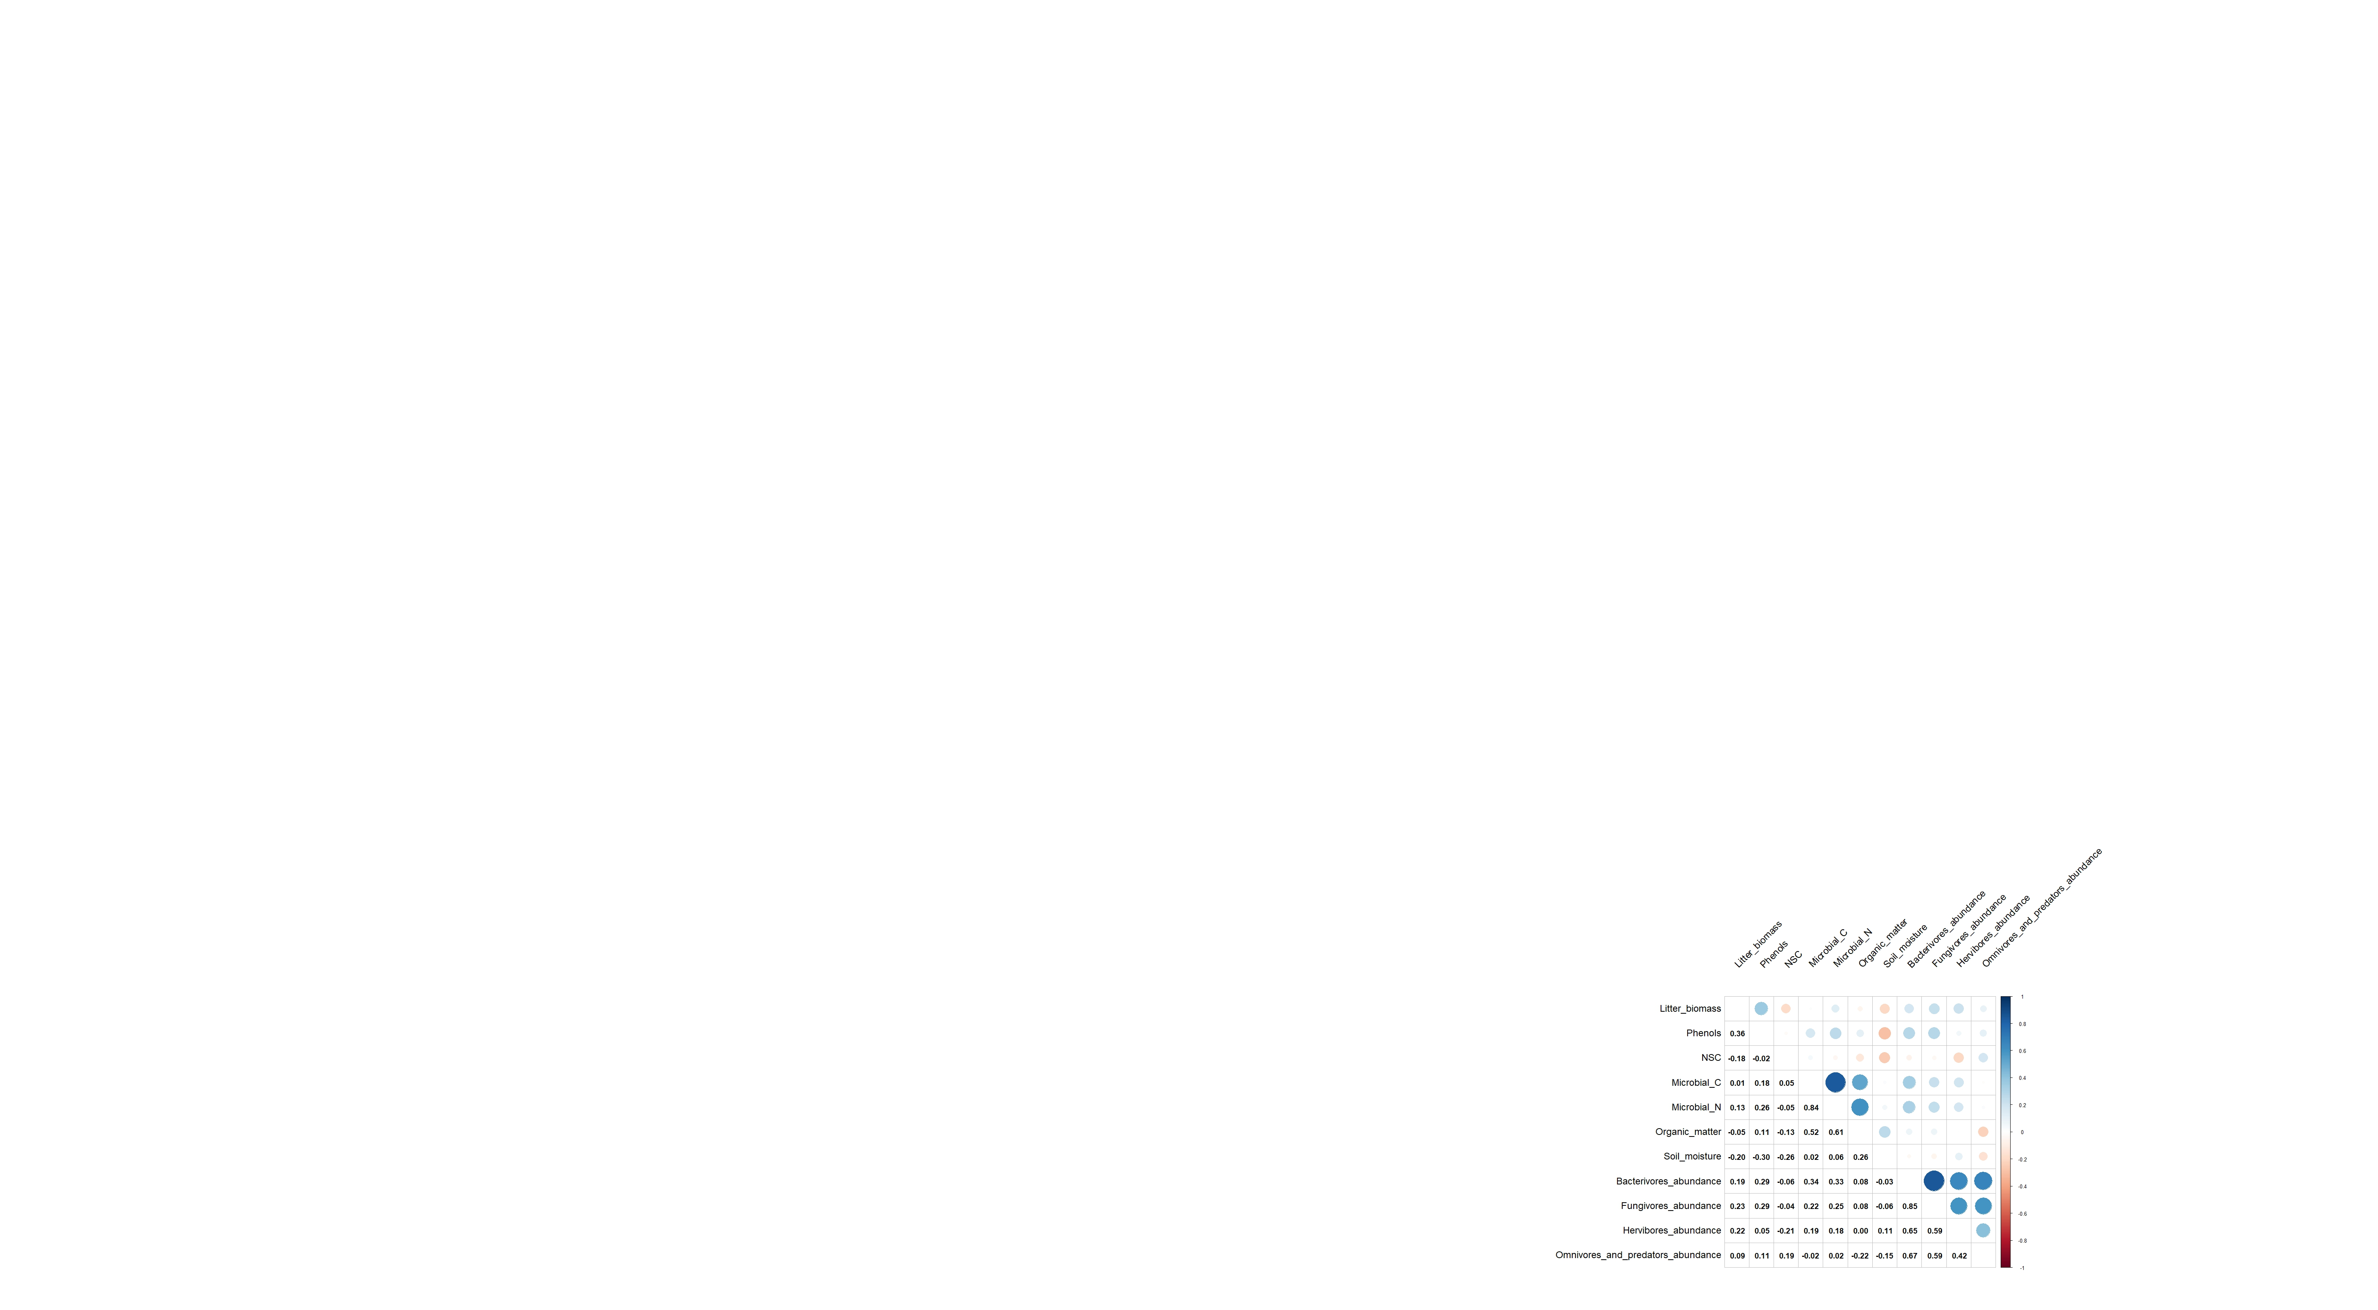

**Figure S7.** Correlation coefficients (Pearson‘s r) among variables included in the Structural Equation Model.

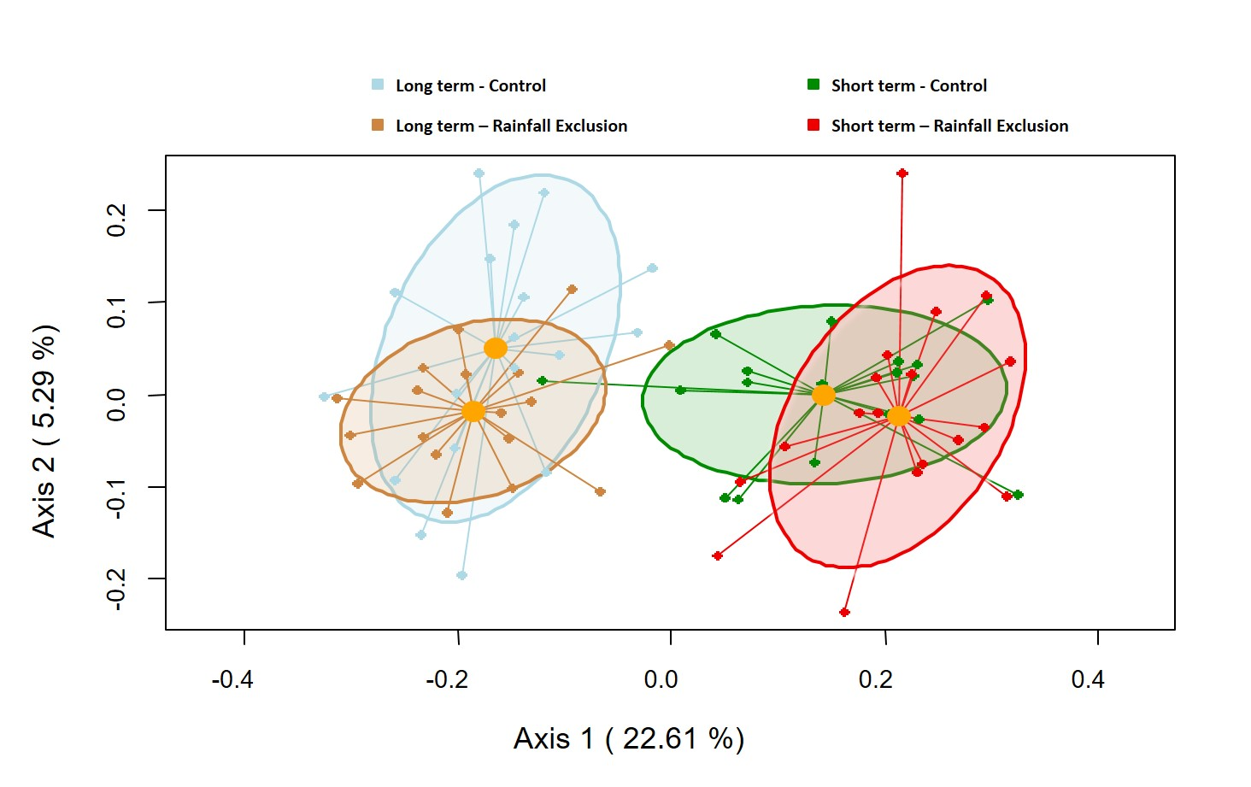

**Figure S8.** Ordination plot (PCoA) of the nematode community structure for the four combinations of site and treatment. The X-axis and Y-axis represent the two main coordinate axes, and their percentages indicate the amount of variation captured in each axis. Yellow points represent the centroids of the ellipses. Ellipses are painted with 95% margin of confidence.

|  |  |  |  |
| --- | --- | --- | --- |
| **#** | **Path** | **Justification** | **Ref** |
| **1** | Rainfall exclusion 🡪 Litter biomass | Drought can induce a reduction of carbon investment in leaf area and negatively affect the production of litter biomass | 19, 21 |
| **2** | Rainfall exclusion 🡪 Root chemistry | Drought can change the chemical composition of tree roots. Plants subjected to drought can increase the allocation of non-structural carbohydrates to the roots. | 7, 16, 17 |
| **3** | Rainfall exclusion 🡪 Microbial biomass | Soil microbes are dependent on soil water content. Reductions in soil moisture can have negative effects soil microbial biomass. | 5, 8, 24 |
| **4** | Rainfall exclusion 🡪 Soil abiotic properties | Rainfall exclusion translates into lower soil moisture. Rainfall exclusion and drought can induce significant reductions in soil organic matter. | 2, 4, 8, 9, 11 |
| **5** | Litter biomass 🡪  Soil abiotic properties | Litter biomass is a main source of soil organic matter and influences soil water content. | 20, 23 |
| **6** | Soil abiotic properties 🡪 Microbial biomass | Soil microbes are highly dependent on soil moisture. Organic matter retains soil moisture favouring soil microbes. Moreover, it represents an important resource for many saprophytic microbes. | 5, 8, 24 |
| **7** | Root chemistry 🡪 Microbial biomass | Root chemistry can affect soil microbial communities through the quality and quantity of root exudates. | 13 |
| **8** | Root chemistry 🡪 Herbivores | Phenols are relevant defence compounds in many plant species.  Herbivore nematodes could use root sugars and starch as an energy source. | 3, 6, 14, 22, 29 |
| **9** | Microbial biomass 🡪 Fungivores and Bacterivores | Fungivore and bacterivore nematodes show strong dependence on microbial biomass as a food resource. | 15, 28 |
| **10** | Soil abiotic properties 🡪 All nematode trophic groups | Nematodes strongly depend on soil water content for movement and access to resources. Sensitivity to drought varies among trophic groups. Organic matter is known to affect soil biodiversity due to its control of resources availability. | 1, 12, 25, 27 |
| **11** | Relationships between nematode trophic groups | Directional relationships among nematodes in higher (omnivores, predators) and lower (bacterivores, fungivores, herbivores) trophic levels suggest top-down or bottom-up trophic controls of nematode abundance. Bi-directional relationships between different trophic groups could reflect similar preferences for particular abiotic and biotic microsite conditions. | 10, 18, 26, 28 |

**Table S1.** Hypothesized causal mechanisms linking rainfall exclusion andthe abundance of the different nematode trophic groups.

**Table S2.** Summary of main characteristics of the two study forests measured before the installation of the rainfall exclusion infrastructures. For stand structure and soil variables, values represent mean ± SE (n = 36, except for tree density and basal area where n = 3). There were no significant differences among control and drought plots in any of the variables analysed (p > 0.05) at any of the two sites.

|  |  |  |  |  |  |  |  |
| --- | --- | --- | --- | --- | --- | --- | --- |
|  | **Short-term rainfall exclusion**  **Los Alcornocales (Spain)** | | |  | **Long-term rainfall exclusion**  **Puéchabon (France)** | | |
| Latitude | 36º 34’ 07’’ N | | |  | 43º 44’ 29’’ N | | |
| Longitude | 5º32’21’’ O | | |  | 03º 35’ 46’’ E | | |
| Altitude (m a.s.l) | 270 | | |  | 209 | | |
| Mean annual temperature (ºT) | 16.4 | | |  | 13.5 | | |
| Mean annual precipitation (mm) | 910 | | |  | 883 | | |
| Stand structure | Control |  | Drought |  | Control |  | Drought |
| Tree density (stems/ha) | 233.33 ± 0.02 |  | 244.44 ± 11.11 |  | 5933 ± 874 |  | 6433 ± 546 |
| Basal area (m2/ha) | 28.89 ± 8.46 |  | 27.58 ± 1.73 |  | 24.9 ± 0.92 |  | 29.8 ± 1.71 |
| Tree height (m) | 11.59 ± 0.62 |  | 11.63 ± 0.61 |  | 3.84 ± 1.29 |  | 4.05 ± 1.25 |
| Diameter at breast height (cm) | 37.54 ± 3.13 |  | 35.07± 3.06 |  | 6.91 ± 0.61 |  | 7.21 ± 0.22 |
| Soil variables |  |  |  |  |  |  |  |
| Texture (% sand) | 72.33 ± 1.69 |  | 72.84 ± 1.66 |  | 20.71 ± 1.23 |  | 21.88 ± 0.95 |
| pH | 5.53 ± 0.36 |  | 5.33 ± 0.21 |  | 7.23 ± 0.11 |  | 7.42 ± 0.17 |

Table S3. Results of the Linear Mixed Models that analyses the effect of the rainfall exclusion treatment on soil moisture at different depths in the Spanish short-term site. Block and year were included as fixed factors to control for spatial and temporal autocorrelation. Texture was included as a covariate to control for the effect of the differences in geological composition between sampling points. Month was included as a random factor. Df shows the degrees of freedom of the numerator and denominator.

|  |  |  |  |  |  |
| --- | --- | --- | --- | --- | --- |
| **Depth** | **Factor** |  | **df (num, den)** | **F** | **p-value** |
| **10 cm** | Block |  | 2,1026 | 7.60 | <0.001 |
|  | Year |  | 2,1027 | 12.41 | <0.001 |
|  | Texture |  | 1,1026 | 10.57 | 0.001 |
|  | Rainfall exclusion |  | 1,1026 | 13.09 | <0.001 |
| **20 cm** | Block |  | 2,993 | 35.28 | <0.001 |
| Year |  | 2,994 | 17.67 | <0.001 |
| Texture |  | 1,993 | 4.05 | 0.045 |
| Rainfall exclusion |  | 1,993 | 61.75 | <0.001 |
| **30 cm** | Block |  | 2,1027 | 38.21 | <0.001 |
| Year |  | 2,1028 | 33.01 | <0.001 |
| Texture |  | 1,1027 | 4.46 | 0.035 |
| Rainfall exclusion |  | 1,1027 | 146.73 | <0.001 |
| **40 cm** | Block |  | 2,1025 | 41.93 | <0.001 |
|  | Year |  | 2,1026 | 32.01 | <0.001 |
|  | Texture |  | 1,1025 | 18.53 | <0.001 |
|  | Rainfall exclusion |  | 1,10250 | 155.93 | <0.001 |

Table S4. Results of the Linear Mixed Models performed to test the effect on soil moisture of the rainfall exclusion treatment at the French long-term site. Year and month were included as random factors. Df shows the degrees of freedom of the numerator and denominator.

|  |  |  |  |  |  |
| --- | --- | --- | --- | --- | --- |
| **Depth** | **Factor** |  | **df** | **F-value** | **p-value** |
| **15 cm** | Rainfall exclusion |  | 1,10658 | 6851.1 | <0.001 |
| **30 cm** | Rainfall exclusion |  | 1,10057 | 714.17 | <0.001 |

Table S5. Results of the Generalized Linear Models that analyze pre-treatment differences in nematode richness, diversity (H’), abundances and indices at the short-term site. Values represent Z-values for richness and F-values for the rest of variables. Asterisks denote significant effects: **p < 0.01, *p < 0.05, †p < 0.01.

|  |  |  |  |
| --- | --- | --- | --- |
| **Variable** | **Block** | **Rainfall exclusion** | **R2** |
| Diversity |  |  |  |
| Richness | 0.17 | 8.81** | 0.20 |
| H’ | 0.15 | 9.68** | 0.22 |
| Abundance |  |  |  |
| Total | 2.74† | 3.45† | 0.20 |
| Bacterivore | 1.58 | 0.42 | 0.09 |
| Fungivore | 2.36 | 6.04* | 0.24 |
| Herbivore | 3.24† | 3.85* | 0.22 |
| Predator | 0.26 | 0.56 | 0.03 |
| Omnivore | 1.76 | 0.01 | 0.09 |
| Indices |  |  |  |
| Maturity index | 1.29 | 0.93 | 0.09 |
| Plant Parasitic index | 0.35 | 1.65 | 0.06 |
| Structure index | 2.47 | 0.06 | 0.12 |
| Enrichment index | 0.56 | 1.85 | 0.08 |
| F:B | 0.05 | 3.20† | 0.09 |
| Prey:predator | 3.14† | 4.76* | 0.24 |

**Table S6.** Summary of mean values ± SE in control and rainfall exclusion plots included in the Structural Equation Model for the short-term site.

|  |  |  |  |  |  |
| --- | --- | --- | --- | --- | --- |
| Variables | Control |  | Drought | F-value | p-value |
| Soil abiotic variables |  |  |  |  |  |
| Organic matter (%) | 10.54 ±1.06 |  | 9.75 ± 0.69 | 0.26 | 0.607 |
| Soil Water Content (%) | 26.22 ± 0.78 |  | 22.85 ± 0.99 | 7.81 | 0.009 |
| Microbial variables |  |  |  |  |  |
| Microbial C | 615.87 ± 55.74 |  | 658.57 ± 32.4 | 0.49 | 0.488 |
| Microbial N | 127.61 ± 11.76 |  | 122.62 ± 6.18 | 0.16 | 0.691 |
| Plant variables |  |  |  |  |  |
| Litter biomass | 358.21 ± 22.07 |  | 338.03 ± 36.19 | 0.26 | 0.614 |
| Non-structural carbohydrates | 37.36 ± 1.99 |  | 46.52 ± 2.87 | 6.59 | 0.015 |
| Phenols | 200.22 ± 10.14 |  | 193.18 ± 10.06 | 0.24 | 0.624 |

Table S7. Results of the Generalized Linear Mixed Models that analyze the effect of rainfall exclusion on nematode diversity, abundance and indices at the short-term site, controlling for pre-treatment differences between control and rainfall exclusion plots. Only variables that showed marginal or significant differences between treatments before the start of the experiment were analyzed (see Table S5). Asterisks denote significant effects: **p < 0.01, *p < 0.05, †p < 0.01. R2m represents marginal R2 values associated only with the fixed effects of the models.

|  |  |  |  |  |
| --- | --- | --- | --- | --- |
| **Variable** | **Block** | **Pre-treatment values** | **Rainfall exclusion** | **R2m** |
| Diversity |  |  |  |  |
| Richness | 2.39 | 0.13 | 0.04 | 0.12 |
| H’ | 2.73† | 0.65 | 0.18 | 0.15 |
| Abundance |  |  |  |  |
| Total | 2.33 | 0.07 | 7.41* | 0.26 |
| Fungivore | 4.87* | 1.59 | 11.89** | 0.40 |
| Herbivore | 0.21 | 1.49 | 3.35† | 0.13 |
| Indices |  |  |  |  |
| F/B | 0.16 | 3.71† | 0.01 | 0.10 |
| Prey/predator | 2.62† | 2.64 | 3.33† | 0.24 |

**Table S8.** Results of the Generalized Linear Models that analyze the effect of the rainfall exclusion treatment on the abundance of the dominant families of nematodes (i.e. > individual/g soil). The *Filenchus* genus was analyzed separately from the *Tylenchidae* family due to their different trophic habits.Values represent F-values.Asterisks denote significant effects: ****p < 0.0001, ***p < 0.001, **p < 0.01, *p < 0.05, † p < 0.01.

|  |  |  |  |  |  |
| --- | --- | --- | --- | --- | --- |
| **Variable** | **Site** | **Block [Site]** | **Rainfall exclusion** | **Site × Rainfall exclusion** | **R2** |
| Bacterivores |  |  |  |  |  |
| Cephalobidae CeCeeCCephalobidae | 87.21**** | 1.71 | 7.15** | 3.21 | 0.61 |
| Plectidae | 29.74**** | 2.22† | 0.64 | 9.04*** | 0.41 |
| Rhabitidae | 5.01* | 1.97 | 0.85 | 5.14* | 0.21 |
| Monhysteridae | 19.14**** | 0.69 | 0.02 | 4.15* | 0.27 |
| Prismatolaimidae | 1.04 | 0.39 | 0.97 | 0.65 | 0.06 |
| Teratocephalidae | 6.63* | 1.56 | 0.11 | 0.46 | 0.16 |
| Fungivores |  |  |  |  |  |
| Filenchus | 50.49**** | 5.63**** | 5.04* | 1.74 | 0.53 |
| Aphelenchoididae | 14.28*** | 0.67 | 5.01* | 0.01 | 0.24 |
| Aphelenchidae | 12.33*** | 1.71 | 4.01* | 1.08 | 0.25 |
| Anguinidae | 9.59** | 1.06 | 1.18 | 1.03 | 0.18 |
| Herbivores |  |  |  |  |  |
| Tylenchidae | 34.71**** | 0.63 | 0.26 | 1.44 | 0.35 |
| Criconematidae | 0.01 | 1.58 | 0.83 | 2.81† | 0.12 |
| Paratylenchidae | 9.33** | 4.13** | 0.51 | 0.86 | 0.27 |
| Omnivores |  |  |  |  |  |
| Aporcelaimidae | 44.43**** | 0.58 | 0.29 | 2.76 | 0.41 |
| Noordidae | 14.63*** | 3.17* | 7.73** | 7.52** | 0.37 |
| Qudsianematidae | 44.52**** | 2.74* | 3.03† | 1.33 | 0.46 |

Table S9. Results of the PERMANOVA test that analyses the effect of rainfall exclusion on the ordination and composition of nematodes communities at the short- and long-term sites.

|  |  |  |  |  |
| --- | --- | --- | --- | --- |
| **Factors** | **Df** | **F** | **p-value** | **R2** |
| Site | 1 | 18.37 | 0.001 | 0.20 |
| Block [Site] | 4 | 1.90 | 0.002 | 0.08 |
| Rainfall Exclusion | 1 | 1.89 | 0.049 | 0.02 |
| Site × Rainfall exclusion | 1 | 1.74 | 0.06 | 0.02 |
| Residuals | 67 |  |  | 0.68 |
| Total | 71 |  |  |  |

**Bibliography**

1.Ankrom, K.E., Franco, A.L.C., Fonte, S.J., Gherardi, L.A., de Tomasel,C.M., Andriuzzi, W.S, Shaw, E.A.,Sala, O.E.,Wall, D.H., 2020. Ecto- and endoparasitic nematodes respond differently across sites to changes in precipitation. Oecologia 193, 761–771. https://doi.org/10.1007/s00442-020-04708-7

2.Bogdziewicz, M., Fernández-Martínez, M., Espelta, J.M., Ogaya, R., Penuelas, J., 2020. Is forest fecundity resistant to drought? Results from an 18-yr rainfall-reduction experiment. New Phytologist 227, 1073–1080. https://doi.org/10.1111/nph.16597

3.Cabello, S., Lorenz, C., Crespo, S., Cabrera, J., Ludwig, R., Escobar, C., Hofmann, J., 2014. Altered sucrose synthase and invertase expression afects the local and systemic sugar metabolism of nematode infected Arabidopsis thaliana plants. Journal of Experimental Botany 65, 201–212. https ://doi.org/10.1093/jxb/ert359

4.Chen, X., Zhang, D., Liang, G., Qiu, Q., Liu, J., Zhou, G., Liu, S., Chu, G., Yan, J., 2016. Effects of precipitation on soil organic carbon fractions in three subtropical forests in southern China. Plant Ecology 9, 10–19.  <https://doi.org/10.1093/jpe/rtv027>

5.Curiel Yuste, J., Barba, J., Fernandez-Gonzalez, A.J., Fernandez-Lope, M., Mattana, S., Martinez-Vilalta, J., Nolis, P., Lloret, F., 2012. Changes in soil bacterial community triggered by drought-induced gap succession preceded changes in soil C stocks and quality. Ecology and Evolution 2, 3016–3031. https://doi.org/10.1002/ece3.409

6.D’Errico, G., Woo, S.L., Lombardi, N., Manganiello, G., Roversi, P.F., 2018. Activity of chestnut tannins against the Southern root-knot nematode meloidogyne incognita. Redia 101, 53–59. https://doi.org/10.19263/REDIA-101.18.08

7. de Vries, F.T., Williams, A., Stringer, F., Willcocks, R., McEwing, R., Langridge, H., Straathof, A.L., 2019. Changes in root-exudate-induced respiration reveal a novel mechanism through which drought affects ecosystem carbon cycling. New Phytologist 224, 132–145. https://doi.org/10.1111/nph.16001

8. Delgado-Baquerizo, M., Maestre, F.T., Reich, P.B., Jeffries, T.C., Gaitan, J.J., Encinar, D., Berdugo, M., Campbell, C.D., Singh, B.K., 2016. Microbial diversity drives multifunctionality in terrestrial ecosystems. Nature Communications 7, 1–8. https://doi.org/10.1038/ncomms10541

9. Deng, L., Peng, C., Kim, D.-G., Li, J., Liu, Y., Hai, X., Liu, Q., Huang, C., Shangguan, Z., Kuzyakov, Y., 2021. Drought effects on soil carbon and nitrogen dynamics in global natural ecosystems. Earth-Science Reviews 214, 103501. https://doi.org/https://doi.org/10.1016/j.earscirev.2020.103501

10. Eisenhauer, N., Cesarz, S., Koller, R., Worm, K., Reich, P.B., 2012. Global change belowground: Impacts of elevated CO 2, nitrogen, and summer drought on soil food webs and biodiversity. Global Change Biology 18, 435–447. https://doi.org/10.1111/j.1365-2486.2011.02555.x

11. Fenner, N., Freeman, C., 2011. Drought-induced carbon loss in peatlands. Nature Geoscienc*e* 4**,**895–900. https://doi.org/10.1038/ngeo1323

12. Ferris, H., Bongers, T., 2006. Nematode indicators of organic enrichment. Journal of Nematology 38, 3–12.

13. Haichar, F.E., Santaella, C., Heulin, T., Achouak, W., 2014. Root exudates mediated interactions belowground. Soil Biology and Biochemistry 77, 69–80.

14. Hofmann, J., Grundler, F.M.W., 2007. How do nematodes get their sweets? Solute supply to sedentary plant-parasitic nematodes. Nematology 9, 451–458. https://doi.org/10.1163/156854107781487305

15.Holmstrup, M., Damgaard, C., Schmidt, I.K., Arndal, M.F., Beier, C., Mikkelsen, T.N., … Christensen, S., 2017. Long-term and realistic global change manipulations had low impact on diversity of soil biota in temperate heathland. Scientific Reports 7, 1–11. https://doi.org/10.1038/srep41388

16.Karlowsky, S., Augusti, A., Ingrisch, J., Hasibeder, R., Lange, M., Lavorel, S., Bahn, M., Gleixner, G., 2018. Land use in mountain grasslands alters drought response and recovery of carbon allocation and plant-microbial interactions. Journal of Ecology 106, 1230– 1243. <https://doi.org/10.1111/1365-2745.12910>

17.Karlowsky, S., Augusti, A., Ingrisch, J., Akanda, M. K. U., Bahn, M., Gleixner, G., 2018. Drought-Induced Accumulation of Root Exudates Supports Post-drought Recovery of Microbes in Mountain Grassland. Frontiers in Plant Science 9, 1593. https://www.frontiersin.org/article/10.3389/fpls.2018.01593

18.Khan, Z., Kim, Y.H., 2007. A review on the role of predatory soil nematodes in the biological control of plant parasitic nematodes. Applied Soil Ecology 35, 370–379. https://doi.org/10.1016/j.apsoil.2006.07.007

19. Lemma B, Nilsson I, Kleja DB et al (2007) Decomposition and substrate quality of leaf litters and fine roots from three exotic plantations and native forest in the southwestern highlands of Ethiopia. Soil Biol Biochem 39:2317–2328. <https://doi.org/10.1016/j.soilbio.2007.03.032>

20. Limousin J-M, Rambal S, Ourcival J-M, Rodrıguez-Calcerrada J, Perez-Ramos IM, Rodrıguez-Cortina R, Misson L, Joffre R. 2012. Morphological and phenological shoot plasticity in a Mediterranean evergreen oak facing long-term increased drought. Oecologia 169: 565–577. https://doi.org/[10.1007/s00442-011-2221-8](https://doi.org/10.1007/s00442-011-2221-8)

21. Lucas-Borja, M. E., Hedo de Santiago, J., Yang, Y., Shen, Y., & Candel-Pérez, D. 2019. Nutrient, metal contents and microbiological properties of litter and soil along a tree age gradient in Mediterranean forest ecosystems. Science of the Total Environment 650, 749–758. <https://doi.org/10.1016/j.scitotenv.2018.09.079>

22. Maistrello, L., Vaccari, G., Sasanelli, N., 2010. Effect of chestnut tannins on the root-knot nematode Meloidogyne javanica. Helminthologia 47, 48–57. https://doi.org/10.2478/s11687-010-0008-9

23. Ogaya R, Penuelas J. 2006. Contrasting foliar responses to drought in *Quercus ilex* and *Phillyrea latifolia*. Biologia Plantarum 50, 373–382. https://doi.org/[10.1007/s10535-006-0052-y](http://dx.doi.org/10.1007/s10535-006-0052-y)

24. Van der Molen, M.K., Dolman, A.J., Ciais, P., Eglin, T., Gobron, N., Law, B.E., … Wang, G., 2011. Drought and ecosystem carbon cycling. Agricultural and Forest Meteorology 151, 765–773. https://doi.org/10.1016/j.agrformet.2011.01.018

25. Wang, X., Nielsen, U.N., Yang, X., Zhang, L., Zhou, X., Du, G., Li, G., Chen, S., Xiao, S., 2018. Grazing induces direct and indirect shrub effects on soil nematode communities. Soil Biology and Biochemistry 121, 193–201. https://doi.org/10.1016/j.soilbio.2018.03.007

26. Wang, X., Xiao, S., Yang, X., Liu, Z., Zhou, X., Du, G., Zhang, L., Guo, A., Chen, S., Nielsen, U.N., 2019. Dominant plant species influence nematode richness by moderating understory diversity and microbial assemblages. Soil Biology and Biochemistry 137. https://doi.org/10.1016/j.soilbio.2019.107566

27. Xiong, D., Wei, C.Z., Wubs, E.R.J., Veen, G.F., Liang, W., Wang, X., Li, Q., Van der Putten, W.H., Han, X., 2020. Nonlinear responses of soil nematode community composition to increasing aridity. Global Ecology and Biogeography 29, 117–126. https://doi.org/10.1111/geb.13013

28. Zhang, X., Guan, P., Wang, Y., Li, Q., Zhang, S., Zhang, Z., Bezemer, T.M., Liang, W., 2015. Community composition, diversity and metabolic footprints of soil nematodes in differently-aged temperate forests. Soil Biology and Biochemistry 80, 118–126. https://doi.org/10.1016/j.soilbio.2014.10.003

29. Zhao, D., You, Y., Fan, H., Zhu, X., Wang, Y., Duan, Y., Xuan, Y., Chen, L., 2018. The role of sugar transporter genes during early infection by root-knot nematodes. International Journal of Molecular Science 19, 302. https://doi.org/10.3390/ijms19010302